Table of Contents

UNITED STATES
SECURITIES AND EXCHANGE COMMISSION

Washington, D.C. 20549

SCHEDULE 14A

Proxy Statement Pursuant to Section 14(a) of the
Securities Exchange Act of 1934 (Amendment No. )

☑ Filed by the Registrant ☐ Filed by a Party other than the Registrant

CHECK THE APPROPRIATE BOX:

- Preliminary Proxy Statement

- Confidential, For Use of the Commission Only (as permitted by Rule 14a-6(e)(2)) ☑ Definitive Proxy Statement

- Definitive Additional Materials

- Soliciting Material Under Rule 14a-12
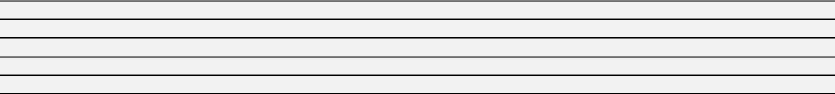


United Technologies Corporation

(Name of Registrant as Specified In Its Charter)
(Name of Person(s) Filing Proxy Statement, if Other Than the Registrant)

PAYMENT OF FILING FEE (CHECK THE APPROPRIATE BOX):

- No fee required.


- Fee computed on table below per Exchange Act Rules 14a-6(i)(1) and 0-11.

  - Title of each class of securities to which transaction applies:
  - Aggregate number of securities to which transaction applies:
  - Per unit price or other underlying value of transaction computed pursuant to Exchange Act Rule 0-11 (set forth the amount on which the filing fee is calculated and state how it was determined):
  - Proposed maximum aggregate value of transaction:
  - Total fee paid:

- Fee paid previously with preliminary materials:

- Check box if any part of the fee is offset as provided by Exchange Act Rule 0-11(a)(2) and identify the filing for which the offsetting fee was paid previously. Identify the previous filing by registration statement number, or the form or schedule and the date of its filing.

  - Amount previously paid:
  - Form, Schedule or Registration Statement No.:
  - Filing Party:
  - Date Filed:

Table of Contents


Table of Contents
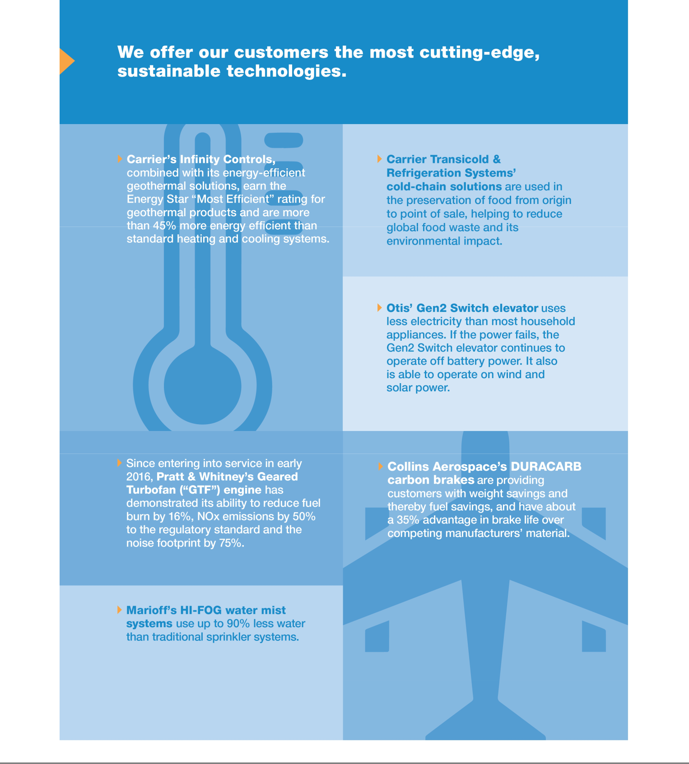

Table of Contents

 |  |  |  |  | March 18, 2019
Notice of 2019 Annual Meeting of Shareowners
 | Meeting Information
 | DATE AND TIME: |  | LOCATION: |  | Your vote is very important. Please
 | April 29, 2019 |  | UTC Center for Intelligent Buildings |  | submit your proxy or voting instructions
 | 8:00 a.m. Eastern Time |  | 13995 Pasteur Boulevard |  | as soon as possible.
 | (doors open at 7:30 a.m.) |  | Palm Beach Gardens, Florida 33418

Agenda

- Election of the Thirteen Director Nominees Listed in the Proxy Statement

- Advisory Vote to Approve Executive Compensation

- Appoint PricewaterhouseCoopers LLP to Serve as Independent Auditor for 2019

- Approve an Amendment to the Restated Certificate of Incorporation to Eliminate Supermajority Voting for Certain Business Combinations

- Ratify the 15% Special Meeting Ownership Threshold in the Company’s Bylaws

- Other Business, if Properly Presented

Who may vote:

If you owned shares of UTC Common Stock at the close of business on February 28, 2019, you are entitled to receive this notice of the Annual Meeting and to vote at the meeting, either in person or by proxy.

How to attend:

Please request a ticket in advance by following the instructions on page 77.

Please review the Proxy Statement and vote in one of the four ways described below.

By Order of the Board of Directors.

Peter J. Graber-Lipperman
Corporate Vice President, Secretary & Associate General Counsel

Voting methods available to you:

THE INTERNET | BY TELEPHONE
Visit the website on your proxy card. | Call the telephone number on your proxy
 | card.


BY MAIL


Sign, date and return your proxy card in the enclosed envelope.

IN PERSON


Attend the Annual Meeting in Palm Beach Gardens, Florida. See pages 77-78 for instructions on how to attend and vote in person.

United Technologies Notice of 2019 Annual Meeting of Shareowners and Proxy Statement i


Table of Contents


TABLE OF CONTENTS

Notice of 2019 Annual Meeting of Shareowners |  |  |  |  |  |  |  |  |  |  |  |  |  |  |  |  |  |  |  |  |  |  |  |  |  |  |  |  |  |  |  |  | i
Proxy Summary |  |  |  |  |  |  |  |  |  |  |  |  |  |  |  |  |  |  |  |  |  |  |  |  |  |  |  |  |  |  |  |  | 1
CORPORATE GOVERNANCE
PROPOSAL 1:
Election of Directors |  |  |  |  |  |  |  |  |  |  |  |  |  |  |  |  |  |  |  |  |  |  |  |  |  |  |  |  |  |  |  | 6
Nominees |  |  |  |  |  |  |  |  |  |  |  |  |  |  |  |  |  |  |  |  |  |  |  |  |  |  |  |  |  |  |  |  | 9
Corporate Governance |  |  |  |  |  |  |  |  |  |  |  |  |  |  |  |  |  |  |  |  |  |  |  |  |  |  |  |  |  |  |  | 17
Corporate Responsibility |  |  |  |  |  |  |  |  |  |  |  |  |  |  |  |  |  |  |  |  |  |  |  |  |  |  |  |  |  |  |  | 23
Compensation of Directors |  |  |  |  |  |  |  |  |  |  |  |  |  |  |  |  |  |  |  |  |  |  |  |  |  |  |  |  |  |  |  | 28
Share Ownership |  |  |  |  |  |  |  |  |  |  |  |  |  |  |  |  |  |  |  |  |  |  |  |  |  |  |  |  |  |  |  | 30
EXECUTIVE COMPENSATION
PROPOSAL 2:
Advisory Vote to Approve Executive Compensation |  |  |  |  |  |  |  |  |  |  |  |  |  |  |  |  |  |  |  |  |  |  |  |  |  |  |  |  |  |  |  | 32
Compensation Discussion and Analysis |  |  |  |  |  |  |  |  |  |  |  |  |  |  |  |  |  |  |  |  |  |  |  |  |  |  |  |  |  |  |  | 33
Executive Summary |  |  |  |  |  |  |  |  |  |  |  |  |  |  |  |  |  |  |  |  |  |  |  |  |  |  |  |  |  |  |  | 33
How We Make Pay Decisions and Assess Our Programs |  |  |  |  |  |  |  |  |  |  |  |  |  |  |  |  |  |  |  |  |  |  |  |  |  |  |  |  |  |  |  | 38
Our Principal Elements of Compensation |  |  |  |  |  |  |  |  |  |  |  |  |  |  |  |  |  |  |  |  |  |  |  |  |  |  |  |  |  |  |  | 41
CEO Pay Overview |  |  |  |  |  |  |  |  |  |  |  |  |  |  |  |  |  |  |  |  |  |  |  |  |  |  |  |  |  |  |  | 46
How We Assess Pay-for-Performance |  |  |  |  |  |  |  |  |  |  |  |  |  |  |  |  |  |  |  |  |  |  |  |  |  |  |  |  |  |  |  | 48
Pay Decisions for the Other NEOs |  |  |  |  |  |  |  |  |  |  |  |  |  |  |  |  |  |  |  |  |  |  |  |  |  |  |  |  |  |  |  | 50
Other Compensation Elements |  |  |  |  |  |  |  |  |  |  |  |  |  |  |  |  |  |  |  |  |  |  |  |  |  |  |  |  |  |  |  | 54
Other Executive Compensation Policies and Practices |  |  |  |  |  |  |  |  |  |  |  |  |  |  |  |  |  |  |  |  |  |  |  |  |  |  |  |  |  |  |  | 56
Report of the Compensation Committee |  |  |  |  |  |  |  |  |  |  |  |  |  |  |  |  |  |  |  |  |  |  |  |  |  |  |  |  |  |  |  | 57
Compensation Tables |  |  |  |  |  |  |  |  |  |  |  |  |  |  |  |  |  |  |  |  |  |  |  |  |  |  |  |  |  |  |  | 58
CEO Pay Ratio |  |  |  |  |  |  |  |  |  |  |  |  |  |  |  |  |  |  |  |  |  |  |  |  |  |  |  |  |  |  |  | 70
AUDIT
Report of the Audit Committee |  |  |  |  |  |  |  |  |  |  |  |  |  |  |  |  |  |  |  |  |  |  |  |  |  |  |  |  |  |  |  | 72
PROPOSAL 3:
Appoint an Independent Auditor for 2019 |  |  |  |  |  |  |  |  |  |  |  |  |  |  |  |  |  |  |  |  |  |  |  |  |  |  |  |  |  |  |  | 73
OTHER PROPOSALS
PROPOSAL 4:
Approve an Amendment to the Restated Certificate of Incorporation |  |  |  |  |  |  |  |  |  |  |  |  |  |  |  |  |  |  |  |  |  |  |  |  |  |  |  |  |  |  |  | 75
PROPOSAL 5:
Ratify the 15% Special Meeting Ownership Threshold in the Company’s Bylaws |  |  |  |  |  |  |  |  |  |  |  |  |  |  |  |  |  |  |  |  |  |  |  |  |  |  |  |  |  |  |  | 76
OTHER SHAREOWNER INFORMATION
Frequently Asked Questions About the Annual Meeting |  |  |  |  |  |  |  |  |  |  |  |  |  |  |  |  |  |  |  |  |  |  |  |  |  |  |  |  |  |  |  | 77
Other Important Information |  |  |  |  |  |  |  |  |  |  |  |  |  |  |  |  |  |  |  |  |  |  |  |  |  |  |  |  |  |  |  | 82
APPENDICES
Appendix A: Reconciliation of GAAP Measures to Corresponding Non-GAAP Measures |  |  |  |  |  |  |  |  |  |  |  |  |  |  |  |  |  |  |  |  |  |  |  |  |  |  |  |  |  |  |  | 86
Appendix B: Financial Performance Metrics Used in UTC’s Incentive Compensation Plans |  |  |  |  |  |  |  |  |  |  |  |  |  |  |  |  |  |  |  |  |  |  |  |  |  |  |  |  |  |  |  | 88
Appendix C: Proposed Amendment to the Corporation’s Restated Certificate of Incorporation |  |  |  |  |  |  |  |  |  |  |  |  |  |  |  |  |  |  |  |  |  |  |  |  |  |  |  |  |  |  |  | 89

Important Notice Regarding the Availability of Proxy Materials for the Annual Meeting of Shareowners to be held on April 29, 2019. This Notice of the 2019 Annual Meeting of Shareowners and Proxy Statement, and UTC’s 2018 Annual Report are both available free of charge at www.proxyvote.com. References in either document to our website are for the convenience of readers, and information available at or through our website is not a part of nor is it incorporated by reference in the Proxy Statement or Annual Report.

The Board of Directors of United Technologies Corporation (“UTC”, the “Company” or the “Corporation”) is soliciting proxies to be voted at our 2019 Annual Meeting of Shareowners on April 29, 2019, and at any postponed or reconvened meeting. We expect that this Proxy Statement will be mailed and made available to shareowners beginning on or about March 18, 2019. At the meeting, votes will be taken on the five matters listed in the Notice of Meeting.

- United Technologies Notice of 2019 Annual Meeting of Shareowners and Proxy Statement


Table of Contents


PROXY

Summary

ANNUAL MEETING AGENDA

- PROPOSAL 1: Election of Directors PAGES 6–16

BOARD RECOMMENDATION: FOR EACH DIRECTOR NOMINEE
- PROPOSAL 2:

Advisory Vote to Approve Executive Compensation PAGE 32
BOARD RECOMMENDATION: FOR

- PROPOSAL 3: Appoint PricewaterhouseCoopers LLP

to Serve as Independent Auditor for 2019
PAGES 73–74
BOARD RECOMMENDATION: FOR
- PROPOSAL 4:

Approve an Amendment to the Restated Certificate of Incorporation
PAGE 75
BOARD RECOMMENDATION: FOR
- PROPOSAL 5:

Ratify the 15% Special Meeting Ownership Threshold in
the Company’s Bylaws PAGE 76
BOARD RECOMMENDATION: FOR

16%

net income

growth

14%

diluted EPS

growth

8%

organic sales

growth

The summary below highlights selected information in this Proxy Statement. Please review the entire Proxy Statement and UTC’s 2018 Annual Report before voting your shares.

2018 Performance Highlights

Strategic Highlights

2018 was a transformational year for UTC. With two bold steps, we have positioned our businesses to deliver strong, long-term value to our shareowners, greater opportunity to our employees, and world-class products and services to our customers well into the future.

First, we completed our acquisition of Rockwell Collins, making UTC the preeminent systems and component supplier to the aerospace and defense industry. Our new Collins Aerospace Systems (“Collins Aerospace”) business unit, which combined UTC Aerospace Systems with Rockwell Collins, will enable us to offer customers a full suite of systems throughout an entire aircraft. Just as important, this acquisition will enhance our ability to develop electrical, mechanical and software solutions, and to deliver even more innovative products and services to our customers.

Second, we conducted a rigorous yearlong portfolio review, culminating in our plan to separate UTC into three industry-leading companies. Under this plan, both Carrier and Otis will become independent companies, while Collins Aerospace and Pratt & Whitney will remain under the UTC umbrella. Each company is expected to have the resources, capital and strategic flexibility to drive the continued innovation required to meet the evolving needs of their respective customers and markets.

Financial Highlights

We also delivered solid financial results. Notably, we achieved 14% diluted earnings per share (“EPS”) growth (GAAP and non-GAAP), results that exceeded the expectations we communicated to investors at the beginning of the year. At the same time, sales growth was 11% (GAAP), which included 8% organic growth (non-GAAP), demonstrating how our investments in innovation are paying off across all business lines. We also delivered cash flow from continuing operations of $6.3 billion (GAAP) and free cash flow of $4.4 billion (non-GAAP), while returning $2.5 billion to shareowners through dividends and share buybacks during 2018.

Net Sales Diluted Earnings Per Share

(in billions) ($ per share)

GAAP

Non-GAAP⁽¹⁾

Cash Flow⁽²⁾ Net Income
(in billions) (in billions)

GAAP

Non-GAAP⁽¹⁾

- See Appendix A on pages 86-87 for more information regarding these non-GAAP financial measures.

- “GAAP cash flow” is cash flow from continuing operations while “Non-GAAP cash flow” is free cash flow.

United Technologies Notice of 2019 Annual Meeting of Shareowners and Proxy Statement 1


Table of Contents

PROXY SUMMARY

Executive Compensation Overview

Compensation Committee’s 2018 Pay Decisions and Program Changes

As discussed in detail on pages 41-46, the Compensation Committee (the “Committee”) makes annual pay decisions on three principal components of our executive compensation program: base salary, annual bonus and long-term incentives (“LTI”). Total direct compensation for each Named Executive Officer (“NEO”) shown in the chart below, reflects the Committee’s assessment of Company, business unit and individual performance in 2018. For this reason, it includes the February 2019 LTI grant values approved by the Committee. This differs from the January 2018 LTI award values shown in the Summary Compensation Table on page 58, which reflect the Committee’s assessment of 2017 performance and is based on accounting valuations. Importantly, while total direct compensation provides a useful picture of the Committee’s 2018 pay decisions, the actual value an executive earns will ultimately depend on the Company’s stock price and future performance against pre-established goals.

2018 NEO TOTAL DIRECT COMPENSATION

 |  |  |  |  |  |  |  |  |  | Base | Annual
 |  | Base Salary |  | Annual Bonus |  |  |  | LTI |  | Salary | Bonus | LTI | Total
 |  |  |  |  |  |  |  |  |  | ($K) | ($K) | ($K) | ($K)
Gregory J. Hayes |  |  |  |  | 72% |  |  |  |  | $1,600 | $3,500 | $13,000 | $18,100
Akhil Johri |  |  |  |  | 68% |  |  |  |  | $900 | $1,200 | $4,500 | $6,600
Robert K. Ortberg |  |  |  |  | 96% |  |  |  |  | $112* | $140* | $6,000 | $6,252
Judith F. Marks |  |  |  |  | 70% |  |  |  |  | $875 | $900 | $4,100 | $5,875
David L. Gitlin |  |  |  |  | 65% |  |  |  |  | $900 | $1,300 | $4,100 | $6,300
 |  |  |  |  |  | “At-Risk” Compensation
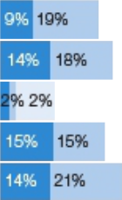

- Reflects a pro-rata portion of Mr. Ortberg’s base salary and the target annual bonus paid to him for the portion of the year that he was a UTC employee (November 26, 2018, the closing date of the Rockwell Collins acquisition, through December 31, 2018). Mr. Ortberg’s annualized 2018 base salary of $1,170,500 was previously approved by the Rockwell Collins Compensation Committee prior to UTC’s acquisition of the company.

RECENT CHANGES TO OUR COMPENSATION PROGRAM

What we changed |  |  | Why we changed it
 | We changed our annual bonus funding formula for business unit executives. |  |  | With the announcement of our intention to separate UTC, Otis and Carrier into
 |  |  |  | independent companies, the Committee believes business unit executives should focus
 | Beginning in 2019, the annual bonus funding formula for business unit executives will be |  |  | on segment performance during the pre-separation transition period.
 | based solely on business unit performance. Previously, 60% of funding was based on
 | business unit performance and 40% on UTC’s overall performance.
 | The mix of LTI for our Executive Leadership Group (“ELG”) has changed. |  |  | Over the past two years, the Committee had included restricted stock units (“RSUs”) in
 |  |  |  | the ELG LTI mix to enhance retention during a period of significant business
 | Beginning with the 2019 awards, ELG members (which include each of our NEOs) |  |  | investment. With the Company’s announcement to separate into three independent
 |  |  |  | companies, the Committee believes that a return to the prior LTI structure of 50% SARs
 | received 50% of their annual LTI awards in stock appreciation rights (“SARs”) and 50% in
 |  |  |  | and 50% PSUs will help drive long-term performance during the transition period and
 | performance share units (“PSUs”).
 | performance share units (“PSUs”). |  |  | beyond.

- United Technologies Notice of 2019 Annual Meeting of Shareowners and Proxy Statement

Table of Contents

PROXY SUMMARY

How We Align Pay with Performance

Our compensation program is designed to reward strong financial performance and strategic leadership that drives long-term, sustainable shareowner value. The largest portion of compensation for our CEO and our other NEOs is “at-risk” compensation — annual bonuses and long-term incentive awards that are contingent on Company performance relative to five key financial metrics.

Why these metrics? The Committee believes that these five metrics are essential indicators of the long-term financial health of our Company and therefore serve the fundamental objective of our executive compensation program: the alignment of executive pay with the interests of our shareowners. The Committee also believes that each of these metrics measure a particularly salient aspect of Company performance:

Annual Bonus Metrics

PSU Metrics

● Earnings measures the immediate impact of operating

● 3-Year EPS Growth measures the Company’s ability to create

decisions on the Company’s annual performance. (For

long-term, sustainable value that will ultimately drive total

Corporate executive bonuses, we use net income, a UTC-wide

shareowner return.

goal; for each business unit we use earnings before interest

and taxes (“EBIT”) as the relevant “earnings” metric.)

● 3-Year Return on Invested Capital (“ROIC”) measures the

efficiency with which we allocate capital resources, taking into

● Free Cash Flow (“FCF”) measures the Company’s ability to

account not just the quantity of earnings, but also the quality

generate cash to fund our operations and key business

of earnings and investments that drive sustainable growth.

investments, whether that means funding critical research and

development, strategic acquisitions, paying down debt, or

● 3-Year Relative Total Shareowner Return (“TSR”)

distributing earnings to shareowners.

measures our ability to return value to our shareowners relative to competing investment opportunities and is consistent with our program’s pay-for-performance objectives.

How 2018 Performance Affected Incentive Payouts

The table below shows UTC’s performance measured against the pre-established performance goals set for our 2018 annual bonus and the 3-year performance cycle for our 2016 PSU awards.

Incentive Plans⁽¹⁾ |  | Performance |  | Performance |  | Payout
Incentive Plans⁽¹⁾ |  | Results |  | Factor |  | Factor
2018 Annual Bonus⁽²⁾
Earnings (net income) |  | $5.9 billion |  | 152% | 125%⁽³⁾
Free Cash Flow |  | $4.9 billion |  | 95%
2016 PSUs
3-Year EPS Growth |  | 4.4% |  | 98% | 116%
3-Year ROIC |  | 11.1% |  | 131%
3-Year Relative TSR vs. Companies within the S&P 500 Index |  | 54.9th %ile |  | 120%

- Performance goals and results are based on non-GAAP financial measures. See Appendix B on page 88 for definitions of the performance metrics used for our incentive compensation plans. For additional details on how these goals and results were measured, see pages 42-43.

- Reflects annual bonus goals and results for UTC. Business unit goals and results differ. Refer to pages 42-43 for additional details.

- The Committee used its discretion and reduced the calculated payout factor from 129% to 125%. See page 43 for additional details on this adjustment.

United Technologies Notice of 2019 Annual Meeting of Shareowners and Proxy Statement | 3

Table of Contents

PROXY SUMMARY

Governance and Board Highlights

UTC is committed to strong corporate governance practices, which the Board believes are critical to achieving long-term shareowner value and which strengthen Board and Management accountability. The following are highlights of our governance framework and the diversity of our Board:

INDEPENDENT AND ENGAGED BOARD |  | GOVERNANCE BEST PRACTICES

92% |  | of our director nominees are independent
All |  | standing committees (except Finance) are comprised
 |  | entirely of independent directors
99% |  | overall attendance by directors at nine Board meetings
 |  | in 2018
98% |  | overall attendance by directors at committee meetings
 |  | in 2018
75% |  | or more of the Board and applicable committee
 |  | meetings were attended by each director in 2018
100% |  | director attendance at the 2018 Annual Meeting
REFRESHED BOARD
+7 |  | new independent directors since 2016
-5 |  | independent directors retired since 2016
75% |  | of independent director nominees have served less
 |  | than 9 years

DIVERSITY IN BACKGROUND OF THE DIRECTOR NOMINEES
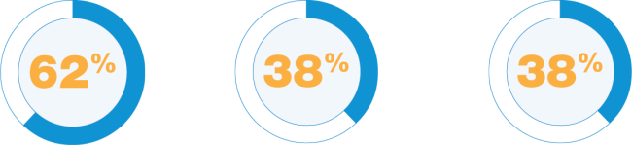

current or former women and people current or former

CEOs of color CFOs or Chief
Investment Officers

DIVERSITY IN TENURE OF THE NOMINEES

<3 years

3-8 years

≥9 years

- Annual election of all directors

- Majority voting for directors in uncontested elections

- Robust Lead Director role with explicit responsibilities

- Proxy access

- Shareowners can act by written consent

- 15% of shareowners can call special meetings

- Independent directors meet regularly without Management

- Board regularly reviews strategic direction and priorities

- Board regularly reviews significant risks, including cybersecurity risk

- Board regularly reviews government relations activities

- Annual advisory vote on executive compensation

- Rigorous stock ownership requirements for directors and senior management

- No hedging, short sales or pledging of UTC securities

- Annual Board, committee and director evaluations

- Active and ongoing shareowner engagement
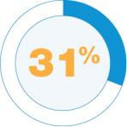
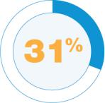
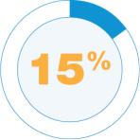

with STEM degrees worked outside the worked in

United States government

We believe that diversity in experience and perspective on the Board are of the utmost importance for reaching sound decisions that drive shareowner value.

- United Technologies Notice of 2019 Annual Meeting of Shareowners and Proxy Statement

Table of Contents

PROXY SUMMARY

BOARD NOMINEES

Skills and Expertise

LLOYD J. AUSTIN III
General, U. S. Army (Retired) and Former Commander | 2016 | 2 |  | ■ | ■ |  | ■ | ■
of U. S. Central Command | 2016 | 2 |  | ■ | ■ |  | ■ | ■
DIANE M. BRYANT
Technology Industry Executive | 2017 | 1 | ■ |  |  |  | ■ |  | ■
JOHN V. FARACI
Retired Chairman & Chief Executive Officer, | 2005 | 2 | ■ |  | ■ | ■ |  | ■
International Paper | 2005 | 2 | ■ |  | ■ | ■ |  | ■
JEAN-PIERRE GARNIER
Chairman, Idorsia Pharmaceuticals Ltd. | 1997 | 3 |  |  | ■ | ■ |  | ■ | ■
GREGORY J. HAYES
Chairman & Chief Executive Officer, | 2014 | 0 | ■ |  |  | ■ | ■ | ■
United Technologies Corporation | 2014 | 0 | ■ |  |  | ■ | ■ | ■
CHRISTOPHER J. KEARNEY
Retired Chairman, SPX FLOW, Inc. | 2018 | 1 |  |  |  | ■ | ■ | ■
ELLEN J. KULLMAN
INDEPENDENT LEAD DIRECTOR | 2011 | 3 |  |  | ■ | ■ |  | ■ | ■
Retired Chair & Chief Executive Officer, | 2011 | 3 |  |  | ■ | ■ |  | ■ | ■
E. I. du Pont de Nemours and Company
MARSHALL O. LARSEN
Retired Chairman, President & Chief Executive Officer, | 2012 | 3 | ■ |  |  | ■ |  | ■
Goodrich Corporation | 2012 | 3 | ■ |  |  | ■ |  | ■
HAROLD W. MCGRAW III
Chairman Emeritus, S&P Global Inc. | 2003 | 1 | ■ |  | ■ | ■ |  | ■
(formerly McGraw Hill Financial, Inc.) | 2003 | 1 | ■ |  | ■ | ■ |  | ■
MARGARET L. O’SULLIVAN
Professor, Harvard University Kennedy School | 2017 | 0 |  | ■ | ■ |  | ■
DENISE L. RAMOS
Retired Chief Executive Officer, ITT Inc. | 2018 | 1 | ■ |  |  | ■ |  | ■ | ■
FREDRIC G. REYNOLDS
Retired Executive Vice President & Chief Financial | 2016 | 2 | ■ |  |  |  | ■ |  | ■
Officer, CBS Corporation | 2016 | 2 | ■ |  |  |  | ■ |  | ■
BRIAN C. ROGERS
Non-Executive Chairman, T. Rowe Price Group, Inc. | 2016 | 2 | ■ |  |  | ■ | ■ | ■



All directors, except Mr. Hayes, are independent.

All directors are elected annually by majority vote.

United Technologies Notice of 2019 Annual Meeting of Shareowners and Proxy Statement | 5

Table of Contents

PROPOSAL 1

Election of Directors


We are seeking your support for the election of the thirteen individuals that the Board has nominated to serve on the Board of Directors for a one-year term beginning on the date of the Annual Meeting. We believe that the nominees have the qualifications consistent with our position as a large, diversified industrial corporation with worldwide operations. We also believe that the nominees have the experience and perspective to guide the Company as we separate into three independent companies, and as we adjust to rapidly changing technologies, business cycles and competitive environments.

Criteria for Board Membership

The Board and the Committee on Governance and Public Policy (the “Governance Committee”) believe that there are general attributes all directors must exhibit and that other key skills and expertise should be represented on the Board as a whole, but not necessarily by each director.

The following attributes are essential for all UTC directors and we believe that our current directors exhibit these attributes:

- Objectivity and independence in making informed business decisions

- Extensive knowledge, experience and judgment

- The highest integrity

- Diversity of perspective

- A willingness to devote the extensive time necessary to fulfill a director’s duties

- An appreciation for the role of the corporation in society

- Loyalty to the interests of UTC and its shareowners

While we do not have a policy on Board diversity, a director’s ability to contribute to the diversity of perspectives necessary in Board deliberations is an attribute that is critical to the Company’s long-term success.

Key Skills and Expertise

The Board and the Governance Committee have identified the following principal skills and expertise that are essential to effective oversight in light of the Company’s business requirements and strategy:

Financial


Government

Leadership of a financial firm, management of an enterprise’s finance function or of a large P&L, resulting in proficiency in complex financial management, financial reporting processes, capital allocation, capital markets, and mergers and acquisitions — representing the importance we place on accurate financial reporting, and robust financial controls and compliance.

Directors who have served in senior positions in the government or the military provide constructive insights about how significant government policies and public policy issues may affect our Company and how to effectively respond to those matters.

- United Technologies Notice of 2019 Annual Meeting of Shareowners and Proxy Statement

Table of Contents


International


Knowledge of Company/ Industry


Risk

Management/
Oversight


Senior

Leadership


Technology and Innovation

PROPOSAL 1 ELECTION OF DIRECTORS


UTC has operations around the world and a significant portion of our sales come from outside the United States.
Directors with international experience thus provide valuable business, political and cultural perspectives.

Knowledge of or experience in UTC’s specific industries, whether acquired through service as a senior leader in one of these industries, as an institutional investor, through longer-term service on the UTC Board or through experience with an industrial company that transformed its portfolio of businesses.

This experience is critical to the Board’s role in overseeing and understanding major risk exposures, including significant financial, operational, compliance, reputational, strategic, country, political, and cybersecurity risks.

Extensive leadership experience with a significant enterprise, resulting in a practical understanding of organizations, processes and strategic planning, along with demonstrated strengths in developing talent, succession planning, and driving change and long-term growth.


Experience in research and development, engineering, science, digital media or technology. This translates into an understanding of UTC’s technological innovations, development and marketing challenges, how to anticipate technological trends, and how to generate disruptive innovation — all of which helps us to execute our business objectives and strategy.

The chart below illustrates the diverse set of key skills and areas of expertise represented on our Board. Each director’s biography highlights the three key skills and areas of expertise upon which the Board particularly relies in addition to describing each director’s significant work experience and service.

KEY SKILLS AND EXPERTISE
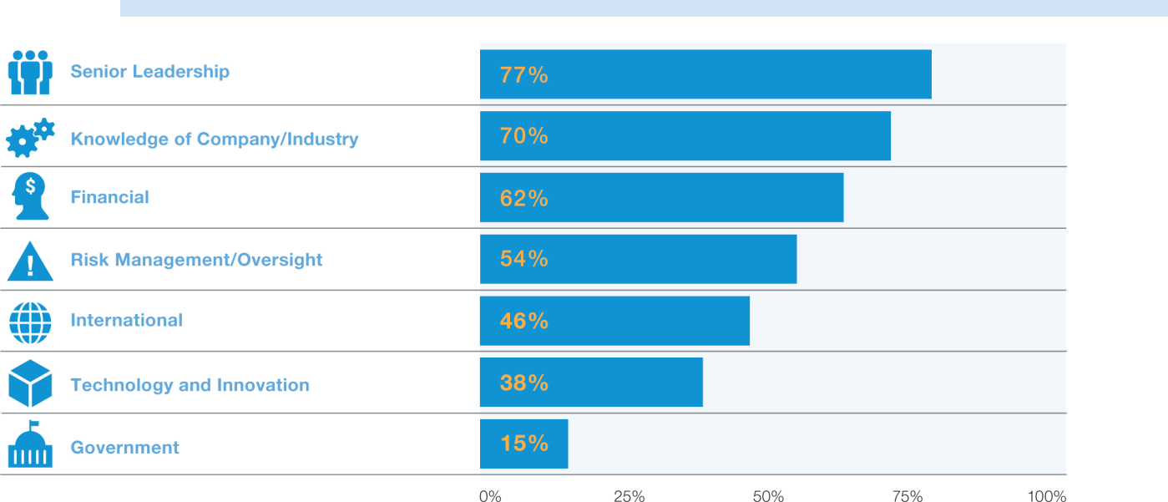

United Technologies Notice of 2019 Annual Meeting of Shareowners and Proxy Statement | 7

Table of Contents

PROPOSAL 1 ELECTION OF DIRECTORS

Director Orientation and Education

Director Orientation

New directors participate in an orientation program to familiarize them with the roles and responsibilities of the Board, including topics tailored to each director’s committee assignments. New directors also learn about the Company’s strategy, our business units, financial statements, significant financial, accounting and risk management issues, and our compliance programs.

Director Continuing Education

As part of the directors’ continuing education, the Board strives to visit at least one of UTC’s business units each year. This gives directors a firsthand understanding of the business unit’s operations and facilitates interactions with employees and key executives. For example, in 2018 directors visited two facilities in Florida (Carrier’s Center for Intelligent Buildings, a state-of-the-art building technology and customer experience center, and a Pratt & Whitney test facility) and two facilities in Connecticut (Pratt & Whitney’s new Engineering & Technology Center and the United Technologies Research Center).

Directors also are encouraged to attend outside continuing education programs. Additional presentations and materials, including updates on recent business developments and on topical and beneficial subjects, are provided from time to time to certain directors or to all directors, as appropriate.

Board Self-Evaluation Process

The Board appreciates that robust and constructive self-evaluation is an essential element of good corporate governance, Board effectiveness, and continuous improvement. To this end, the Board evaluates annually its own performance and that of the standing committees and individual directors.


The Governance Committee is responsible for and oversees the design and the manner in which the annual self-evaluation is completed.

The self-evaluation informs the Board’s consideration of the following:

- Board roles

The Lead Director or non-Executive Chairman (as applicable) and the Governance Committee Chair jointly lead the self-evaluation process.

- Opportunities to increase the Board’s effectiveness, including the addition of new skills and expertise

- Refreshment objectives, including composition and diversity

- Succession planning

As part of the 2018 evaluation process, each of the independent directors conferred with Mrs. Kullman, our Lead Director, or Mr. Rogers, the Chair of the Governance Committee, to provide practical feedback and allow for the candid assessment of peer contributions and performance. Afterwards, Mrs. Kullman and Mr. Rogers collaborated to provide a summary of the assessment, which the Board discussed in its private session.

The self-evaluation process has generated improvements to our corporate governance practices and the Board’s effectiveness, including:

- Expanding the Lead Director’s role and responsibilities

- Allocating more time to private sessions of the independent directors

- Restructuring the standing committees to allocate more time to strategy discussion at the meetings of the full Board

- Improving the Board’s self-evaluation process itself

Board Refreshment and Nominating Process

The Governance Committee regularly reviews with the Board the key skills and expertise that are most important in selecting candidates to serve as directors, taking into account UTC’s varied operations and the mix of capabilities and experience represented on the Board already. As part of the Board’s annual evaluation of its overall effectiveness, the Board considers the following with regard to its composition:

- United Technologies Notice of 2019 Annual Meeting of Shareowners and Proxy Statement

Table of Contents

PROPOSAL 1 ELECTION OF DIRECTORS

Does the Board reflect the diversity of experience, skills and perspectives that continuously enhance its ability to carry out its oversight role and need to effectively support UTC’s growth and strategy?

Based on these considerations, the Board adjusts the priority it gives to various director qualifications when identifying candidates.

Outcomes Since 2016:

- Seven new independent directors

- More diverse Board

- Technology & cyber expertise

- Senior government & military experience

- Enhanced financial expertise

- Industrial spin-off experience

Our Governance Guidelines require that directors retire at the annual meeting after reaching age 72, unless the Board makes an exception to the policy in special circumstances. The Governance Guidelines and Bylaws, however, do not impose term limits because the Board believes that a director who serves for an extended period develops a deep understanding of the Company’s history, practices and strategy, and is therefore uniquely positioned to provide insight and perspective regarding UTC’s current operations and strategic direction. Nonetheless, the Board’s self-evaluation process, including individual director evaluations, contributes to the Governance Committee’s consideration of each incumbent’s skills and experience as part of the nomination and refreshment process.

The Governance Committee considers candidates recommended by directors, Management and shareowners who meet the qualifications UTC seeks in its directors. A shareowner may recommend a director candidate by submitting a letter addressed to the UTC Corporate Secretary (see page 81 for contact information). The Governance Committee also may engage search firms to assist in identifying and evaluating qualified candidates and to ensure that the Committee is considering a larger and diverse pool of potential candidates.

Nominees

The Board, upon the recommendation of the Governance Committee, has nominated for election to the Board the thirteen individuals listed in this Proxy Statement. All are current directors of UTC and were elected by the shareowners at the 2018 Annual Meeting, except for Mr. Kearney and Ms. Ramos who joined the Board in December 2018.

Christine Todd Whitman is not standing for re-election. Having reached the mandatory retirement age in the Governance Guidelines, she will retire from the Board on April 29, 2019. Management and the directors extend their sincere appreciation to Governor Whitman for her years of dedicated service to UTC.

Mr. Kearney and Ms. Ramos possess particularly relevant experience in light of UTC’s intention to separate into three independent companies, as discussed on page 1. Among other attributes, Mr. Kearney brings to the Board and its committees (Audit and Finance) skills and expertise in Senior Leadership, Risk Management/Oversight, and Knowledge of the Company/Industry (see pages 6-7 for descriptions of these skills). Moreover, Mr. Kearney served as Chairman, President & CEO at the industrial company SPX Corporation. In that role, he led the company through a portfolio transformation resulting in the spin-off of SPX FLOW, where he served in a similar position until his recent retirement. Ms. Ramos brings to the Board and its committees (Audit and Compensation) skills and expertise in Senior Leadership, Technology and Innovation, and Knowledge of the Company/Industry, among other desired attributes. Ms. Ramos has served as the chief financial officer of two companies, including ITT Corporation, which, during her tenure as CFO, separated into three publicly traded companies. One of these companies was ITT Inc., a diversified manufacturer of industrial products where Ms. Ramos recently served as President & CEO.

If, prior to the 2019 Annual Meeting, any nominee becomes unavailable to serve, the Board may select a replacement nominee or reduce the number of directors to be elected. If the Board selects a replacement nominee, the proxy holders will vote the shares for which they serve as proxy for that replacement nominee.


The Board of Directors recommends a vote

FOR each of the following nominees:

United Technologies Notice of 2019 Annual Meeting of Shareowners and Proxy Statement | 9

Table of Contents

PROPOSAL 1 ELECTION OF DIRECTORS

Experience:

- Commander, U.S. Central Command (military leadership), 2013-2016

- 33rd Vice Chief of Staff of the U.S. Army, 2012-2013
- Commander of United States Forces — Iraq, 2010-2011

Other Current Directorships:

- Nucor Corporation, since 2017
- Tenet Healthcare Corporation, since 2018
- Guest Services, Inc. (non-public)

Experience:

- Chief Operating Officer, Google Cloud (technology and innovation), 2017-2018

- Group President, Data Center Group, Intel Corporation (advanced technology, enterprise, cloud and communications infrastructure), 2017

- Executive Vice President and General Manager, Data Center Group, Intel Corporation, 2012-2017

- Corporate Vice President and Chief Information Officer, Intel Corporation, 2008-2012

Other Current Directorships:

- Broadcom Inc., since 2019

Other Leadership Experience and Service:
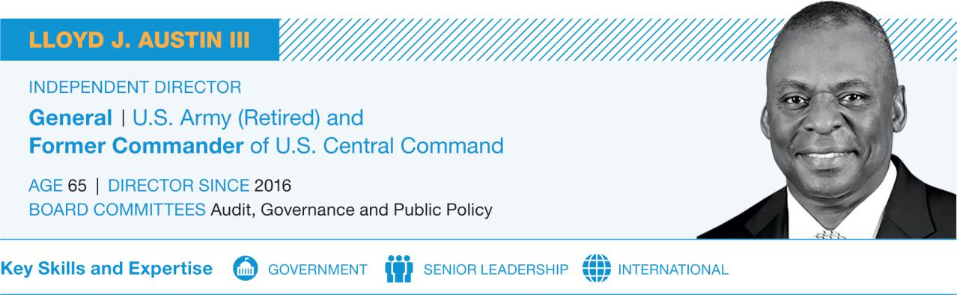

- Former Class of 1951 Leadership Chair for the Study of Leadership, U.S. Military Academy at West Point, 2016-2018

- Board of Trustees, Auburn University
- Board of Trustees, Carnegie Corporation of New York

- Council on Foreign Relations
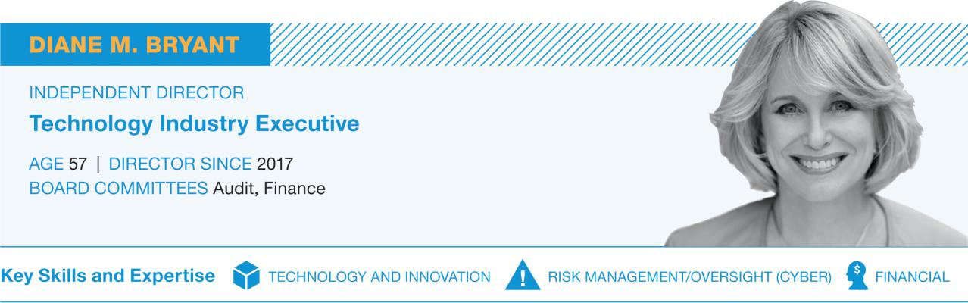

Other Leadership Experience and Service:

- Chancellor’s Board of Advisors, University of California-Davis

- Dean’s Executive Committee, University of California-Davis College of Engineering

- Former Executive Sponsor, Network of Intel African American Employees

- Former Member, Anita Borg Institute Technical Board

- Established Diane Bryant Endowed Scholarship Fund for Diversity in Engineering at the University of California-Davis

- United Technologies Notice of 2019 Annual Meeting of Shareowners and Proxy Statement


Table of Contents

Experience:

- Operating Partner, Advent International (global private equity), since 2016

- Chairman & Chief Executive Officer, International Paper (paper, packaging and distribution), 2003-2014

- Executive Vice President and Chief Financial Officer, International Paper, 2000-2003

- Chief Executive Officer and Managing Director, Carter Holt Harvey, Ltd. (former New Zealand subsidiary of International Paper), 1995-1999

PROPOSAL 1 ELECTION OF DIRECTORS
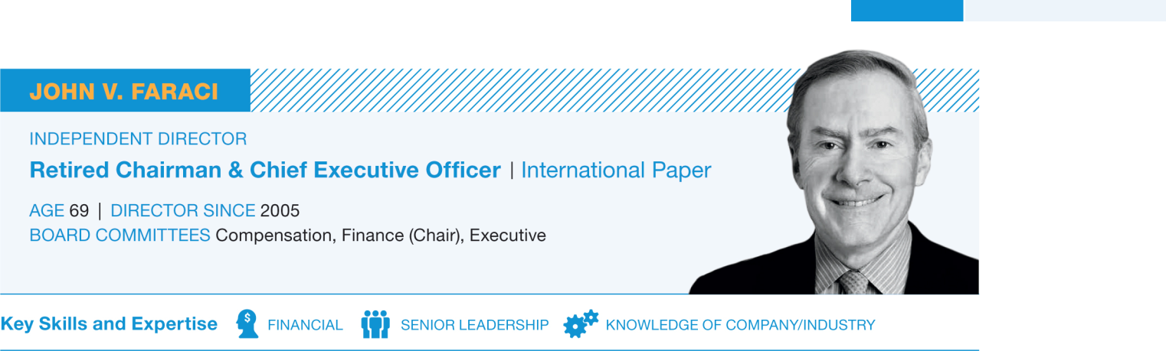

Other Current Directorships:

- ConocoPhillips Company, since 2015
- PPG Industries, Inc., since 2012

Other Leadership Experience and Service:

- Board of Trustees, American Enterprise Institute
- Council on Foreign Relations
- Chairman, Board of Trustees, Denison University
- Board of Directors, National Fish and Wildlife Foundation

- Advisory Board, Royal Bank of Canada

United Technologies Notice of 2019 Annual Meeting of Shareowners and Proxy Statement | 11

Table of Contents

PROPOSAL 1 ELECTION OF DIRECTORS

Experience:

- Chairman of the Board of Directors (non-executive), Idorsia Pharmaceuticals Ltd. (biopharmaceuticals), since 2017

- Operating Partner, Advent International (global private equity), since 2011

- Actelion Ltd., Chairman of the Board of Directors (non-executive), 2011-2017

- Chief Executive Officer, Pierre Fabre S.A. (pharmaceuticals), 2008-2010

- Chief Executive Officer and Executive Member of the Board of Directors, GlaxoSmithKline plc (pharmaceuticals), 2000-2008

- Chief Executive Officer, SmithKline Beecham plc (pharmaceuticals), 2000

Experience:

- Chairman & Chief Executive Officer, United Technologies Corporation, since 2016

- President, Chief Executive Officer and Director, United Technologies Corporation, 2014-2016

- Senior Vice President and Chief Financial Officer, United Technologies Corporation, 2008-2014

- Chief Operating Officer and Executive Member of the Board of Directors, SmithKline Beecham plc, 1996-2000
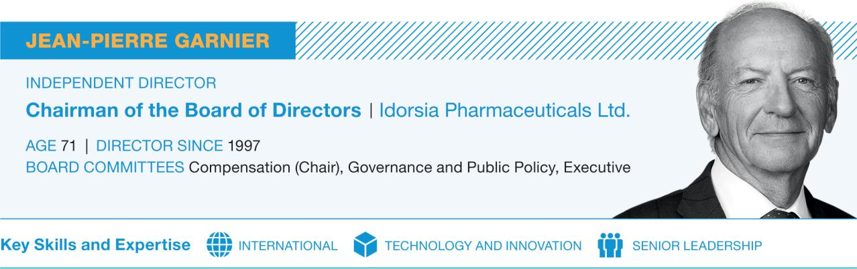

Other Current Directorships:

- Chairman of the Board of Directors (non-executive), CARMAT, since December 2018

- Radius Health, Inc., since 2015

Former Public Company Directorships:

- Renault S.A., 2009-2016

Other Leadership Experience and Service:

- Advisory Board, Newman’s Own Foundation
- Board of Trustees, Max Planck Florida Institute for Neuroscience

- Knight Commander of the Order of the British Empire

- Officier de la Légion d’Honneur of France
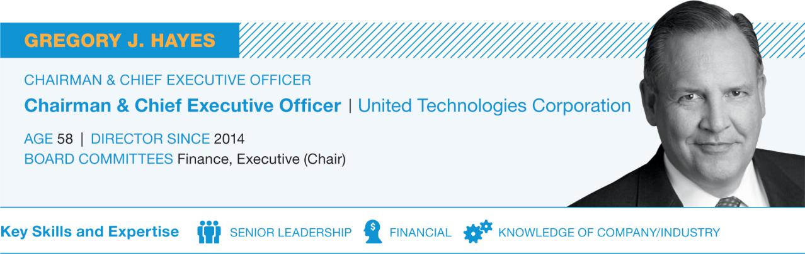

- Various senior positions since joining UTC in 1999 through the merger with Sundstrand Corporation, including Vice President, Accounting and Finance, and responsibility for UTC’s Corporate Strategy function

Former Public Company Directorships:

- Nucor Corporation, 2014-2018

- United Technologies Notice of 2019 Annual Meeting of Shareowners and Proxy Statement

Table of Contents

Experience:

- Managing Partner, Eagle Marsh Holdings, LLC (business and real estate investments), since 2016

- Chairman, SPX FLOW, Inc. (global supplier of highly engineered flow components, process equipment and turnkey solutions for the power and energy, food and beverage, and industrial markets), 2016-2017

- Chairman, President & Chief Executive Officer, SPX FLOW, Inc., 2015

- Chairman, President & Chief Executive Officer, SPX Corporation (global multi-industry manufacturer), 2007-2015

Experience:

- Chair & Chief Executive Officer, E. I. du Pont de Nemours and Company (provider of basic materials and innovative products and services for diverse industries), 2009-2015

- President, E. I. du Pont de Nemours and Company, 2008

- Executive Vice President, E. I. du Pont de Nemours and Company, 2006-2008

- Group Vice President, E. I. du Pont de Nemours and Company, 1998-2006

Other Current Directorships:

- Amgen Inc., since 2016

PROPOSAL 1 ELECTION OF DIRECTORS
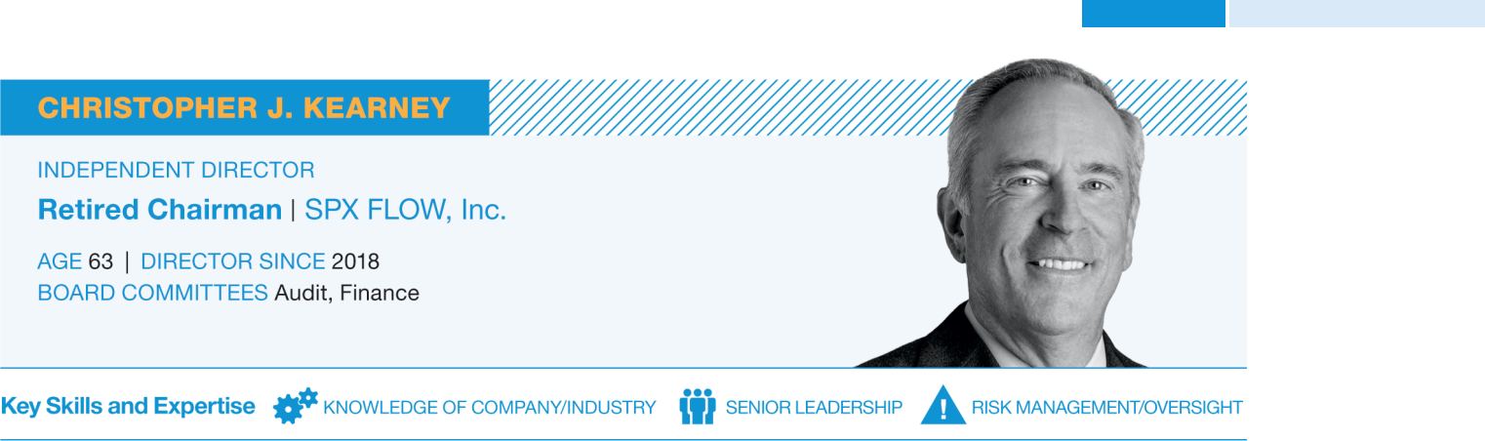

- President & Chief Executive Officer, SPX Corporation, 2004-2007

- Vice President, Secretary and General Counsel, SPX Corporation, 1997-2004

Other Current Directorships:

- Nucor Corporation, since 2008

Former Public Company Directorships:

- Polypore International Inc., 2012-2015

Other Leadership Experience and Service:

- Advisory Board, Warburg Pincus, LLC
- Former Chairman, Foundation for the Carolinas
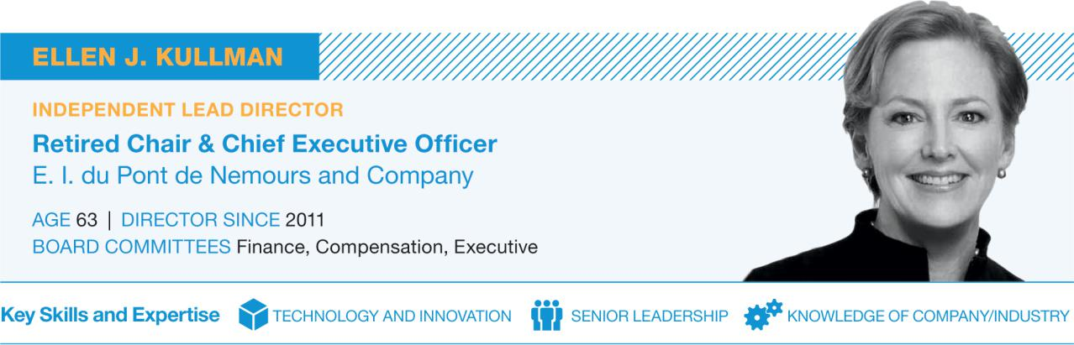

- Goldman Sachs, since 2016
- Dell Technologies Inc., since 2016 (public company since December 2018)

- Carbon3D, Inc. (non-public)

Other Leadership Experience and Service:

- Co-Chair, Paradigm for Parity
- National Academy of Engineering
- Board of Advisors, Tufts University School of Engineering

- Board of Trustees, Northwestern University
- The Business Council
- North American Advisory Council, Temasek Holdings

United Technologies Notice of 2019 Annual Meeting of Shareowners and Proxy Statement | 13

Table of Contents

PROPOSAL 1 ELECTION OF DIRECTORS

Experience:

- Chairman, President & Chief Executive Officer, Goodrich Corporation (supplier of systems and services to the aerospace and defense industry), 2003-2012

- President, Chief Operating Officer and Director, Goodrich Corporation, 2002-2003

- Executive Vice President, Goodrich Corporation, and President and Chief Operating Officer, Goodrich Aerospace, 1995-2002

Experience:

- Chairman Emeritus, S&P Global Inc. (formerly McGraw Hill Financial, Inc.) (ratings, benchmarks and analytics for financial reports), since 2015

- Chairman, McGraw Hill Financial, Inc., 1999-2015
- President and Chief Executive Officer, The McGraw-Hill Companies, 1998-2013

- President and Chief Operating Officer, The McGraw-Hill Companies, 1993-1998

Other Current Directorships:

- Phillips 66 Company, since 2012

Other Current Directorships:
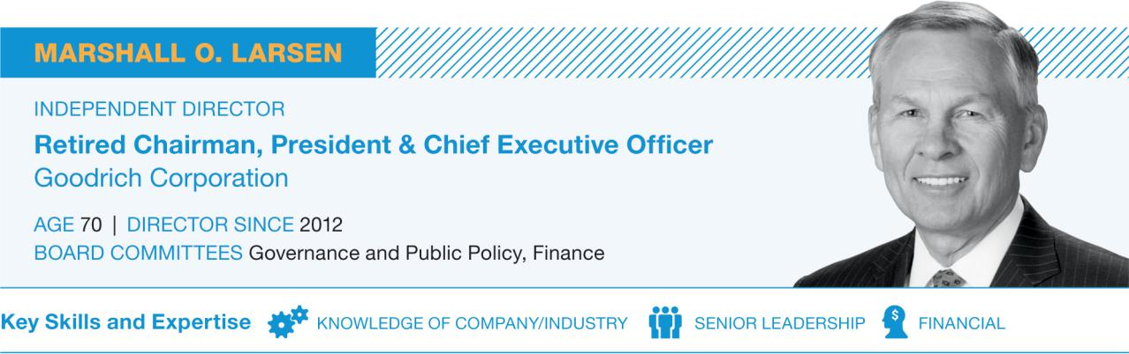

- Air Lease Corporation, since 2014
- Becton, Dickinson and Company, since 2007
- Lowe’s Companies, Inc., since 2004

Other Leadership Experience and Service:

- Dean’s Advisory Council, Krannert School of Management, Purdue University
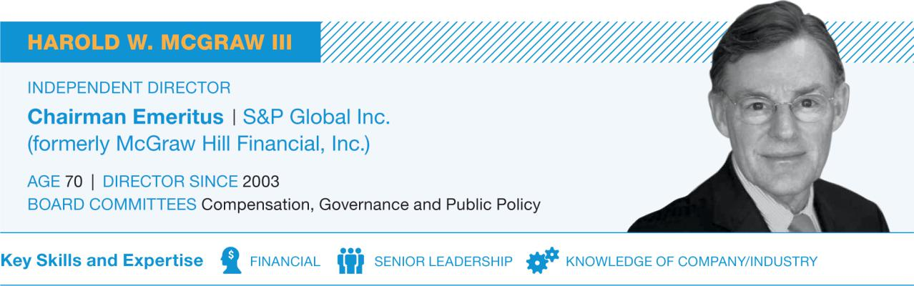

Other Leadership Experience and Service:

- Board of Trustees, Asia Society
- Former Chairman, Business Roundtable
- Board of Trustees, Carnegie Hall
- Director Emeritus, Committee Encouraging Corporate Philanthropy

- Board of Trustees, New York Public Library
- Chairman, U.S. Council for International Business
- U.S. Trade Representative’s Advisory Committee for Trade Policy and Negotiations

- United Technologies Notice of 2019 Annual Meeting of Shareowners and Proxy Statement

Table of Contents

Experience:

- Jeane Kirkpatrick Professor of the Practice of International Affairs, Harvard University Kennedy School (higher education), since 2009

- Director of the Geopolitics of Energy Project, Harvard University Kennedy School, since 2011

- Lecturer and Senior Fellow, Harvard University Kennedy School, 2008-2009

- Deputy National Security Advisor for Iraq and Afghanistan, National Security Council, 2005-2007

- Special Assistant to the President, National Security Council, 2004-2007

- Deputy Director (Governance), Iraq Coalition Provisional Authority, 2003-2004

Experience:

- Chief Executive Officer & President, ITT Inc. (formerly ITT Corporation – a diversified manufacturer of critical components and customized technology solutions), 2011-2018

- Senior Vice President and Chief Financial Officer, ITT Corporation, 2007-2011

- Chief Financial Officer, Furniture Brands International (home furnishings), 2005-2007

PROPOSAL 1 ELECTION OF DIRECTORS
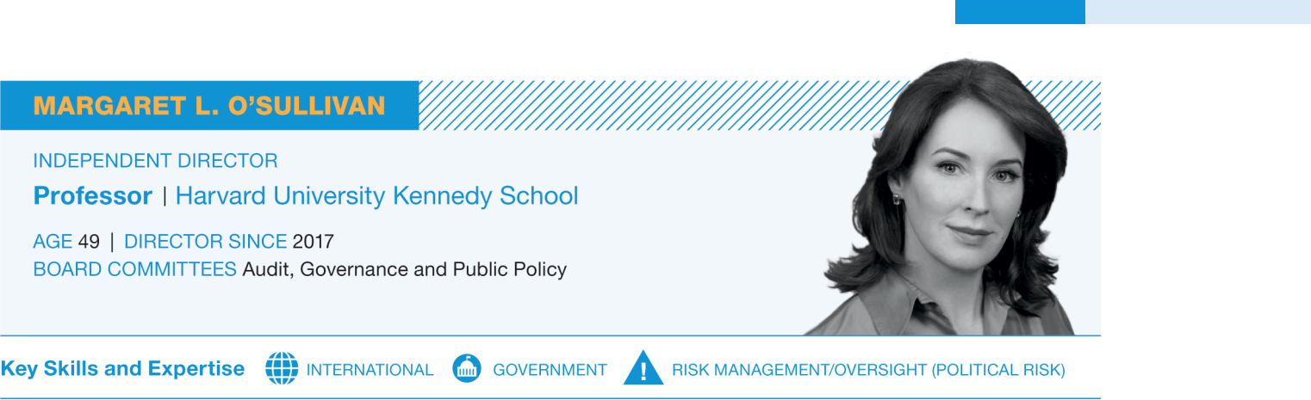

- Principal Advisor to the President’s Special Envoy to the Northern Ireland Peace Process, U.S. Department of State, 2001-2003

- Fellow, The Brookings Institution, 1997-2001

Other Leadership Experience and Service:

- Aspen Strategy Group
- Adjunct Senior Fellow, Council on Foreign Relations
- Advisory Council, George W. Bush Institute Women’s Initiative

- Board of Trustees, The German Marshall Fund of the United States

- Board of Trustees, The International Crisis Group
- International Advisory Board, Linklaters LLP
- Board of Directors, The Mission Continues
- North America Chair, The Trilateral Commission
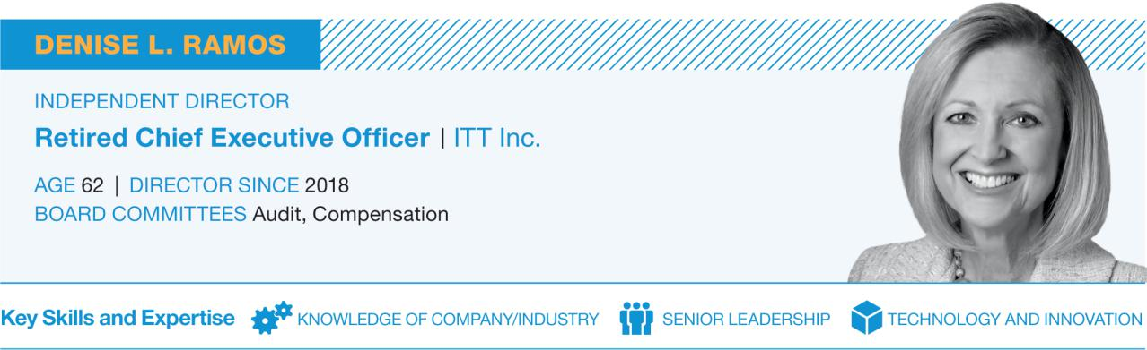

- Senior Vice President & Corporate Treasurer, Yum! Brands, Inc., and Chief Financial Officer, KFC Corporation (U.S. Division), 2000-2005

Other Current Directorships:

- Phillips 66 Company, since 2016

Former Public Company Directorships:

- ITT Inc., 2011-2018
- Praxair, Inc., 2014-2016

United Technologies Notice of 2019 Annual Meeting of Shareowners and Proxy Statement | 15

Table of Contents

PROPOSAL 1 ELECTION OF DIRECTORS

Experience:

- Executive Vice President and Chief Financial Officer, CBS Corporation (mass media), 2005-2009

- President and Chief Executive Officer, Viacom Television Stations Group (CBS predecessor), 2001-2005

- Executive Vice President and Chief Financial Officer, Viacom, Inc., 2000-2001

- Executive Vice President and Chief Financial Officer, Westinghouse Electric Corporation, 1994-2000

- Various positions at PepsiCo, Inc., 1982-1994

Experience:

- Chairman of the Board of Directors, T. Rowe Price Group, Inc. (investment management), 2007-2017

- Chief Investment Officer, T. Rowe Price Group, Inc., 2004-2017

- Various other senior leadership roles since joining T. Rowe Price Group, Inc., in 1982

Other Current Directorships:
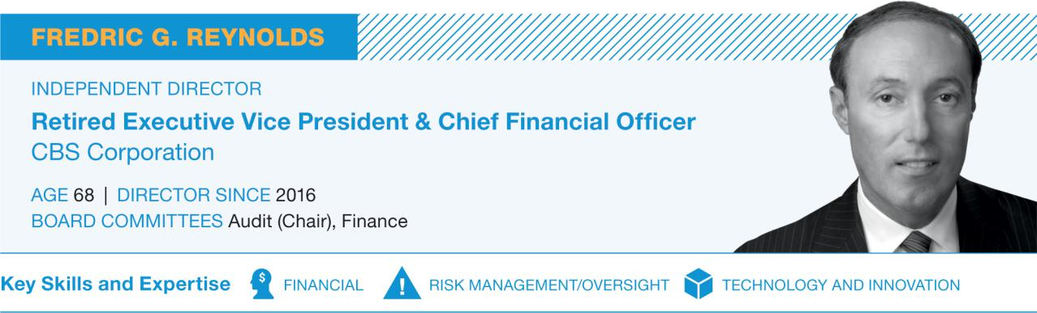

- Hess Corporation, since 2013
- Mondelēz International, Inc. (formerly Kraft Foods, Inc.), since 2007

- MGM Holdings, Inc. (non-public)
- NEP Group, Inc. (non-public)
- Pinterest (non-public)

Former Public Company Directorships:

- AOL, Inc., 2009-2015
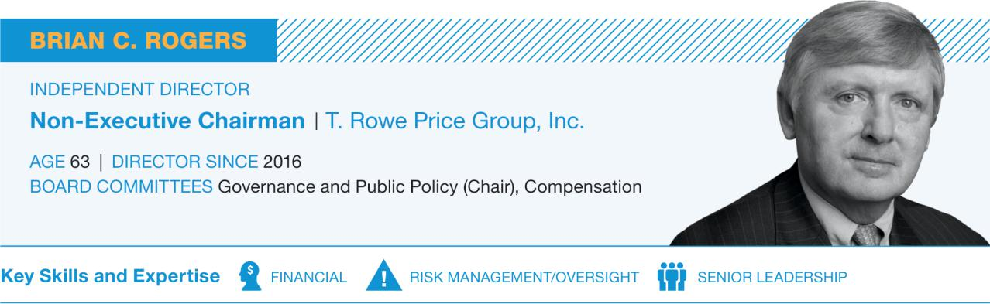

Other Current Directorships:

- Chairman of the Board (non-executive), T. Rowe Price Group, Inc., since 2017

- Lowe’s Companies, Inc., since 2018

Other Leadership Experience and Service:

- Chairman, Finance Committee, Archdiocese of Baltimore

- Board of Directors, Harvard Management Company
- Board of Trustees, Johns Hopkins Medicine

- United Technologies Notice of 2019 Annual Meeting of Shareowners and Proxy Statement

Table of Contents

CORPORATE

Governance

Our Commitment to Sound Corporate Governance

UTC is committed to strong corporate governance practices that are designed to maintain high standards of oversight, accountability, integrity and ethics while promoting long-term growth in shareowner value.

Our governance structure enables independent, experienced and accomplished directors to provide advice, insight and oversight to advance the interests of the Company and our shareowners. UTC has long strived to maintain sound governance standards, as reflected in our Code of Ethics, Governance Guidelines, our systematic approach to risk management, and in our commitment to transparent financial reporting and strong internal controls.

We encourage you to visit the Corporate Governance section of our website (www.utc.com) where you can access information about corporate governance at UTC, including:


- Governance Guidelines

- Board Committee Charters

- Certificate of Incorporation and Bylaws

- Code of Ethics

- Director Independence Policy

- Related Person Transactions Policy

- Public Activities

- Stock ownership requirements

- Information about our Ombudsman Program, which allows UTC’s employees and other stakeholders to raise questions confidentially and outside the usual management channels

- Information about how to communicate concerns to the Board of Directors

Shareowner Engagement

The Board and Management believe in transparent and open communication with investors. Over the years, those engagements have improved our corporate governance practices, increased shareowner rights, changed the Board’s composition, and improved the design of our executive compensation program and disclosure.

Each fall we solicit feedback from our largest shareowners on changes that the Board (or a Committee) is considering regarding UTC’s executive compensation program and our corporate governance practices. In the spring, after the proxy statement is filed, our discussions generally focus on the clarity and effectiveness of our disclosures and on matters that are of interest to investors. We also have discussed other topics with investors, such as leadership structure, corporate social responsibility, and UTC’s diversity and sustainability initiatives.

In addition, Management and independent directors routinely engage with our shareowners on financial performance, capital allocation and business strategy. In 2018, Management hosted the Investor and Analyst Meeting, presented at five industry conferences, hosted shareowners at UTC’s Corporate Headquarters and visited shareowners in the Americas and Europe.

In 2018, we engaged with institutional investors holding more than 350 million shares of UTC Common Stock, which represents over 40% of our shares outstanding.

United Technologies Notice of 2019 Annual Meeting of Shareowners and Proxy Statement 17

Table of Contents

CORPORATE GOVERNANCE

Board Leadership Structure

Chairman and CEO Roles

The Governance Committee routinely reviews our governance practices and board leadership structure. Under our Corporate Governance Guidelines, the Board does not have a policy on whether the CEO also is permitted to serve as Chairman of the Board. Instead, the Board selects the structure that it believes will provide the most effective leadership and oversight for the Company in the circumstances. In making this decision at any given point in time, the Board considers a range of factors, including: the Company’s operating and financial performance; any recent or anticipated changes in the CEO role; the effectiveness of the processes and structures for Board interaction with and oversight of Management; and the importance of maintaining a single voice in leadership communications and Board oversight, both internally and with investors.

Lead Director Responsibilities

Under our Corporate Governance Guidelines, the Board designates a non-employee director to serve as Lead Director when the Chairman is not independent. The Lead Director’s responsibilities include the following and essentially mirror the non-executive Chairman’s responsibilities under UTC’s Guidelines and Bylaws:


- Calls and presides over private sessions of the independent directors or special meetings of the Board of Directors

- Serves as a liaison between the independent directors and the Chairman

- Engages with significant constituencies, as requested

- Works with the Chairman to plan and set the agenda for Board meetings

- Oversees the evaluation and compensation of the CEO’s performance

- Facilitates succession planning and management development

- Works jointly with the Chair of the Governance Committee to lead the Board’s annual self-evaluation process

- Authorizes retention of outside advisors and consultants who report to the Board on board-wide issues

The Board believes that a non-executive Chairman or Lead Director with well-defined responsibilities enhances the effectiveness of the independent directors, improves risk management and oversight, and provides a channel for independent directors to candidly raise issues or concerns for Board consideration.

UTC’s independent directors meet in regularly scheduled private sessions without Management and in additional sessions when requested. In practice, the private sessions occur before or after most Board meetings.

- United Technologies Notice of 2019 Annual Meeting of Shareowners and Proxy Statement

Table of Contents

CORPORATE GOVERNANCE

Board Committees

Our Board has four standing committees: Audit, Governance and Public Policy, Compensation and Finance. Except for the Finance Committee (which includes our CEO as a member), each standing committee is composed exclusively of independent directors. Each standing committee has the authority to retain independent advisors to assist in the fulfillment of its responsibilities, to approve the fees paid to those advisors and to terminate their engagements.

All committee charters, which are reviewed by each committee annually, are available on the Corporate Governance section of UTC’s website (see page 17).

Fredric G. Reynolds

(Chair)

Lloyd J. Austin III Diane M. Bryant Christopher J. Kearney* Margaret L. O’Sullivan Denise L. Ramos*

2018 Meetings: 8

- Assists the Board in overseeing: the integrity of UTC’s financial statements; the independence, qualifications and performance of UTC’s internal and external auditors; the Company’s compliance with its policies and procedures, internal controls, Code of Ethics, and applicable laws and regulations; and policies and procedures relating to risk assessment and management

- Nominates, for appointment by shareowners, an accounting firm to serve as UTC’s independent auditor and maintains responsibility for compensation, retention and oversight of the auditor

- Pre-approves all auditing services and permitted non-audit services to be performed for UTC by its independent auditor

- Reviews and approves the appointment and replacement of the senior Internal Audit executive

The Board determined in 2018 that Messrs. Reynolds and Kearney, and Ms. Ramos each are “audit committee financial experts,” as that term is defined in the Securities and Exchange Commission (“SEC”) rules.


Brian C. Rogers

(Chair)

Lloyd J. Austin III Jean-Pierre Garnier Marshall O. Larsen Harold W. McGraw III Margaret L. O’Sullivan Christine Todd Whitman

2018 Meetings: 4

- Identifies and recommends qualified candidates for election to the Board

- Develops and recommends appropriate corporate governance guidelines

- Oversees the design and conduct of the annual self-evaluation of the Board, its committees and individual directors

- Recommends appropriate compensation of directors

- Submits to the Board recommendations for committee assignments

- Reviews and monitors the orientation of new Board members and the continuing education of all directors

- Reviews and oversees UTC’s positions on significant public issues and corporate social responsibility, including diversity, the environment and safety

* Appointed to the Committee effective December 10, 2018.

United Technologies Notice of 2019 Annual Meeting of Shareowners and Proxy Statement | 19

Table of Contents

CORPORATE GOVERNANCE


Jean-Pierre Garnier

(Chair)

John V. Faraci Ellen J. Kullman Harold W. McGraw III Denise L. Ramos* Brian C. Rogers

2018 Meetings: 5

John V. Faraci

(Chair)

Diane M. Bryant Gregory J. Hayes Christopher J. Kearney* Ellen J. Kullman Marshall O. Larsen Fredric G. Reynolds Christine Todd Whitman

2018 Meetings: 5

- Reviews UTC’s executive compensation policies and practices to ensure that they adequately and appropriately align executive and shareowner interests

- Reviews and approves the design of and sets performance goals for the annual bonus and long-term incentive awards for executives

- Evaluates the performance of UTC, the business units and the NEOs relative to the pre-established performance goals set by the Committee for the annual and long-term incentive programs

- Approves compensation levels for ELG members and executive officers

- Reviews a risk assessment of UTC’s compensation policies, plans and practices

- Reviews and monitors the management of UTC’s financial resources and financial risks

- Considers plans for significant acquisitions and divestitures and their potential financial impact, and monitors progress on pending and completed transactions

- Reviews significant financing programs in support of business objectives

- Reviews significant capital appropriations

- Reviews policies and programs related to: dividends and share repurchases; financing, working and long-term capital requirements; managing foreign exchange exposure, interest rates and raw material prices; investment of pension assets; and insurance and risk management

* Appointed to the Committee effective December 10, 2018.

Director Independence

Under UTC’s Director Independence Policy and New York Stock Exchange (“NYSE”) listing standards a majority of our directors must be independent; meaning, the director does not have a direct or indirect material relationship with UTC (other than as a director). The Director Independence Policy guides the independence determination and includes the categories of relationships that the Board has determined are not material relationships that would impair a director’s independence. The policy is available on our Company website (see page 17).

Before joining the Board and annually thereafter, each director completes a questionnaire seeking information about relationships and transactions that may require disclosure, that may affect the independence determination, or that may affect the heightened independence standards that apply to members of the Audit and Compensation Committees. The Governance Committee’s assessment of independence considers all known relevant facts and circumstances about those relationships bearing on the independence of a director or nominee. The assessment also considers sales and purchases of products and services, in the ordinary course of business, between UTC (including its subsidiaries) and other companies or charitable organizations where directors and nominees (and their immediate family members) may have relationships pertinent to the independence determination.

In each of the past three years, the annual payments UTC made or received for products and services as well as UTC’s charitable contributions fell well below the thresholds in our Independence Policy and NYSE listing standards (the greater of $1 million or 2% of the other company or organization’s total gross revenues). The Board has determined that each of the nominees for election at the 2019 Annual Meeting, other than Mr. Hayes, are independent under UTC’s Independence Policy and NYSE listing standard because none of the nominees, other than Mr. Hayes, has a business, financial, family or other relationship with UTC that is considered material.

- United Technologies Notice of 2019 Annual Meeting of Shareowners and Proxy Statement

Table of Contents

CORPORATE GOVERNANCE

How We Manage Risk

Our Risk Management Framework

UTC encounters a range of risks, including legal, financial, operational, strategic, and reputational. And among these broad categories, specific risks include human capital, market conditions, the overall political climate, and the impact of disruptive events, such as natural disasters.

To manage these risks, UTC has implemented a comprehensive enterprise risk management (“ERM”) program that conforms to the Enterprise Risk – Management Integrated Framework established by the Committee of Sponsoring Organizations of the Treadway Commission (“COSO”). As part of UTC’s ERM program, each business unit president is responsible for identifying and reporting to the Chairman & CEO – as part of a mid-year compliance review – the notable business and compliance risks that could affect the business’ operating plan and strategic initiatives, assessing the likelihood and potential impact of the pertinent risks, and designing the mitigation plans. The Chairman & CEO, Chief Financial Officer, and General Counsel report to the Board at least annually on business unit risks, functional risks and the associated mitigation plans.

The Board’s Role in Risk Management

The full Board is responsible for the oversight of UTC’s risk management process and structure, while the Audit Committee oversees UTC’s overall policies and practices for enterprise risk management. In addition, responsibility for the oversight of specific risk categories is allocated among the Board and its committees as follows:

BOARD RISK OVERSIGHT: AREAS OF RESPONSIBILITY


Full Board of Directors

- Risk management program

- Major strategies and business objectives

- Most significant risks, such as major litigation

- Succession planning

- Government relations

Audit Committee

- Financial

- Operational

- Compliance

- Reputational

- Strategic

- Cybersecurity

Committee on Governance and Public Policy

- Corporate governance

- Director candidate review

- Conflicts of interest

- Director independence

- Environment

- Safety

- Equal employment opportunity

- Public policy issues

Compensation Committee

- Compensation and benefits policies, practices and plans

- Incentive plan performance metrics and goals

- Compensation levels for senior leaders

- Compensation plan design

- Executive retention

Finance Committee

- Capital structure

- Financing

- Pensions

- Capital transactions

- Foreign exchange, interest rates and raw material prices

Compensation Risk and Mitigation

The Compensation Committee believes that executive compensation payouts must align with the Company’s financial performance, be earned in a manner consistent with UTC’s Code of Ethics, promote long-term, sustainable value for shareowners, and strike a balance between appropriate levels of financial opportunity and risk. Through UTC’s ERM framework, the Compensation Committee identifies, monitors and mitigates compensation risk in the following ways:

- Emphasis on Long-Term Performance. Long-term incentives are the cornerstone of UTC’s executive compensation program. Our LTI program incorporates long-term financial performance metrics which align executive and shareowner interests.

- Rigorous Share Ownership Requirements. UTC maintains significant share ownership requirements for our senior executives and directors. These requirements are intended to reduce risk by aligning the economic interests of executives and directors with those of our shareowners. A significant stake in future performance discourages the pursuit of short-term opportunities that can create excessive risk.

United Technologies Notice of 2019 Annual Meeting of Shareowners and Proxy Statement | 21

Table of Contents

CORPORATE GOVERNANCE

- Prohibition on Short Sales, Pledging and Hedging of UTC Securities. UTC prohibits directors, officers and employees from entering into transactions involving short sales of our securities. Further, directors and executive officers are prohibited from pledging or assigning an interest in UTC stock, stock options or other equity interests as collateral for a loan. Transactions in put options, call options or other derivative securities that have the effect of hedging the value of UTC securities also are prohibited, whether or not those securities were granted to or held, directly or indirectly, by a director, officer or employee.

- Clawback Policy. UTC maintains a comprehensive policy on recoupment (see page 56 for more details) that applies to both annual and long-term incentive compensation. The policy allows UTC to clawback compensation in a number of circumstances including, but not limited to, financial restatements, compensation earned as a result of financial miscalculations, violations of UTC’s Code of Ethics and violations of post-employment restrictive covenants.

- Post-Employment Covenants. Executive Leadership Group members (which include each of our NEOs) may not engage in post-employment activities detrimental to UTC, such as disclosing proprietary information, soliciting UTC employees or engaging in competitive activities.

Public Policy Engagement

UTC’s government relations initiatives are intended to educate and inform officials and the public on a broad range of public policy issues that are important to our businesses. These initiatives are consistent with the interests of UTC’s shareowners and are not based on the personal agendas of individual directors, officers or employees. The Board reviews and monitors the Company’s government relations activities, including the activities of the United Technologies Corporation Federal Political Action Committee (“UTC PAC”), which is funded entirely by voluntary employee contributions.

UTC does not make political contributions to candidates for federal office. The UTC PAC is nonpartisan and supports candidates for federal office and the national political organizations of both major parties — thus providing employees, regardless of their political affiliations, with a legal and ethical way to speak with a unified voice on issues that are important to our Company. The UTC PAC’s contributions are available on our website (see page 17).

UTC does not contribute to candidates for state and local office or to state and local party committees. We also do not make contributions to fund communications to the public that expressly advocate the election or defeat of a federal candidate, nor do we provide funding to support or oppose ballot measures.

UTC’s federal lobbying activities and expenditures can be reviewed through the reports filed with Congress that can be accessed through our Company website (see page 17). UTC’s state lobbying activities, which also are available through our website, are generally limited to 10 states and involve issues such as building safety and related building codes, economic development, and various business regulation issues.

For the third consecutive year, UTC was recognized as a “Trendsetter” by the nonprofit and nonpartisan Center for Political Accountability (“CPA”) — placing UTC among the 57 companies in the S&P 500 that received the highest scores on the CPA-Zicklin Index for Corporate Political Disclosure and Accountability.

- United Technologies Notice of 2019 Annual Meeting of Shareowners and Proxy Statement

Table of Contents

CORPORATE

Responsibility

Corporate Sustainability

UTC has long recognized the value of sustainable practices, and since 1992 has implemented sustainability initiatives throughout our value chain. We believe our operations should not compromise the environmental or economic health of future generations, and we also have seen firsthand how responsible management practices provide value to our operations, employees, customers, shareowners and the communities where we operate.

We believe that trends in urbanization and population growth will continue to increase demand for more sustainable products and behaviors. Each of UTC’s major businesses is critical to modern life and the continuing development of prosperous economies around the world. As a recognized leader in these sectors, UTC is well-positioned to reduce the impact of urbanization and population growth on the environment. We offer our customers the most cutting-edge, sustainable technologies, while continually working to reduce the environmental footprint of our manufacturing facilities. Some of these technologies are highlighted on the inside front cover of this Proxy Statement and others include:

Aerospace

● Since entering into service

in early 2016, Pratt & Whitney’s Geared Turbofan (“GTF”) engine

has demonstrated its ability to reduce fuel burn by 16%, NOx emissions by 50% to the regulatory standard and the noise footprint by 75%.

● Collins Aerospace’s next

generation nacelle system, featuring a 360-degree acoustically smooth inlet, helps reduce noise from aircraft powered by engines like Pratt & Whitney’s GTF engine.

50%
reduction of NOx emissions

Less

noise pollution

Commercial Buildings

- Otis’ Gen2 machine uses flexible polyurethane steel-reinforced belts in place of steel cables and features ReGen drive technology – innovations that reduce energy consumption by 75% under normal operation compared to conventional systems without regenerative technology.


Food Transportation

75%
reduction in energy consumption

● Collins Aerospace’s

SmartProbe Air Data System reduces the number of sensors and pneumatic pressure lines, resulting in weight savings of up to 50% when compared to traditional systems, thereby reducing fuel burn.

Reduces

fuel burn

- Carrier’s NaturaLINE unit combines a natural refrigerant CO₂ with

energy-efficient technology

to reduce the carbon
footprint of marine
container refrigeration by
28%, when compared to

previous Carrier equipment

using conventional
synthetic refrigerants.

28%
reduction in carbon footprint

United Technologies Notice of 2019 Annual Meeting of Shareowners and Proxy Statement | 23

Table of Contents

CORPORATE RESPONSIBILITY

Since 1997 we have achieved:
35% | 62% | all during a period when we nearly
reduction in our | reduction in water | tripled our sales
greenhouse gas | consumption
emissions



Progress Toward Our 2020 Environmental Sustainability Goals

We set five-year environmental sustainability goals for which we track progress on an annual basis. Our current goals are for the period between 2016 and 2020. We are committed to a targeted reduction in environmental impacts, irrespective of business growth. As a result, we measure our

progress towards these goals in absolute terms, rather than adjusting for the opening or closing of manufacturing facilities.⁽¹⁾ In 2018, we saw progress in all of our goals:

FIVE-YEAR ENVIRONMENTAL SUSTAINABILITY GOALS⁽²⁾
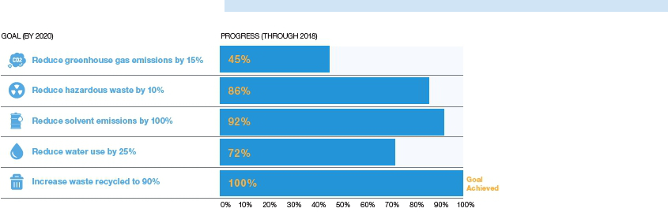

- Consistent with the Greenhouse Gas Protocol, UTC’s goals and targets are adjusted to reflect the impact of acquired companies at the time of acquisition and to remove divested companies from UTC’s measured performance. For example, goals and actual performance were recalibrated in 2013 to account for the Goodrich acquisition and in 2015 to reflect the sale of Sikorsky. UTC’s goals and targets are not adjusted for the opening of new facilities due to organic growth or for the closing of facilities without a divestiture. Actual levels reflect data reported quarterly by UTC sites under common reporting and quality standards. Reported data are reviewed and consolidated by UTC’s Corporate Office. UTC annually submits site energy use and greenhouse gas emissions data for independent review based on International Standards Organization 14064 Part 3 criteria for the validation of greenhouse gas assertions.

- The 2020 goals and progress toward these goals are compared to the following 2015 adjusted baselines: greenhouse gas emissions (2.0 million mtCO2e), hazardous waste generation (60.6 million pounds), chlorinated and brominated solvent air chemical emissions (149,325 pounds), water use (1.77 billion gallons) and total industrial waste recycled (77%).

2018 Recognition for Sustainability Practices

CDP (formerly the Carbon Disclosure Project)

The CDP rated UTC as a “leadership company” with an A- rating for our actions and performance to reduce greenhouse gas emissions and mitigate climate change.

We are committed to a targeted reduction in

environmental impacts, regardless of business growth.

- United Technologies Notice of 2019 Annual Meeting of Shareowners and Proxy Statement

Table of Contents

CORPORATE RESPONSIBILITY

Corporate Citizenship

UTC takes great pride in building a diverse work environment, supporting lifelong employee learning, and contributing to charitable and community causes. In the same way that we set the highest standards for our business operations, we apply the highest corporate responsibility standards and rigorous performance measurements to these efforts.

UTC’s Commitment to Diversity and Inclusion

We are committed to creating a diverse, inclusive workforce and nurturing an environment where all employees can be themselves and share ideas openly. Our efforts focus on advancing gender parity, encouraging employee-led engagement and enhancing opportunities for professionals who want to return to work after voluntary time away.

Advancing Gender Parity

UTC is committed to the advancement of women in leadership positions. In 2017, we joined the Paradigm for Parity (“P4P”) coalition and put this commitment into action by adopting the P4P five-point roadmap shown below. As a signatory to P4P, we set a goal to achieve 50% women in leadership roles by 2030. Several activities currently underway are advancing our efforts towards achieving our goal, including our Inclusive Leaders Curriculum training for managers and other employees. We also recognize that sponsorship is important to career advancement so we provide a framework for high-performing women to have that support and visibility.
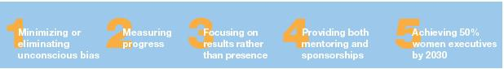

Employee Engagement

We support and encourage our employees to join Employee Resource Groups (“ERGs”), which foster advocacy, professional development, education and mentoring, along with community outreach. We support nine global ERGs (African-American, Asian-American, Disability, Generational, Hispanic-American, LGBTQ Pride, Military Veterans, Professional and Women) with more than 100 chapters and an estimated 5,000 members.

Opportunities to Re-enter the Workforce

We understand that returning to work after a career break can be challenging. The UTC Re-Empower Program, launched in 2017, eases this transition by helping professionals bring their knowledge, experience and creativity back to the workforce after voluntary time off. This program offers on-the-job experience, career guidance and mentoring over a 16-week period.

United Technologies Notice of 2019 Annual Meeting of Shareowners and Proxy Statement | 25

Table of Contents

CORPORATE RESPONSIBILITY

2018 Recognition for Diversity and Inclusion

Among America’s Best Employers for Women


UTC was ranked among Forbes’ best employers for women through its opinion survey of 40,000 Americans, including 25,000 women, working for companies with at least 1,000 employees.


Among Best Places to Work for LGBTQ Equality


UTC earned a 100% rating from the Human Rights Campaign Foundation’s Corporate Equality Index, along with the distinction of being one of the Best Places to Work for LGBTQ Equality.


Among Best Places to Work for Employment Disability Inclusion

UTC was recognized by the Disability Equality Index (“DEI”), a joint initiative between Disability:IN and the American Association of People with Disabilities, as a 2018 DEI Best Place to Work.

Among Noteworthy Companies for Diversity Practices

UTC was named a noteworthy company by DiversityInc, which recognizes the top U.S. companies for diversity and inclusion management, with a focus on hiring, retaining and promoting women, minorities, people with disabilities, LGBTQ employees and veterans.

Among Best Places for Women to Work


UTC was recognized by Fairygodboss as the ninth best workplace for women in 2018. This ranking was determined by a survey around overall job satisfaction, equal treatment at work and whether female employees would recommend that other women work for their employer.

“Innovation is our lifeblood. UTC’s future depends on our ability to attract, develop and retain the best talent. After all, companies don’t innovate – people do. That’s why we are committed to fostering a diverse, inclusive workforce. It’s the right thing to do and an imperative for a global growing business.”

Gregory J. Hayes, Chairman & Chief Executive Officer

Among Best Companies for Latinas to Work


For the sixth straight year, UTC was ranked among the top 10 best places to work for Latinas out of 50 companies honored by Latina Style Magazine.

- United Technologies Notice of 2019 Annual Meeting of Shareowners and Proxy Statement

Table of Contents

CORPORATE RESPONSIBILITY

Our Employee Scholar Program

At UTC, we support a culture of lifelong learning in which our employees are encouraged to expand their knowledge and capabilities to maintain their competitive skills in an ever-changing world. We aspire to maintain a highly educated workforce capable of the innovation required of our technology-driven company.

Our Employee Scholar Program has been in place for more than 20 years and has been consistently recognized as one of the most comprehensive company-sponsored employee education programs in the world.

40,200+ | $1.3 billion | 6,000+ | 60+
degrees earned since 1996 | invested since 1996 | employees participated in 2018 | countries with participating
 |  |  | employees in 2018




UTC Gives Back to the Community

At UTC, we are committed to enhancing the quality of life everywhere we do business because we believe positive engagement builds vibrant communities. Through financial contributions and employee volunteerism, UTC and our employees support thousands of civic, cultural, economic and social welfare organizations around the globe that share in our mission of making the world a better place.

Since 2012, we have invested more than $250 million in the communities where we operate, an amount that includes in excess of $20 million in employee contributions and company matching grants. UTC’s corporate responsibility commitments are bolstered by the impact that our employees have close to home and around the world. Whether mentoring students in STEM (science, technology, engineering and math) subjects, teaching lessons in environmental stewardship or providing disaster relief, our employees contribute their expertise, creativity and passion to help build resilient communities.

We continue to support leading nonprofit

organizations worldwide through grants and the
work of UTC employees who donate their time

and energy.

United Technologies Notice of 2019 Annual Meeting of Shareowners and Proxy Statement | 27

Table of Contents

COMPENSATION

of Directors

Pay Structure

Annual Retainer

The following chart shows annual retainers for non-employee directors for the April 2018 to April 2019 Board cycle. 40% is payable in cash and the remaining 60% is payable in deferred stock units (“DSUs”), although a director also may elect to receive 100% of the retainer in DSUs.

 |  |  |  | Deferred
Role |  | Cash ($) |  | Stock Units ($) |  | Total ($)
All Directors (base retainer) | $120,000 |  | $180,000 |  |  | $300,000
Incremental Amount Above Base Retainer*
Lead Director | $32,000 |  | $48,000 |  |  | $80,000
Audit Committee Chair | $16,000 |  | $24,000 |  |  | $40,000
Audit Committee Member | $12,000 |  | $18,000 |  |  | $30,000
Compensation Committee Chair | $10,000 |  | $15,000 |  |  | $25,000
Finance Committee Chair | $10,000 |  | $15,000 |  |  | $25,000
Committee on Governance and Public Policy Chair | $10,000 |  | $15,000 |  |  | $25,000

* Directors serving in multiple leadership roles receive incremental compensation for each role.

Directors do not receive additional compensation for attending regularly scheduled Board or committee meetings, but do receive an additional
$5,000 for each special meeting attended in person. The directors did not attend any special Board or committee meetings in person during 2018.

Annual retainers are paid each year following the Annual Meeting. New directors joining the Board between the Annual Meeting and the end of September receive 100% of the annual retainer. Directors joining the Board between October and the next Annual Meeting receive 50% of the annual retainer. After a non-employee director leaves the Board, DSUs are converted into shares of UTC Common Stock, payable either in a lump-sum or in 10- or 15-year installments in accordance with the director’s prior elections.

Effective at the 2019 Annual Meeting, the total base retainer will be $310,000, comprised of $124,000 in cash and $186,000 in DSUs. There are no changes to the incremental role-based retainers.

New Director Restricted Stock Unit (“RSU”) Award

Non-employee directors receive a one-time $100,000 RSU award when first elected to the Board. This award vests in equal portions over five years and is distributed in shares of UTC Common Stock upon termination of service. Mr. Kearney and Ms. Ramos each received this award when they joined the Board in December 2018.

Treatment of Dividends

When UTC pays a dividend on Common Stock, each director is credited with additional DSUs and RSUs equal in value to the dividend paid on the corresponding number of shares of UTC Common Stock.

- United Technologies Notice of 2019 Annual Meeting of Shareowners and Proxy Statement

Table of Contents

COMPENSATION OF DIRECTORS

2018 Director Compensation

 |  | Fees Earned or |  | Stock |  | All Other
Name |  | Paid in Cash ($) |  | Awards ($)⁽¹⁾ |  | Compensation ($)⁽²⁾ |  | Total ($)
Lloyd J. Austin III |  | $132,000 |  | $198,000 |  | $6,236 |  | $336,236
Diane M. Bryant |  | $0 |  | $330,000 |  | $857 |  | $330,857
John V. Faraci |  | $0 |  | $325,000 |  | $1,236 |  | $326,236
Jean-Pierre Garnier |  | $0 |  | $325,000 |  | $1,236 |  | $326,236
Christopher J. Kearney⁽³⁾ |  | $0 |  | $265,000 |  | $0 |  | $265,000
Ellen J. Kullman |  | $0 |  | $380,000 |  | $1,236 |  | $381,236
Marshall O. Larsen |  | $132,000 |  | $198,000 |  | $1,236 |  | $331,236
Harold W. McGraw III |  | $120,000 |  | $180,000 |  | $1,236 |  | $301,236
Margaret L. O’Sullivan |  | $132,000 |  | $198,000 |  | $857 |  | $330,857
Denise L. Ramos⁽³⁾ |  | $0 |  | $265,000 |  | $0 |  | $265,000
Fredric G. Reynolds |  | $136,000 |  | $204,000 |  | $1,236 |  | $341,236
Brian C. Rogers |  | $0 |  | $325,000 |  | $1,236 |  | $326,236
Christine T. Whitman |  | $120,000 |  | $180,000 |  | $857 |  | $300,857

- Stock Awards consist of the grant date fair value of DSU and RSU awards credited to the director’s account, including any portion of the annual cash retainer that the director elected to receive as DSUs. The value of DSU and RSU awards has been calculated in accordance with the Compensation — Stock Compensation Topic of the FASB ASC using assumptions described in Note 12: Employee Benefit Plans, to the Consolidated Financial Statements in Exhibit 13 to UTC’s 2018 Annual Report on Form 10-K. The number of units credited to each director in 2018 was calculated by dividing the value of the award by $120.15, the NYSE closing price per share of UTC Common Stock on April 30, 2018, which was the date of the 2018 Annual Meeting. For directors who joined the Board following the Annual Meeting, the number of DSUs and RSUs was based on the NYSE closing price of UTC Common Stock effective on the date of his or her appointment. Since DSU awards vest on the grant date, but are not distributed until the director leaves the Board, the only unvested units as of December 31, 2018 are the following unvested portions of the new director RSU awards: L. Austin III, 562 units; D. Bryant, 541 units; C. Kearney, 837 units; M. O’Sullivan, 666 units; D. Ramos, 837 units; F. Reynolds, 419 units; and B. Rogers, 419 units. The aggregate number of shares underlying awards outstanding for each director can be found in the table on page 30.

- Amounts in this column include incidental benefits and matching contributions made to eligible universities, colleges and certain other eligible nonprofit organizations under the Company’s matching gift program that covers non-employee directors as well as company employees.

- Mr. Kearney and Ms. Ramos were elected to the Board effective December 10, 2018. In accordance with the Board’s annual retainer policy, they received 50% of the total value of the annual retainer for their Board service from the date of election until the date of the 2019 Annual Meeting. They also received the new director RSU award in 2018.

United Technologies Notice of 2019 Annual Meeting of Shareowners and Proxy Statement | 29

Table of Contents

SHARE

Ownership

Share Ownership Requirements

Our rigorous share ownership requirements detailed below promote and strengthen the alignment of our non-employee directors and Management with the interests of our shareowners.

6X |  | 5X |  | 4X |  | 3X
base salary for the Chairman & |  | annual base cash retainer for |  | base salary for the CFO and |  | base salary for other ELG
CEO |  | independent directors |  | business unit CEO and |  | members
 |  |  |  | presidents

Non-employee directors must achieve their required ownership level within five years of joining the Board and ELG members (including the NEOs) must achieve theirs within five years of appointment to the ELG. If ownership requirements are not met after this five-year period, the individual is not permitted to sell UTC shares until achieving the required level. All directors and ELG members currently comply with their respective ownership requirements or are on track to meet them within the five-year period.

Beneficial Share Ownership of Directors and Executive Officers

The following table shows information as of February 18, 2019, regarding the beneficial ownership of UTC Common Stock by: (i) each director and nominee; (ii) each NEO; (iii) and the directors and executive officers as a group. None of these individuals or the group as a whole beneficially owned more than 1% of UTC Common Stock as of that date. Unless otherwise noted, each person named in the table has sole voting power and sole investment power.

 |  |  |  | RSUs Convertible |  | DSUs Convertible |  | Total Shares
 |  | SARs Exercisable |  | to Shares within |  | to Shares within |  | Beneficially
Directors and Executive Officers |  | within 60 days⁽¹⁾ |  | 60 days⁽²⁾ |  | 60 days⁽³⁾ |  | Owned⁽⁴⁾
L. Austin III |  | — |  | 424 |  | 5,104 |  | 5,528
D. Bryant |  | — |  | 403 |  | 7,208 |  | 7,611
J. Faraci |  | — |  | 2,352 |  | 51,025 |  | 53,377
J. Garnier |  | — |  | — |  | 86,549 |  | 104,659
D. Gitlin |  | 25,488 |  | — |  | — |  | 50,733⁽⁵⁾
G. Hayes |  | 112,690 |  | — |  | — |  | 271,286⁽⁶⁾
A. Johri |  | 26,108 |  | — |  | — |  | 65,643
C. Kearney |  | — |  | — |  | 1,381 |  | 3,123
E. Kullman |  | — |  | 1,526 |  | 20,083 |  | 21,615⁽⁶⁾
M. Larsen |  | — |  | 1,465 |  | 17,021 |  | 23,918⁽⁵⁾
J. Marks |  | — |  | — |  | — |  | 87
H. McGraw III |  | — |  | 3,141 |  | 52,191 |  | 58,937
R. Ortberg |  | — |  | — |  | — |  | 92,884
M. O’Sullivan |  | — |  | 189 |  | 3,088 |  | 3,277
D. Ramos |  | — |  | — |  | 1,381 |  | 1,381
F. Reynolds |  | — |  | 704 |  | 6,437 |  | 29,366
B. Rogers |  | — |  | 704 |  | 9,844 |  | 15,548⁽⁵⁾
C. Whitman |  | — |  | 3,141 |  | 36,104 |  | 46,095
Directors & Executive Officers
as a group (25 in total)⁽⁷⁾⁽⁸⁾⁽⁹⁾ |  |  |  |  |  |  |  | 1,275,045

- United Technologies Notice of 2019 Annual Meeting of Shareowners and Proxy Statement

Table of Contents

SHARE OWNERSHIP

- The SARs in the table reflect the net number of shares of UTC Common Stock that would be issued to the executive officers if their vested SARs were exercised within 60 days of February 18, 2019. Once vested, each SAR can be exercised for the number of shares of UTC Common Stock having a value equal to the increase in value of a share of UTC Common Stock from the date the SAR was granted through the exercise date. The net number of shares of UTC Common Stock was calculated using $106.48 per share, which was the NYSE closing price on the last trading day in 2018.

- The non-employee director RSUs vest in equal portions over five years and are distributed in shares of UTC Common Stock upon termination of service. The table reflects the vested portion of the RSUs, which are the number of shares in which the director and nominee has the right to acquire beneficial ownership at any time within 60 days after February 18, 2019, following termination of service.

- The non-employee director DSUs are converted into UTC Common Stock upon termination of service. The table reflects the number of shares in which the director and nominee has the right to acquire beneficial ownership at any time within 60 days after February 18, 2019, following termination of service.

- Includes stock units credited to the executive officer under the UTC Savings Restoration Plan (“SRP”) that are converted into shares of UTC Common Stock following retirement or separation of employment. As of February 18, 2019, the NEOs held the following units in the SRP: D. Gitlin (2,380 units); G. Hayes (7,929 units); A. Johri (1,545 units); J. Marks (54 units); and R. Ortberg (61 units). The executive officers as a group held 30,345 units in the SRP.

- Includes shares for which voting and investment power is jointly held by the director or NEO: D. Gitlin (20,093 shares); M. Larsen (5,432 shares); and B. Rogers (5,000 shares).

- Includes shares for which a spouse holds sole voting and investment power: G. Hayes (2,183 shares); and E. Kullman (6 shares).

- Reflects the holdings of directors and executive officers as of February 18, 2019. A complete list of UTC’s executive officers is included in the Company’s 2018 Annual Report on Form 10-K.

- Includes 7,301 shares for which the spouse of an executive officer who is not an NEO shares voting and investment power.

- Includes 1,546 shares for which the spouse of an executive officer who is not an NEO holds sole voting and investment power, and 22 shares for which the same executive officer shares voting and investment power with a spouse.

Certain Beneficial Owners

The following table shows all holders known to UTC to be beneficial owners of more than 5% of the outstanding shares of Common Stock as of December 31, 2018.

Name and Address |  | Shares |  | Percent of Class
State Street Corporation⁽¹⁾
State Street Financial Center |  | 89,786,914 |  | 10.4%
One Lincoln Street
Boston, MA 02111
The Vanguard Group⁽²⁾
100 Vanguard Boulevard
Malvern, PA 19355 |  | 65,593,077 |  | 7.6%
BlackRock, Inc.⁽³⁾
55 East 52nd Street
New York, NY 10055 |  | 54,035,145 |  | 6.3%

- State Street Corporation reported in an SEC filing that, as of December 31, 2018, it held sole voting power with respect to zero shares of Common Stock, shared voting power with respect to 81,137,873 shares of Common Stock, sole dispositive power with respect to zero shares of Common Stock, and shared dispositive power with respect to 89,777,522 shares of Common Stock. State Street Corporation also reported that its wholly owned subsidiary, State Street Bank and Trust Company, is the trustee for the UTC Common Stock in the UTC Employee Savings Plan Master Trust, which beneficially owns 5.9% of Common Stock of UTC, and that in this capacity State Street Bank and Trust Company has dispositive power and voting power over the shares in certain circumstances.

- The Vanguard Group reported in an SEC filing that, as of December 31, 2018, it held sole voting power with respect to 919,135 shares of Common Stock, shared voting power with respect to 197,765 shares of Common Stock, sole dispositive power with respect to 64,469,610 shares of Common Stock, and shared dispositive power with respect to 1,123,467 shares of Common Stock.

- BlackRock, Inc., reported in an SEC filing that, as of December 31, 2018, it held sole voting power with respect to 47,755,974 shares of Common Stock and sole dispositive power with respect to 54,035,145 shares of Common Stock.

United Technologies Notice of 2019 Annual Meeting of Shareowners and Proxy Statement | 31

Table of Contents

PROPOSAL 2

Advisory Vote to Approve

EXECUTIVE COMPENSATION


Each year we ask shareowners to approve, on an advisory basis, the compensation of UTC’s Named Executive Officers (“NEOs”). Before voting, we encourage you to read and consider the Compensation Discussion and Analysis on pages 33-56, along with the compensation tables on pages 58-69.

How is Shareowner Feedback Considered?

UTC values and considers shareowner opinions when making executive compensation decisions. Over the years, shareowner input has substantially contributed to our executive compensation program’s Guiding Principles, which can be found on page 34 of this Proxy Statement. We actively engage in annual discussions with investors on executive compensation matters. The Compensation Committee uses this feedback in its annual evaluation and management of our program. Shareowner feedback also is reflected in our ongoing effort to enhance the clarity and transparency of the compensation disclosures in this Proxy Statement.

Why Should I Vote “FOR” this Proposal?

Our executive compensation program is structured to advance its fundamental objective: aligning our executives’ compensation with the long-term interests of UTC shareowners. Our program is designed to reward financial performance and effective strategic leadership, key elements in building sustainable shareowner value. The performance metrics used in our incentive plans align with shareowner interests by correlating the timing and amount of actual payouts to our short-, medium- and long-term performance. Compensation opportunities are structured to reward the appropriate balance of financial, strategic and operational business results, and to require ethical and responsible conduct in pursuit of these goals. The Board and its Compensation Committee believe that UTC’s executive compensation program has effectively aligned pay with performance, while facilitating the retention of highly talented executives who are critical to our long-term success.

Accordingly, the Board recommends that shareowners vote FOR the following resolution:

“RESOLVED, that the compensation of UTC’s NEOs, as disclosed pursuant to the compensation disclosure rules of the Securities and Exchange Commission, including the Compensation Discussion and Analysis, compensation tables and related information provided in this Proxy Statement, is hereby APPROVED on an advisory basis.”

As a matter of law, the approval or disapproval of this Proposal 2 may not be construed as overruling any decision by UTC or the Board, or as imposing any duty or obligation on UTC, the Board or any individual director.


The Board of Directors recommends a vote FOR this proposal.

- United Technologies Notice of 2019 Annual Meeting of Shareowners and Proxy Statement

Table of Contents

COMPENSATION

Discussion and Analysis

Executive Summary |  |  |  |  |  |  |  |  |  |  |  | 33 |  |  | 2018 NAMED EXECUTIVE OFFICERS
How We Make Pay Decisions
 |  |  |  |  |  |  |  |  |  |  |  |  |  |  | GREGORY J. HAYES |  | JUDITH F. MARKS
and Assess Our Programs |  |  |  |  |  |  |  |  |  |  | 38 |  |  |  | GREGORY J. HAYES |  | JUDITH F. MARKS
 |  |  |  |  |  |  |  |  |  |  |  |  |  |  | Chairman & CEO |  | President, Otis
Our Principal Elements of Compensation |  |  |  |  |  |  |  |  |  |  |  | 41 |  |  | Chairman & CEO
 |  |  |  |  |  |  |  |  |  |  |  |  |  |  | AKHIL JOHRI |  | DAVID L. GITLIN
CEO Pay Overview |  |  |  |  |  |  |  |  |  |  |  | 46 |  |  | AKHIL JOHRI |  | DAVID L. GITLIN
 |  |  |  |  |  |  |  |  |  |  |  |  |  |  | Executive Vice President & |  | President & Chief
How We Assess Pay-for-Performance |  |  |  |  |  |  |  |  |  |  | 48 |  |  |  | Executive Vice President &
 |  |  |  |  |  |  |  |  |  |  |  |  |  |  | Chief Financial Officer |  | Operating Officer,
Pay Decisions for the Other NEOs |  |  |  |  |  |  |  |  |  |  |  | 50 |  |  | Chief Financial Officer
 |  |  |  |  |  |  |  |  |  |  |  | 50 |  |  |  |  | Collins Aerospace
 |  |  |  |  |  |  |  |  |  |  |  | 50 |  |  | ROBERT K. ORTBERG
Other Compensation Elements |  |  |  |  |  |  |  |  |  |  | 54
 |  |  |  |  |  |  |  |  |  |  |  |  |  |  | CEO, Collins Aerospace
Other Executive Compensation Policies |  |  |  |  |  |  |  |  |  |  | 56 |  |  |  | CEO, Collins Aerospace
and Practices


In this section, we discuss our compensation philosophy and explain how our executive compensation program is structured to advance our fundamental objective of aligning our executives’ compensation with the long-term interests of UTC shareowners. We also explain how the Compensation Committee of the Board (the “Committee”) determines compensation for the members of our Executive Leadership Group (“ELG”), which is comprised of approximately 30 of our most senior executives and includes each of the NEOs listed above. This discussion also explains the Committee’s rationale for specific 2018 pay decisions.

Executive Summary

Investor Engagement

SHAREOWNER OUTREACH EFFORTS

We actively seek and highly value feedback from shareowners and their advisors. The Committee annually considers this feedback along with factors such as external market data and staff and consultant recommendations in its ongoing assessment of the effectiveness of our program.

96%
support

RESPONSE TO OUR 2018 SAY-ON-PAY VOTE

Each year we consider the results of our advisory vote on executive compensation (“say-on-pay”) from the prior year. In 2018, 96% of the votes cast (excluding abstentions and broker non-votes) voted in favor of the Committee’s 2017 executive compensation decisions. We interpreted this result as an endorsement of our compensation program’s design and direction.

2018 SHAREOWNER FEEDBACK

This past year, shareowners also expressed support for our recent executive compensation program changes, which are discussed in detail in the Proxy Summary on page 2.

United Technologies Notice of 2019 Annual Meeting of Shareowners and Proxy Statement | 33

Table of Contents

COMPENSATION DISCUSSION AND ANALYSIS

Our Executive Compensation Philosophy

The Committee believes that there must be a meaningful link between the compensation paid to our executives and our goal of long-term, sustainable growth for our shareowners. This core philosophy is embedded in the following principles, which guide all aspects of our compensation program:

UTC’S GUIDING PRINCIPLES FOR EXECUTIVE COMPENSATION

Competitiveness


Total compensation should be sufficiently competitive to attract, retain and motivate a leadership team capable of maximizing UTC’s performance. Each element should be benchmarked relative to peers.

Long-Term Focus


For our most senior executives, long-term, stock-based compensation opportunities should significantly outweigh short-term, cash-based opportunities. Annual objectives should complement sustainable, long-term performance.

Balance

The portion of total compensation contingent on performance should increase with an executive’s level of responsibility. Annual and long-term incentive opportunities should reward the appropriate balance of short-, medium- and long-term financial, strategic and operational business results.

Pay-for-Performance


A substantial portion of compensation should be variable, contingent and directly linked to individual, company and business unit performance.

Responsibility


A complete commitment to ethical and corporate responsibility is a fundamental principle incorporated into all aspects of our compensation program. Compensation should take into account each executive’s responsibility to act at all times in accordance with our Code of Ethics and our environmental, health and safety objectives. Financial, strategic and operational performance must not compromise these values.

Shareowner Alignment

The financial interests of executives should be aligned with the long-term interests of our shareowners through stock-based compensation and performance metrics that correlate with long-term shareowner value.

Principal Components of Compensation

The following table summarizes the principal components of our executive compensation program. The Committee structures these elements to promote and reward financial performance through a variety of performance metrics and time horizons. For additional details on each of these components refer to pages 41-46.

Pay Component |  | Time Horizon |  | Performance Measures |  | Purpose
Base Salary |  | 1 year |  | Individual achievement |  | Attract and retain talent
Annual Bonus |  | 1 year |  | Earnings
 |  |  |  | Free cash flow |  | Drive near-term performance goals
 |  |  |  | Individual achievement
Performance Share Units |  | 3 years |  | Adjusted earnings per share
 |  |  |  | Return on invested capital |  | Drive medium-term performance goals
 |  |  |  | Total shareowner return vs. the S&P 500 |  | Drive medium-term performance goals
 |  |  |  | Share price appreciation
Restricted Stock Units |  | 3 years |  | Share price appreciation |  | Retain talent
Stock Appreciation Rights |  | 10 years |  | Share price appreciation |  | Drive long-term share price appreciation

- United Technologies Notice of 2019 Annual Meeting of Shareowners and Proxy Statement

Table of Contents

COMPENSATION DISCUSSION AND ANALYSIS

2018 Performance Highlights

STRATEGIC HIGHLIGHTS

Two transformational changes to our company occurred in 2018.

First, on November 26, 2018, we completed the acquisition of Rockwell Collins, making UTC the preeminent systems and component supplier to the aerospace and defense industry. The merged business, Collins Aerospace, will be able to offer customers a full suite of systems throughout an entire aircraft. This acquisition enhances our capabilities in the development of intelligent aircraft, integrated and optimized aircraft products and services, and advanced defense systems.

Second, we completed a comprehensive business portfolio review and subsequently announced our intention to separate our commercial businesses – Carrier and Otis – into independent companies. As standalone companies, we believe Carrier and Otis will have the resources, capital and strategic flexibility to focus on the unique needs of their respective customers. We further believe that focused companies perform better, offer greater transparency to investors and bring operating discipline and enhanced competitiveness within their specific industries. We expect this proposed separation to be tax free to our shareowners for U.S. federal income tax purposes and to be completed by mid-year 2020.

OPERATIONAL HIGHLIGHTS

- Pratt & Whitney: Achieved net sales growth of 20% (GAAP), which included 14% organic growth (non-GAAP), while nearly doubling the 2017 production of the GTF engine and, for the first time in over 30 years, manufactured more than 1,000 large commercial and military engines.

- Collins Aerospace: Secured a number of substantial product placement wins from key customers – examples include a contract to provide an advanced nacelle system for Dassault Aviation’s Falcon 6X business jet, selection by Boeing to provide its ACES 5 ejection seat and a fully integrated landing gear system for the U.S. Air Force’s new T-X jet trainer, and development of the main electric power generation system for South Korea’s KF-X fighter.

- Otis: Saw the launch of the IoT-enabled Otis ONE service platform, which collects real-time performance data to help predict and prevent equipment shutdowns. This digital ecosystem combines Otis’ decades of experience in remote elevator monitoring with the latest in data analytics, machine learning and the Internet of Things.

- Carrier: Through its investments in innovation and research and development, Carrier launched more than 100 products in 2018. During the same period, Carrier achieved net sales and organic growth of 6% (GAAP and non-GAAP).

“Our decision to separate UTC into three companies is a pivotal moment in our history and will best position each independent company to drive sustained growth, lead its industry in innovation and customer focus, and maximize value creation.”

Gregory J. Hayes, Chairman & Chief Executive Officer

United Technologies Notice of 2019 Annual Meeting of Shareowners and Proxy Statement | 35

Table of Contents

COMPENSATION DISCUSSION AND ANALYSIS

FINANCIAL HIGHLIGHTS*

In 2018, we delivered strong financial results. We achieved 14% diluted EPS growth (GAAP and non-GAAP) and increased sales by 11% (GAAP), which included organic growth of 8% (non-GAAP) — our best in over a decade. We also generated $6.3 billion of cash flow from continuing operations (GAAP) and free cash flow of $4.4 billion (non-GAAP), while spending $4.0 billion in company- and customer-funded research and development. Further, we continued our 82-year tradition of paying a dividend to shareowners and increased the dividends paid in 2018 by 4.2%.

GAAP FINANCIAL MEASURES* |  | NON-GAAP FINANCIAL MEASURES*
NET SALES (in billions) |  | ADJUSTED NET SALES (in billions)
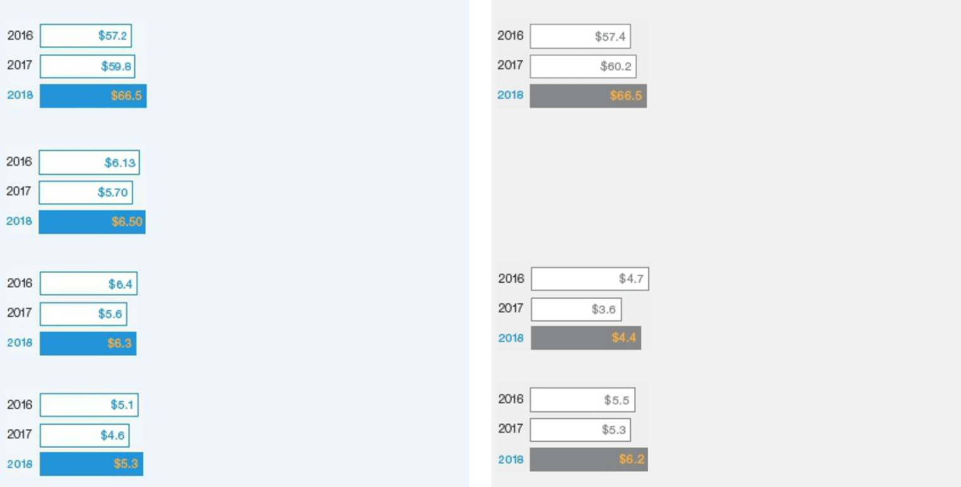

DILUTED EPS ($ per share)

ADJUSTED DILUTED EPS ($ per share)

CASH FLOW FROM OPERATIONS (in billions)

FREE CASH FLOW (in billions)

NET INCOME (in billions) | ADJUSTED NET INCOME (in billions)

* See Appendix A on pages 86-87 for additional information regarding these GAAP and non-GAAP financial measures.

16% |  | 14% |  | 8%
net income |  | diluted EPS |  | organic sales
growth |  | growth |  | growth

- United Technologies Notice of 2019 Annual Meeting of Shareowners and Proxy Statement

Table of Contents

COMPENSATION DISCUSSION AND ANALYSIS

Shareowner Value Creation

DIVIDENDS PAID (PER COMMON SHARE)
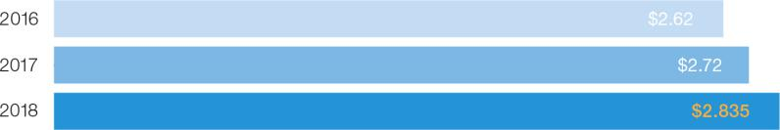

82nd | $2.5 billion | 4.2% increase
consecutive year we paid dividends | paid in 2018 to investors through dividends | in dividends per share paid to shareowners
to shareowners | and share buybacks | during 2018

During his four-plus years as CEO, Mr. Hayes has led UTC’s efforts to invest in the development of innovative products and to execute transformative, strategic transactions, while focusing on efforts to more rapidly and efficiently satisfy our customers’ needs. For example, the strong customer demand for Pratt & Whitney’s game-changing GTF engine continues, with more than 1,300 firm and option orders in 2018. The historic Rockwell Collins acquisition was successfully completed in the last quarter of 2018 and our new Collins Aerospace business unit is poised to become one of the world’s leading aerospace systems and component suppliers. UTC’s investment in digital technologies is producing results in each of our business units. For example, Carrier’s Automated Logic business developed the new OptiFlex virtual integrator platform that enables building operators to monitor up to 50,000 data points from various building systems, subsystems and devices using a single computer server. Further, Pratt & Whitney’s FAST solution, which is used for predictive and preventive aircraft maintenance, continues to expand on a growing number of aircraft platforms.

Over the last four years, we have spent $15.5 billion in company- and customer-funded research and development.

In short, we believe we have built a solid foundation for future UTC earnings growth following a multi-year cycle of heavy product and strategic investments. The chart below illustrates UTC’s annualized TSR compared to our Compensation Peer Group (“CPG”) and other major market indices over varying time periods.

TOTAL SHAREOWNER RETURN (AS OF DECEMBER 31, 2018)*
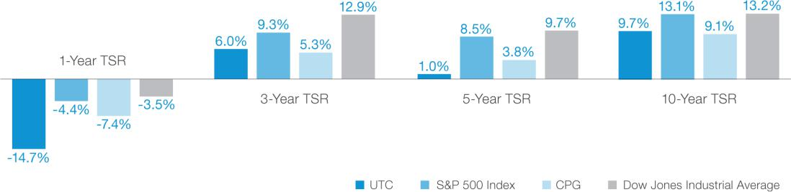

- TSR values are provided by S&P Capital IQ and are calculated on an annualized basis as of December 31, 2018. The CPG composite returns are determined by calculating the TSR for each peer company, then a weighted average is applied based on each company’s market capitalization at the beginning of the measurement period.

United Technologies Notice of 2019 Annual Meeting of Shareowners and Proxy Statement | 37

Table of Contents

COMPENSATION DISCUSSION AND ANALYSIS

How 2018 Performance Affected Incentive Payouts

As previously discussed on page 3, the Committee utilizes five key financial metrics that it believes are essential to the long-term financial health of our Company. The chart below shows UTC’s performance against these pre-established financial goals set for our 2018 annual bonus and our 2016-2018 PSU awards.

Incentive Plans⁽¹⁾ |  | Threshold |  | Target |  | Maximum |  | Actual |  | Payout Factor
2018 Annual Bonus⁽²⁾
UTC Earnings (net income) |  | $5.1 billion |  | $5.6 billion |  | $6.2 billion |  | $5.9 billion |  | 152%
UTC Free Cash Flow |  | $3.8 billion |  | $5.0 billion |  | $6.3 billion |  | $4.9 billion |  | 95%
 |  |  |  | Calculated UTC Financial Performance Factor |  |  |  |  |  | 129%⁽³⁾
 |  | Committee Approved UTC Financial Performance Factor |  |  |  |  |  |  |  | 125%⁽³⁾
2016-2018 Performance Share Units
EPS Growth | 1.5% |  | 4.5% |  | 7.5% |  | 4.4% |  |  | 98%
Return on Invested Capital | 9% |  | 10.5% |  | 12.5% |  | 11.1% |  |  | 131%
UTC’s TSR rank vs. S&P 500 companies⁽⁴⁾ |  | 25th %ile |  | 50th %ile |  | 75th %ile |  | 54.9th %ile |  | 120%
 |  |  |  |  | Committee Approved Payout Factor |  |  |  |  | 116%

- Performance goals and results are based on non-GAAP financial measures. See Appendix B on page 88 for details.

- Reflects annual bonus goals and results for the UTC financial performance factor. Business unit goals and results differ. See pages 42-43 for details.

- The Committee used its discretion and reduced the calculated payout factor from 129% to 125%. See page 43 for additional details on this adjustment.

- TSR is calculated using a 60-day average stock price at the beginning and end of the performance period for UTC and the companies within the S&P 500 Index at the beginning of the performance period.

How We Make Pay Decisions and Assess Our Programs

WHO DOES WHAT


Compensation Committee

Oversees our programs

- Sets financial, strategic and operational goals and objectives for the Company, the business units and the CEO, as they relate to the annual and long-term incentive programs.

- Assesses Company, business unit and NEO performance relative to the pre-established goals and objectives set for the year.

- Approves CEO pay adjustments based on its assessment of CEO performance.

- Reviews the CEO’s recommendations for pay changes for ELG members and executive officers, and makes adjustments as appropriate.

- Evaluates the competitiveness of the compensation packages for ELG members and executive officers.

- Approves all executive compensation program design changes, including severance, change-in-control and supplemental benefit arrangements.

- Reviews risk assessments of UTC’s compensation plans, policies and practices.

- Considers shareowner input regarding executive compensation decisions and policies.

- All decisions are subject to review by the other independent directors.

CEO

Provides selective input to the Committee

- Considers the performance of each ELG member/executive officer, his or her business unit and/or function, market benchmarks, internal equity and retention risk when determining pay recommendations.

- Presents the Committee with recommendations for each principal element of compensation for ELG members (including the other NEOs) and executive officers.

- Does not have any role in the Committee’s determination of his own compensation.

Management and the Independent Consultant

Provide insight and assistance

The Executive Vice President & Chief Human Resources Officer, along with UTC’s Human Resources staff and the independent compensation consultant, provide insights on program design and compensation market data to assist the Committee with its decisions. Management also has been delegated oversight responsibility of executive compensation plan administration.

- United Technologies Notice of 2019 Annual Meeting of Shareowners and Proxy Statement

Shareowners

Provide feedback on our programs

In assessing our program each year, the Committee reviews the feedback received from shareowners. This feedback, along with other factors, helps the Committee in its decisions and its ongoing assessment of the effectiveness of our program.

Table of Contents

COMPENSATION DISCUSSION AND ANALYSIS

Role of Independent Compensation Consultant

The Compensation Committee retained Pearl Meyer & Partners (“Pearl Meyer”) to serve as its executive compensation consultant for 2018. Although Pearl Meyer may make recommendations on the form and amount of compensation, the Committee makes all decisions regarding the compensation of our NEOs and other ELG members.

During 2018, Pearl Meyer advised the Committee on a variety of subjects, including compensation plan design and trends, pay-for-performance analytics, benchmarking data and related matters. Pearl Meyer reports directly to the Committee, participates in meetings as requested and communicates with the Committee Chair between meetings as necessary. A Pearl Meyer representative attended each of the five Committee meetings in 2018.

Prior to engaging Pearl Meyer, the Committee reviewed the firm’s qualifications, independence and any potential conflicts of interest. Pearl Meyer does not perform other services for or receive other fees from UTC (except for an incidental amount of $9,400 in 2018 for participation in certain business surveys). The Committee therefore determined that Pearl Meyer qualified as an independent consultant. The Committee has the sole authority to modify or approve Pearl Meyer’s compensation, determine the nature and scope of its services, evaluate its performance, terminate the engagement, and hire a replacement or additional consultant at any time.

The Committee also uses market data from other compensation consulting firms for benchmarking and other purposes. However, this benchmark data is generally available broadly to these firms’ other consulting clients. No other consulting firm made recommendations to the Committee or Management on peer group composition or on the form, amount or design of executive compensation in 2018.

Our Compensation Peer Group

How We Use Peer Group Data. We compare our executive compensation program to those at the 23 companies that make up our Compensation Peer Group (“CPG”). Data from a broader range of companies, including the Fortune 100, are used for insight into general compensation trends and to supplement CPG data when necessary and appropriate. To maintain a sufficiently competitive executive compensation program, the Committee believes the target value of each principal element of compensation should approximate the market median of the companies UTC views as competitors for executive talent. The Committee annually evaluates each compensation element relative to the market for each ELG member’s role and makes adjustments as necessary. However, individual compensation may vary from market median benchmarks based on the Committee’s assessment of Company, business unit/function and individual performance, job scope, retention risk, tenure, and other factors that it determines to be relevant to its evaluation.

How Our Compensation Peer Group is Constructed. The CPG’s composition reflects a mix of both industry and non-industry peers that the Committee views as competitors for senior executive talent. Like UTC, 11 of these 23 companies are Dow Jones Industrial Average components. In its 2018 review, the Committee made no adjustments to the CPG. The Committee believes the companies in the CPG provide a relevant comparison based on their similarity to UTC in size, geographic footprint and operational complexity, taking into account factors such as revenue, market capitalization, global scope of operations, manufacturing footprint, research and development activities, and diversified product portfolios. The CPG is constructed to serve the specific purpose of benchmarking executive compensation. For this reason, we do not use the relative financial performance of the CPG as a performance metric in our incentive compensation programs.

We target compensation to approximate the

market median.

United Technologies Notice of 2019 Annual Meeting of Shareowners and Proxy Statement | 39

Table of Contents

COMPENSATION DISCUSSION AND ANALYSIS

OUR COMPENSATION PEER GROUP

Companies in Blue represent Dow Jones Industrial Average components.

Aerospace & Defense | Equipment & Machinery | Technology/Communications | Consumer Packaged Goods | Oil & Gas
Boeing | 3M | AT&T | Johnson & Johnson | Chevron
General Dynamics | Caterpillar | Cisco | Procter & Gamble
Lockheed Martin | Deere | IBM
Northrop Grumman | Eaton | Verizon
Raytheon | Emerson Electric
 | Johnson Controls



Chemicals | Diversified Industrials | Automotive | Pharmaceuticals
DowDuPont | General Electric | General Motors | Pfizer
 | Honeywell









PEER GROUP DATA*
 |  |  |  |  | Market
 |  |  | Net Sales |  | Capitalization
 |  |  | (in billions) |  | (in billions) |  | Employees
25th percentile | $34.5 |  |  | $46.9 |  | 89,750
50th percentile | $53.8 |  |  | $97.8 |  | 104,000
75th percentile | $93.6 |  |  | $201.3 |  | 128,550
UTC | $66.5 |  |  | $91.9 |  | 240,200
UTC Rank |  |  | 59th |  | 49th |  | 98th

- Peer company data is provided by S&P Capital IQ. Net sales and employee data reflect the most recent publicly available information (as of February 21, 2019). Net sales are based on continuing operations, as reported, in accordance with U.S. GAAP financial reporting standards. Market capitalization for peer companies is calculated based on shares outstanding as of December 31, 2018.

Timeline for Compensation Decisions

The Committee followed the below process to make 2018 annual pay decisions for each of the principal components of compensation included in total direct compensation as detailed on pages 2 and 46:

February 2018 | April 2018 | December 2018 | February 1, 2019 | February 5, 2019 | 1st Quarter of 2019
2018 base salary | 2018 base salary | Review of preliminary 2018 | Review of final 2018 | 2019 LTI awards granted. | 2018 annual bonuses
adjustments were approved. | adjustments took effect. | Company/ business | Company/business unit/ |  | paid.
Performance goals for the |  | unit/individual performance. | individual performance.
2018 annual bonuses were |  |  | Financial performance
approved. |  |  | factors and individual payout
 |  |  | levels for 2018 annual
 |  |  | bonuses were approved.
 |  |  | Performance goals for the
 |  |  | 2019-2021 PSU awards were
 |  |  | approved.
 |  |  | 2019 LTI award values were
 |  |  | approved.

- United Technologies Notice of 2019 Annual Meeting of Shareowners and Proxy Statement

Table of Contents

COMPENSATION DISCUSSION AND ANALYSIS

Our Principal Elements of Compensation

Base Salary

To attract and retain talented and qualified executives, we provide competitive base salaries, which we target at the market median. Each year the Committee reviews the CEO’s recommendations for base salary adjustments for ELG members relative to peer market data for similar roles. The Committee has complete discretion to modify or approve the CEO’s recommendations. The CEO has no involvement in the Committee’s determination of his own base salary. Actual salaries may vary from market medians based on factors such as job scope and responsibilities, experience, tenure, individual performance, retention risk, and internal pay equity.

Annual Bonus

OUR OBJECTIVES

The Committee believes its methodology for determining annual bonus awards accomplishes the following objectives:

- Sets financial performance goals that are consistent with the Committee’s assessment of the opportunities and risks for the upcoming year, as communicated to investors.

- Establishes challenging but achievable performance goals for our executives.

- Provides incentive opportunities that are market competitive.

- Allows the Committee to make discretionary adjustments if it determines that measured performance does not fully align with its assessment of overall performance.

ANNUAL BONUS TARGETS

The Committee approves annual bonus target levels based on relevant market data for each ELG member’s role. Target levels are expressed as a percentage of base salary and generally approximate the market median. The 2018 annual bonus targets for each NEO are shown below:

NEO |  | ANNUAL BONUS TARGET
Gregory J. Hayes |  | 175%
Akhil Johri |  | 100%
Robert K. Ortberg |  | 125%
Judith F. Marks |  | 100%
David L. Gitlin |  | 100%

SETTING FINANCIAL PERFORMANCE METRICS AND GOALS FOR 2018

For 2018, the Committee established annual performance goals at threshold, target and maximum levels for two financial metrics: earnings and free cash flow (“FCF”). Performance relative to these pre-established goals determines the financial performance factors for UTC and each business unit.

The charts below show the weighting of each financial metric. UTC’s financial performance factor determines the annual bonus pool for Corporate executives, while a blend of the UTC factor and business unit-specific financial performance factors are used to determine the pool for business unit executives for 2018.

UTC FINANCIAL PERFORMANCE FACTOR |  | BUSINESS UNIT FINANCIAL PERFORMANCE FACTORS


United Technologies Notice of 2019 Annual Meeting of Shareowners and Proxy Statement | 41

Table of Contents

COMPENSATION DISCUSSION AND ANALYSIS

BACKGROUND ON FINANCIAL PERFORMANCE METRICS AND GOALS

How are performance metrics defined for annual bonus purposes?

UTC Earnings

UTC’s net income, adjusted for restructuring, non-recurring and other significant, non-operational items.*

UTC FCF

UTC FCF, adjusted for restructuring, non-recurring and other significant, non-operational items.*

Business Unit Earnings

Business unit earnings before interest and taxes (“EBIT”) at constant currency, adjusted for restructuring, non-recurring and other significant, non-operational items, and the impact of acquisitions/ divestitures.*

Business Unit FCF

Business unit FCF, adjusted for restructuring, non-recurring and other significant, non-operational items.*

Why has the Committee The Committee believes that
selected these metrics? adjusted net income is an
appropriate UTC-wide goal
because it includes the impact of
items such as tax, interest and
foreign exchange fluctuations,
which are managed at the
Corporate level and thus relevant
to assessing UTC’s overall
performance.

The Committee believes that FCF performance is a relevant measure of the Company’s ability to generate cash to fund our operations and key business investments.

The Committee believes operating earnings growth, exclusive of tax, interest and foreign exchange exposure should be the focus of business unit performance.

The Committee believes that FCF performance is a relevant measure of the business units’ ability to generate cash to fund our operations and key business investments.

Why does the Company use non-GAAP financial performance goals for annual bonus purposes?

The Committee believes annual bonuses should not be positively or negatively impacted by short-term decisions made in the best interest of UTC’s long-term business strategies. Using non-GAAP performance measures encourages decision-making that considers long-term value creation that does not conflict with short-term incentive metrics. Adjustments for restructuring, non-recurring and other significant, non-operational items and acquisitions and divestures, provides a more stable performance assessment of the Company’s core business, and aligns compensation opportunities with the non-GAAP financial expectations we communicate to investors.

How did the Committee set | An adjusted net income goal was | The UTC FCF goal was set to | Adjusted EBIT goals were set to | FCF goals were set to contribute
performance goals? | set to correspond to the expected | align with the performance | contribute to the overall adjusted | to the overall UTC goal and to
 | adjusted EPS range | expectations communicated to | UTC net income goal and reflect | align with each business unit’s
 | communicated to investors for the | investors for the year. | each business unit’s anticipated | strategic business plan for the
 | year. |  | opportunities and challenges for | year.
 |  |  | the year.
What goals did the Committee | A $5.6 billion adjusted net income | $5.0 billion FCF goal. | Adjusted EBIT goals ranged from | FCF goals ranged from $1.0 to
set for 2018? | goal was set to correspond to an |  | $1.5 to $3.1 billion. | $2.1 billion.
 | adjusted EPS of $7.00, which fell
 | within the EPS range
 | communicated to investors at the
 | beginning of the year.

* See Appendix B on page 88 for a detailed definition on how we calculate earnings and FCF for the purposes of determining the UTC and business unit financial performance factors.

PAYOUT FACTORS

Payout factors begin at 50% of target (for threshold-level performance) and are capped at 200% of target (for maximum-level performance). There are no payouts for below threshold-level performance and at no point can the Committee approve a payout factor above 200% of target.

UTC Earnings Goal* |  | Threshold |  | Target |  | Maximum
Adjusted Net Income |  | $5.1 billion |  | $5.6 billion |  | $6.2 billion
Payout Factor (as a % of target) |  | 50% |  | 100% |  | 200%
UTC Free Cash Flow Goal* |  | Threshold |  | Target |  | Maximum
Free Cash Flow |  | $3.8 billion |  | $5.0 billion |  | $6.3 billion
Payout Factor (as a % of target) |  | 50% |  | 100% |  | 200%

- Reflects the goals set for the UTC financial performance factor. Earnings and FCF goals for our business units vary.

42United Technologies Notice of 2019 Annual Meeting of Shareowners and Proxy Statement

Table of Contents

COMPENSATION DISCUSSION AND ANALYSIS

HOW 2018 FINANCIAL PERFORMANCE RESULTS LED TO THE FINANCIAL PERFORMANCE FACTORS

What 2018 financial results were used to determine the financial performance factors?

UTC Earnings

UTC’s adjusted 2018 net income was $6.2 billion. The Committee subsequently adjusted out the benefit of the Rockwell Collins acquisition, which was completed in the last quarter of the performance period, and neutralized the effect of the Tax Reform and Jobs Act. The resulting net income used for annual bonus purposes was $5.9 billion.

UTC FCF |  | Business Unit Earnings |  | Business Units FCF
UTC’s free cash flow was $4.4 |  | Adjusted business unit EBIT |  | Free cash flow results for the
billion, which was adjusted to $4.9 |  | ranged from $1.6 to $3.1 billion. |  | business units ranged from $1.2
billion for annual bonus purposes |  |  |  | to $2.0 billion.
to exclude restructuring, non-
recurring and other significant,
non-operational items, including
the benefit of the Rockwell Collins
acquisition that occurred in the
last quarter of the performance
period.

What were the payout factors | 152% of target. | 95% of target. | Ranged from 77% to 114% of | Ranged from 80% to 200% of
for each metric? |  |  | target. | target.
What were the calculated | The weighted earnings and free cash flow payout factors resulted in a |  | After incorporating the UTC factor, the weighted earnings and free cash
financial performance factors? | blended UTC financial performance factor of 129% of target. |  | flow payout factors resulted in blended financial performance factors for
 |  |  | the business units ranging from 99% to 141% of target.
Did the Committee make any | The Committee used its discretion and reduced the calculated UTC |  | The Committee used its discretion and adjusted some of the business
adjustments to the calculated | financial performance factor from 129% to 125% of target to account for |  | units’ calculated financial performance factors upward and others
financial performance factors? | certain issues with a Pratt & Whitney supplier program, which it deemed |  | downward to account for various items it deemed relevant to assessing
 | relevant to assessing the overall performance of the Company. See |  | overall performance. After these adjustments, the business unit factors
 | “Committee’s Use of Discretion in Annual Bonus Awards” below for |  | ranged from 95% to 130% of target. See “Committee’s Use of Discretion
 | more details. |  | in Annual Bonus Awards” below for more details.

POOL DETERMINATION

Annual bonus funding pools are calculated by first multiplying each executive’s annual bonus target value (base salary x target bonus percentage) by the applicable UTC or business unit financial performance factor approved by the Committee. These amounts are then aggregated to determine award pools for Corporate executives and each business unit, and are subsequently allocated among eligible executives based on individual performance.

INDIVIDUAL PERFORMANCE

Our NEOs begin the year with individual financial, strategic and operational objectives. Based on the CEO’s assessment of each NEO’s performance, he may recommend that the Committee make a discretionary adjustment to increase or decrease the annual bonus calculated using the applicable financial performance factor. The Committee considers these recommendations and makes adjustments as it deems appropriate. Mr. Hayes has no role in the Committee’s determination of his own annual bonus.

COMMITTEE’S USE OF DISCRETION IN ANNUAL BONUS AWARDS

As previously discussed, the annual bonus program is designed to closely align individual payouts with performance relative to pre-established goals. However, the Committee retains the authority to make upward or downward adjustments if it determines that Company, business unit and/or individual performance measured by the metrics does not accurately reflect the overall quality of performance for the year. Although the achievement of financial performance goals remains the primary basis for determining actual annual bonus amounts, the Committee has previously made positive and negative discretionary adjustments to financial performance factors and as a result of individual performance. Examples of situations that could result in discretionary adjustment include:

- Material, unforeseen circumstances beyond Management’s control that affected financial performance results relative to the established goals or certain non-recurring charges or credits unrelated to operating performance;

- Tax or accounting rule adjustments that positively or negatively impact performance;

- Changes to the Company’s capital structure;

- An executive’s performance relative to specific individual annual objectives; or

- An executive’s failure to adhere to UTC’s Code of Ethics, Enterprise Risk Management program or other Company policies.

United Technologies Notice of 2019 Annual Meeting of Shareowners and Proxy Statement | 43

Table of Contents

COMPENSATION DISCUSSION AND ANALYSIS

Long-Term Incentive Awards

Each year the Committee reviews the design of our LTI awards to ensure consistency with our program’s fundamental objective of aligning the interests of executives and shareowners while attracting and retaining talented senior leaders. Our annual LTI awards are subject to three-year, service-based (and in the case of PSUs, performance-based) vesting requirements, with limited exceptions for death, disability, retirement, change-in-control and certain qualifying involuntary terminations.

2018 LTI VEHICLES

The Committee approves a total LTI award value for each NEO at its meeting prior to the grant date. For the January 2, 2018 grant, our NEOs received their annual award weighted in the LTI vehicles shown in the chart to the right. The number of PSUs, SARs and RSUs awarded is determined based on the 30-day average of UTC’s closing stock price prior to the grant date. This method has been adopted as a mechanism to stabilize the impact of potential volatility of UTC’s stock price on the date of grant. However, because the award value is ultimately determined based on the closing price of UTC Common Stock on the grant date and other accounting valuation assumptions, the value approved by the Committee differs from the grant date fair value shown in the Summary Compensation Table on page 58.

2018 NEO LTI MIX
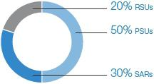

PERFORMANCE SHARE UNITS

PSUs vest at the end of a three-year performance period if, and to the extent that, the Company achieves performance goals established by the Committee. When a PSU vests, it converts into one share of UTC Common Stock. Unvested PSUs do not earn dividend equivalents. PSUs are designed to deliver market median compensation at target levels of performance. Performance below or above target levels will result in payouts that differ from the market median.

Performance Metrics and Goals for the 2018-2020 PSUs. On January 2, 2018, the Committee granted PSU awards subject to pre-established three-year performance goals. On November 26, 2018, UTC completed the $30+ billion (including debt) acquisition of Rockwell Collins. Given the significant change to the Company’s capital structure and the financial impact of this transaction, the Committee adjusted the performance goals for the 2018 and 2017 PSUs to neutralize the impact of the transaction. This adjustment was necessary to maintain the same level of challenge as the originally established performance goals and is in accordance with plan provisions designed to maintain the integrity of the performance goals in such scenarios. The adjusted goals for 2018 PSUs are described below.

EARNINGS PER SHARE GROWTH (“EPS”)
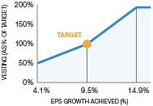

EPS Growth (weighted 35%)

- Three-year EPS compound annual growth rate goal was set at 9.5%.

- Aligned with our mid-range strategic business plan.

- Reflects what the Committee determined to be a challenging yet attainable target.

RETURN ON INVESTED CAPITAL (“ROIC”)
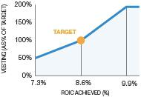

Return on Invested Capital (weighted 35%)

- ROIC goal was set at 8.6%.

- ROIC is calculated using a quarterly average over the three-year performance period.

- Incentivizes our executives to make disciplined capital allocation decisions.

- United Technologies Notice of 2019 Annual Meeting of Shareowners and Proxy Statement

Table of Contents

COMPENSATION DISCUSSION AND ANALYSIS

TOTAL SHAREOWNER RETURN (“TSR”) VS. S&P 500
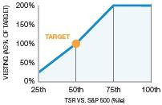

Relative TSR (weighted 30%)

- Cumulative three-year TSR goal was set at the 50th percentile relative to the companies within the S&P 500 Index at the beginning of the performance period.

- Vesting does not occur if UTC’s TSR ranks below the 25th percentile and is capped at 200% of target if TSR reaches the 75th percentile.

- If UTC’s three-year TSR is negative, the payout for this portion of the award is capped at 100% of target regardless of UTC’s relative performance vs. the S&P 500 companies.

- Beginning and end periods measured using a 60-day average.

Why We Compare UTC’s TSR to the TSR of the Companies within the S&P 500 Index. The Committee believes that comparing UTC’s TSR to the companies within the S&P 500 provides an appropriate benchmark for measuring our share price performance as a large capitalization company. The Committee does not set TSR goals relative to the performance of the CPG (see pages 39-40 for more details on our peer group) because the CPG is used solely to measure the competitiveness of our executive compensation program. The Committee believes the S&P 500 provides a more comprehensive and relevant comparison for our share price performance and, unlike the CPG, is not a self-selected, customized benchmark based on a limited number of companies.

What the Committee Considers when Setting Performance Goals. When setting financial performance goals for our PSU awards, the Committee considers various long-term business factors, including, but not limited to, planned share buybacks, macroeconomic market trends, pension headwinds/tailwinds and cost reduction plans. Certain items such as unplanned share buybacks, restructuring charges, and non-recurring and non-operational items may be excluded from performance results, as appropriate, to maintain the validity of the targets as originally formulated. See Appendix B on page 88 for a definition of how we calculate these metrics.

PSU Vesting (2016-2018 Performance Period). PSU awards granted on January 4, 2016, were subject to vesting based on UTC’s three-year performance relative to pre-established EPS growth, ROIC and relative TSR goals. The performance results used to determine the final payout factor for the 2016-2018 performance period were as follows:

Metric |  | Weight |  | Threshold |  | Target |  | Maximum |  | Actual |  | Payout Factor
3-Year EPS Growth |  | 35% |  | 1.5% |  | 4.5% |  | 7.5% |  | 4.4% |  | 98%
12-Quarter Average ROIC |  | 35% |  | 9% |  | 10.5% |  | 12.5% |  | 11.1% |  | 131%
3-Year TSR vs. the S&P 500 |  | 30% |  | 25th %ile |  | 50th %ile |  | 75th %ile |  | 54.9th %ile |  | 120%
 |  |  |  |  |  |  |  | Final Payout Factor |  |  |  | 116%

The 2018 GAAP diluted EPS of $6.50 was adjusted to $7.61 to account for the impact of restructuring, non-recurring and other significant items unrelated to operational performance (see Appendix A on pages 86-87 for details on GAAP and non-GAAP financial measures). For PSU vesting purposes, the Committee neutralized the impact of the Rockwell Collins acquisition (completed in the last quarter of the performance period) and the effects of the Tax Reform and Jobs Act (passed into law in the middle of the performance period), resulting in diluted EPS of $7.17. These adjustments are in accordance with plan provisions and were made to maintain the integrity of the original goals, which did not anticipate these significant events.

STOCK APPRECIATION RIGHTS

SARs entitle the award recipient to receive at the time of exercise shares of UTC Common Stock with a market value equal to the difference between the market price of UTC Common Stock on the date the SARs are exercised and the exercise price that was set at the grant date (i.e., the closing price of UTC Common Stock on the date of grant). SARs vest and become exercisable after three years and expire 10 years from the grant date.

To align shareowner and executive interests, SAR awards directly link NEO compensation to share price appreciation. The Committee believes the 10-year term of these awards incentivizes long-term shareowner value creation.

United Technologies Notice of 2019 Annual Meeting of Shareowners and Proxy Statement | 45

Table of Contents

COMPENSATION DISCUSSION AND ANALYSIS

RESTRICTED STOCK UNITS

Since 2017, ELG members (including each of our NEOs) have received 20% of their annual total LTI award in the form of RSUs. RSUs vest three years from the grant date and earn dividend equivalents during the vesting period that are reinvested as additional RSUs each time UTC pays a dividend to shareowners. The reinvested RSUs vest on the same date as the underlying RSUs. The Committee believes this time-based vesting vehicle has enhanced senior executive retention during a period of significant business investment and market volatility. RSUs have less upside potential than SARs, but have a stabilizing effect on the value of LTIP grants.

SPECIAL EQUITY-BASED AWARDS

The Committee also may, from time to time, approve special equity grants for purposes such as recruitment, retention and recognition, or to drive the achievement of specific strategic performance goals. These special grants may be in the form of PSUs, SARs, RSUs, restricted stock or performance-based SARs. Since these grants are awarded for special purposes, we do not include them in total direct compensation which is intended to show the Committee’s annual pay decisions as it relates to its evaluation of executive performance.

CEO Pay Overview

CEO PAY FOR 2018

 |  | $1.6M |  | $3.5M |  | 175% target |  | $13.0M
 |  | base salary |  | annual bonus |  | annual bonus |  | LTI award
 |  | 6.7% increase in 2018 |  | aligned with the UTC |  | No change from prior year |  | approved by the Committee in
 |  |  |  | performance factor of 125% |  |  |  | February 2019 and aligned with
 |  |  |  |  |  |  |  | the market median
Total Direct Compensation

Unlike the amounts reported in the Summary Compensation Table, total direct compensation, shown in the chart below for each year, represents the annual pay decisions by the Committee that specifically reflect its assessment of Company, business unit and individual performance. For example, 2018 total direct compensation includes the LTI values approved by the Committee for awards made in early February 2019 because these awards reflect its assessment of 2018 performance. The Summary Compensation Table, by contrast, shows the grant date fair value of the January 2018 LTI awards, which reflects the Committee’s assessment of 2017 performance. Further, due to the valuation methodology used to determine the number of shares granted (see page 44), the LTI award values approved by the Committee, and included in total direct compensation, differ from the accounting grant date fair value ultimately reported in the Summary Compensation Table in the following year. Other elements included in the Summary Compensation Table, such as changes in pension values and other formulaic compensation components are excluded from total direct compensation because they do not relate to performance and are outside the scope of the Committee’s annual pay decisions. The Committee therefore believes that total direct compensation renders a more accurate and up-to-date reflection of its assessment of performance.

CEO TOTAL DIRECT COMPENSATION

2016
Reflects January 2017 LTI Grant

2017
Reflects January 2018 LTI Grant

2018
Reflects February 2019 LTI Grant

- United Technologies Notice of 2019 Annual Meeting of Shareowners and Proxy Statement

Table of Contents

COMPENSATION DISCUSSION AND ANALYSIS

Pay Decisions for the CEO
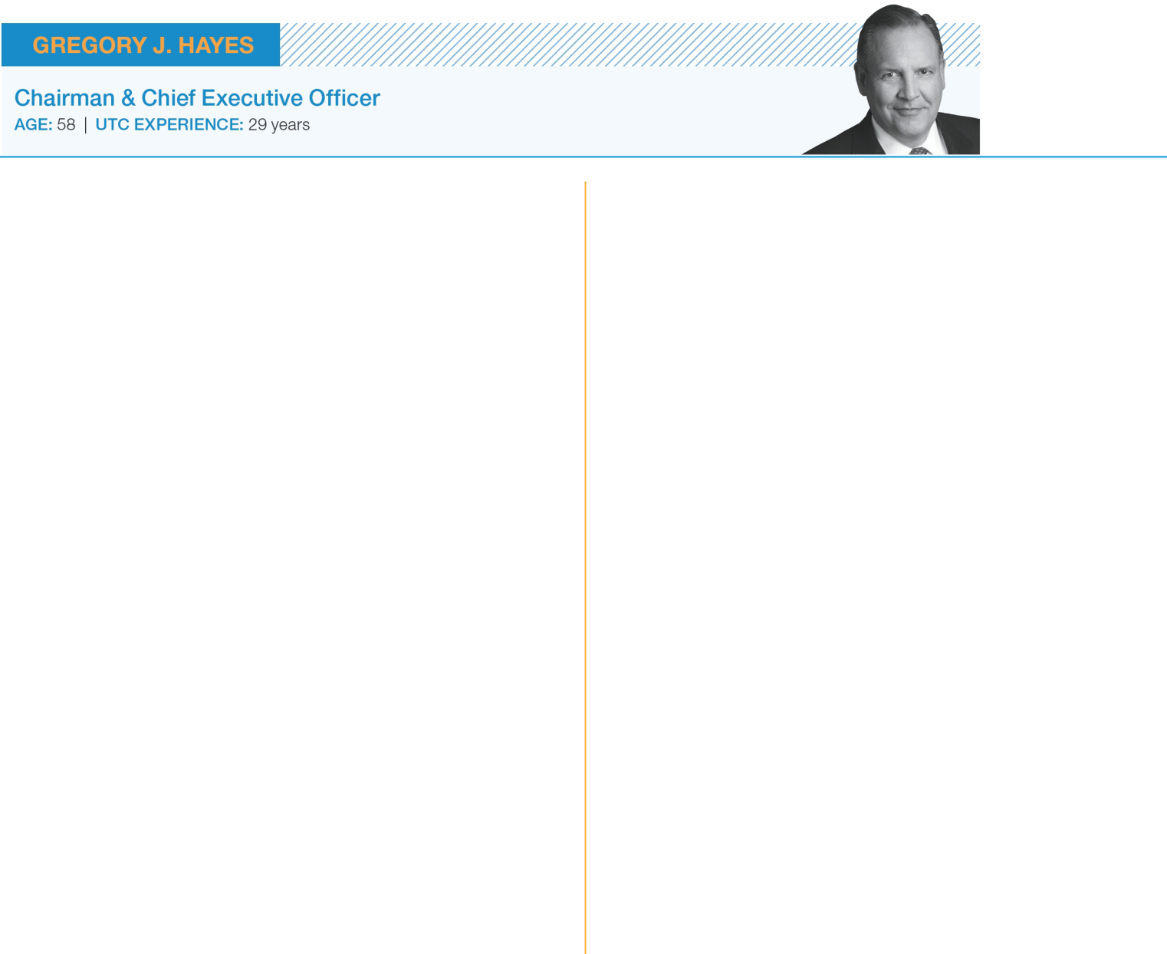

TOTAL DIRECT COMPENSATION
$18.10 MILLION

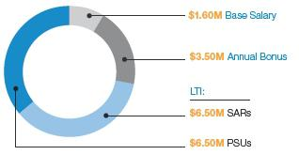

The Committee assessed Mr. Hayes’ 2018 performance favorably. Under his leadership, UTC successfully executed its 2018 financial, strategic and operational objectives in tandem with closing the Rockwell Collins acquisition and conducting an in-depth analysis of the Company’s business portfolio. The Committee’s compensation decisions below reflect his ability to deliver near-term performance while focusing on long-term strategic initiatives.

Base Salary. The Committee increased Mr. Hayes’ base salary from $1.5 to $1.6 million, effective April 2018, consistent with the market median for our Compensation Peer Group (“CPG”).

Annual Bonus. UTC’s 2018 annual bonus factor is determined based on adjusted net income and free cash flow performance against pre-established goals. 2018 adjusted net income of $5.9 billion used for annual bonus purposes exceeded the $5.6 billion goal, resulting in a payout factor of 152% for the earnings metric. Free cash flow used for annual bonus purposes equaled $4.9 billion, compared to the

$5.0 billion goal. This resulted in a 95% payout factor for the UTC cash flow metric. In combination, these results generated a UTC financial performance factor of 129%. The Committee subsequently adjusted the calculated factor to 125%, as discussed in detail on page 43.

The Committee used this adjusted factor and awarded Mr. Hayes a
$3.5 million annual bonus, an amount that aligned with the Company’s adjusted performance factor of 125%.

LTI. The Committee approved a 2019 long-term incentive award of $13 million, an amount that exceeds the value of Mr. Hayes’ 2018 grant and aligns with the CPG market median for his role. As previously noted, due to differences in valuation methodologies (see page 44 for details), the grant date fair value of this award will be reported as $13.4 million in next year’s Summary Compensation Table.

INDIVIDUAL PERFORMANCE HIGHLIGHTS

- Delivery of strong financial performance in 2018, including diluted EPS growth of 14% (GAAP and non-GAAP) and net income growth of 16% (GAAP and non-GAAP). In addition, net sales growth was 11% (GAAP), which included organic growth of 8% (non-GAAP).

- Successful completion of the $30+ billion (including debt) Rockwell Collins acquisition, one of the largest aerospace acquisitions in history.

- Completion of the Company’s portfolio review which resulted in our plan to separate UTC, Carrier and Otis into three standalone companies, allowing these businesses to focus on their core competencies and unique competitive challenges.

- Continued commitment to innovation, as evidenced by UTC’s strategic purchase of Predikto, Inc., a cloud-based analytics software company, with expertise that enables customers to predict, prevent and control equipment failures.

- Effectively driving a high-performance culture while emphasizing ethical standards, transparency and corporate responsibility.

United Technologies Notice of 2019 Annual Meeting of Shareowners and Proxy Statement | 47

Table of Contents

COMPENSATION DISCUSSION AND ANALYSIS

How We Assess Pay-for-Performance

The Summary Compensation Table on page 58 provides annual compensation data presented in accordance with the Securities and Exchange Commission’s (“SEC”) requirements. While helpful for cross-company comparisons, this SEC-mandated format uses accounting conventions to estimate values of long-term incentive awards at the time of grant. As might be expected, these estimated values can differ significantly from the actual value that is ultimately earned from these awards. Because the Committee believes this format does not adequately measure CEO compensation for the purpose of assessing pay-for-performance alignment, it also considers realizable and realized compensation as supplemental measures in its evaluation of CEO pay-for-performance. These measures are described in detail below.

Summary Compensation Table Realizable Compensation Realized Compensation

Basic concept

Uses SEC methodology, which includes a mix of both compensation actually earned during the year and future contingent pay opportunities.

Purpose

Three-year average compensation measure that captures how UTC’s year-end stock price affects the in-the-money
value⁽¹⁾ of previously granted equity awards.

Includes only pay actually earned during the year, including any gains realized on equity awards that were granted in prior years.

SEC-mandated compensation disclosure.

Used to evaluate pay-for-performance alignment by correlating the value of an executive’s long-term incentive awards with the returns our shareowners receive from investing in UTC stock over the same period.

Used to evaluate pay-for-performance alignment by focusing on the strength of the correlation between UTC’s stock performance and the actual cash and equity payouts earned by our CEO during the year.

How it is calculated

Sum of: |  | Three-Year Average of: |  | Sum of:
Base salary paid during the year |  | Base salary paid |  | Base salary paid during the year
Annual bonus earned for the applicable year’s |  | Annual bonus earned |  | Annual bonus earned for the applicable year’s
performance |  |  |  | performance
Accounting grant date fair value of equity awards granted |  | In-the-money value⁽¹⁾ of equity awards granted during the |  | Gains realized on equity awards exercised and vested
during the year reflecting prior year’s performance |  | prior three fiscal years, calculated using the stock price at |  | during the year
 |  | the end of the third year
All other compensation |  | Other direct⁽²⁾ compensation |  | Other direct⁽²⁾ compensation
Change in the actuarial value of pension benefits |  | Excludes: |  | Excludes:


Above-market earnings of nonqualified deferred compensation

Future pay opportunities that may or may not be realized.

- Change in the actuarial present value of pension benefits
- Above-market earnings of nonqualified deferred compensation
- Other indirect⁽³⁾ compensation

- Change in the actuarial present value of pension benefits
- Above-market earnings of nonqualified deferred compensation
- Other indirect⁽³⁾ compensation

- Defined as the difference between the closing stock price of UTC Common Stock at the end of the fiscal year and the exercise price of the award (if any) multiplied by the number of shares underlying equity awards. For PSU awards for which the vesting factor is not yet known, the target number of shares is used.

- Includes personal use of the Corporate aircraft, leased vehicle expenses, financial planning, security benefits, healthcare benefits and other miscellaneous items.

- Includes insurance premiums and Company contributions to nonqualified deferred compensation plans and defined contribution retirement plans.

- United Technologies Notice of 2019 Annual Meeting of Shareowners and Proxy Statement

Table of Contents

COMPENSATION DISCUSSION AND ANALYSIS

The following charts compare the Summary Compensation Table values reported for Mr. Hayes for the past three years to his realizable and realized compensation for the same period. These supplemental methodologies provide the Committee with relevant measures to assess the pay-for-performance relationship by focusing on the strength of the correlation between UTC’s stock price performance and compensation realizable and realized during these time periods. The Committee believes that the design of our executive compensation program, with its significant focus on “at-risk” pay, reinforces its key objectives of driving long-term shareowner value, aligning executive and shareowner interests, and rewarding pay-for-performance.

CEO PAY-FOR-PERFORMANCE
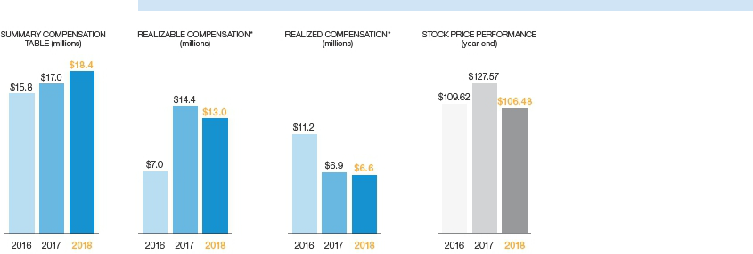

* Refer to the table on page 48 to see how we calculate realizable and realized compensation.

Our program’s fundamental objective is to drive

long-term shareowner value, align executive
and shareowner interests, and reward

pay-for-performance.

United Technologies Notice of 2019 Annual Meeting of Shareowners and Proxy Statement | 49

Table of Contents

COMPENSATION DISCUSSION AND ANALYSIS

Pay Decisions for the Other NEOs

The Committee makes annual compensation decisions for our NEOs based on their individual performance and the overall performance of the Company (and the business unit and/or function, where applicable). The following pages show each NEO’s 2018 total direct compensation values. As discussed on page 46, total direct compensation includes only those pay elements that relate to the Committee’s assessment of 2018 performance (i.e., it includes 2019 LTI grants that reflected 2018 performance, rather than 2018 LTI grants that reflected 2017 performance). We also provide individual performance highlights that contributed to the Committee’s pay decisions for each NEO.
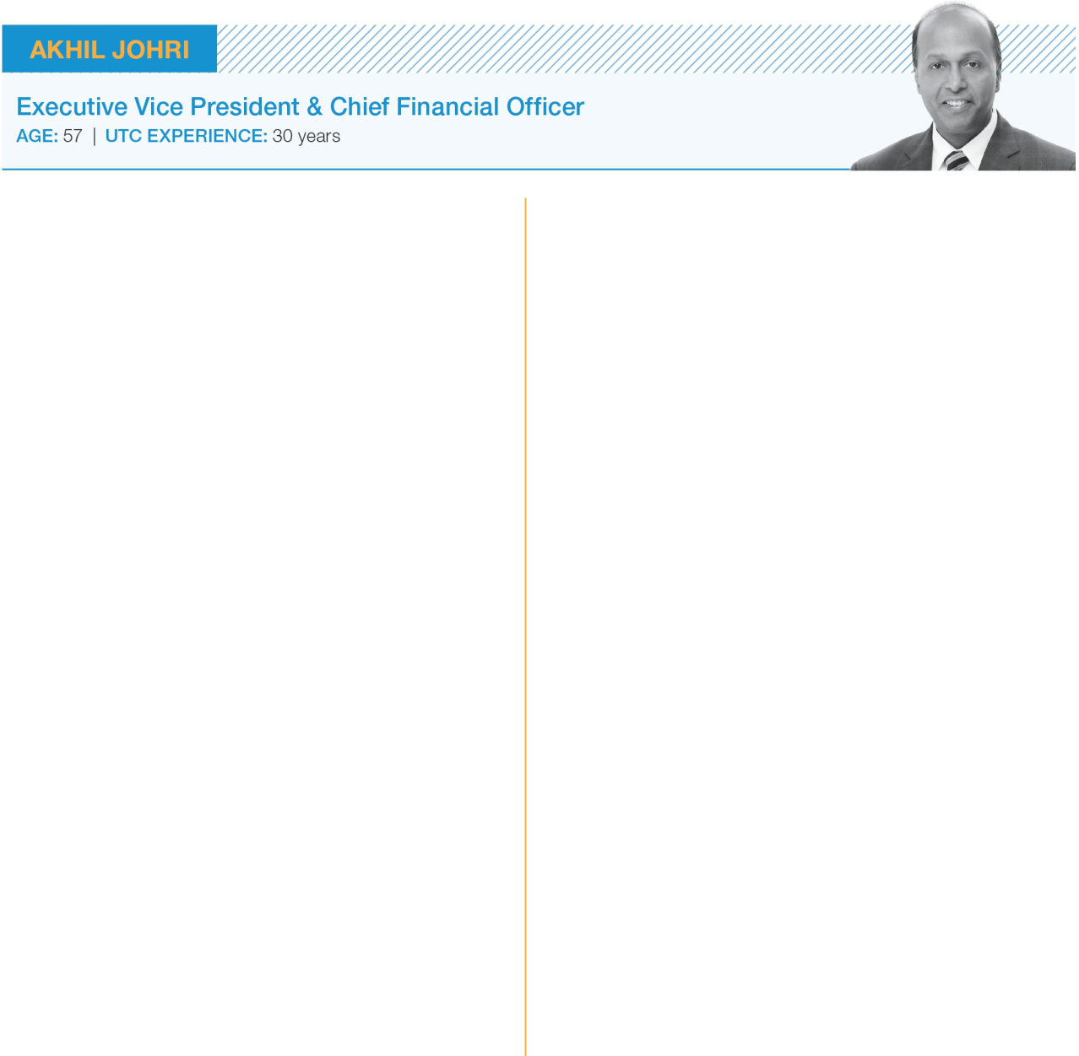

TOTAL DIRECT COMPENSATION $6.60 MILLION

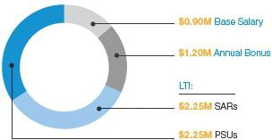

Base Salary. During 2018, Mr. Johri received a merit increase to his base salary from $860,000 to $900,000. This increase reflected the Committee’s favorable assessment of his performance, as well as its efforts to keep Mr. Johri’s base salary aligned with the CPG and Fortune 100 market medians for his role. Following this increase, Mr. Johri’s base salary closely aligns with the market median.

Annual Bonus. The Committee considered the UTC adjusted financial performance factor of 125% (as previously discussed on page 43), Mr. Johri’s effective leadership of UTC’s Finance function and the individual performance considerations noted here, and awarded him a $1.2 million annual bonus for 2018. This amount is closely aligned with the adjusted 125% UTC financial performance factor.

LTI. In consideration of Mr. Johri’s strong 2018 performance, the Committee approved a $4.5 million 2019 LTI award, an amount above the CPG and Fortune 100 market medians for his role. As previously noted, due to differences in valuation methodologies, the grant date fair value of this award will be reported as $4.6 million in next year’s Summary Compensation Table.

INDIVIDUAL PERFORMANCE HIGHLIGHTS

- Effective management of UTC’s Finance function, as evidenced by our strong 2018 financial performance, including:

  - 14% diluted EPS growth (GAAP and non-GAAP), an amount that exceeded the expectations we communicated to investors at the beginning of
the year;

  - Net sales growth of 11% (GAAP), which included organic growth of 8% (non-GAAP); and

  - Growth in net income from continuing operations of 16% (GAAP and non-GAAP).

- Leadership in driving UTC’s disciplined capital allocation strategy, including:

  - $2.5 billion returned to shareowners in 2018 through dividends and share repurchases; and

  - $4.0 billion in company- and customer-funded investments in research and development.

- Significant role in completing the Rockwell Collins acquisition and the business portfolio review that culminated in our plan to separate UTC, Carrier and Otis into three independent companies.

- Ranked best CFO in the Aerospace and Defense Electronics sector by Institutional Investor magazine based on a survey of analysts and shareowners.

- United Technologies Notice of 2019 Annual Meeting of Shareowners and Proxy Statement

Table of Contents

COMPENSATION DISCUSSION AND ANALYSIS


TOTAL DIRECT COMPENSATION $6.25 MILLION

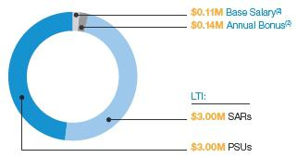

Mr. Ortberg served in the role of Chairman, President and CEO of Rockwell Collins until UTC’s acquisition of the company on November 26, 2018. Upon the completion of the acquisition, Mr. Ortberg became CEO of the combined Collins Aerospace business, and UTC and Mr. Ortberg entered into an agreement that provided for the following:

Base Salary. Mr. Ortberg’s full-year base salary remained at its pre-acquisition level of $1,170,500 following the closing.

Annual Bonus. Mr. Ortberg’s target annual bonus was reduced from 150% to 125% of base salary following the acquisition. Since the acquisition of Rockwell Collins did not close until November 26, 2018, UTC elected to pay Mr. Ortberg a pro-rata portion of his target annual bonus ($140,300) for the period between the closing and December 31, 2018.

LTI. The value of Mr. Ortberg’s 2019 annual LTI grant was reduced to $6.0 million from his last Rockwell Collins LTI award of $7.3 million. As previously noted, due to differences in valuation methodologies, the grant date fair value of this award will be reported as $6.2 million in next year’s Summary Compensation Table.

Other Compensation Elements. Under the terms of Mr. Ortberg’s Rockwell Collins change-in-control agreement, he had the right to terminate his employment with UTC for “good reason” within two years following the acquisition, and receive severance and benefit continuation. The Company, however, wanted to retain Mr. Ortberg and eliminate his incentive to terminate,

and Mr. Ortberg wished to continue his employment with the Company following the acquisition. Accordingly, we reached an agreement whereby Mr. Ortberg waived his rights and benefits under his change-in-control agreement. In exchange, the Company agreed to grant Mr. Ortberg an RSU award valued at $9.875 million following the closing. Importantly, Mr. Ortberg’s agreement with UTC provides for certain post-termination restrictive covenants that protect UTC’s interests, including non-competition, customer and employee non-solicitation, non-disclosure, and intellectual property protections. In replacing a contingent change-in-control severance benefit with a stock-based retention award with important restrictive covenants, this compensation strategy serves the best interest of the Company.

INDIVIDUAL PERFORMANCE HIGHLIGHTS

- During 2018, Mr. Ortberg effectively led Rockwell Collins to the successful closing of its merger with UTC.

- Notwithstanding the challenges of the merger process, under Mr. Ortberg’s leadership, Rockwell Collins delivered solid operational and strategic results in 2018, positioning the new Collins Aerospace business for the future. Examples include:

  - Successful delivery of the OLED F-35 advanced helmet display system for safety of flight evaluation, an outstanding technical achievement.

  - Entry into service of the Flight Operations and Maintenance Exchanger (FOMAX) program, which positions Collins Aerospace as a leader in connected aviation with real-time secure data gathering and transmissions during all phases of flight.

  - Meeting key milestones for the Boeing 777X.

  - Exceeding cost and sales synergy goals for the

B/E Aerospace acquisition.

  - Maintained outstanding employee engagement throughout the 15-month merger approval process.
- Includes Rockwell Collins years of service.

- Reflects a prorated portion of base salary and annual bonus paid to Mr. Ortberg for the portion of the year he was a UTC employee.

United Technologies Notice of 2019 Annual Meeting of Shareowners and Proxy Statement | 51

Table of Contents

COMPENSATION DISCUSSION AND ANALYSIS

TOTAL DIRECT COMPENSATION $5.88 MILLION
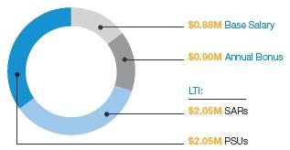

Base Salary. Ms. Marks received a base salary increase from $850,000 to $875,000 in 2018. This increase reflected the Committee’s favorable assessment of her performance in her short tenure as President of Otis. Ms. Marks’ base salary is now closely aligned with our CPG market median.

Annual Bonus. The unadjusted UTC financial
performance factor (129%, as discussed on page 43) and

the Otis factor (78%), resulted in a blended financial
performance factor of 99% of target. The Committee
subsequently used its discretion and reduced the Otis
factor to 95% of target. Based on this factor, along with

the individual performance considerations noted here, the

Committee awarded Ms. Marks an annual bonus of
$900,000, an amount that is slightly above Otis’ blended

financial performance factor.

LTI. In consideration of Ms. Marks’ strong 2018 performance, the Committee approved a $4.1 million 2019 LTI award, an amount above the CPG market median for her role. As previously noted, due to differences in valuation methodologies, the grant date fair value of this award will be reported as $4.2 million in next year’s Summary Compensation Table.

Other Compensation Elements. Ms. Marks joined UTC in late 2017 as President of Otis. In early 2018, UTC paid Ms. Marks a one-time $500,000 cash sign-on bonus to offset compensation she forfeited with her former employer.

INDIVIDUAL PERFORMANCE HIGHLIGHTS

- Leading Otis’ significant efforts to digitalize the entire business, including the 2018 launch of the Otis ONE digital platform, which collects real-time performance data to help predict and prevent equipment shutdowns.

- Major contract wins for some of the world’s largest and most complex projects, including:

  - Installation of 171 escalators and moving walkways for SNCF French Rail, which includes a 15-year maintenance contract and “mid-life” renovations.

  - More than 200 units to be installed in the new Resorts World Las Vegas entertainment complex.

  - More than 2,500 units for metro, rail and airport projects in 11 cities across China.

  - Selected to provide nine super double-deck elevators for the iconic Haikou Twin Towers project on Hainan Island off the coast of southern China.

- Exceeded 2 million units under maintenance contracts for the first time in Otis’ history.

- United Technologies Notice of 2019 Annual Meeting of Shareowners and Proxy Statement

Table of Contents

COMPENSATION DISCUSSION AND ANALYSIS


TOTAL DIRECT COMPENSATION $6.30 MILLION

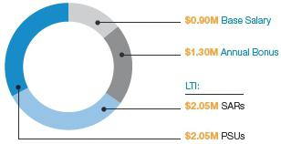

Mr. Gitlin served in the role of President, UTC Aerospace Systems (“UTAS”), until the completion of the Rockwell Collins acquisition on November 26, 2018, at which point he transitioned to the role of President & Chief Operating Officer of the combined Collins Aerospace business. Since Mr. Gitlin led the UTAS business for most of the year, the Committee evaluated his performance relative to the performance of the pre-merger UTAS organization.

Base Salary. Mr. Gitlin’s base salary remained at $900,000 for 2018, an amount that is closely aligned with the CPG market median for his role.

Annual Bonus. The unadjusted UTC financial performance factor (129%, as discussed on page 43) and the UTAS factor (111%) resulted in a blended financial performance factor of 118% of target. The Committee subsequently adjusted the UTAS factor to 130% in recognition of the successful closing of the Rockwell Collins acquisition and the continued integration of the two businesses. Based on these results, along with the individual performance considerations noted here, the Committee awarded Mr. Gitlin an annual bonus of $1.3 million, an amount moderately above UTAS’ blended financial performance factor.

LTI. In consideration of Mr. Gitlin’s strong 2018 performance, the Committee approved a $4.1 million 2019 LTI award, an amount above the CPG market median for his role. As previously noted, due to differences in valuation methodologies, the grant date fair value of this award will be reported as $4.2 million in next year’s Summary Compensation Table.

INDIVIDUAL PERFORMANCE HIGHLIGHTS

- Successful closing of the Rockwell Collins acquisition and his continued efforts in support of the integration of the merged Collins Aerospace business.

- Met or exceeded all key financial and operational goals for the year, notwithstanding the significant additional challenges associated with the closing of the acquisition of Rockwell Collins and the ongoing integration process.

- Leadership in driving substantial Collins Aerospace accomplishments, including:

  - Selection by Dassault Aviation to furnish an advanced nacelle system for its Falcon 6X business jet, providing for quieter and more fuel-efficient operations.

  - Achieved significant wins for wheel and brake systems in 2018, with more than 35 airlines selecting Collins Aerospace’s equipment, which represent commitments totaling more than $500 million.

  - Selection by Boeing to provide the ACES 5 ejection seat and fully integrated landing gear system for the U.S. Air Force’s new T-X jet trainer.

  - Contracted to develop state-of-the-art electric power generation system for South Korea’s KF-X fighter.

United Technologies Notice of 2019 Annual Meeting of Shareowners and Proxy Statement | 53

Table of Contents

COMPENSATION DISCUSSION AND ANALYSIS

Other Compensation Elements

Retirement and Deferred Compensation Benefits

Retirement and deferred compensation plans help UTC attract and retain talented executives. Over the years, the Committee has updated these programs to maintain a competitive position within an evolving market. We believe the overall design of our retirement and deferred compensation programs is currently consistent with compensation practices in the marketplace and provides participating executives with benefits that approximate the Compensation Peer Group market median.

Below are brief descriptions of each retirement and deferred compensation arrangement we offer. See the Pension Benefits and the Nonqualified Deferred Compensation sections on pages 63-66 for more details.

Plan |  | Description
UTC Employee |  | Employees hired prior to January 1, 2010, are eligible to participate in this tax-qualified pension plan. Effective December 31, 2014, participants who had been
Retirement Plan |  | covered by the original final average earnings (“FAE”) formula of this plan transitioned to a more modest cash balance formula, which was already in effect for
 |  | newer participants. See page 63 for details on these formulas.
UTC Pension |  | An unfunded, nonqualified retirement plan utilizing the same benefit formula, compensation recognition, retirement eligibility and vesting provisions as the tax-
Preservation Plan |  | qualified UTC Employee Retirement Plan. For employees hired prior to January 1, 2010, it provides pension benefits not provided under the tax-qualified
 |  | pension plan because of Internal Revenue Code limits.
UTC Employee |  | A tax-qualified plan where employees receive a matching contribution in the form of UTC stock units with a value equal to 60% of the first 6% of pay (consisting
Savings Plan |  | of base salary plus annual bonus) contributed by the employee. Salaried employees hired on or after January 1, 2010, who are not eligible to participate in the
 |  | UTC Employee Retirement Plan receive an additional age-based Company contribution (ranging from 3% to 5.5% of earnings) to their UTC Employee Savings
 |  | Plan account.
UTC Savings |  | An unfunded, nonqualified plan that matches the executive’s contributions with Company contributions in UTC stock units at the same rate as the UTC
Restoration Plan |  | Employee Savings Plan, to the extent such contributions exceed Internal Revenue Code limits.
UTC Company |  | An unfunded, nonqualified plan for which salaried employees hired on or after January 1, 2010, may receive an additional age-based Company automatic
Automatic Contribution |  | contribution (ranging from 3% to 5.5% of earnings) for amounts above the Internal Revenue Code limits applicable to the qualified UTC Employee Savings Plan.
Excess Plan |  | Participants receiving benefits under this plan are ineligible to accrue a benefit under the UTC Pension Preservation Plan described above.
UTC Deferred |  | An unfunded, nonqualified, deferred compensation plan that offers executives the opportunity to defer up to 50% of base salary and up to 70% of annual bonus.
Compensation Plan
UTC PSU Deferral Plan |  | An unfunded, nonqualified, deferred compensation plan that allows executives to defer between 10% and 100% of their vested PSU awards. Upon vesting, the
 |  | deferred portion of each PSU award is converted into deferred stock units that accrue dividend equivalents.

- United Technologies Notice of 2019 Annual Meeting of Shareowners and Proxy Statement

Table of Contents

COMPENSATION DISCUSSION AND ANALYSIS

Perquisites and Other Benefits

We provide the following benefits to our senior executives, which the Committee believes are consistent with market practice and contributes to recruitment and retention.

Perquisite/Benefits* |  | Description
ELG Life Insurance |  | ELG members appointed prior to January 31, 2015, may receive company-funded life insurance coverage up to three times their base salary at age 62
 |  | (projected or actual). This benefit is not available to Ms. Marks and Mr. Ortberg, who were appointed to the ELG after January 31, 2015.
ELG Long-Term |  | The ELG long-term disability program provides an annual benefit upon disability that is equal to 80% of base salary plus target annual bonus.
Disability
Healthcare |  | ELG members are eligible to participate in the same health benefit program we offer to our other employees.
Executive Physical |  | ELG members are eligible for a comprehensive annual executive physical.
Executive Leased |  | UTC provides ELG members with an annual allowance toward the costs of a leased vehicle. The value of the allowance varies by ELG appointment date. Any
Vehicle |  | costs above the annual allowance are paid directly by the executive.
Financial Planning |  | ELG members are eligible to receive an annual financial planning benefit.
Personal Aircraft |  | Our CEO is allowed personal use of the Corporate aircraft for up to 50 hours per year. The Committee believes this optimizes the efficient use of Mr. Hayes’ time.
Usage |  | Under this policy, Mr. Hayes also may fly commercially, subject to review by UTC security personnel. No other UTC employees are permitted to use the
 |  | Corporate aircraft for personal reasons.
Security Arrangements |  | The Committee approved a security system benefit for Mr. Hayes’ personal residence after a third-party security assessment was performed in 2017.

* See footnote (5) to the Summary Compensation Table on page 59 for more details on these perquisites/benefits.

Severance and Change-in-Control Arrangements

ELG members participate in severance and change-in-control arrangements similar to programs in effect at the majority of the companies within our Compensation Peer Group. The Committee believes such arrangements are part of a competitive executive compensation program. Our severance program incorporates post-employment restrictive covenants designed to protect UTC’s interests, including non-competition, non-solicitation and non-disclosure obligations.

Severance and change-in-control benefits are contingent upon certain future events that may never occur. The Committee, therefore, does not consider these contingent benefits when setting other compensation elements or measuring total direct compensation.

For specific details on our severance and change-in-control arrangements, and how these programs have evolved over time, see the Potential Payments on Termination or Change-in-Control section on pages 66-69.

United Technologies Notice of 2019 Annual Meeting of Shareowners and Proxy Statement | 55

Table of Contents

COMPENSATION DISCUSSION AND ANALYSIS

Other Executive Compensation Policies and Practices

Succession Planning

On an annual basis, the Chairman & CEO and the Executive Vice President & Chief Human Resources Officer provide the Board with information about the succession planning for key senior leadership roles, including the CEO. Succession plans include a readiness assessment, biographical information and future career development plans. The Board’s views are incorporated into succession plans which are updated annually based on this feedback.

Employment Agreements

The Committee does not believe fixed-term executive employment contracts that guarantee minimum levels of compensation over multiple years enhance shareowner value. Accordingly, our U.S.-based executives do not have employment contracts, except for certain agreements with employees from acquired businesses (such as Mr. Ortberg’s agreement described on page 67). We also have agreements with non-U.S.-based executives where local regulations and practices require employment contracts.

Post-Employment Restrictive Covenants

ELG members may not engage in activities after termination or retirement that are detrimental to UTC, such as disclosing proprietary information, soliciting UTC employees or engaging in competitive activities. Violations can result in a clawback of annual and long-term incentive awards.

Clawback Policy

UTC has a comprehensive policy on recoupment (“clawback”) of executive compensation, which applies to both our annual and long-term incentive compensation programs. In the event of a financial restatement or recalculation of a financial metric applicable to an award, the Company has the right to recover annual bonus payments and gains realized from vested long-term incentive awards from any executive (including NEOs) involved in activities that caused the restatement or recalculation. Clawbacks of bonuses, long-term incentive awards and compensation realized from prior awards also may be triggered by violations of our Code of Ethics, failure to meet employee health and safety standards, violations of post-employment restrictive covenants, or the exposure of UTC to excessive risk as determined under our Enterprise Risk Management program (for additional details on this program refer to page 21). In addition, the Company has the right to recover compensation when an executive’s negligence (including negligent supervision of a subordinate) causes significant harm to UTC. If required or otherwise appropriate, the Company may publicly disclose the circumstances surrounding the Committee’s decision to seek recoupment.

No Short Sales, Pledging or Hedging of UTC Securities and No Underwater Option Buyouts

UTC does not allow its directors, officers or executives to enter into short sales of UTC Common Stock. Similarly, directors and executive officers may not pledge or assign an interest in UTC Common Stock or other equity interests as collateral for a loan. Additionally, transactions in put options, call options or other derivative securities that have the effect of hedging the value of UTC securities are also prohibited, whether or not those securities were granted to or held, directly or indirectly, by the director, officer or employee. UTC’s LTIP prohibits buyouts of underwater stock options and stock appreciation rights.

Tax Deductibility of Incentive Compensation

To the extent consistent with other compensation objectives, the Committee has sought to minimize UTC’s compensation-related tax burden. For 2018, Internal Revenue Code section 162(m) limited UTC’s deduction to $1 million for annual compensation paid to our NEOs, as defined in section 162(m).

- United Technologies Notice of 2019 Annual Meeting of Shareowners and Proxy Statement

Table of Contents

REPORT OF THE

Compensation Committee

The Compensation Committee establishes and oversees the design and function of UTC’s executive compensation program. We have reviewed and discussed the foregoing Compensation Discussion and Analysis with the Management of the Company, and have recommended to the Board of Directors that the Compensation Discussion and Analysis be included in UTC’s Proxy Statement for the 2019 Annual Meeting.


COMPENSATION COMMITTEE

 | Jean-Pierre Garnier, Chair | Ellen J. Kullman | Denise L. Ramos
 | John V. Faraci | Harold W. McGraw III | Brian C. Rogers
 |  | United Technologies Notice of 2019 Annual Meeting of Shareowners and Proxy Statement |  | 57

Table of Contents

COMPENSATION

Tables

SUMMARY COMPENSATION TABLE
 |  |  |  |  |  |  |  |  |  |  | Change
 |  |  |  |  |  |  |  |  |  |  | in Pension
 |  |  |  |  |  |  |  |  |  |  | Value and |  |  |  |  |  | Total
 |  |  |  |  |  |  |  |  |  |  | Nonqualified |  |  |  |  |  | Without
 |  |  |  |  |  |  |  |  |  |  | Deferred |  |  |  |  |  | Change in
 |  |  |  |  | Bonus ($)⁽¹⁾ |  | Stock |  | Option |  | Compensation |  | All Other |  |  |  | Pension
Year |  |  | Salary ($) |  | Bonus ($)⁽¹⁾ |  | Awards ($)⁽²⁾ |  | Awards ($)⁽³⁾ |  | Earnings ($)⁽⁴⁾ |  | Compensation ($)⁽⁵⁾ |  | Total ($) |  | Value ($)
GREGORY J. HAYES • Chairman & Chief Executive Officer
2018 | $1,575,000 |  |  | $3,500,000 |  | $8,878,810 |  | $3,165,260 |  | $829,344 |  | $469,901 |  |  | $18,418,315 |  | $17,599,694
2017 | $1,500,000 |  |  | $3,300,000 |  | $7,877,818 |  | $2,589,650 |  | $1,277,981 |  | $482,044 |  |  | $17,027,493 |  | $15,759,799
2016 | $1,450,000 |  |  | $3,000,000 |  | $4,960,217 |  | $3,706,560 |  | $2,392,716 |  | $321,842 |  |  | $15,831,335 |  | $13,448,390
AKHIL JOHRI • Executive Vice President & Chief Financial Officer
2018 | $890,000 |  |  | $1,200,000 |  | $2,950,834 |  | $1,051,810 |  | $0 |  | $361,924 |  |  | $6,454,568 |  | $6,454,568
2017 | $851,250 |  |  | $1,100,000 |  | $2,674,030 |  | $883,225 |  | $198,047 |  | $356,512 |  |  | $6,063,064 |  | $5,865,017
2016 | $766,667 |  |  | $1,100,000 |  | $1,609,731 |  | $1,207,440 |  | $151,840 |  | $259,356 |  |  | $5,095,034 |  | $4,943,194
ROBERT K. ORTBERG • Chief Executive Officer, Collins Aerospace⁽⁶⁾
2018 | $112,240 |  |  | $140,300 |  | $9,875,022 |  | $0 |  | $30,107 |  | $147,381 |  |  | $10,305,050 |  | $10,274,943
JUDITH F. MARKS • President, Otis
2018 | $868,750 |  |  | $1,400,000⁽⁷⁾ |  | $2,950,834 |  | $1,051,810 |  | $0 |  | $241,555 |  |  | $6,512,949 |  | $6,512,949
DAVID L. GITLIN • President & Chief Operating Officer, Collins Aerospace
2018 | $900,000 |  |  | $1,300,000 |  | $2,950,834 |  | $1,051,810 |  | $0 |  | $239,548 |  |  | $6,442,192 |  | $6,442,192
2017 | $812,500 |  |  | $1,100,000 |  | $6,855,052 |  | $943,250 |  | $385,996 |  | $181,970 |  |  | $10,278,768 |  | $9,892,772

- Bonus. Cash bonuses provided under the UTC Annual Executive Incentive Compensation Plan. Payments are primarily based on measured performance against pre-established goals. However, the Committee retains discretion to adjust annual bonus amounts based on its assessment of overall performance. Consequently, we report annual bonuses in the Bonus column rather than in the Non-Equity Incentive Plan Compensation column. For Mr. Ortberg, the amount shown reflects a pro-rata target bonus paid for the period between November 26, 2018 (the closing date of the Rockwell Collins acquisition) and the end of the calendar year.

- Stock Awards. Grant date fair value of PSUs and RSUs issued under the LTIP, calculated in accordance with the Compensation — Stock Compensation Topic of the FASB ASC, but excluding the effect of estimated forfeitures. The assumptions made in calculating the fair value of these awards are set forth in Note 12: Employee Benefit Plans, to the Consolidated Financial Statements in Exhibit 13 to UTC’s 2018 Annual Report on Form 10-K (“2018 Form 10-K”). PSU awards are discussed in the Compensation Discussion and Analysis and in footnote (2) of the Grants of Plan-Based Awards table on page 60 of this Proxy Statement. The grant date fair values shown for PSU awards granted in 2018 to our NEOs assume target-level performance. If the highest level of performance is achieved, the grant date fair values would be: Mr. Hayes, $10,453,351; Mr. Johri, $3,470,081; Ms. Marks, $3,470,081; and Mr. Gitlin, $3,470,081. Mr. Ortberg did not receive PSUs in 2018. Following the close of the Rockwell Collins acquisition, UTC entered into an agreement with Mr. Ortberg to waive his rights and benefits under his Rockwell Collins change-in-control agreement. In exchange, he was granted a one-time retention RSU award which includes various post-termination restrictive covenants that protect UTC’s interests. Additional details concerning this award can be found on page 67.

- Option Awards. Grant date fair value of SARs granted under the LTIP, calculated in accordance with the Compensation — Stock Compensation Topic of the FASB ASC, but excluding the effect of estimated forfeitures. The assumptions made in the valuation of these awards are set forth in Note 12: Employee Benefit Plans, to the Consolidated Financial Statements in Exhibit 13 to UTC’s 2018 Form 10-K.

- Change in Pension Value and Nonqualified Deferred Compensation Earnings. The amounts in this column reflect the change, if any, in the year-over-year actuarial present value of each executive’s accrued benefit under UTC’s defined benefit plans and above-market earnings (if any) under UTC’s deferred compensation plans. Actuarial value computations are based on the assumptions established in accordance with the Compensation — Retirement Benefits Topic of the FASB ASC and discussed in Note 12: Employee Benefit Plans, to the Consolidated Financial Statements in Exhibit 13 to UTC’s 2018 Form 10-K. The actuarial value of pension benefits normally increases each year with the value of additional pension benefits earned (if applicable) and age, which reduces the time required to retire with an unreduced benefit. This year there was a net reduction in actuarial value for Mr. Johri and Mr. Gitlin because the discount rate used to determine the present value of these benefits increased from 3.59% in 2017 to 4.28% in 2018. In accordance with SEC rules, no amount is reported for the NEOs with a negative value. The total year-over-year decrease in pension benefits for Mr. Johri was -$54,011 and for Mr. Gitlin was -$39,886. UTC’s deferred compensation plans do not provide above-market rates of return. However, an above-market interest rate is paid under the frozen Sundstrand Corporation Deferred Compensation Plan, which was assumed by UTC upon the acquisition of Sundstrand Corporation in 1999. Mr. Hayes accrued $10,723 in above-market earnings under this plan in 2018.

- United Technologies Notice of 2019 Annual Meeting of Shareowners and Proxy Statement

Table of Contents

COMPENSATION TABLES

- All Other Compensation. The 2018 amounts in this column consist of the following items:

 |  |  |  |  |  |  |  |  |  | Company
 |  | Personal |  |  |  |  |  | Company |  | Contributions to
 |  | Use of |  |  |  |  |  | Contributions |  | Non-Qualified
 |  | Corporate |  | Leased |  | Insurance |  | to 401(k) |  | Retirement |  | Relocation |  | Financial |  | Healthcare
Name |  | Aircraft^{(a)} |  | Vehicle^{(b)} |  | Premiums^{(c)} |  | Plans^{(d)} |  | Plans^{(e)} |  | Benefits^{(f)} |  | Planning^{(g)} |  | Benefits^{(h)} |  | Misc. |  | Total
G. Hayes | $85,401 |  | $44,598 |  | $143,741 |  | $9,900 |  | $165,600 |  | $0 |  | $0 |  | $18,574 |  | $2,087 |  |  | $469,901
A. Johri | $0 |  | $31,371 |  | $129,963 |  | $25,025 |  | $156,065 |  | $0 |  | $4,900 |  | $13,465 |  | $1,135 |  |  | $361,924
R. Ortberg | $0 |  | $2,100 |  | $0 |  | $0 |  | $9,904 |  | $133,984 |  | $0 |  | $1,116 |  | $277 |  |  | $147,381
J. Marks | $0 |  | $16,780 |  | $0 |  | $15,125 |  | $55,719 |  | $124,006 |  | $16,000 |  | $13,502 |  | $423 |  |  | $241,555
D. Gitlin | $0 |  | $33,388 |  | $63,604 |  | $9,900 |  | $62,100 |  | $36,309 |  | $16,000 |  | $17,113 |  | $1,134 |  |  | $239,548

  - Incremental variable operating costs incurred for personal air travel which includes fuel (calculated on the basis of aircraft-specific average consumption rates and fleet average fuel costs), fleet average landing and handling fees, additional crew lodging and meal allowances and catering and hourly maintenance contract charges, when applicable. Because fleet-wide aircraft utilization is primarily for business purposes (approximately 99% in 2018), capital and other fixed expenditures are not treated as an incremental cost.

  - Annual costs incurred by UTC in connection with a leased vehicle provided to the executive. Mr. Ortberg’s amount reflects a monthly vehicle allowance under the legacy Rockwell Collins car program.

  - Premiums paid on behalf of the executive under the ELG life insurance program. This benefit was eliminated for ELG members appointed after January 31, 2015, thereby excluding Ms. Marks and Mr. Ortberg. Under this program, UTC pays the premiums on a cash value life insurance contract owned by the executive. Life insurance benefits equal up to three times the executive’s actual or projected base salary at age 62. Once vested (age 55 or older with three years of service as an ELG member), UTC funds the policy to maintain coverage following retirement.

  - Dollar value of Company matching contributions made into the UTC Employee Savings Plan, which includes an additional Company automatic contribution for employees hired on or after January 1, 2010 (e.g., Mr. Johri and Ms. Marks) who do not participate in UTC’s pension plans which were closed to new participants. Mr. Johri does have a benefit under the UTC pension plans with respect to his service before January 1, 2010, but due to his break in UTC service no longer accrues additional benefits. For further details on this Plan refer to page 54.

  - Dollar value of Company contributions to the UTC Savings Restoration Plan (“SRP”) and the UTC Company Automatic Contribution Excess Plan (“CACEP”). Under the SRP, participants are credited with a benefit equal to the Company matching contribution that the executive did not receive under the UTC Employee Savings Plan due to IRC limits. For executives hired on or after January 1, 2010, including Mr. Johri and Ms. Marks, the CACEP provides an additional age-based Company automatic contribution for compensation earned over IRC limits. The amounts shown for Mr. Ortberg represent matching and retirement contributions made under the legacy Rockwell Collins Non-Qualified Retirement Savings Plan for the period between November 26, 2018 and December 31, 2018. For additional details on these UTC Plans, see page 65 of this Proxy Statement.

  - Costs associated with relocation expenses, which include tax reimbursement payments of $11,418 for Mr. Ortberg and $26,400 for Ms. Marks.

  - Costs associated with a financial planning benefit available to ELG members.

  - Costs incurred by the Company associated with annual executive physicals and Company-covered healthcare benefits.

- All values shown in the Summary Compensation Table for Mr. Ortberg reflect compensation earned as a UTC employee for the period between November 26, 2018 (the closing date of the Rockwell Collins acquisition) and December 31, 2018.

- Includes a cash sign-on bonus of $500,000 paid in the first quarter of 2018 to offset compensation forfeited from Ms. Marks’ former employer.

United Technologies Notice of 2019 Annual Meeting of Shareowners and Proxy Statement | 59

Table of Contents

COMPENSATION TABLES
GRANTS OF PLAN-BASED AWARDS
 |  |  |  |  |  |  | All Other
 |  |  |  |  |  | All Other | Option Awards:
 |  |  | Estimated Future Payouts under |  |  | Stock Awards: | Number of | Exercise or | Grant Date Fair
 |  |  | Equity Incentive Plan Awards⁽²⁾ |  |  | Number of | Securities | Base Price of | Value of Stock
 |  |  |  |  |  | Shares of Stock | Underlying | Option Awards | and Option
Grant Date⁽¹⁾ |  |  | Threshold (#) | Target (#) | Maximum (#) | or Units (#)⁽³⁾ | Options (#)⁽⁴⁾ | ($/Sh)⁽⁵⁾ | Awards ($)⁽⁶⁾
G. HAYES
1/2/2018 |  |  | 3,880 | 48,500 | 97,000 | — | — | — | $6,379,690
1/2/2018 |  |  | — | — | — | — | 161,000 | $128.16 | $3,165,260
1/2/2018 |  |  | — | — | — | 19,500 | — | — | $2,499,120
A. JOHRI
1/2/2018 |  |  | 1,288 | 16,100 | 32,200 | — | — | — | $2,117,794
1/2/2018 |  |  | — | — | — | — | 53,500 | $128.16 | $1,051,810
1/2/2018 |  |  | — | — | — | 6,500 | — | — | $833,040
R. ORTBERG
12/3/2018⁽⁷⁾ |  |  | — | — | — | 79,895 | — | — | $9,875,022
J. MARKS
1/2/2018 |  |  | 1,288 | 16,100 | 32,200 | — | — | — | $2,117,794
1/2/2018 |  |  | — | — | — | — | 53,500 | $128.16 | $1,051,810
1/2/2018 |  |  | — | — | — | 6,500 | — | — | $833,040
D. GITLIN
1/2/2018 |  |  | 1,288 | 16,100 | 32,200 | — | — | — | $2,117,794
1/2/2018 |  |  | — | — | — | — | 53,500 | $128.16 | $1,051,810
1/2/2018 |  |  | — | — | — | 6,500 | — | — | $833,040

(1) The Committee approved the 2018 annual long-term incentive awards at its December 2017 meeting, specifying the first business day of the next calendar year as the award grant date.

(2) Number of PSUs granted under the LTIP, which vest based on performance relative to three-year EPS growth and ROIC goals (each weighted at 35%) and a three-year relative TSR goal (weighted at 30%), except in certain limited circumstances as detailed in footnotes (2), (4) and (6) on pages 68-69. Vesting ranges from a payout of 8% of target if threshold performance is achieved for the least weighted metric (relative TSR) to a maximum payout of 200% if maximum performance is achieved for all three metrics. If UTC’s three-year TSR is negative, the payout for the TSR portion of the award is capped at 100% regardless of UTC’s relative TSR performance versus the companies within the S&P 500. Each PSU corresponds to one share of UTC Common Stock. Unvested PSUs do not accrue dividend equivalents. Vested PSUs are settled in unrestricted shares of UTC Common Stock at the end of the performance period following the Committee’s review and approval of performance achievement levels.

(3) Number of RSUs granted under the LTIP, which vest three years from the grant date subject to the executive’s continued employment, except in certain limited circumstances as detailed in footnotes (2), (4) and (6) on pages 68-69. Each RSU corresponds to one share of UTC Common Stock. When UTC pays a dividend to shareowners, RSUs earn dividend equivalents during the vesting period that are reinvested as additional RSUs. The reinvested RSUs vest on the same date as the underlying RSUs.

(4) Number of SARs granted under the LTIP, which vest and become exercisable three years from the grant date subject to the executive’s continued employment, except in certain limited circumstances as detailed in footnotes (2), (4) and (6) on pages 68-69.

(5) The SAR exercise price equals the NYSE closing price of UTC Common Stock on the grant date.

(6) Grant date fair value of awards granted in 2018, with vesting assumed at 100% of target for performance-based awards. Values are calculated in accordance with the Compensation – Stock Compensation Topic of the FASB ASC, but excluding the effect of estimated forfeitures.

(7) One-time retention RSU award granted to Mr. Ortberg in accordance with his agreement to waive his rights and benefits under his Rockwell Collins change-in-control agreement and to assume certain post-employment restrictive covenants. This award vests on the third anniversary of the acquisition of Rockwell Collins, subject to continued UTC employment, except in certain circumstances as detailed in footnotes (2), (4) and (6) on pages 68-69.

- United Technologies Notice of 2019 Annual Meeting of Shareowners and Proxy Statement

Table of Contents

 |  |  |  |  |  |  |  |  |  |  |  |  |  |  |  | COMPENSATION TABLES
OUTSTANDING EQUITY AWARDS AT FISCAL YEAR-END
 |  |  |  |  | Option Awards |  |  |  |  |  |  |  | Stock Awards
 |  |  |  |  |  |  |  |  |  |  |  |  |  |  |  |  |  | Equity Incentive
 |  |  |  |  |  |  |  |  |  |  |  |  |  |  | Equity Incentive |  |  | Plan Awards:
 |  |  |  |  |  |  |  |  |  |  |  |  |  |  | Plan Awards: |  |  |  |  | Market or
 |  | Number of |  |  | Number of |  |  |  |  |  |  |  |  |  | Number of |  |  | Payout Value
 |  | Securities |  |  | Securities |  |  |  |  |  | Number |  | Market Value |  | Unearned |  |  |  | of Unearned
 |  | Underlying |  |  | Underlying |  |  |  |  |  | of Shares or |  | of Shares or |  | Shares, Units |  |  | Shares, Units
 |  | Unexercised |  |  | Unexercised |  | Option |  | Option |  | Units of Stock |  | Units of Stock |  | or Other Rights |  |  | or Other Rights
 |  | Options (#) |  |  | Options (#) |  | Exercise |  | Expiration |  | That Have Not |  | That Have Not |  | That Have Not |  |  | That Have Not
Grant Date |  | Exercisable |  |  | Unexercisable |  | Price ($)⁽¹⁾ |  | Date |  | Vested (#)⁽²⁾ |  | Vested ($)⁽³⁾ |  | Vested (#)⁽⁴⁾ |  |  |  | Vested ($)⁽⁵⁾
G. HAYES
1/2/2018 |  | — |  |  | 161,000⁽⁶⁾ |  | $128.16 |  | 1/1/2028 |  | 19,936⁽⁹⁾ | $2,122,785 |  | 97,000 |  |  |  |  | $10,328,560
1/3/2017 |  | — |  |  | 151,000⁽⁷⁾ |  | $110.83 |  | 1/2/2027 |  | 21,454⁽¹⁰⁾ |  | $2,284,422 | 101,000 |  |  |  |  | $10,754,480
1/4/2016 |  | — |  |  | 264,000⁽⁸⁾ |  | $95.57 |  | 1/3/2026 |  | — |  | — | 61,480 |  |  |  |  | $6,546,390
1/2/2015 |  | 165,500 |  |  | — |  | $115.04 |  | 1/1/2025 |  | — |  | — |  |  | — |  |  |  | —
1/2/2014 |  | 71,500 |  |  | — |  | $112.49 |  | 1/1/2024 |  | — |  | — |  |  | — |  |  |  | —
1/2/2013 |  | 107,000 |  |  | — |  | $84.00 |  | 1/1/2023 |  | — |  | — |  |  | — |  |  |  | —
1/3/2012 |  | 122,000 |  |  | — |  | $74.66 |  | 1/2/2022 |  | — |  | — |  |  | — |  |  |  | —
1/3/2011 |  | 103,000 |  |  | — |  | $78.99 |  | 1/2/2021 |  | — |  | — |  |  | — |  |  |  | —
1/4/2010 |  | 86,000 |  |  | — |  | $71.63 |  | 1/3/2020 |  | — |  | — |  |  | — |  |  |  | —
A. JOHRI
1/2/2018 |  | — |  |  | 53,500⁽⁶⁾ |  | $128.16 |  | 1/1/2028 |  | 6,645⁽⁹⁾ | $707,560 |  | 32,200 |  |  |  |  | $3,428,656
1/3/2017 |  | — |  |  | 51,500⁽⁷⁾ |  | $110.83 |  | 1/2/2027 |  | 7,221⁽¹⁰⁾ |  | $768,892 | 34,400 |  |  |  |  | $3,662,912
1/4/2016 |  | — |  |  | 86,000⁽⁸⁾ |  | $95.57 |  | 1/3/2026 |  | — |  | — | 19,952 |  |  |  |  | $2,124,489
1/2/2015 |  | 134,600 |  |  | — |  | $115.04 |  | 1/1/2025 |  | — |  | — |  |  | — |  |  |  | —
1/2/2015 |  | 40,500 |  |  | — |  | $115.04 |  | 1/1/2025 |  | — |  | — |  |  | — |  |  |  | —
1/2/2015 |  | — |  |  | — |  | — |  | — |  | 13,422⁽¹¹⁾ |  | $1,429,175 |  |  | — |  |  |  | —
1/3/2012 |  | 30,500 |  |  | — |  | $74.66 |  | 1/2/2022 |  | — |  | — |  |  | — |  |  |  | —
1/3/2011 |  | 22,500 |  |  | — |  | $78.99 |  | 1/2/2021 |  | — |  | — |  |  | — |  |  |  | —
1/4/2010 |  | 7,250 |  |  | — |  | $71.63 |  | 1/3/2020 |  | — |  | — |  |  | — |  |  |  | —
R. ORTBERG
12/3/2018 |  | — |  |  | — |  | — |  | — |  | 79,895⁽¹²⁾ | $8,507,220 |  |  |  | — |  |  |  | —
11/13/2017 |  | — |  |  | — |  | — |  | — |  | 30,341⁽¹³⁾ |  | $3,230,710 |  |  | — |  |  |  | —
11/13/2017 |  | — |  |  | — |  | — |  | — |  | 20,228⁽¹⁴⁾ |  | $2,153,877 |  |  | — |  |  |  | —
J. MARKS
1/2/2018 |  | — |  |  | 53,500⁽⁶⁾ |  | $128.16 |  | 1/1/2028 |  | 6,645⁽⁹⁾ | $707,560 |  | 32,200 |  |  |  |  | $3,428,656
11/1/2017 |  | — |  |  | — |  | — |  | — |  | 17,129⁽¹¹⁾ |  | $1,823,896 |  |  | — |  |  |  | —
11/1/2017 |  | — |  |  | — |  | — |  | — |  | 8,564⁽¹⁵⁾ |  | $911,895 |  |  | — |  |  |  | —
 |  |  |  |  |  |  | United Technologies Notice of 2019 Annual Meeting of Shareowners and Proxy Statement |  |  |  |  |  |  |  |  |  |  |  |  | 61

Table of Contents

COMPENSATION TABLES
 |  |  |  |  | Option Awards |  |  |  |  |  |  |  | Stock Awards
 |  |  |  |  |  |  |  |  |  |  |  |  |  |  |  |  | Equity Incentive
 |  |  |  |  |  |  |  |  |  |  |  |  |  |  | Equity Incentive |  | Plan Awards:
 |  |  |  |  |  |  |  |  |  |  |  |  |  |  | Plan Awards: |  | Market or
 |  |  | Number of |  | Number of |  |  |  |  |  |  |  |  |  | Number of |  | Payout Value
 |  |  | Securities |  | Securities |  |  |  |  |  | Number |  | Market Value |  | Unearned |  | of Unearned
 |  |  | Underlying |  | Underlying |  |  |  |  |  | of Shares or |  | of Shares or |  | Shares, Units |  | Shares, Units
 |  |  | Unexercised |  | Unexercised |  | Option |  | Option |  | Units of Stock |  | Units of Stock |  | or Other Rights |  | or Other Rights
 |  |  | Options (#) |  | Options (#) |  | Exercise |  | Expiration |  | That Have Not |  | That Have Not |  | That Have Not |  | That Have Not
Grant Date |  |  | Exercisable |  | Unexercisable |  | Price ($)⁽¹⁾ |  | Date |  | Vested (#)⁽²⁾ |  | Vested ($)⁽³⁾ |  | Vested (#)⁽⁴⁾ |  | Vested ($)⁽⁵⁾
D. GITLIN
1/2/2018 |  |  | — |  | 53,500⁽⁶⁾ |  | $128.16 |  | 1/1/2028 |  | 6,645⁽⁹⁾ | $707,560 |  | 32,200 |  | $3,428,656
10/11/2017 |  |  | — |  | — |  | — |  | — |  | 34,957⁽¹⁶⁾ |  | $3,722,221 |  | — |  | —
1/3/2017 |  |  | — |  | 55,000⁽⁷⁾ |  | $110.83 |  | 1/2/2027 |  | 7,744⁽¹⁰⁾ |  | $824,581 | 36,600 |  | $3,897,168
1/4/2016 |  |  | — |  | 79,000⁽⁸⁾ |  | $95.57 |  | 1/3/2026 |  | — |  | — |  | 18,328 | $1,951,565
1/2/2015 | 46,000 |  |  |  | — |  | $115.04 |  | 1/1/2025 |  | — |  | — |  | — |  | —
1/2/2014 | 24,500 |  |  |  | — |  | $112.49 |  | 1/1/2024 |  | — |  | — |  | — |  | —
11/12/2013 |  |  | — |  | — |  | — |  | — |  | 15,753⁽¹¹⁾ |  | $1,677,379 |  | — |  | —
1/2/2013 | 18,900 |  |  |  | — |  | $84.00 |  | 1/1/2023 |  | — |  | — |  | — |  | —
8/1/2012 | 45,036 |  |  |  | — |  | $74.79 |  | 7/31/2022 |  | — |  | — |  | — |  | —

- The exercise price of each SAR is equal to the NYSE closing price of UTC Common Stock on the grant date.

- RSUs which include dividend equivalents (if applicable) earned during the vesting period which are reinvested as additional RSUs each time UTC pays a dividend to shareowners. The reinvested RSUs vest on the same date as the underlying RSUs.

- Calculated by multiplying the number of unvested RSUs by $106.48, the NYSE closing price of UTC Common Stock on the last trading day of 2018.

- PSUs that are subject to vesting contingent on Company performance relative to pre-established performance goals measured over a three-year period and the executive’s continued employment, except in certain limited circumstances as detailed in footnotes (2), (4) and (6) on pages 68-69. The number of shares shown with respect to PSU awards granted in 2018 and 2017 assumes maximum-level performance, based on vesting estimates as of December 31, 2018. Final payouts for the 2018 and 2017 PSU awards will be based on actual performance at the end of the three-year performance periods. The number of shares shown for the 2016 PSU awards reflect vesting at 116% of target based on actual performance through December 31, 2018. The service condition for this award was satisfied on January 2, 2019.

- Calculated by multiplying the number of unvested 2018 and 2017 PSUs and the number of vested 2016 PSUs by the NYSE closing price of UTC Common Stock on the last trading day of 2018.

- SARs scheduled to vest on January 2, 2021, subject to the executive’s continued employment, except in certain limited circumstances as detailed in footnotes (2), (4) and (6) on pages 68-69.

- SARs scheduled to vest on January 3, 2020, subject to the executive’s continued employment, except in certain limited circumstances as detailed in footnotes (2), (4) and (6) on pages 68-69.

- SARs that vested on January 4, 2019.

- RSUs scheduled to vest on January 2, 2021, subject to the executive’s continued employment, except in certain limited circumstances as detailed in footnotes (2), (4) and (6) on pages 68-69. These RSU awards earn dividend equivalents during the vesting period.

- RSUs scheduled to vest on January 3, 2020, subject to the executive’s continued employment, except in certain limited circumstances as detailed in footnotes (2), (4) and (6) on pages 68-69. These RSU awards earn dividend equivalents during the vesting period.

- ELG RSUs granted upon the executive’s appointment to the ELG which vest in the event of a mutually agreeable separation (as defined on page 66) following three years of ELG service or upon death, disability or change-in-control. These RSU awards earn dividend equivalents during the vesting period.

- One-time retention RSU award granted to Mr. Ortberg in accordance with his agreement to waive his rights and benefits under his Rockwell Collins change-in-control agreement and to assume certain post-employment restrictive covenants. This RSU award will vest on the third anniversary of the Rockwell Collins acquisition, subject to continued UTC employment, except in certain circumstances as detailed in footnotes (2), (4) and (6) on pages 68-69. This RSU award earns dividend equivalents during the vesting period.

- Rockwell Collins PSUs that converted to UTC RSUs on November 26, 2018 (the closing date of the acquisition), in accordance with the terms of the merger agreement between UTC and Rockwell Collins. The award was converted at the target performance level and will vest on October 2, 2020, subject to continued employment with UTC, except in certain circumstances as detailed in footnotes (2), (4) and (6) on pages 68-69. This RSU award does not earn dividend equivalents during the vesting period.

- Rockwell Collins RSUs that were converted to UTC RSUs on November 26, 2018 (the close date of the acquisition), in accordance with the terms of the merger agreement between UTC and Rockwell Collins. This award vests in three equal annual installments on the anniversary of the grant date. At the time these awards were converted to UTC RSUs, two tranches were unvested, and remain subject to continued service vesting requirements, except in certain circumstances as detailed in footnotes (2), (4) and (6) on pages 68-69. This RSU award does not earn dividend equivalents during the vesting period.

- RSUs granted to Ms. Marks to offset the value of compensation forfeited upon her departure from her former employer. This award vests three years from the grant date, subject to continued service with the Company or upon death, disability or change-in-control. This RSU award earns dividend equivalents during the vesting period.

- Retention RSU award granted to Mr. Gitlin which will vest on October 11, 2020, subject to continued employment or earlier in the case of death, disability or change-in-control. This RSU award earns dividend equivalents during the vesting period.

- United Technologies Notice of 2019 Annual Meeting of Shareowners and Proxy Statement

Table of Contents

 |  |  |  |  |  |  |  |  | COMPENSATION TABLES
OPTIONS EXERCISED AND STOCK VESTED
 |  |  | Option Awards |  |  |  |  | Stock Awards
 |  |  | Number of Shares |  |  | Value Realized |  | Number of Shares |  |  |  | Value Realized
Name |  |  | Acquired on Exercise (#)⁽¹⁾ |  |  | on Exercise ($)⁽²⁾ |  | Acquired on Vesting (#)⁽³⁾ |  |  |  | on Vesting ($)⁽⁴⁾
G. Hayes |  |  | — |  |  | — |  | 11,060 |  |  |  | $1,408,823
A. Johri | 18,200 |  |  |  |  | $1,268,542 |  | 42,006 |  |  |  | $5,381,370
R. Ortberg |  |  | — |  |  | — |  |  | — |  |  | —
J. Marks |  |  | — |  |  | — |  |  | — |  |  | —
D. Gitlin |  |  | — |  |  | — |  | 3,080 |  |  |  | $392,330

- SARs exercised during 2018.

- Calculated by multiplying the number of shares acquired upon exercise by the difference between the market price of UTC Common Stock on the exercise date and the grant price of the award.

- PSUs and RSUs that converted to shares of UTC Common Stock on a one-for-one basis upon vesting in 2018. PSUs granted on January 2, 2015 vested at 28% of target on February 12, 2018, based on performance through December 31, 2017. Mr. Johri elected to defer the receipt of his vested PSUs in the amount of $337,834 into the UTC PSU Deferral Plan, as detailed on pages 65-66.

- Calculated by multiplying the number of vested PSUs and RSUs by the market price of UTC Common Stock on the vesting date.

PENSION BENEFITS

Overview of Plans. Salaried employees hired before January 1, 2010, participate in the UTC Employee Retirement Plan (“ERP”) and the UTC Pension Preservation Plan (“PPP”), as described below. The ERP is a tax-qualified plan subject to Internal Revenue Code (“IRC”) provisions that, as of December 31, 2018, limit recognized annual compensation to $275,000 and annual retirement benefits to $220,000.

The PPP is an unfunded, nonqualified retirement plan that utilizes the same benefit formula, retirement eligibility and vesting provisions as the ERP, but provides benefits that cannot be accrued under the ERP due to the IRC limits described above.

Pension Benefit Formula. Through the end of 2014, both the ERP and PPP used a traditional final average earnings (“FAE”) retirement benefit formula for salaried employees hired prior to July 1, 2002. Under this formula, the plans provided an annual benefit equal to 2% of the executive’s earnings (defined below) for each year of service up to a maximum of 20 years, plus 1% of earnings for each year of service thereafter, minus 1.5% of the executive’s Social Security benefit for each year of service (up to a maximum 50% offset of the annual Social Security benefit). Earnings recognized under this formula consist of the highest average annual base salary and annual bonus received over any consecutive five calendar-year period ending on or before December 31, 2014. The FAE formula does not recognize long-term incentive compensation.

Effective December 31, 2014, for employees hired prior to July 1, 2002, the FAE formula was replaced by a cash balance formula. Employees hired after June 30, 2002, but prior to January 1, 2010, accrue benefits under this cash balance formula. The cash balance formula credits a participant’s account with amounts that grow each month through two types of credits — pay credits and interest credits. Pay credits range from 3% to 8% of base salary and annual bonus, depending on the participant’s age. Interest credits are based on 30-year U.S. Treasury Bond yields and are subject to annual adjustments but cannot fall below 3.8%.

Distribution Options. The following distribution options are available for election by Plan participants:

Plan |  | FAE Benefit Formula |  |  | Cash Balance Benefit Formula
Employee Retirement Plan |  | ● | Lump-sum payment |  | ● | Lump-sum payment
 |  | ● | Annuity payments |  | ● | Annuity payments
Pension Preservation Plan |  | ● | Lump-sum* payment |  | ● | Lump-sum payment
 |  | ● | Annuity payments |  | ● | Annuity payments
 |  | ● Two- to 10-year annual installments |  |  | ● Two- to 10-year annual installments

- Uses a discount rate equal to the Barclay’s Capital Municipal Bond Index averaged over five years (currently 2.304%). This non-taxable investment index is intended to yield an after-tax income stream on the net after-tax proceeds reinvested in tax-free bonds that are comparable to a more tax efficient annuity distribution.

United Technologies Notice of 2019 Annual Meeting of Shareowners and Proxy Statement | 63

Table of Contents

COMPENSATION TABLES

Vesting and Retirement. Under both the ERP and the PPP, vesting requires three years of service. The normal retirement age under both the FAE and the cash balance benefit formulas is 65, but the FAE formula also provides full retirement benefits at age 62 for a participant who retires with at least 10 years of service. Early retirement benefits also are available under the FAE formula beginning at age 55 with at least 10 years of service, reduced by 0.2% for each month by which retirement precedes age 62. The value of the cash balance account is not impacted by an employee’s age at retirement. As of December 31, 2018, Messrs. Hayes and Johri were eligible for early retirement under the FAE formula.

Other Formulas Used. Benefits shown below for Mr. Hayes also include amounts accrued under a different formula used in a predecessor Sundstrand pension plan that was merged into UTC’s pension plans, upon the acquisition of Sundstrand Corporation. Benefits shown for Mr. Ortberg are based on the formula under the frozen Rockwell Collins qualified and nonqualified pension plans which merged into the UTC ERP and PPP, respectively, as of December 31, 2018.

 |  |  |  | Number of Years of |  | Present Value of |  | Payments During Last
Name |  | Plan Name |  | Credited Service (#) |  | Accumulated Benefit ($)⁽¹⁾ |  | Fiscal Year ($)
G. Hayes |  | UTC Employee Retirement Plan |  | 29 |  | $1,355,349 |  | —
 |  | UTC Pension Preservation Plan |  | 29 |  | $10,526,882 |  | —
 |  | Total |  |  |  | $11,882,231 |  | —
A. Johri⁽²⁾ |  | UTC Employee Retirement Plan |  | 15 |  | $756,700 |  | —
 |  | UTC Pension Preservation Plan |  | 15 |  | $1,699,475 |  | —
 |  | Total |  |  |  | $2,456,175 |  | —
R. Ortberg |  | UTC Employee Retirement Plan⁽³⁾ |  | 19 |  | $718,044 |  | —
 |  | UTC Pension Preservation Plan⁽³⁾ |  | 19 |  | $381,077 |  | —
 |  | Total |  |  |  | $1,099,121 |  | —
J. Marks⁽⁴⁾ |  | UTC Employee Retirement Plan |  | — |  | — |  | —
 |  | UTC Pension Preservation Plan |  | — |  | — |  | —
 |  | Total |  |  |  | — |  | —
D. Gitlin |  | UTC Employee Retirement Plan |  | 21 |  | $633,872 |  | —
 |  | UTC Pension Preservation Plan |  | 21 |  | $1,306,345 |  | —
 |  | Total |  |  |  | $1,940,217 |  | —

- The assumptions used to determine the present value of the accumulated pension benefit are described in the pension expense assumptions of Note 12: Employee Benefit Plans, to the

Consolidated Financial Statements in Exhibit 13 to UTC’s 2018 Form 10-K. The following additional assumptions also are used: (i) the NEOs are assumed to retire at age 62, the earliest date the NEOs can retire without a reduction of benefits due to age; (ii) projected lump-sum payments under the UTC Pension Preservation Plan (“PPP”) are calculated using a lump-sum interest rate of 3.5% (for Mr. Hayes) or 4.0% (for other NEOs who will receive a lump-sum payment). The PPP lump-sum interest rate used for Mr. Hayes differs from the other NEOs because he will reach age 62 in 2022 and the current low interest rate environment will still have an influence on his PPP lump-sum interest rate. The other NEOs who will receive PPP lump-sum payments will not reach age 62 until after 2023, by which time it is assumed the PPP lump-sum interest rate will return to the historic norm of 4.0%; (iii) unless an NEO elected another form of benefit payment, the amounts shown assume the following form of payment: (a) 70% in a monthly annuity and 30% in a lump-sum payment for benefits earned under the final average earnings (“FAE”) formula of the UTC Employee Retirement Plan (“ERP”); (b) a lump-sum payment for benefits earned under the cash balance formula of the ERP; and (c) a lump-sum payment for benefits accrued under the PPP (with the exception of a monthly life annuity for Mr. Ortberg’s PPP benefit, consistent with his election).

- Mr. Johri was first employed by UTC in November 1986 and later separated from UTC service before returning to the Company in 2015. Mr. Johri had accrued pension benefits under the FAE formula of the ERP and the PPP. However, he was not eligible for early retirement upon his departure and distribution of his previously accrued benefit did not occur. Upon rejoining UTC, Mr. Johri was no longer eligible to participate in UTC’s pension plans, and now receives age-based Company automatic contributions under the UTC Employee Savings Plan and the UTC Company Automatic Contribution Excess Plan (detailed in footnotes (5(d)) and (5(e)) on page 59).

- The present value of the accumulated benefits shown for Mr. Ortberg are based on benefits earned under the legacy Rockwell Collins qualified and nonqualified defined benefit pension plans which were frozen in 2006 and have since merged into the equivalent UTC pension plans. The number of years of credited service for Mr. Ortberg reflects the years of service he had when the plans were frozen. Benefit calculations are based on age, years of service, and average annual base salary and annual bonus. Payments to Mr. Ortberg from the legacy Rockwell Collins nonqualified pension plan are payable upon separation from service as a monthly life annuity. A portion of Mr. Ortberg’s accrued nonqualified pension benefits were previously distributed to him in a lump-sum payment in accordance with the change-in-control provisions in that plan.

- Ms. Marks was hired by UTC after January 1, 2010, and therefore does not participate in UTC’s legacy pension plans.

- United Technologies Notice of 2019 Annual Meeting of Shareowners and Proxy Statement

Table of Contents

COMPENSATION TABLES

NONQUALIFIED DEFERRED COMPENSATION

UTC offers the following nonqualified deferred compensation programs:

Plan Name |  | Description
UTC Savings |  | The SRP is a nonqualified, unfunded deferred compensation arrangement that offers participants the opportunity to defer up to 6% of pay (base
Restoration Plan |  | salary plus annual bonus) above the annual Internal Revenue Code compensation limit ($275,000 in 2018) applicable to the tax-qualified UTC
(“SRP”) |  | Employee Savings Plan. Using the UTC Employee Savings Plan’s matching contribution formula, the SRP credits matching contributions equal to
 |  | 60% of the amount deferred by the executive in the form of UTC deferred stock units. Participants are vested in their own deferrals and vest in the
 |  | UTC match upon the earlier of three years of service or two years in the Plan. SRP balances may be distributed at the election of the participant in a
 |  | lump-sum payment or in annual installments over periods ranging from two to 15 years. Employee deferrals are distributed in cash and the
 |  | Company match is distributed in shares of UTC Common Stock.
Company Automatic |  | Salaried employees, including NEOs, hired on or after January 1, 2010, do not participate in UTC’s pension plans. These employees do, however,
Contribution Excess |  | receive age-based Company automatic contributions (ranging from 3% to 5.5% of salary and annual bonus) to their tax-qualified UTC Employee
Plan (“CACEP”) |  | Savings Plan account. The purpose of the unfunded, nonqualified CACEP is to continue to credit these age-based Company automatic contributions
 |  | on compensation that exceeds the IRC limit applicable to the tax-qualified UTC Employee Savings Plan. Participants receiving benefits under the
 |  | CACEP do not accrue a benefit under the PPP. Participants are vested in UTC contributions upon the earlier of three years of service or two years in
 |  | the Plan. CACEP balances may be distributed at the election of the participant in a lump-sum payment or in annual installments over periods
 |  | ranging from two to 15 years.
UTC Deferred |  | The DCP is a nonqualified, unfunded deferred compensation arrangement that offers participants the opportunity to defer up to 50% of base salary
Compensation Plan |  | and up to 70% of annual bonus until retirement or for a fixed period, selected by the participant, of at least five years. All distributions are made in
(“DCP”) |  | cash, either in a lump-sum or in two to 15 annual installments per the participant’s election. If a participant’s employment terminates before he or she
 |  | is eligible to retire, all balances are paid as a lump-sum in the April following termination.
UTC PSU |  | The PSU Deferral Plan allows executives to defer between 10% and 100% of their vested PSU awards that would otherwise be settled in
Deferral Plan |  | unrestricted shares of UTC Common Stock. The deferred portion of the PSU award is converted into deferred stock units that accrue dividend
 |  | equivalents. Distributions from the plan are made in a lump-sum or in two to 15 annual installments, either upon retirement or at a future date
 |  | selected by the executive (which may be no earlier than five years from the year the PSUs are deferred). Distributions are made in whole shares of
 |  | Common Stock with any fractional units paid in cash.

 |  |  |  | Executive |  | Registrant |  | Aggregate |  | Aggregate |  | Aggregate
 |  |  |  | Contributions |  | Contributions |  | Earnings in |  | Withdrawals/ |  | Balance at
Name |  | Plan |  | in Last FY ($)⁽¹⁾ |  | in Last FY ($)⁽²⁾ |  | Last FY ($)⁽³⁾ |  | Distributions ($) |  | Last FYE ($)⁽⁴⁾
G. Hayes |  | UTC Deferred Compensation Plan |  | $0 |  | $0 |  | -$134,093 |  | $0 |  | $780,248
 |  | UTC Savings Restoration Plan |  | $276,000 |  | $165,600 |  | -$238,031 |  | $0 |  | $2,574,933
 |  | Sundstrand Corporation Deferred Compensation Plan |  | $0 |  | $0 |  | $27,959 |  | $0 |  | $580,509
A. Johri |  | UTC Deferred Compensation Plan |  | $0 |  | $0 |  | -$39,194 |  | $0 |  | $769,789
 |  | UTC Savings Restoration Plan |  | $102,900 |  | $61,740 |  | -$48,385 |  | -$28,622⁽⁵⁾ |  | $463,356
 |  | UTC Company Automatic Contribution Excess Plan |  | $0 |  | $94,325 |  | $8,711 |  | $0 |  | $275,171
 |  | UTC PSU Deferral Plan⁽⁶⁾ |  | $337,834 |  | $0 |  | -$49,115 |  | $0 |  | $288,719
R. Ortberg |  | Rockwell Collins Deferred Compensation Plan⁽⁷⁾ |  | $0 |  | $0 |  | -$46,219 |  | $0 |  | $624,488
 |  | Rockwell Collins Non-Qualified Savings Plan⁽⁸⁾ |  | $7,203 |  | $9,904 |  | -$708 |  | $0 |  | $20,382
J. Marks |  | UTC Savings Restoration Plan |  | $43,625 |  | $6,563 |  | -$3,462 |  | $0 |  | $46,726
 |  | UTC Company Automatic Contribution Excess Plan |  | $0 |  | $49,156 |  | $893 |  | $0 |  | $50,049
D. Gitlin |  | UTC Savings Restoration Plan |  | $103,500 |  | $62,100 |  | -$82,834 |  | $0 |  | $732,783

- Amounts shown in this column are included in the Salary and Bonus columns of the Summary Compensation Table on page 58, with the exception of Mr. Johri’s contributions into the UTC PSU Deferral Plan.

- Amounts shown in this column are included in the All Other Compensation column of the Summary Compensation Table on page 58.

- Amounts shown reflect hypothetical investment returns to accounts based on fixed income, bond and equity indices selected by the participant. Participants also may elect UTC stock units with dividend reinvestments (except for the CACEP). These returns do not constitute above-market earnings, except for $10,723 credited to Mr. Hayes under the frozen Sundstrand Corporation Deferred Compensation Plan. This amount is included in the Change in Pension Value and Nonqualified Deferred Compensation Earnings column of the Summary Compensation Table on page 58.

- The sum of contributions (both by the executive and UTC) and credited earnings on those deferrals, less withdrawals. Of these totals, the following amounts have been included in the Summary Compensation Table in prior years: $1,883,697 (Mr. Hayes), $1,019,019 (Mr. Johri) and $138,480 (Mr. Gitlin).

United Technologies Notice of 2019 Annual Meeting of Shareowners and Proxy Statement | 65

Table of Contents

COMPENSATION TABLES

- Mr. Johri’s 2013 separation from service triggered distributions of his previously accrued SRP benefit in 10 annual installments which will continue through 2023. Benefits Mr. Johri has earned under the Plan since he was rehired in 2015 are not included in these distributions.

- Mr. Johri elected to defer the receipt of his 2015 PSU vesting under the UTC PSU Deferral Plan, as reported in the Options Exercised and Stock Vested table on page 63.

- Mr. Ortberg participates in the legacy Rockwell Collins Deferred Compensation Plan which allows executives to defer up to 50% of their base salaries and/or as much as 100% of their annual bonus. With respect to distributions, participants may elect to receive their balances at a future specified date while in-service, at retirement (up to 15 annual installments or as a lump-sum) or upon termination (lump-sum only). All deferrals of base salary and/or annual bonus made in a calendar year are subject to the same distribution election.

- Mr. Ortberg participates in the legacy Rockwell Collins Non-Qualified Savings Plan which provides an employer match and Company automatic retirement contribution that were not contributed to the Rockwell Collins tax-qualified retirement savings plan due to IRC limits. Company matching contributions equal 62.5% of the first 8% of employee contributions and company automatic retirement contributions range from 0.5% to 6% of base salary and annual bonus, based on the sum of the employee’s age and years of service.

POTENTIAL PAYMENTS ON TERMINATION OR CHANGE-IN-CONTROL

SEVERANCE BENEFITS

Over the last 10 years, the Committee has made a number of modifications to the ELG severance program to align with market best practices and to serve the evolving needs of the Company. These changes were applied prospectively due to existing contractual commitments. Therefore, benefit eligibility depends on when the executive was appointed to the ELG, as shown in the table below:

 |  |  |  | ELG Appointment Date
 |  |  |  | Between January 2006 and
 |  | Prior to January 2006 |  | April 2013 |  | On or after May 2013
ELG Cash Separation |  | 2.5x base salary |  | 2.5x base salary |  | No cash benefit
Benefit
Conditions to Receive |  | ● Mutually agreeable separation, and |  | ● Mutually agreeable separation prior to |  | N/A
Cash Separation |  | ● 3+ years as an ELG member |  | age 62, and
Benefit |  |  |  | ● 3+ years as an ELG member, or
 |  |  |  | ● Change-in-control
ELG RSU Award* |  | No award granted |  | Grant value equal to 2x base salary at time |  | Grant value up to $2 million, depending on
 |  |  |  | of grant |  | role
Conditions to Vest in |  | N/A |  | ● Mutually agreeable separation on or |  | ● Mutually agreeable separation, and
the ELG RSU Award |  |  |  | after age 62, and |  | ● 3+ years as an ELG member, or
 |  |  |  | ● 3+ years as an ELG member, or |  | ● Change-in-control
 |  |  |  | ● Change-in-control
NEO Participation |  | Gregory Hayes |  | N/A |  | Akhil Johri
 |  |  |  |  |  | David Gitlin
 |  |  |  |  |  | Judith Marks

* ELG RSUs receive dividend equivalents during the vesting period that are reinvested as additional RSUs and are subject to the same vesting conditions as the underlying award.

A mutually agreeable separation occurs when:

- An ELG member’s position with UTC has been eliminated or diminished by a divestiture, restructuring, shift in priorities or similar event;

- An ELG member retires between age 62 and 65 with the Company’s consent; or

- An executive retires at age 65 or older.

Voluntary terminations prior to age 62 or terminations related to misconduct do not qualify as mutually agreeable separations.

Receipt of the ELG cash separation benefit and the ELG RSU award is contingent upon the executive entering into an agreement containing the following restrictive covenants for the protection of UTC: (i) non-competition; (ii) employee non-solicitation; (iii) non-disparagement; (iv) protection of confidential, sensitive and proprietary information; and (v) post-termination cooperation. The ELG separation benefit is not treated as compensation for purposes of determining benefits under UTC’s pension plans or any other benefit programs. Distributions are subject to certain restrictions imposed by Internal Revenue Code Section 409A.

- United Technologies Notice of 2019 Annual Meeting of Shareowners and Proxy Statement

Table of Contents

COMPENSATION TABLES

Agreement with Robert K. Ortberg. In anticipation of Mr. Ortberg’s continuing role with the Company following the acquisition of Rockwell Collins, Mr. Ortberg agreed to waive his rights and benefits under his Rockwell Collins change-in-control agreement. UTC then granted Mr. Ortberg a one-time, retention RSU award valued at $9,875,022. The award vests three years from the acquisition date, subject to Mr. Ortberg’s continued employment with UTC. Vesting will accelerate in the event of an adverse change to the terms and conditions of his employment, as detailed on pages 68-69. Under the terms of this agreement, Mr. Ortberg is subject to post-termination restrictive covenants that protect UTC, including restrictions on competitive activities, customer and employee solicitation and disclosure of Company information and intellectual property. This compensation strategy focuses on retaining Mr. Ortberg and better serves UTC’s interests.

Mr. Ortberg was appointed to the ELG upon the close of the Rockwell Collins acquisition. However, he did not receive an ELG RSU award in connection with his appointment. His retention RSU award described above includes restrictive covenants substantially similar to those applicable to the ELG RSU award.

CHANGE-IN-CONTROL BENEFITS

Change-in-control severance protection under our legacy Senior Executive Severance Plan (“SESP”) was designed to ensure continuity of management in potential change-in-control situations. In response to changing market practices, we closed this program to new participants effective June 2009. Accordingly, Mr. Hayes is the only NEO who remains eligible for the SESP benefit. NEOs appointed to the ELG on or after June 2009 do not participate in the SESP and are instead covered by the ELG RSU award which would vest in the event of a qualifying termination following a change-in-control.

For Mr. Hayes, the SESP provides a cash severance benefit of 2.99x the sum of base salary and target annual bonus for the year in which termination occurs, subject to various restrictive covenants. The SESP cash severance is reduced by 1/36th for each month that termination occurs after age 62 and, accordingly, is completely phased out at age 65.

A change-in-control generally occurs upon:

- The acquisition of 20% of UTC’s outstanding shares by a person or a group;

- Incumbent directors no longer constitute a majority of the Board; or

- A merger or similar event where UTC shareowners own less than 50% of the voting shares of the new organization.

Benefits under the legacy SESP, the UTC 2018 Long-Term Incentive Plan and the predecessor long-term incentive plan are subject to a “double trigger” where benefits are provided only if a change-in-control is followed by an involuntary termination or termination by the executive for “good reason” within two years following a change-in-control. “Good reason” generally includes material adverse changes in an executive’s compensation, responsibilities, authority, reporting relationship or work location. Under the LTIP, upon a qualifying termination following a change-in-control or in the event of death, the vesting of outstanding equity awards will be accelerated. For performance-based awards, acceleration will occur at either the greater of actual or target performance levels (for the 2018 LTIP) or at target performance (for the predecessor plan).

United Technologies Notice of 2019 Annual Meeting of Shareowners and Proxy Statement | 67

Table of Contents

COMPENSATION TABLES

The table below estimates the value of payments and benefits that each NEO would have been entitled to receive had employment terminated on December 31, 2018, under various hypothetical circumstances. Under UTC’s programs, benefit eligibility and the value of benefits an executive may receive vary depending on the reason for termination and whether the executive is eligible for retirement at that time.

Payment Type |  | G. Hayes |  | A. Johri |  | R. Ortberg |  | J. Marks |  | D. Gitlin
Involuntary Termination (for cause)
Cash Payment |  | $0 |  | $0 |  | $0 |  | $0 |  | $0
Pension Benefit⁽¹⁾ |  | $13,546,111 |  | $2,482,139 |  | $513,095 |  | $0 |  | $1,500,390
SAR Award Value⁽²⁾ |  | $0 |  | $0 |  | $0 |  | $0 |  | $0
Stock Award Value⁽²⁾ |  | $0 |  | $0 |  | $0 |  | $0 |  | $0
Sub-Total |  | $13,546,111 |  | $2,482,139 |  | $513,095 |  | $0 |  | $1,500,390
Less: Vested Pension |  | -$13,546,111 |  | -$2,482,139 |  | -$513,095 |  | $0 |  | -$1,500,390
Amount Triggered due to Termination |  | $0 |  | $0 |  | $0 |  | $0 |  | $0
Voluntary Termination
Cash Payment |  | $0 |  | $0 |  | $0 |  | $0 |  | $0
Pension Benefit⁽¹⁾ |  | $13,546,111 |  | $2,482,139 |  | $513,095 |  | $0 |  | $1,500,390
SAR Award Value⁽³⁾⁽⁴⁾ |  | $14,996,210 |  | $2,779,958 |  | $0 |  | $0 |  | $1,852,063
Stock Award Value⁽³⁾⁽⁴⁾ |  | $19,585,292 |  | $6,556,293 |  | $1,490,507 |  | $0 |  | $0
Sub-Total |  | $48,127,613 |  | $11,818,390 |  | $2,003,602 |  | $0 |  | $3,352,453
Less: Vested Pension and Equity |  | -$48,127,613 |  | -$11,818,390 |  | -$2,003,602 |  | $0 |  | -$3,352,453
Amount Triggered due to Termination |  | $0 |  | $0 |  | $0 |  | $0 |  | $0
Involuntary Termination (not for cause)
Cash Payment⁽⁵⁾ |  | $4,000,000 |  | $0 |  | $0 |  | $0 |  | $0
Pension Benefit⁽¹⁾ |  | $13,546,111 |  | $2,482,139 |  | $513,095 |  | $0 |  | $1,500,390
SAR Award Value⁽³⁾⁽⁶⁾ |  | $14,996,210 |  | $2,779,958 |  | $0 |  | $0 |  | $2,713,953
Stock Award Value⁽³⁾⁽⁶⁾⁽⁷⁾ |  | $19,585,292 |  | $7,985,468 |  | $13,891,807 |  | $0 |  | $6,776,813
Sub-Total |  | $52,127,613 |  | $13,247,565 |  | $14,404,902 |  | $0 |  | $10,991,156
Less: Vested Pension and Equity |  | -$48,127,613 |  | -$11,818,390 |  | -$2,003,602 |  | $0 |  | -$3,352,453
Amount Triggered due to Termination |  | $4,000,000 |  | $1,429,175 |  | $12,401,300 |  | $0 |  | $7,638,703
Termination Following a Change-in-Control
Cash Payment⁽⁸⁾ |  | $13,156,000 |  | $0 |  | $0 |  | $0 |  | $0
Pension Benefit⁽¹⁾ |  | $13,546,111 |  | $2,482,139 |  | $513,095 |  | $0 |  | $1,500,390
SAR Award Value⁽⁹⁾ |  | $14,996,210 |  | $2,779,958 |  | $0 |  | $0 |  | $2,713,953
Stock Award Value⁽⁹⁾ |  | $21,495,117 |  | $8,575,899 |  | $13,891,807 |  | $5,157,679 |  | $12,546,219
Sub-Total |  | $63,193,438 |  | $13,837,996 |  | $14,404,902 |  | $5,157,679 |  | $16,760,562
Less: Vested Pension and Equity |  | -$42,750,373 |  | -$9,986,934 |  | -$2,003,602 |  | $0 |  | -$3,352,453
Amount Triggered due to Termination |  | $20,443,065 |  | $3,851,062 |  | $12,401,300 |  | $5,157,679 |  | $13,408,109

- Estimated lump-sum value of the nonqualified portion of the retirement benefits accrued under UTC’s pension plans, assuming retirement or termination on December 31, 2018, payable as of such date or attainment of age 55 (if later) based on the plan’s 2019 lump-sum basis. The present value of benefits payable under the qualified plan are shown in the Pension Benefits table on page 64.

- Outstanding equity awards will be forfeited upon involuntary termination (for cause).

- Equity awards are valued based on the closing price of UTC Common Stock on the NYSE ($106.48) on the last trading day of 2018. For PSUs, maximum-level vesting is shown for the 2018 and 2017 PSU grants, respectively, based on estimated performance as of December 31, 2018. The actual vesting of 116% of target is shown for the 2016 PSU grant.

- SARs and RSUs awards granted under UTC’s annual LTI program that are outstanding for more than one year will vest in the event of voluntary termination only after attaining qualifying retirement under the LTIP (defined as either: (i) age 65; (ii) age 55 plus 10 years of service; or (iii) “Rule of 65” — age 50 to 55 plus years of service add up to 65 or more). For executives who have attained qualifying retirement status, PSUs outstanding for at least one year will remain eligible to vest at the completion of the performance period to the extent performance targets are achieved. All NEOs, except for Mr. Gitlin and Ms. Marks, have satisfied at least one of these qualifying retirement conditions. For non-retirement eligible executives who voluntarily terminate, all unvested awards are cancelled and vested SARs may be exercised up to 90 days following separation. Special out-of-cycle and ELG RSU awards do not have retirement eligibility treatment and, therefore, forfeit upon voluntary termination (except for Mr. Ortberg’s retention RSU award which was granted in exchange for waiving his rights and benefits under his Rockwell Collins change-in-control agreement). This RSU award must be outstanding for more than one year to vest in the event of voluntary termination, after attaining qualifying retirement. Awards granted to Mr. Ortberg under the legacy Rockwell Collins long-term incentive plan, and subsequently converted to UTC RSUs upon the acquisition of Rockwell Collins, will vest on a pro-rata basis upon voluntary retirement on or after age 55.

- United Technologies Notice of 2019 Annual Meeting of Shareowners and Proxy Statement

Table of Contents

COMPENSATION TABLES

- ELG cash separation benefit equal to 2.5x base salary payable as a lump-sum in the event of a mutually agreeable separation (defined on page 66) following at least three years of ELG service. ELG members appointed on or after May 2013, including Messrs. Johri, Ortberg and Gitlin and Ms. Marks, are not eligible for this cash separation benefit and instead received an ELG RSU grant (except for Mr. Ortberg), as described in footnote (7) below.

- SARs and RSUs awards granted under UTC’s annual LTI program that are outstanding for more than one year will vest and PSUs will remain eligible to vest (to the extent performance targets are achieved) in the event of involuntary termination (not for cause) after an executive qualifies for retirement. For executives who have not yet qualified for retirement but have held awards for at least one year, in the event of involuntary termination (not for cause) a pro-rata portion of SARs and RSUs will vest and a pro-rata portion of PSUs will remain eligible to vest at the completion of the performance period to the extent performance goals are achieved. Special out-of-cycle and ELG RSU awards do not have retirement eligibility treatment and, therefore, forfeit upon involuntary termination (not for cause), except for Mr. Ortberg’s retention RSU award which was granted in exchange for waiving his rights and benefits under his Rockwell Collins change-in-control agreement. This award will vest in the event of involuntary termination (not for cause). Awards granted to Mr. Ortberg under the legacy Rockwell Collins long-term incentive plan, and subsequently converted to UTC RSUs upon the acquisition of Rockwell Collins, will vest in the case of involuntarily termination (not for cause).

- ELG RSUs will vest in the case of mutually agreeable separation (as defined on page 66) following three years of ELG service. Mr. Ortberg did not receive an ELG RSU award upon his appointment to the ELG. Instead, he was granted a retention RSU award in exchange for waiving his Rockwell Collins change-in-control agreement. The UTC retention RSU award granted to Mr. Ortberg includes post-termination restrictive covenants substantially similar to those restrictive covenants applicable to UTC’s standard ELG RSU award (see page 67 for additional details).

- Mr. Hayes is the only NEO eligible for change-in-control benefits under the Senior Executive Severance Plan (“SESP”), which was closed to new participants effective June 2009. The SESP provides a lump-sum cash benefit equal to 2.99x the sum of base salary and target annual bonus. ELG members appointed on or after June 2009 but prior to May 2013 are eligible for the standard ELG cash severance payment upon change-in-control (2.5x base salary), while ELG members appointed on or after May 2013 (Messrs. Johri, Ortberg and Gitlin, and Ms. Marks) are not eligible for a cash payment under either program.

- In the event of qualifying termination following a change-in-control (as defined on page 67), the LTIP provides for the accelerated vesting of all outstanding equity awards (including awards outstanding for less than one year, special out-of-cycle and ELG RSU awards). Values shown reflect the closing stock price on the last trading day of 2018 and PSUs vesting at target (for awards granted under the predecessor to the UTC 2018 Long-Term Incentive Plan), except where actual performance is known as of December 31, 2018. As part of the agreement with Mr. Ortberg to waive his Rockwell Collins change-in-control agreement, UTC agreed to include the definition of “good reason” under Mr. Ortberg’s Rockwell Collins change-in-control agreement for the retention RSU award described on page 67.

United Technologies Notice of 2019 Annual Meeting of Shareowners and Proxy Statement | 69

Table of Contents

CEO

Pay Ratio

Background

As required by the Dodd-Frank Wall Street Reform and Consumer Protection Act, the SEC adopted a rule requiring companies to disclose the ratio of the median employee’s total annual compensation relative to total annual compensation of the CEO. The following section explains the methodology that we used, in accordance with the SEC rules, to identify the median employee and to calculate the 2018 ratio.

How We Identified the Median Employee

UTC used the following parameters to identify the employee whose pay was at the median of all UTC employees globally.

Consistently Applied Compensation Measure

The compensation measure we used to identify the median employee was gross cash compensation paid to employees from October 1, 2017 to

September 30, 2018. Gross cash compensation varies by country and is based on local pay practices, but generally includes:

- Base salary (including any local allowances)

- Incentive pay (including cash bonuses, sales incentives and other variable pay programs)

- Any other cash awards or payments⁽¹⁾

Employees Included

For the purposes of identifying the median employee, we included all active UTC employees (excluding the CEO) on October 1, 2018, located in the 40 countries in which UTC has operations. UTC’s employee population in these 40 countries represents 95% (or 202,584) of our 213,106 active employees on that date. As of October 1, 2018, our global population consisted of 69,410 U.S. employees and 143,696 non-U.S. employees.

Employees Excluded

We excluded 10,522 employees from 40 countries under the SEC’s de minimis exemption⁽²⁾ and an estimated 30,599 employees from 19 businesses acquired by UTC in 2018.⁽³⁾

Methodology and Material Assumptions

Annualized pay. Pay was annualized for employees who worked a partial year between October 1, 2017 and September 30, 2018. Partial-year employees include mid-year hires, employees on paid or unpaid leave, and employees on active military duty.

Foreign exchange rates. Foreign currencies were converted into U.S. dollars as of October 1, 2018, based on the average daily spot rates during September 2018.

Unavailable data. In a few jurisdictions, sufficient employee-level compensation data was unavailable for the full period. This impacted 4,988 of our employees. In such cases, UTC used known data for these employees and annualized the full year or employment period. Sensitivity testing was then completed to ensure this population did not materially impact the outcome of the median employee.

- In some countries, due to differences in payroll systems and local laws and regulations, gains realized on the vesting and/or exercise of equity awards, as well as company contributions to government-sponsored benefit plans, may be included.

- The countries and approximate number of UTC employees excluded from the calculation are as follows: Argentina (117), Bahrain (105), Bosnia/Herzegovina (10), Botswana (7), Brunei (34), Bulgaria (48), Costa Rica (15), Cyprus (36), Egypt (273), El Salvador (13), Estonia (53), Fiji (3), Guatemala (44), Honduras (9), Hungary (710), Indonesia (790), Kazakhstan (27), Kenya (1), Latvia (15), Lebanon (1), Luxembourg (120), Malawi (3), Malaysia (1,126), Morocco (270), Mozambique (4), Namibia (6), Panama (53), Papua New Guinea (7), Philippines (2), Qatar (126), Romania (117), Russia (2,963), Serbia Montenegro (8), Slovakia (119), Slovenia (35), South Africa (428), Thailand (775), Turkey (1,485), Ukraine (377), and Vietnam (187).

- In accordance with the SEC’s rules, the following entities acquired in 2018 and the approximate number of employees from each entity that were excluded from the calculation are: ALFA

(2), San Luca (6), CID (13), Coicaud (10), Goldbud (3), GunIift (4), Integra (14), Limarlift (23), LV3 (9), Mastro (7), Midtjysk Elektro (3), Mikro Systems (134), Rockwell Collins (30,205), Predikto (17), PUGLIA (1), S2 Security (132), Unilift (3), WICO Aufzüge (7), and Zedex (6).

- United Technologies Notice of 2019 Annual Meeting of Shareowners and Proxy Statement

Table of Contents

CEO PAY RATIO

Calculating the Ratio

Summary Compensation Table Values

Once we identified the median employee using gross cash compensation as our compensation measure, we then calculated the 2018 total compensation for our CEO and the median employee for the full year using the same methodology required by the SEC for reporting in the Summary Compensation Table (see page 58 of this Proxy Statement). For the CEO and the median employee, the Summary Compensation Table values include employee fringe benefits, such as company contributions to healthcare and retirement plans.

Results

The 2018 total annual compensation value for Mr. Hayes was $18,418,315 and for UTC’s global median employee was $71,799, resulting in a ratio of 257:1.

With approximately 67% of our employees located outside the United States, UTC has operations in nearly every country in the world. We believe paying competitive wages targeted at the median of local labor markets within our diverse industry segments is essential to ensuring a productive, engaged workforce and a sustainable business. Consequently, a global ratio may not be particularly informative without any context for foreign labor markets and the diversity in the roles of UTC’s employees around the world.

Comparing UTC’s Ratio to Other Companies

A number of factors unrelated to compensation significantly impact this calculation and are particularly important when comparing UTC’s ratio to ratios at other companies. These factors include: industry-specific pay differentials, company and organizational structure (e.g., outsourcing versus insourcing), and the geographic location of employee populations.

United Technologies Notice of 2019 Annual Meeting of Shareowners and Proxy Statement | 71

Table of Contents

REPORT OF THE

Audit Committee

The Audit Committee assists the Board of Directors in its oversight responsibilities relating to: the integrity of UTC’s financial statements; the independence, qualifications and performance of UTC’s internal and external auditors; the Company’s compliance with its policies and procedures, internal controls, Code of Ethics and applicable laws and regulations; policies and procedures with respect to risk assessment and management; and such other responsibilities as delegated by the Board from time to time. The Committee’s specific responsibilities and duties are set forth in the Audit Committee Charter adopted by the Board, which is available on the Company’s website.

Management has the primary responsibility for the financial statements and the financial reporting processes, including the system of internal accounting controls. PricewaterhouseCoopers LLP (“PwC”), the Company’s Independent Auditor, is responsible for expressing an opinion on the conformity of the Company’s audited financial statements with generally accepted accounting principles and on the effectiveness of the Company’s internal control over financial reporting.

In performing its oversight responsibilities, the Committee has reviewed and discussed with Management and the Independent Auditor UTC’s audited financial statements for the year ended December 31, 2018, as well as the representations of management and the independent auditor’s opinion thereon regarding UTC’s internal control over financial reporting as required by Section 404 of the Sarbanes-Oxley Act. The Committee discussed with UTC’s internal and independent auditors the overall scope and plans for their respective audits. The Committee met with the internal and independent auditors, with and without Management present, to discuss the results of their examinations, the evaluation of UTC’s internal controls, management’s representations regarding internal control over financial reporting, and the overall quality of UTC’s financial reporting.

The Committee has discussed with UTC’s independent auditor the matters required by the Public Company Accounting and Oversight Board’s (“PCAOB”) Auditing Standard No. 1301 Communications with Audit Committees. It has also discussed with UTC’s independent auditor its independence from UTC and its management, including the written disclosures and letter from UTC’s independent auditor required by the PCAOB’s Rule 3526, Communication with Audit Committees Concerning Independence, as approved by the SEC. The Committee has concluded that PwC’s provision of non-audit services as described in the table on page 73 is compatible with PwC’s independence.

UTC’s Independent Auditor represented to the Committee that UTC’s audited financial statements were fairly presented in accordance with generally accepted accounting principles in the United States of America. Based on the reviews and discussions referred to above, the Committee has recommended to the Board of Directors that the audited financial statements be included in UTC’s Annual Report on Form 10-K for the year ended December 31, 2018 for filing with the SEC. The Committee nominates the firm of PricewaterhouseCoopers LLP for appointment by the shareowners as UTC’s Independent Auditor for 2019.

AUDIT COMMITTEE
 | Fredric G. Reynolds, Chair |  |  | Diane M. Bryant |  | Margaret L. O’Sullivan
 | Lloyd J. Austin III |  |  | Christopher J. Kearney |  | Denise L. Ramos

- United Technologies Notice of 2019 Annual Meeting of Shareowners and Proxy Statement

Table of Contents

PROPOSAL 3

Appoint an Independent

AUDITOR FOR 2019


As required by our Bylaws, we are asking shareowners to vote on a proposal to appoint a firm of independent registered public accountants to serve as the Company’s Independent Auditor until the next annual meeting. PricewaterhouseCoopers LLP (“PwC”), an independent registered public accounting firm, served as UTC’s Independent Auditor in 2018 and the Audit Committee has nominated, and the Board of Directors has approved, the firm for appointment by the shareowners to serve again as UTC’s Independent Auditor for 2019 until the next Annual Meeting in 2020.

Frequently Asked Questions About the Auditor

How Is the Auditor Reviewed by the Company?

The Audit Committee is directly responsible for the nomination, compensation, retention and oversight of the Company’s Independent Auditor. To fulfill this responsibility, the Committee engages in a comprehensive annual evaluation of the Independent Auditor’s qualifications, performance and independence, and periodically considers the advisability and potential impact of selecting a different independent registered public accounting firm to serve in that capacity.

Is the Audit Partner Rotated?

In accordance with SEC rules and PwC policies, audit partners are subject to rotation requirements that limit the number of consecutive years an individual partner may provide service to our Company. For lead and concurring audit partners, the maximum number of consecutive years of service in that capacity is five years. The selection process for the lead audit partner pursuant to this rotation policy includes a meeting between the Chair of the Audit Committee and the candidate for the role as well as consideration of the candidate by the full Committee and with Management.

Will the Auditor Attend the Annual Meeting?

Representatives of PwC will attend the 2019 Annual Meeting. The representatives will have an opportunity to make any statements and will be available to respond to appropriate questions from shareowners.

What Were the Auditor’s Fees in 2018 and 2017?

(in thousands) |  | Audit |  | Audit-Related |  | Tax |  | All Other Fees |  | Total
2017 |  | $38,370 |  | $6,637 |  | $17,000 |  | $1,320 |  | $63,327
2018 |  | $45,100 |  | $8,291 |  | $20,826 |  | $418 |  | $74,635

Audit Fees. Fees in both years consisted of fees for the audit of UTC’s consolidated annual financial statements and the effectiveness of its internal control over financial reporting, the review of interim financial statements in UTC’s quarterly reports on Form 10-Q and the performance of audits in accordance with statutory requirements. Audit fees for statutory audits were $16,900,000 in 2018 and $16,400,000 in 2017. In 2018, the Audit fees also included non-recurring fees for integrated and statutory audits related to the adoption of new accounting standards and integrated audit fees associated with the acquisition of Rockwell Collins.

Audit-Related Fees. Fees in both years consisted of audit-related fees for financial and tax due diligence assistance related to acquisition and disposition activity, employee benefit plan audits, advice regarding the application of generally accepted accounting principles for proposed transactions, special reports pursuant to agreed-upon procedures, contractually required audits and compliance assessments. Audit-related fees in 2018 also included approximately $4,000,000 of fees associated with carve out audits for the divestment of certain businesses, of which approximately $850,000 of these fees were reimbursed by the acquirer of a divested business.

United Technologies Notice of 2019 Annual Meeting of Shareowners and Proxy Statement 73

Table of Contents

PROPOSAL 3 APPOINT AN INDEPENDENT AUDITOR FOR 2019

Tax Fees. In 2018, tax fees consisted of approximately $9,846,000 for U.S. and non-U.S. tax compliance, related planning and assistance with tax refund claims and expatriate tax services, and approximately $10,980,000 for tax consulting and advisory services that included fees associated with the plan to separate UTC into three independent companies. In 2017, tax fees consisted of approximately $11,000,000 for U.S. and non-U.S. tax compliance, related planning and assistance with tax refund claims and expatriate tax services, and approximately $6,000,000 for tax consulting and advisory services.

All Other Fees. In 2018, all other fees primarily consisted of accounting research software, government compliance, and proxy consulting services. All other fees in 2017 primarily consisted of accounting research software, cybersecurity risk assessment, government compliance, and proxy consulting services.

How Does the Committee Monitor and Control Non-Audit Services?

The Audit Committee has adopted procedures requiring its review and approval in advance of all particular engagements for services provided by UTC’s Independent Auditor. Consistent with applicable laws, the procedures permit limited amounts of services, other than audit, review or attest services, to be approved by one or more members of the Committee pursuant to authority delegated by the Committee, provided the Committee subsequently is informed of each particular service approved by delegation. All of the engagements and fees for 2018 and 2017 were approved by the Committee. The Committee reviews with PwC whether the non-audit services to be provided are compatible with maintaining the firm’s independence. The Board also has adopted the policy that in any year fees paid to the Independent Auditor for non-audit services shall not exceed the fees paid for audit and audit-related services. Non-audit services consist of those described above, as included in the tax fees and all other fees categories.

Why Should I Vote FOR This Proposal?

Through its review process, the Audit Committee determined that PwC has acquired extensive knowledge of the Company’s operations, performance and development through its previous service as the Company’s Independent Auditor. The Audit Committee and the Board of Directors believe that the continued retention of PwC as our Independent Auditor is in the best interest of the Company and our shareowners.


The Board of Directors recommends a vote FOR the appointment of PwC to serve as the Company’s Independent Auditor for 2019.

- United Technologies Notice of 2019 Annual Meeting of Shareowners and Proxy Statement

Table of Contents

PROPOSAL 4

Approve an Amendment

TO THE RESTATED CERTIFICATE OF INCORPORATION


The Board unanimously recommends that shareowners approve an amendment to the Company’s Restated Certificate of Incorporation to eliminate Article Ninth, which requires a supermajority voting standard for the approval of certain business combination transactions.

Why Should I Vote FOR This Proposal?

Background on the Current Supermajority Requirement. Article Ninth of UTC’s Restated Certificate of Incorporation (“Certificate”) currently requires a vote of 80% of the Company’s outstanding shares to repeal Article Ninth or to approve certain business combinations with an interested party, which is a party that owns 10% or more of the Company’s outstanding common stock. Article Ninth is the only provision in the Company’s Certificate or Bylaws requiring a supermajority vote.

Article Ninth was approved by the Company’s shareowners in 1983 to protect against a self-interested action by large shareowners by requiring broad shareowner consensus to make certain fundamental changes. While such protections can be beneficial to shareowners in certain instances, the Board believes that such provisions also can limit the ability of shareowners to effectively participate in corporate governance. The Board also is cognizant that shareowners generally oppose supermajority provisions such as the one in our Certificate. Indeed, when Management presented the same proposal for shareowner approval at the 2018 Annual Meeting, it received nearly a 99% favorable vote; but, notwithstanding the Company’s concerted efforts to increase turnout, the proposal still fell short because less than 80% of the outstanding shares voted in favor of repeal.

Why We Now Propose to Eliminate This Requirement. The Committee carefully considered the input from shareowners – including the broad, albeit insufficient, support that the same proposal received at the 2018 Annual Meeting – as well as the advantages and disadvantages of maintaining the supermajority vote requirements in Article Ninth. In turn, the Committee recommended and the Board unanimously adopted a resolution on February 4, 2019, authorizing and declaring it advisable and in the best interests of the Company to amend the Certificate to eliminate the supermajority voting provisions contained in Article Ninth by deleting Article Ninth in its entirety, and recommended the submission of this amendment for shareowner approval again in 2019.

What Happens If This Proposal Is Approved?

The proposed amendment would delete the current Article Ninth from our Certificate of Incorporation. A copy of the proposed amendment, marked with strike-outs to show the deletions, is included in Appendix C on pages 89-91.

If this proposal is approved, the amended Certificate would become effective upon the filing of a Certificate of Amendment with the State of Delaware, which the Company would file promptly following the shareowner vote. Thereafter, there will be no supermajority provisions in the Company’s Certificate or Bylaws and approval of any business combinations would be subject to the approval of the requisite number of shareowners required under the Delaware General Corporation Law (the “DGCL”). Any future amendments to the Certificate would require the approval of owners of a majority of the outstanding shares of common stock pursuant to Section 242 of the DGCL.


The Board of Directors recommends a vote FOR this proposal to amend the Company’s Restated Certificate of Incorporation.

United Technologies Notice of 2019 Annual Meeting of Shareowners and Proxy Statement 75

Table of Contents

PROPOSAL 5

Ratify the 15% Special Meeting

OWNERSHIP THRESHOLD IN THE COMPANY’S BYLAWS


The Board unanimously recommends that shareowners ratify the 15% special meeting ownership threshold in the Company’s Bylaws.

Why Should I Vote FOR This Proposal?

Background on Shareowners’ Right to Call a Special Meeting. In October 2017, the UTC Board proactively amended the Company’s Bylaws to provide that shareowners collectively owning at least 25% of the Company’s Common Stock may call a special meeting upon written request to the Secretary of the Corporation. The Bylaws previously did not provide for the right of shareowners to call a special meeting.

UTC subsequently received a shareowner proposal, which was voted on at the 2018 Annual Meeting, to amend the Bylaws to reduce the threshold from 25% to 10%. The proposal received support from about 47% of the voted shares.

The outcome of the vote prompted engagement with shareowners holding a significant portion of the Company’s outstanding Common Stock. The feedback was mixed. Some shareowners favored the 25% threshold, some favored a 10% threshold and others thought that, while the 25% threshold was too high, a 10% threshold was too low.

The Governance Committee then considered shareowner feedback, the 2018 shareowner vote, an analysis of voting outcomes on similar proposals at other companies, and benchmarking data of proxy peer companies. In October 2018, the Committee recommended — and the Board approved — an amendment to the Bylaws that reduced the threshold to 15% because it best reflected the range of feedback from shareowners regarding the appropriate ownership threshold for calling a special meeting.

Why Are We Asking Shareowners to Ratify the Reduced Ownership Threshold for Special Meetings?

While the amendment to the Bylaws in October 2018 took effect immediately, the Board announced its intention in the Form 8-K that was filed with the SEC disclosing the change (and other matters) that the Company would seek shareowner ratification of the 15% ownership threshold at the 2019 Annual Meeting.

The Board recommends that shareowners ratify the existing 15% threshold in the Bylaws. The Board will consider a vote in favor of the ratification as a vote to maintain the 15% ownership threshold. If the threshold provision is not ratified, the Board expects to engage with shareowners again and to consider what actions, if any, should be taken with regard to the special meeting threshold.

The Board of Directors recommends a vote FOR this proposal to ratify the 15% Special Meeting Ownership Threshold in the Company’s Bylaws.

- United Technologies Notice of 2019 Annual Meeting of Shareowners and Proxy Statement

Table of Contents

FREQUENTLY ASKED QUESTIONS

About the Annual Meeting

Your vote is


very important.

Why am I Being Provided with these Proxy Materials?

We are providing these proxy materials to you in connection with the solicitation by the Board of Directors of United Technologies Corporation of proxies to be voted at our 2019 Annual Meeting of Shareowners and at any postponed or reconvened meeting.

Who Can Vote in Person at the Meeting?

All registered shareowners are entitled to vote at the Annual Meeting if you owned shares of UTC Common Stock at the close of business on February 28, 2019, which is referred to as the “record date.” A list of registered shareowners entitled to vote at the meeting will be available at UTC’s offices (see page 81 for the address) during the ten days prior to the meeting and at the meeting.

If, on the record date, you are a beneficial owner of shares held in street name and wish to vote in person at the Annual Meeting, then you must obtain a valid proxy from the bank, brokerage firm or other intermediary that holds your shares and present it to the Inspector of Election at the meeting.

When and Where is the Annual Meeting?

We will hold our Annual Meeting on April 29, 2019, at 8:00 a.m. Eastern Time at the UTC Center for Intelligent Buildings, 13995 Pasteur Boulevard, Palm Beach Gardens, Florida 33418.

May I Attend the Annual Meeting?

You or your authorized proxy may attend the Annual Meeting if you were a registered or beneficial shareowner of UTC Common Stock or if you owned shares through an employee savings plan at the close of business on February 28, 2019. Please see below about how to request a ticket to the meeting.

Does the Company Have a Policy About Directors’ Attendance at the Annual Meeting?

The Company does not have a written policy requiring that directors attend the Annual Meeting, but directors are encouraged to do so unless there is an unavoidable scheduling conflict. All directors at the time attended the 2018 Annual Meeting.

How Do I Request a Ticket in Advance of the Meeting?

To request an admission ticket to the Annual Meeting, please contact our Corporate Secretary’s Office (see page 81 for contact information).
Seating at the Annual Meeting is limited and requests for tickets will be processed in the order in which they are received.

- Beneficial Shareowners. If you own shares in street name through an account with a bank, brokerage firm or other intermediary, then send proof of your UTC share ownership as of the record date (for example, a brokerage firm account statement or a “legal proxy” from your intermediary) along with your ticket request. If you are not sure what proof to send, check with your intermediary.

- Registered Shareowners. If your shares are registered in your name with UTC’s stock registrar and transfer agent, Computershare Trust Company, N.A. (“Computershare”), or if you own shares through an employee savings plan, no proof of ownership is required because UTC can verify your ownership.

For security reasons, be prepared to show a form of government-issued photo identification when presenting your ticket for admission to the meeting. If you forget to bring your ticket, you will be admitted only if you provide photo identification. If you do not request a ticket in advance, you will be admitted only if space is available and you provide photo identification and satisfactory evidence that you were a shareowner of Common Stock as of the record date.

If you need special assistance at the meeting because of a disability, please contact our Corporate Secretary’s Office (see page 81 for contact information).

We ask that shareowners request
tickets in advance to attend.

United Technologies Notice of 2019 Annual Meeting of Shareowners and Proxy Statement 77

Table of Contents

FREQUENTLY ASKED QUESTIONS ABOUT THE ANNUAL MEETING

What is the Quorum Requirement for the Annual Meeting?

Under the Company’s Bylaws, a quorum is required to transact business at the Annual Meeting. The holders of a majority of the outstanding shares of UTC Common Stock as of the record date, present either in person or by proxy and entitled to vote, will constitute a quorum. As of the record date, 862,332,297 shares of Common Stock were issued and outstanding.

How Do I Vote?

Registered Shareowners.

VOTE ON THE INTERNET | VOTE BY TELEPHONE
You can vote online at: | In the United States or Canada, you can
www.proxyvote.com. | vote by telephone. Easy-to-follow voice
 | prompts allow you to vote your shares and
 | confirm that your instructions have been
 | properly recorded.


Internet and telephone voting facilities will be available 24 hours a day until 11:59 p.m. Eastern Time on April 28, 2019 (except for participants in an employee savings plan, who must submit voting instructions earlier, as described on pages 78-79).

To authenticate your Internet or telephone vote, you will need to enter your confidential voter control number as shown on the voting materials you received. If you vote online or by telephone, you do not need to return a proxy card or voting instruction card.

VOTE BY MAIL

You can mail the proxy card or voting instruction form enclosed with your printed proxy materials. Mark, sign and date your proxy card or voting instruction form and return it in the prepaid envelope we have provided, or in an envelope addressed to:

Vote Processing, c/o Broadridge Financial Solutions 51 Mercedes Way Edgewood, NY 11717

Please allow sufficient time for delivery of your proxy card if you decide to vote by mail.

VOTE AT THE ANNUAL MEETING

Most shareowners may vote by submitting a ballot in person at the Annual Meeting. See page 77 for more information.

If you have already voted online, by telephone or by mail, your vote at the Annual Meeting will supersede your earlier vote.

Beneficial Shareowners. If you own shares in street name through an account with a bank, brokerage firm or other intermediary, then your intermediary will send you printed copies of the proxy materials or provide instructions on how to access proxy materials electronically. You are entitled to direct the intermediary how to vote your shares by following the voting instructions that the intermediary provides to you.

Shares Held in a UTC Employee Savings Plan. You can direct the voting of your proportionate interest in shares of UTC Common Stock held by the ESOP Fund and the Common Stock Fund under a UTC employee savings plan by returning a voting instruction card or by providing voting instructions by the Internet or by telephone. If you do not provide voting instructions (or if your instructions are incomplete or unclear) as to one or more of the matters to be voted on, the savings plan trustee will vote your proportionate interest in shares held by the ESOP Fund for the voting choice that receives the greatest number of votes based on voting instructions received from ESOP Fund participants. Similarly, the trustee will vote your uninstructed proportionate interest in shares held by the Common Stock Fund for the voting choice that receives the greatest number of votes based on voting instructions received from the Common Stock Fund participants. For shares of Common Stock held in the ESOP Fund that are not allocated to participant accounts, the trustee will make the voting choice that receives the greatest number of votes from those ESOP Fund participants who have submitted voting instructions.

Shares Held in the Rockwell Collins Retirement Savings Plan. If shares of UTC Common Stock are attributable to your account under the Rockwell Collins Retirement Savings Plan, you may direct the plan trustee to vote such shares by returning a voting instruction card or by providing voting instructions by the Internet or by telephone. If you do not provide voting instructions, then the trustee will not vote the shares attributable to your account. The trustee will vote the shares of UTC Common Stock in the Plan that have not been credited to the participants’ accounts in the same proportion on each proposal that the participants’ credited and instructed shares have been voted.

- United Technologies Notice of 2019 Annual Meeting of Shareowners and Proxy Statement

Table of Contents

FREQUENTLY ASKED QUESTIONS ABOUT THE ANNUAL MEETING

Shares Held in the B/E Aerospace, Inc. Savings Plan. If shares of UTC Common Stock are attributable to your account under the B/E Aerospace, Inc. Savings Plan, you may direct the plan trustee to vote such shares by returning a voting instruction card or by providing voting instructions by the Internet or by telephone. If you do not timely provide voting instructions, then the trustee will vote the shares attributable to your account in the same proportion to the shares held in the Plan for which directions were timely received.

Earlier Voting Deadline for Participants in an Employee Savings Plan. Broadridge Financial Solutions must receive your voting instructions by 11:00 a.m. Eastern Time on April 25, 2019, so that it will have time to tabulate all voting instructions of participants and communicate those instructions to the trustees, who will vote the shares held by the savings plans. Because the trustees are designated to vote on your behalf, you will not be able to vote your shares held in a savings plan in person at the Annual Meeting.

Changing Your Vote. If you are a registered shareowner:

● | If you voted by telephone or the Internet, access the method you | ● | Write to the UTC Corporate Secretary (see page 81 for contact
 | used and follow the instructions given for revoking a proxy. |  | information) providing your name and account information.
● | If you mailed a signed proxy card, mail a new proxy card with a | ● | Vote in person at the Annual Meeting.
 | later date (which will override your earlier proxy card).

If you are a beneficial shareowner, ask your bank, brokerage firm or other intermediary about how to revoke or change your voting instructions.

How Will My Shares Be Voted?

Each share of UTC Common Stock is entitled to one vote. Your shares will be voted in accordance with your instructions. In addition, if you have returned a signed proxy card or submitted voting instructions by telephone or the Internet, the proxy holders will have, and intend to exercise, discretion to vote your shares (other than shares held in a UTC employee savings plan) in accordance with their best judgment on any matters not identified in this Proxy Statement that are brought to a vote at the Annual Meeting. We do not know of any such additional matters at this time, however.

If your shares are registered in your name and you sign and return a proxy card or vote by telephone or the Internet but do not give voting instructions on a particular matter, the proxy holders will be authorized to vote your shares on that matter in accordance with the Board’s recommendation. If you hold your shares through an account with a broker and do not give voting instructions on a matter, your broker is permitted under New York Stock Exchange rules to vote your shares in its discretion only on Proposal 3 (appointment of the Independent Auditor) and is required to withhold a vote on each of the other Proposals, resulting in a so-called “broker non-vote.” The impact of abstentions and broker non-votes on the overall voting results is shown in the table below.

How Do Voting Abstentions and Broker Non-Votes Affect the Voting Results?

Matter Vote Required for Approval Impact of Abstentions Impact of Broker Non-Votes

Election of Directors Votes FOR a nominee must exceed 50% of
the votes cast for that nominee.

Not counted as votes cast; no impact on outcome.

Not counted as votes cast; no impact on outcome.

Advisory Vote on Executive Compensation Votes FOR the proposal must exceed votes
AGAINST it.

Not counted as votes cast; no impact on outcome.

Not counted as votes cast; no impact on outcome.

Appoint PricewaterhouseCoopers LLP to Approval by a majority of the votes making
serve as Independent Auditor for 2019 up the quorum.

Counted toward quorum; impact is the same Not applicable.
as a vote AGAINST.

Approve an Amendment to the Restated Certificate of Incorporation

Votes FOR must meet or exceed 80% of the Impact is the same as a vote AGAINST. Impact is the same as a vote AGAINST.
outstanding shares.

Ratify the 15% Special Meeting Ownership Votes FOR the proposal must exceed votes
Threshold in the Company’s Bylaws AGAINST it.

Not counted as votes cast; no impact on outcome.

Not counted as votes cast; no impact on outcome.

United Technologies Notice of 2019 Annual Meeting of Shareowners and Proxy Statement | 79

Table of Contents

FREQUENTLY ASKED QUESTIONS ABOUT THE ANNUAL MEETING

What Happens if a Director in an Uncontested Election Receives More Votes “Against” than “For” His or Her Election?

In an uncontested election of directors, any nominee for director who is an incumbent director and who receives a greater number of votes cast “against” than votes “for” his or her election must, under UTC’s Governance Guidelines, promptly tender his or her resignation to the Chair of the Governance Committee following certification of the shareowner vote. The Governance Committee must promptly make a recommendation to the Board about whether to accept or reject the tendered resignation. The director who tendered a resignation may not participate in the Committee’s recommendation or the Board’s consideration.

Under our Governance Guidelines, the Board must act on the Governance Committee’s recommendation no later than 90 days after the date of the shareowners’ meeting. Regardless of whether the Board accepts or rejects the resignation, UTC must promptly file a Report on Form 8-K with the SEC that explains the process by which the decision was reached and, if applicable, the reasons for rejecting the tendered resignation.

If a director’s resignation is accepted, the Governance Committee also will recommend to the Board whether to fill the vacancy or to reduce the size of the Board. Under the UTC Bylaws, a vacancy arising in these circumstances may be filled, at the discretion of the Board, by a majority vote of the directors or at a special meeting of shareowners called by the Board.

Who Counts the Votes?

Broadridge Financial Solutions (“Broadridge”), an independent entity, will tabulate the votes. At the Annual Meeting, a representative of Broadridge will act as the independent Inspector of Election and in this capacity will supervise the voting, decide the validity of proxies and certify the results.

Broadridge has been instructed to keep the vote of each shareowner confidential and the vote may not be disclosed, except in legal proceedings or for the purpose of soliciting shareowner votes in a contested proxy solicitation.

How May the Company Solicit My Proxy?

Employees of UTC may solicit proxies on behalf of the Board of Directors by mail, email, in person and by telephone. These employees will not receive any additional compensation for these activities. UTC will bear the cost of soliciting proxies and will reimburse banks, brokerage firms and other intermediaries for their reasonable out-of-pocket expenses for forwarding proxy materials to shareowners. UTC has retained Georgeson, Inc., to assist in soliciting proxies for a fee of $16,000 plus expenses.

Why Did I Receive a Notice of Internet Availability?

To conserve natural resources and reduce costs, we are sending most shareowners a Notice of Internet Availability of Proxy Materials (“Notice”), as permitted by SEC rules. The Notice explains how you can access UTC’s proxy materials on the Internet and how to obtain printed copies if you prefer. It also explains how you can choose either electronic or print delivery of proxy materials for future annual meetings.

How Can I Receive My Proxy Materials Electronically?

To conserve resources and reduce costs, we encourage shareowners to access their proxy materials electronically.

If you are a registered shareowner, you can sign up at www.computershare-na.com/green to get electronic access to proxy materials for future meetings, rather than receiving them in the mail. Once you sign up, you will receive an email each year explaining how to access UTC’s Annual Report and Proxy Statement, and how to vote online. Your enrollment for electronic access will remain in effect unless you cancel it, which you can do up to two weeks before the record date for any future annual meeting.

If you are a beneficial shareowner you may obtain electronic access to proxy materials by contacting your bank, brokerage firm or other intermediary, or by contacting Broadridge at http://enroll.icsdelivery.com/utc.

- United Technologies Notice of 2019 Annual Meeting of Shareowners and Proxy Statement

Table of Contents

FREQUENTLY ASKED QUESTIONS ABOUT THE ANNUAL MEETING

What Materials Are Mailed to Me When I Share the Same Address as Another UTC Shareowner?

If you share an address with one or more other UTC shareowners, you may have received only a single copy of the Annual Report, Proxy Statement or Notice of Internet Availability of Proxy Materials for your entire household. This practice, known as “householding,” is intended to reduce printing and mailing costs.

If you are a registered shareowner and you prefer to receive a separate Annual Report, Proxy Statement or Notice of Internet Availability of Proxy Materials this year or in the future, or if you are receiving multiple copies at your address and would like to enroll in “householding” and receive a single copy, please contact Computershare at 1-800-488-9281. If you are a beneficial shareowner, please contact your bank, brokerage firm or other intermediary to make your request. There is no charge for separate copies.

How Can I Receive a Copy of the Company’s 2018 Annual Report on Form 10-K?

UTC will provide, without charge, a copy of the Annual Report on Form 10-K to any shareowner upon a request directed to the UTC Corporate Secretary (see below for contact information).

How Do I Submit Proposals and Nominations for the 2020 Annual Meeting?

Shareowner Proposals. To submit a shareowner proposal to be considered for inclusion in UTC’s Proxy Statement for the 2020 Annual Meeting under SEC Rule 14a-8, you must send the proposal to our Corporate Secretary. The Corporate Secretary must receive the proposal in writing by November 19, 2019.

To introduce a proposal for vote at the 2020 Annual Meeting (other than a shareowner proposal included in the Proxy Statement in accordance with SEC Rule 14a-8), UTC’s Bylaws require that the shareowner send advance written notice to the UTC Corporate Secretary for receipt no earlier than December 31, 2019, and no later than January 30, 2020. This notice must include the information specified by Section 1.10 of the Bylaws, a copy of which is available on our website listed below.

Director Nominations at the 2020 Annual Meeting. UTC’s Bylaws require that a shareowner who wishes to nominate a candidate for election as a director at the 2020 Annual Meeting (other than pursuant to the “proxy access” provisions of Section 1.12 of the Bylaws) must send advance written notice to the UTC Corporate Secretary for receipt no earlier than December 31, 2019, and no later than January 30, 2020. This notice must include the information, documents and agreements specified by Section 1.10 of the Bylaws, a copy of which is available on our website listed below.

Director Nominations by Proxy Access. UTC’s Bylaws require that an eligible shareowner who wishes to have a nominee of that shareowner included in UTC’s proxy materials for the 2020 Annual Meeting pursuant to the “proxy access” provisions of Section 1.12 of the Bylaws send advance written notice to the UTC Corporate Secretary for receipt no earlier than October 20, 2019, and no later than November 19, 2019. This notice must include the information, documents and agreements specified by Section 1.12 of the Bylaws, a copy of which is available on our website listed below.

Our Bylaws are available under the Corporate Governance section of the Company website at www.utc.com.

How Do I Contact the Corporate Secretary’s Office?

Shareowners may contact UTC’s Corporate Secretary’s Office in one of the three methods shown below:

Communication Method |  | Contact Information
Write a letter |  | UTC Corporate Secretary
 |  | United Technologies Corporation
 |  | 10 Farm Springs Road
 |  | Farmington, CT 06032
Send an email |  | corpsec@corphq.utc.com
Call |  | 1-860-728-7870
 |  | United Technologies Notice of 2019 Annual Meeting of Shareowners and Proxy Statement |  | 81

Table of Contents

OTHER

Important Information

Cautionary Note Concerning Factors That May Affect Future Results. This Proxy Statement contains statements which, to the extent they are not statements of historical or present fact, constitute “forward-looking statements” under the securities laws. From time to time, oral or written forward-looking statements may also be included in other information released to the public. These forward-looking statements are intended to provide management’s current expectations or plans for our future operating and financial performance, based on assumptions currently believed to be valid. Forward-looking statements can be identified by the use of words such as “believe,” “expect,” “expectations,” “plans,” “strategy,” “prospects,” “estimate,” “project,” “target,” “anticipate,” “will,” “should,” “see,” “guidance,” “outlook”, “confident” and other words of similar meaning in connection with a discussion of future operating or financial performance or the separation transactions. Forward-looking statements may include, among other things, statements relating to future sales, earnings, cash flow, results of operations, uses of cash, share repurchases, tax rates and other measures of financial performance or potential future plans, strategies or transactions of United Technologies or the independent companies following United Technologies’ expected separation into three independent companies, the anticipated benefits of the acquisition of Rockwell Collins or of the separation transactions, including estimated synergies resulting from the Rockwell Collins transaction, the expected timing of completion of the separation transactions, estimated costs associated with such transactions and other statements that are not historical facts. All forward-looking statements involve risks, uncertainties and other factors that may cause actual results to differ materially from those expressed or implied in the forward-looking statements. For those statements, we claim the protection of the safe harbor for forward-looking statements contained in the U.S. Private Securities Litigation Reform Act of 1995. Such risks, uncertainties and other factors include, without limitation:

- the effect of economic conditions in the industries and markets in which we operate in the U.S. and globally and any changes therein, including financial market conditions, fluctuations in commodity prices, interest rates and foreign currency exchange rates, levels of end market demand in construction and in both the commercial and defense segments of the aerospace industry, levels of air travel, financial condition of commercial airlines, the impact of weather conditions and natural disasters and the financial condition of our customers and suppliers;

- challenges in the development, production, delivery, support, performance and realization of the anticipated benefits (including expected returns under customer contracts) of advanced technologies and new products and services;

- the scope, nature, impact or timing of the expected separation transactions and other acquisition and divestiture activity, including among other things integration of acquired businesses into UTC's existing businesses and realization of synergies and opportunities for growth and innovation and incurrence of related costs and expenses;

- future levels of indebtedness, including indebtedness that may be incurred in connection with the expected separation transactions, and capital spending and research and development spending;

- future availability of credit and factors that may affect such availability, including credit market conditions and our capital structure;

- the timing and scope of future repurchases of our common stock, which may be suspended at any time due to various factors, including market conditions and the level of other investing activities and uses of cash;

- delays and disruption in delivery of materials and services from suppliers;

- company and customer-directed cost reduction efforts and restructuring costs and savings and other consequences thereof;

- new business and investment opportunities;

- our ability to realize the intended benefits of organizational changes;

- the anticipated benefits of diversification and balance of operations across product lines, regions and industries;

- the outcome of legal proceedings, investigations and other contingencies;

- pension plan assumptions and future contributions;

- the impact of the negotiation of collective bargaining agreements and labor disputes;

- the effect of changes in political conditions in the U.S. and other countries in which we operate, including the effect of changes in U.S. trade policies or the U.K.'s pending withdrawal from the European Union, on general market conditions, global trade policies and currency exchange rates in the near term and beyond;

- United Technologies Notice of 2019 Annual Meeting of Shareowners and Proxy Statement

Table of Contents

OTHER IMPORTANT INFORMATION

- the effect of changes in tax (including the U.S. tax reform enacted on December 22, 2017), environmental, regulatory (including among other things import/export) and other laws and regulations in the U.S. and other countries in which we operate;

- negative effects of the Rockwell Collins acquisition or the announcement or pendency of the separation transactions on the market price of UTC’s common stock and/or on its financial performance;

- risks relating to the integration of Rockwell Collins, including the risk that the integration may be more difficult, time-consuming or costly than expected or may not result in the achievement of estimated synergies within the contemplated time frame or at all;

- our ability to retain and hire key personnel;

- the expected benefits and timing of the separation transactions, and the risk that conditions to the separation transactions will not be satisfied and/or that the separation transactions will not be completed within the expected time frame, on the expected terms or at all;

- the expected qualification of the separation transactions as tax-free transactions for U.S. federal income tax purposes;

- the possibility that any consents or approvals required in connection with the expected separation transactions will not be received or obtained within the expected time frame, on the expected terms or at all;

- expected financing transactions undertaken in connection with the separation transactions and risks associated with additional indebtedness;

- the risk that dissynergy costs, costs of restructuring transactions and other costs incurred in connection with the expected separation transactions will exceed our estimates; and

- the impact of the expected separation transactions on our businesses and the risk that the separation transactions may be more difficult, time-consuming or costly than expected, including the impact on our resources, systems, procedures and controls, diversion of management’s attention and the impact on relationships with customers, suppliers, employees and other business counterparties.

In addition, our 2018 Annual Report on Form 10-K includes important information as to risks, uncertainties and other factors that may cause actual results to differ materially from those expressed or implied in the forward-looking statements. See the “Notes to Consolidated Financial Statements” under the heading “Note 18: Contingent Liabilities,” the section titled “Management’s Discussion and Analysis of Financial Condition and Results of Operations” under the headings “Business Overview,” “Results of Operations,” “Liquidity and Financial Condition,” and “Critical Accounting Estimates,” and the section titled “Risk Factors.” Our Form 10-K also includes important information as to these factors in the “Business” section under the headings “General,” “Description of Business by Segment” and “Other Matters Relating to Our Business as a Whole,” and in the “Legal Proceedings” section. Additional important information as to these factors is included in our 2018 Annual Report in the section titled “Management’s Discussion and Analysis of Financial Condition and Results of Operations” under the headings “Restructuring Costs,” “Environmental Matters” and “Governmental Matters.” The forward-looking statements speak only as of the date of this report or, in the case of any document incorporated by reference, the date of that document. We undertake no obligation to publicly update or revise any forward-looking statements, whether as a result of new information, future events or otherwise, except as required by applicable law. Additional information as to factors that may cause actual results to differ materially from those expressed or implied in the forward-looking statements is disclosed from time to time in our other filings with the SEC.

Corporate Governance Information, Code of Ethics and How to Contact the Board. UTC’s Corporate Governance Guidelines (and related documents), the charters for each Board Committee and UTC’s Code of Ethics are available on UTC’s website provided on page 17. Printed copies will be provided, without charge, to any shareowner upon a request addressed to the Corporate Secretary through the contact information provided on page 81. The Code of Ethics applies to all directors and employees, including the principal executive, financial and accounting officers. Shareowners and other interested persons may send communications to the Board, the Lead Director or one or more independent directors by (i) using the contact information provided on the Corporate Governance section of UTC’s website at www.utc.com, by (ii) letter addressed to the UTC Corporate Secretary (see page 81 for contact information), or by (iii) contacting the UTC Ombudsman at 1-800-871-9065. Communications relating to UTC’s accounting, internal controls, auditing matters or business practices will be reviewed by the UTC Global Ethics & Compliance Officer and reported to the Audit Committee pursuant to the UTC Governance Guidelines. All other communications will be reviewed by the UTC Corporate Secretary and reported to the Board, as appropriate, pursuant to the Governance Guidelines.

United Technologies Notice of 2019 Annual Meeting of Shareowners and Proxy Statement | 83

Table of Contents

OTHER IMPORTANT INFORMATION

Transactions with Related Persons. UTC has a written policy for the review of transactions with related persons. The Related Person Transactions Policy requires review, approval or ratification of transactions exceeding $120,000 in which UTC is a participant and in which a UTC director, executive officer, a beneficial owner of five percent or more of UTC’s outstanding shares, or an immediate family member of any of the foregoing persons has a direct or indirect material interest. Any such transactions must be reported for review by the UTC Corporate Secretary who will, in consultation with the Corporate Vice President, Global Ethics & Compliance, assess whether the transaction is a transaction with a related person, as such term is defined under UTC’s policy and the relevant SEC rules. Following this review, the Board’s Governance Committee must determine whether the transaction can be approved or not, based on whether the transaction is determined to be in, or not inconsistent with, the best interests of UTC and its shareowners. In making this determination, the Governance Committee must take into consideration whether the transaction is on terms no less favorable to UTC than those available with other parties and the related person’s interest in the transaction. UTC’s policy generally permits employment of relatives of related persons possessing qualifications consistent with UTC’s requirements for non-related persons in similar circumstances, provided the employment is approved by the Executive Vice President & Chief Human Resources Officer and the Corporate Vice President, Global Ethics & Compliance.

State Street Corporation (“State Street”), acting in various fiduciary capacities, filed a Schedule 13G with the SEC reporting that as of December 31, 2018, State Street and certain of its subsidiaries collectively were the beneficial owners of more than five percent of UTC’s outstanding shares of Common Stock. A subsidiary of State Street is the trustee for the UTC Employee Savings Plan Master Trust. Other State Street subsidiaries provide investment management services. During 2018, the UTC Employee Savings Plan Master Trust paid State Street and its subsidiaries approximately $4,761,187 for services as trustee, as investment managers and for administrative and other services.

BlackRock, Inc. (“BlackRock”) filed a Schedule 13G with the SEC reporting that as of December 31, 2018 BlackRock and certain subsidiaries collectively were the beneficial owners of more than five percent of UTC’s outstanding shares of Common Stock. During 2018, BlackRock acted as an investment manager for certain assets within UTC’s pension plans and employee savings plan. BlackRock received approximately $2,660,794 for such services.

Maurice Castonguay, an employee of Pratt & Whitney, is the brother-in-law of Robert J. Bailey, UTC’s Corporate Vice President, Controller, and an executive officer of UTC. In 2018, Mr. Castonguay received approximately $185,330 in total compensation, consisting of his salary and participation in employee benefit plans and programs generally made available to employees of similar responsibility levels.

Sean Dwyer, an employee of Carrier since 2016, is the son-in-law of UTC’s Chairman & CEO, Greg Hayes. In 2018, Mr. Dwyer received approximately $140,999 in total compensation, consisting of his salary and participation in employee benefit plans and programs generally made available to employees of similar responsibility levels.

Garrett Griffiths, an employee of UTC’s Corporate Office, is the son-in-law of Pratt & Whitney President Robert F. Leduc, an executive officer of UTC. In 2018, Mr. Griffiths received approximately $244,549 in total compensation, consisting of his salary and participation in employee benefit plans and programs generally made available to employees of similar responsibility levels.

David Kullman, an employee of Otis since 2016, is the son of Ellen J. Kullman, a UTC Director. In 2018, Mr. Kullman received approximately $127,200 in total compensation, consisting of his salary and participation in employee benefit plans and programs generally made available to employees of similar responsibility levels.

William M. Sullivan, an employee of Collins Aerospace Systems, is the son-in-law of John V. Faraci, a UTC Director. In 2018, Mr. Sullivan received approximately $203,214 in total compensation, consisting of his salary and participation in employee benefit plans and programs generally made available to employees of similar responsibility levels.

Emiliya S. West, an employee of UTC’s Corporate Office, is the sister-in-law of UTC’s Chairman & CEO, Greg Hayes. In 2018, Ms. West received approximately $136,426 in total compensation, consisting of her salary and participation in employee benefit plans and programs generally made available to employees of similar responsibility levels.

Each of the relationships described above was reviewed and approved in accordance with UTC’s Related Person Transactions Policy, which is available on our website listed on page 17.

- United Technologies Notice of 2019 Annual Meeting of Shareowners and Proxy Statement

Table of Contents

OTHER IMPORTANT INFORMATION

Section 16(a) Beneficial Ownership Reporting Compliance. Section 16(a) of the Securities Exchange Act of 1934, as amended, requires certain of our officers as well as each director and any beneficial owner of more than 10% of UTC Common Stock to file reports with the SEC regarding their holdings and transactions in UTC’s equity securities. Based upon a review of these reports as filed with the SEC during or with respect to 2018, and upon written confirmation from our directors and officers, we believe that each director and covered officer met these filing requirements, except that there were inadvertent delays in reporting the following: on behalf of Charles D. Gill, Gregory J. Hayes, and Robert F. Leduc we filed late Form 4’s relating to the UTC Common Stock that each acquired through their respective ownership of Rockwell Collins common stock, which was converted to cash and UTC Common Stock when UTC acquired Rockwell Collins in November 2018. UTC is not aware of any beneficial owners of more than 10% of UTC Common Stock for purposes of Section 16(a).

Incorporation by Reference. In connection with our discussion of director and executive compensation, we have incorporated by reference in this Proxy Statement certain information from Note 12: Employee Benefit Plans, to the Consolidated Financial Statements in Exhibit 13 to UTC’s 2018 Annual Report on Form 10-K filed on February 7, 2019; these are the only portions of such filings that are incorporated by reference in this Proxy Statement.

Company Names, Trademarks and Trade Names. United Technologies Corporation and its subsidiaries’ names, abbreviations thereof, logos, and product and service designators are either the registered or unregistered trademarks or trade names of United Technologies Corporation and its subsidiaries. Names of other companies and organizations, abbreviations thereof, logos of other companies and organizations, and product and service designators of other companies are either the registered or unregistered trademarks or trade names of their respective owners.

United Technologies Notice of 2019 Annual Meeting of Shareowners and Proxy Statement | 85

Table of Contents

APPENDIX A

Reconciliation

OF GAAP MEASURES TO CORRESPONDING NON-GAAP MEASURES

RECONCILIATION OF NET SALES (GAAP) TO ADJUSTED NET SALES (NON-GAAP)

 | (dollars in millions) |  |  |  |  | 2018 |  |  |  |  |  | 2017 |  |  |  | 2016
 | Net sales |  |  |  |  | $66,501 |  |  |  | $59,837 |  |  |  |  |  | $57,244
 | Adjustments to net sales:
 | Pratt & Whitney — charge resulting from customer contract matters |  |  |  |  |  |  |  | — |  |  | $385 |  |  |  | $184
 | Adjusted net sales |  |  |  |  | $66,501 |  |  |  | $60,222 |  |  |  |  |  | $57,428
RECONCILIATION OF NET INCOME FROM CONTINUING OPERATIONS ATTRIBUTABLE TO COMMON SHAREOWNERS AND
DILUTED EARNINGS PER SHARE (GAAP) TO CORRESPONDING NON-GAAP MEASURES
 | (dollars in millions, except per share amounts) |  |  |  |  | 2018 |  |  |  |  |  | 2017 |  |  |  | 2016
 | Net income attributable to common shareowners |  |  |  |  | $5,269 |  |  |  |  |  | $4,552 |  |  |  | $5,055
 | Less: Income (loss) from discontinued operations attributable to common shareowners |  |  |  |  |  |  |  |  | — |  | — |  |  |  | $10
 | Net income from continuing operations attributable to common shareowners |  |  |  |  | $5,269 |  |  |  |  |  | $4,552 |  |  |  | $5,065
 | Adjustments to net income from continuing operations attributable to common shareowners:
 | Restructuring costs |  |  |  |  | $307 |  |  |  |  |  | $253 |  |  |  | $290
 | Significant non-recurring and non-operational charges (gains) |  |  |  |  | ($214) ($143) |  |  |  |  |  |  |  |  |  | $550
 | Significant non-recurring and non-operational items included in net interest expense |  |  |  |  | $42 |  |  |  |  |  | ($3) |  |  |  | $140
 | Income tax expense (benefit) on restructuring costs and significant non-recurring and non-operational items |  |  |  |  | ($5) |  |  |  |  |  | ($11) |  |  |  | ($354)
 | Significant non-recurring and non-operational charges (gains) recorded within income tax expense |  |  |  |  | $773 |  |  |  |  |  | $667 |  |  |  | ($231)
 | Significant non-recurring and non-operational items included in noncontrolling interest |  |  |  |  | ($7) |  |  |  |  |  | — |  |  |  | —
 | Total adjustments to net income from continuing operations attributable to common shareowners |  |  |  |  | $896 |  |  |  |  |  | $763 |  |  |  | $395
 | Adjusted net income from continuing operations attributable to common shareowners |  |  |  |  | $6,165 |  |  |  |  |  | $5,315 |  |  |  | $5,460
 | Weighted average diluted shares outstanding |  |  |  |  | 810 |  |  |  |  |  | 799 |  |  |  | 826
 | Diluted earnings per share — net income attributable to common shareowners |  |  |  |  | $6.50 |  |  |  |  |  | $5.70 |  |  |  | $6.12
 | Net income (loss) from discontinued operations |  |  |  |  |  |  |  |  | — |  | — |  |  |  | ($0.01)
 | Diluted earnings per share — net income from continuing operations attributable to common shareowners |  |  |  |  | $6.50 |  |  |  |  |  | $5.70 |  |  |  | $6.13
 | Impact of non-recurring and non-operational charges (gains) on diluted earnings per share |  |  |  |  | $1.11 |  |  |  |  |  | $0.95 |  |  |  | $0.48
 | Adjusted diluted earnings per share — net income from continuing operations attributable to common shareowners |  |  |  |  | $7.61 |  |  |  |  |  | $6.65 |  |  |  | $6.61
RECONCILIATION OF CASH FLOWS FROM OPERATING ACTIVITIES OF CONTINUING OPERATIONS (GAAP) TO FREE CASH
FLOW (NON-GAAP)
 | (dollars in millions) |  |  |  |  | 2018 |  |  |  |  |  | 2017 |  |  |  | 2016
 | Cash flow provided by operating activities of continuing operations |  |  |  |  | $6,322 |  |  |  |  |  | $5,631 |  |  |  | $6,412
 | Less: Capital expenditures |  |  |  |  | $1,902 |  |  |  |  |  | $2,014 |  |  |  | $1,699
 | Free cash flow from continuing operations |  |  |  |  | $4,420 |  |  |  |  |  | $3,617 |  |  |  | $4,713
 | 86 | United Technologies Notice of 2019 Annual Meeting of Shareowners and Proxy Statement

Table of Contents

 | APPENDIX A | RECONCILIATION OF GAAP MEASURES TO CORRESPONDING NON-GAAP MEASURES
RECONCILIATION OF 2018 NET SALES GROWTH (GAAP) TO ORGANIC SALES GROWTH (NON-GAAP)
 |  |  |  |  |  |  |  |  |  |  | Collins Aerospace
 |  |  |  |  | Carrier |  | Otis |  | Pratt & Whitney |  | Systems |  | Total Net Sales
Net sales growth | 6% |  |  |  |  |  | 5% |  | 20% |  | 13% |  | 11%
Adjustments to net sales growth:
Foreign currency translation | 1% |  |  |  |  |  | 1% |  | — |  | — |  | 1%
Acquisitions and divestitures, net | (1%) |  |  |  |  |  | — |  | — |  | 5% |  | 1%
Other | 0% |  |  |  |  |  | 1% |  | 6% |  | — |  | 1%
Organic sales growth | 6% |  |  |  |  |  | 3% |  | 14% |  | 8% |  | 8%

USE AND DEFINITIONS OF NON-GAAP FINANCIAL MEASURES

The Company reports its financial results in accordance with accounting principles generally accepted in the United States (“GAAP”).

We supplement the reporting of our financial information determined under GAAP with certain non-GAAP financial information. The non-GAAP information presented provides investors with additional useful information, but should not be considered in isolation or as substitutes for the related GAAP measures. Moreover, other companies may define non-GAAP measures differently, which limits the usefulness of these measures for comparisons with such other companies. We encourage investors to review our financial statements and publicly filed reports in their entirety and not to rely on any single financial measure.

Adjusted net sales, organic sales, adjusted net income and adjusted diluted EPS are non-GAAP financial measures. Adjusted net sales represents consolidated net sales from continuing operations (a GAAP measure), excluding significant items of a non-recurring and/or non-operational nature (hereinafter referred to as “other significant items”). Organic sales represents consolidated net sales (a GAAP measure), excluding the impact of foreign currency translation, acquisitions and divestitures completed in the preceding twelve months and other significant items. Adjusted net income represents net income from continuing operations (a GAAP measure), excluding restructuring costs and other significant items. Adjusted diluted EPS represents diluted earnings per share from continuing operations (a GAAP measure), excluding restructuring costs and other significant items. Management believes that the non-GAAP measures just mentioned are useful in providing period-to-period comparisons of the results of the Company’s ongoing operational performance.

Free cash flow is a non-GAAP financial measure that represents cash flow from operations (a GAAP measure) less capital expenditures. Management believes free cash flow is a useful measure of liquidity and an additional basis for assessing UTC’s ability to fund its activities, including the financing of acquisitions, debt service, repurchases of UTC’s common stock and distribution of earnings to shareholders.

A reconciliation of the non-GAAP measures to the corresponding amounts prepared in accordance with GAAP appears in the tables above and on the prior page. The tables provide additional information as to the items and amounts that have been excluded from the adjusted measures.

United Technologies Notice of 2019 Annual Meeting of Shareowners and Proxy Statement | 87

Table of Contents

APPENDIX B

Financial Performance Metrics

USED IN UTC’S INCENTIVE COMPENSATION PLANS

All performance measures are based on performance of continuing operations, unless otherwise noted.

Plan |  | Metric |  | UTC |  | Business Units
Annual Bonus |  | Earnings Metric |  | See Adjusted Net Income metric below. |  | Earnings before interest and taxes (at
 |  |  |  |  |  | constant currency) less:
 |  |  |  |  |  | ● | Restructuring costs;
 |  |  |  |  |  | ● Non-recurring items;
 |  |  |  |  |  | ● Significant, non-operational items; and
 |  |  |  |  |  | ● | Impact of significant
 |  |  |  |  |  |  | acquisitions/divestitures
 |  | Free Cash Flow Metric |  | Consolidated net cash flow provided by |  | Internal measure based on consolidated
 |  |  |  | operating activities, less capital |  | net cash flow provided by operating
 |  |  |  | expenditures (as reported in the 2018 |  | activities, less capital expenditure (both as
 |  |  |  | Annual Report on Form 10-K), adjusted for |  | reported in the 2018 Annual Report on
 |  |  |  | restructuring, non-recurring and other |  | Form 10-K), and adjusted for restructuring,
 |  |  |  | significant, non-operational items. |  | non-recurring and other significant, non-
 |  |  |  |  |  | operational items.

Adjusted Net Income Metric UTC’s net income from continuing
operations attributable to common
shareowners (as reported in the 2018

Annual Report on Form 10-K), adjusted for
restructuring, non-recurring and other
significant, non-operational items.

Internal measure consisting of each business unit’s respective share of UTC net income attributable to common shareowners, but excluding restructuring, non-recurring and other significant, non-operational items.

Long-Term Incentives | Adjusted Earnings Per Share Metric | Diluted earnings per share, subject to adjustments for restructuring, non-recurring and
 |  | other significant, non-operational items.
 | Return on Invested Capital Metric | Quarterly average, net operating profit after tax (“NOPAT”), adjusted for non-controlling
 |  | interest, non-service pension, acquisitions and divestiture earnings, one-timers,
 |  | restructuring, material one-time tax charges and the impact of foreign exchange
 |  | fluctuations, divided by invested capital, adjusted for accumulated other comprehensive
 |  | income, cash and equivalents, acquisition and divestiture borrowings, short-term
 |  | borrowings and material one-time tax charges.
 | Total Shareowner Return Metric | Total investment return on Common Stock between two points in time, using a trailing 60-
 |  | day average, calculated to account for changes in share price and reinvested dividends.

- United Technologies Notice of 2019 Annual Meeting of Shareowners and Proxy Statement


Table of Contents

APPENDIX C

Proposed Amendment to the

CORPORATION’S RESTATED CERTIFICATE OF INCORPORATION

The Restated Certificate of Incorporation would be amended and restated to reflect the following amendment, with deletion of the Article Ninth and replacing the clause with “[Reserved]”:

NINTH: The stockholder vote required to approve Business Combinations (hereinafter defined) shall be as set forth in this Article Ninth.

SECTION 1. Higher Vote for Business Combinations. In addition to any affirmative vote required by law or this Certificate of Incorporation, and except as otherwise expressly provided in

Section 3 of this Article Ninth:

A. any merger or consolidation of the Corporation or any Subsidiary (as hereinafter defined) with (i) any Interested Stockholder (as hereinafter defined) or (ii) any other corporation (whether or not itself an Interested Stockholder) which is, or after such merger or consolidation would be, an Affiliate (as hereinafter defined) of an Interested Stockholder; or

B. any sale, lease, exchange, mortgage, pledge, transfer or other disposition (in one transaction or a series of transactions) to or with any Interested Stockholder or any Affiliate of any Interested Stockholder of any assets of the Corporation or any Subsidiary having an aggregate Fair Market Value of $25,000,000 or more; or

C. the issuance or transfer by the Corporation or any subsidiary (in one transaction or a series of transactions) of any securities of the Corporation or any Subsidiary to any Interested Stockholder or any Affiliate of any Interested Stockholder in exchange for cash, securities or other property (or a combination thereof) having an aggregate Fair Market Value of $25,000,000 or more; or

D. the adoption of any plan or proposal for the liquidation or dissolution of the Corporation proposed by or on behalf of an Interested Stockholder or any Affiliate of any Interested Stockholder; or

E. any reclassification of securities (including any reverse stock split), or recapitalization of the Corporation, or any merger or consolidation of the Corporation with any of its Subsidiaries or any other transaction (whether or not with or into or otherwise involving an Interested Stockholder) which has the effect, directly or indirectly, of increasing the proportionate share of the outstanding shares of any class of equity or convertible securities of the Corporation or any Subsidiary which is directly or indirectly owned by any Interested Stockholder or any Affiliate of any Interested Stockholder;

shall require the affirmative vote of the holders of at least 80% of the voting power of the then outstanding shares of capital stock of the Corporation entitled to vote generally in the election of directors (the “Voting Stock”), voting together as a single class (it being understood that for purposes of this Article Ninth, each share of the Voting Stock shall have the number of votes granted to it pursuant to Article Fourth of this Certificate of Incorporation). Such affirmative vote shall be required notwithstanding the fact that no vote may be required, or that a lesser percentage may be specified, by law or in any agreement with any national securities exchange or otherwise.

SECTION 2. Definition of “Business Combination”. The term “Business Combination” as used in this Article Ninth shall mean any transaction which is referred to in any one or more of paragraphs A through E of Section

SECTION 3. When Higher Vote is Not Required. The provisions of Section 1 of this Article Ninth shall not be applicable to any particular Business Combination, and such Business Combination shall require only such affirmative vote as is required by law and any other provision of this Certificate of Incorporation, if in the case of a Business Combination that does not involve any cash or other consideration being received by the stockholders of the Corporation, solely in their capacities as stockholders, the condition specified in the following paragraph A is met, or if in the case of any other Business Combination, the conditions specified in either of the following paragraphs A or B are met:

Approval by Disinterested Directors. The Business Combination shall have been approved by a majority of the Disinterested Directors (as hereinafter defined).

Price and Procedure Requirements. All of the following conditions shall have been met:

- The aggregate amount of the cash and the Fair Market Value (as hereinafter defined) as of the date of the consummation of the Business Combination (the “Consummation Date”) of the consideration other than cash to be received per share by holders of Common Stock in such Business Combination shall be an amount at least equal to the higher of the following (it being intended that the requirements of this paragraph B(i) shall be required to be met with respect to all shares of Common Stock outstanding, whether or not the Interested Stockholder has previously acquired any shares of the Common Stock):

the highest per share price (including any brokerage commissions, transfer taxes and soliciting dealers’ fees) paid by the Interested Stockholder for any shares of Common Stock acquired by it (1) within the two-year period immediately prior to the first public announcement of the proposal of the Business Combination (the “Announcement Date”) or (2) in the transaction in which it became an Interested Stockholder, whichever is higher, plus interest compounded annually from the date on which the Interested Stockholder became an Interested Stockholder through the Consummation Date at the prime rate of interest of Citibank, N.A. (or other major bank headquartered in New York City selected by a majority of the Disinterested Directors) from time to time in effect in New York City, less the aggregate amount of any cash dividends paid, and the Fair Market Value of any dividends paid in other than cash, per share of Common Stock from the date on which the Interested Stockholder became an Interested Stockholder through the Consummation Date in an amount up to but not exceeding the amount of such interest payable per share of Common Stock; or

the Fair Market Value per share of Common Stock on the Announcement Date.

United Technologies Notice of 2019 Annual Meeting of Shareowners and Proxy Statement | 89

Table of Contents

APPENDIX C PROPOSED AMENDMENT TO THE CORPORATION’S RESTATED CERTIFICATE OF INCORPORATION

- The aggregate amount of the cash and the Fair Market Value as of the Consummation Date of the consideration other than cash to be received per share by holders of shares of any class of outstanding Voting Stock, other than the Common Stock, in such Business Combination shall be an amount at least equal to the highest of the following (it being intended that the requirements of this paragraph B (ii) shall be required to be met with respect to all shares of every such other class of outstanding Voting Stock, whether or not the Interested Stockholder has previously acquired any shares of a particular class of Voting Stock):

the highest per share price (including any brokerage commissions, transfer taxes and soliciting dealers’ fees) paid by the Interested Stockholder for any shares of such class of Voting Stock acquired by it (1) within the two-year period immediately prior to the Announcement Date or (2) in the transaction in which it became an Interested Stockholder, whichever is higher, plus interest compounded annually from the date on which the Interested Stockholder became an Interested Stockholder through the Consummation Date at the prime rate of interest of Citibank, N.A. (or other major bank headquartered in New York City selected by a majority of the Disinterested Directors) from time to time in effect in New York City, less the aggregate amount of any cash dividends paid, and the Fair Market Value of any dividends paid in other than cash, per share of such class of Voting Stock from the date on which the Interested Stockholder became an Interested Stockholder through the Consummation Date in an amount up to but not exceeding the amount of such interest payable per share of such class of Voting Stock;

the Fair Market Value per share of such class of Voting Stock on the Announcement Date; or

the highest preferential amount per share to which the holders of shares of such class of Voting Stock are entitled in the event of any voluntary or involuntary liquidation, dissolution or winding up of the Corporation.

The consideration to be received by holders of a particular class of outstanding Voting Stock (including Common Stock) shall be in cash or in the same form as the Interested Stockholder has previously paid for shares of such class of Voting Stock. If the Interested Stockholder has paid for shares of any class of Voting Stock with varying forms of consideration, the form of consideration for such class of Voting Stock shall be either cash or the form used to acquire the largest number of shares of such class of Voting Stock previously acquired by it.

After such Interested Stockholder has become an Interested Stockholder and prior to the consummation of such Business Combination: (a) except as approved by a majority of the Disinterested Directors, there shall have been no failure to declare and pay at the regular date therefor any full quarterly dividends (whether or not cumulative) on the outstanding Preferred Stock; (b) there shall have been (1) no reduction in the annual rate of dividends paid on the Common Stock (except as necessary to reflect any subdivision of the Common Stock), except as approved by a majority of the Disinterested Directors, and (2) an increase in such annual rate of dividends as necessary to reflect any reclassification (including any reverse stock split), recapitalization, reorganization or any similar transaction which has the effect of reducing the number of outstanding shares of the Common Stock, unless the failure so to increase such annual rate is approved by a majority of the Disinterested Directors; and (c) such Interested Stockholder shall have not become the beneficial owner of any additional shares of Voting Stock except as part of the transaction which results in such Interested Stockholder becoming an Interested Stockholder.

After such Interested Stockholder has become an Interested Stockholder, such Interested Stockholder shall not have received the benefit, directly or indirectly (except proportionately as a stockholder), of any loans, advances, guarantees, pledges or other financial assistance or any tax credits or other tax advantages provided by the Corporation.

A proxy or information statement describing the proposed Business Combination and complying with the requirements of the Securities Exchange Act of 1934 and the rules and regulations thereunder (or any subsequent provisions replacing such Act, rules or regulations) shall be mailed to public stockholders of the Corporation at least 30 days prior to the consummation of such Business Combination (whether or not such proxy or information statement is required to be mailed pursuant to such Act or subsequent provisions).

SECTION 4. Certain Definitions. For the purposes of this Article Ninth:

  - A “person” shall mean any individual, firm, corporation or other entity.

  - “Interested Stockholder” shall mean any person (other than the Corporation or any Subsidiary) who or which: (i) is the beneficial owner, directly or indirectly, of more than 10% of the voting power of the outstanding Voting Stock; or

      - is an Affiliate of the Corporation and at any time within the two-year period immediately prior to the date in question was the beneficial owner, directly or indirectly, of 10% or more of the voting power of the then outstanding Voting Stock; or

      - is an assignee of or has otherwise succeeded to any shares of Voting Stock which were at any time within the two-year period immediately prior to the date in question beneficially owned by any Interested Stockholder, if such assignment or succession shall have occurred in the course of a transaction or series of transactions not involving a public offering within the meaning of the Securities Act of 1933.

    - A person shall be a “beneficial owner” of any Voting Stock:

      - which such person or any of its Affiliates or Associates (as hereinafter defined) beneficially owns, directly or indirectly; or

      - which such person or any of its Affiliates or Associates has (a) the right to acquire (whether such right is exercisable immediately or only after the passage of time), pursuant to any agreement, arrangement or understanding or upon the exercise of conversion rights, exchange rights, warrants or options, or otherwise, or (b) the right to vote pursuant to any agreement, arrangement or understanding; or

- United Technologies Notice of 2019 Annual Meeting of Shareowners and Proxy Statement

Table of Contents

APPENDIX C PROPOSED AMENDMENT TO THE CORPORATION’S RESTATED CERTIFICATE OF INCORPORATION

  - which are beneficially owned, directly or indirectly, by any other person with which such person or any of its Affiliates or Associates has any agreement, arrangement or understanding for the purpose of acquiring, holding, voting or disposing of any shares of Voting Stock.

- For the purposes of determining whether a person is an Interested Stockholder pursuant to paragraph B of this Section 4, the number of shares of Voting Stock deemed to be outstanding shall include shares deemed owned through application of paragraph C of this Section 4 but shall not include any other shares of Voting Stock which may be issuable pursuant to any agreement, arrangement or understanding, or upon exercise of conversion rights, warrants or options, or otherwise.

- “Affiliate” or “Associate” shall have the respective meanings ascribed to such terms in Rule 12b-2 of the General Rules and Regulations under the Securities Exchange Act of 1934, as in effect on January 1, 1983.

- “Subsidiary” means any corporation of which a majority of any class of equity security is owned, directly or indirectly, by the Corporation; provided, however, that for the purposes of the definition of Interested Stockholder set forth in paragraph B of this Section 4, the term “Subsidiary” shall mean only a corporation of which a majority of each class of equity security is owned, directly or indirectly, by the Corporation.

- “Disinterested Director” means any member of the Board of Directors of the Corporation (the “Board”) who is unaffiliated with the Interested Stockholder and was a member of the Board prior to the time that the Interested Stockholder became an Interested Stockholder, and any successor of a Disinterested Director who is unaffiliated with the Interested Stockholder and is recommended to succeed a Disinterested Director by a majority of Disinterested Directors then on the Board.

- “Fair Market Value” means: (i) in the case of stock, the highest closing sale price during the 30-day period immediately preceding the date in question of a share of such stock on the Composite Tape for New York Stock Exchange-Listed Stocks, or, if such stock is not quoted on the Composite Tape, on the New York Stock Exchange, or, if such stock is not listed on such Exchange, on the principal United States securities exchange registered under the Securities Exchange Act of 1934 on which such stock is listed, or, if such stock is not listed on any such exchange, the highest closing bid quotation with respect to a share of such stock during the 30-day period preceding the date in question on the National Association of Securities Dealers, Inc., Automated Quotations System or any system then in use, or if no such quotations are available, the fair market value on the date in question of a share of such stock as determined by a majority of the Disinterested Directors in good faith; and (ii) in the case of property other than cash or stock, the fair market value of such property on the date in question as determined by a majority of the Disinterested Directors in good faith.

- In the event of any Business Combination in which the Corporation survives, the phrase “consideration other than cash to be received” as used in paragraph B(i) and (ii) of Section 3 of this Article Ninth shall include the shares of Common Stock and/or the shares of any other class of outstanding Voting Stock retained by the holders of such shares.

SECTION 5. Powers of Disinterested Directors. A majority of the Disinterested Directors of the Corporation shall have the power and duty to determine, on the basis of information known to them after reasonable inquiry, all facts necessary to determine compliance with this Article Ninth, including without limitation (A) whether a person is an Interested Stockholder, (B) the number of shares of Voting Stock beneficially owned by any person, (C) whether a person is an Affiliate or Associate of another, (D) whether the requirements of paragraph B of Section 3 have been met with respect to any Business Combination, and (E) whether the assets which are the subject of any Business Combination have, or the consideration to be received for the issuance or transfer of securities by the Corporation or any Subsidiary in any Business Combination has, an aggregate Fair Market Value of $25,000,000 or more; and the good faith determination of a majority of the Disinterested Directors on such matters shall be conclusive and binding for all the purposes of this Article Ninth.

SECTION 6. No effect on Fiduciary Obligations of Interested Stockholders. Nothing contained in this Article Ninth shall be construed to relieve the Board of Directors or any Interested Stockholder from any fiduciary obligation imposed by law.

SECTION 7. Amendment, Repeal, etc. Notwithstanding any other provisions of this Certificate of Incorporation or the Bylaws of the Corporation (and notwithstanding the fact that a lesser percentage may be specified by law, this Certificate of Incorporation or the Bylaws of the Corporation), the affirmative vote of the holders of 80% or more of the voting power of the shares of the then outstanding Voting Stock, voting together as a single class, shall be required to amend or repeal, or adopt any provisions inconsistent with, this Article Ninth of this Certificate of Incorporation; provided, however, that the preceding provisions of this Section 7 shall not be applicable to any amendment to this Article Ninth of this Certificate of Incorporation, and such amendment shall require only such affirmative vote as is required by law and any other provisions of this Certificate of Incorporation, if such amendment shall have been approved by a majority of the Disinterested Directors.

United Technologies Notice of 2019 Annual Meeting of Shareowners and Proxy Statement | 91

Table of Contents
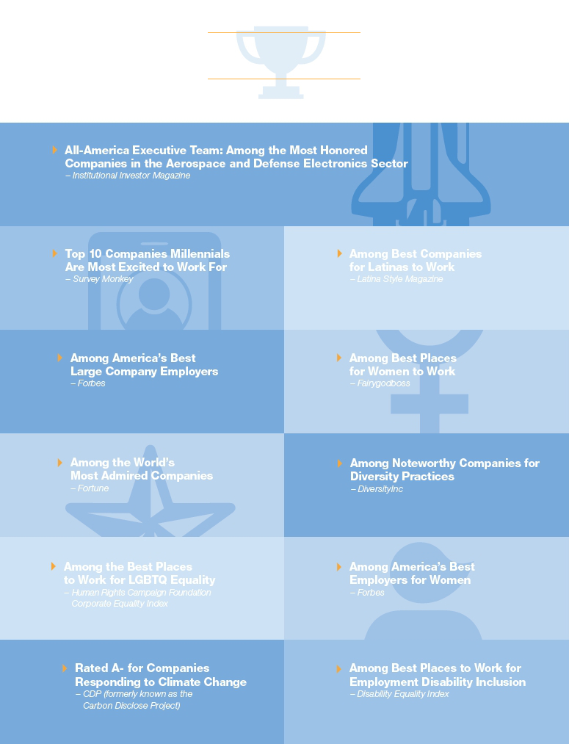

2018 Company Awards

Table of Contents
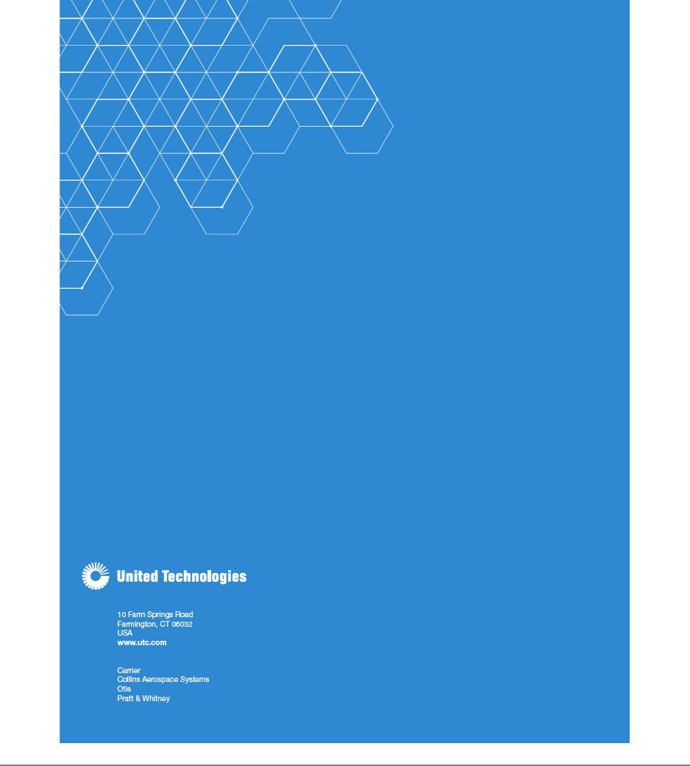

Table of Contents


UNITED TECHNOLOGIES CORPORATION

10 FARM SPRINGS ROAD
FARMINGTON, CT 06032

VOTE BY INTERNET - www.proxyvote.com

Use the Internet to transmit your voting instructions and for electronic delivery of information until 11:59 p.m. Eastern Time on Sunday, April 28, 2019, or until 11:00 a.m. Eastern Time on Thursday, April 25, 2019, for participants in an employee savings plan. Follow the instructions to obtain your records and to create an electronic voting instruction form.

ELECTRONIC DELIVERY OF FUTURE PROXY MATERIALS

If you would like to reduce the costs our Company incurs in mailing proxy materials, you can consent to receive all future proxy statements, proxy cards and annual reports electronically. To sign up for electronic delivery, please follow the instructions above to vote using the Internet and, when prompted, indicate that you agree to receive or access proxy materials electronically in future years.

VOTE BY TELEPHONE - 1-800-690-6903

Use any touch-tone telephone to transmit your voting instructions until 11:59 p.m. Eastern Time on Sunday, April 28, 2019, or the earlier cut-off date and time mentioned above for participants in an employee savings plan. Have your proxy card in hand when you call and then follow the instructions.

VOTE BY MAIL

Mark, sign and date your proxy card and return it in the postage-paid envelope we provided or return it in your own envelope by mailing it to: Vote Processing, c/o Broadridge, 51 Mercedes Way, Edgewood, NY 11717.

TO VOTE, MARK BLOCKS BELOW IN BLUE OR BLACK INK AS FOLLOWS: E55411-P16496-Z73745 KEEP THIS PORTION FOR YOUR RECORDS DETACH AND RETURN THIS PORTION ONLY
THIS PROXY CARD IS VALID ONLY WHEN SIGNED AND DATED.


UNITED TECHNOLOGIES CORPORATION
The Board of Directors recommends a vote FOR
each of the following director nominees: |  |  |  | For | Against | Abstain
1.Election of Directors |  |  |  | For | Against | Abstain
1a. | Lloyd J. Austin III |  |  | ☐ | ☐ | ☐
1b. | Diane M. Bryant |  |  | ☐ | ☐ | ☐
1c. | John V. Faraci |  |  | ☐ | ☐ | ☐
1d. | Jean-Pierre Garnier |  |  | ☐ | ☐ | ☐
1e. | Gregory J. Hayes |  |  | ☐ | ☐ | ☐
1f. | Christopher J. Kearney |  |  | ☐ | ☐ | ☐
1g. | Ellen J. Kullman |  |  | ☐ | ☐ | ☐
1h. | Marshall O. Larsen |  |  | ☐ | ☐ | ☐
1i. | Harold W. McGraw III |  |  | ☐ | ☐ | ☐
1j. | Margaret L. O’Sullivan |  |  | ☐ | ☐ | ☐
1k. | Denise L. Ramos |  |  | ☐ | ☐ | ☐
1l. | Fredric G. Reynolds |  |  | ☐ | ☐ | ☐
1m. | Brian C. Rogers |  |  | ☐ | ☐ | ☐

The Board of Directors recommends a vote FOR the following proposals:

- Advisory Vote to Approve Executive Compensation.

- Appoint PricewaterhouseCoopers LLP to Serve as Independent Auditor for 2019.

- Approve an Amendment to the Restated Certificate of Incorporation to Eliminate Supermajority Voting for Certain Business Combinations.

- Ratify the 15% Special Meeting Ownership Threshold in the Company's Bylaws.

For address changes, please check this box and write them on the back where indicated.

For Against Abstain

☐ ☐ ☐

☐ ☐ ☐

☐ ☐ ☐

☐ ☐ ☐

☐

Please sign exactly as your name(s) appear(s) hereon. When signing as attorney, executor, administrator or other fiduciary, please give full title as such. Joint owners should each sign personally. All holders must sign. If a corporation or partnership, please sign in full corporate or partnership name by authorized officer.

Signature [PLEASE SIGN WITHIN BOX Date Signature (Joint Owners) Dale

Table of Contents

Annual Meeting of Shareowners of United Technologies Corporation

Monday, April 29, 2019, 8:00 a.m. Eastern Time

UTC Center for Intelligent Buildings

13995 Pasteur Boulevard
Palm Beach Gardens, Florida 33418

The purpose of the meeting is to consider the following matters:

- Election of the Thirteen Director Nominees listed in the Proxy Statement

- Advisory Vote to Approve Executive Compensation

- Appoint PricewaterhouseCoopers LLP to Serve as Independent Auditor for 2019

- Approve an Amendment to the Restated Certificate of Incorporation to Eliminate Supermajority Voting for Certain Business Combinations

- Ratify the 15% Special Meeting Ownership Threshold in the Company's Bylaws

- Other business, if properly presented

TICKET REQUESTS: We ask that shareowners request a ticket in advance to attend. Seating at the Annual Meeting is limited and requests for tickets will be processed in the order in which they are received. Please email your request to corpsec@corphq.utc.com or write to the UTC Corporate Secretary, 10 Farm Springs Road, Farmington, CT 06032.

Important Notice Regarding the Availability of Proxy Materials for the Annual Meeting:

The Notice of 2019 Annual Meeting of Shareowners and Proxy Statement, and the 2018 Annual Report are available at:
www.proxyvote.com.

E55412-P16496-Z73745


PROXY

This Proxy is Solicited on Behalf of the Board of Directors of United Technologies Corporation.

The undersigned hereby appoints John V. Faraci, Jean-Pierre Garnier and Ellen J. Kullman, and each of them, each with power of substitution and revocation, as proxies for the undersigned to act and vote at the Annual Meeting of Shareowners of United Technologies Corporation to be held on April 29, 2019, and at any postponed or reconvened meeting, as directed on this Proxy Card, upon the matters set forth on the reverse side hereof, all as described in the Proxy Statement and, in their discretion, upon any other business that may properly come before said meeting, including an adjournment. If this Proxy Card is properly signed and returned, but does not (other than for shares held by the trustees under the employee savings plans) provide voting instructions, then the votes represented by this Proxy Card will be voted FOR the election of the director nominees and FOR Proposals 2, 3, 4 and 5.

This Proxy Card also constitutes voting instructions to the trustees under employee savings plans to vote, in person or by proxy, the proportionate interest of the undersigned in the shares of UTC Common Stock held by the trustees under any such plan(s) as described in the Proxy Statement. Such voting instructions, whether received by telephone, the Internet or as indicated by you on this card, must be received by 11:00 a.m. Eastern Time on Thursday, April 25, 2019. To the extent permitted and as described in the Proxy Statement, the trustee will vote your uninstructed proportionate interest in plan shares if voting instructions are not received by that time.

The undersigned hereby revokes all proxies previously given by the undersigned to vote at the Annual Meeting of Shareowners or any adjournment or postponement thereof.

You are encouraged to specify your choices by marking the appropriate boxes (SEE REVERSE SIDE), but you need not mark any boxes if you wish to vote in accordance with the Board of Directors’ recommendations. The proxies designated above cannot vote these shares unless you sign and return this Proxy Card.

Address Changes:

(If you noted any Address Changes above, please mark the corresponding box on the reverse side.)

