Table of Contents
UNITED STATES
SECURITIES AND EXCHANGE COMMISSION
Washington, D.C. 20549
SCHEDULE 14A
Proxy Statement Pursuant to Section 14(a) of the
Securities Exchange Act of 1934 (Amendment No. )
☑ | Filed by the Registrant | ☐ | Filed by a party other than the Registrant

CHECK THE APPROPRIATE BOX:
☐ |  | Preliminary Proxy Statement
☐ |  | Confidential, for Use of the Commission Only (as permitted by Rule 14a-6(e)(2))
☑ |  | Definitive Proxy Statement
☐ |  | Definitive Additional Materials
☐ |  | Soliciting Material under §240.14a-12

RTX Corporation
(Name of Registrant as Specified In Its Charter)
(Name of Person(s) Filing Proxy Statement, if other than the Registrant)
PAYMENT OF FILING FEE (CHECK ALL BOXES THAT APPLY):
☑ |  | No fee required
☐ |  | Fee paid previously with preliminary materials
☐ |  | Fee computed on table in exhibit required by Item 25(b) per Exchange Act Rules 14a-6(i)(1) and 0-11

Table of Contents
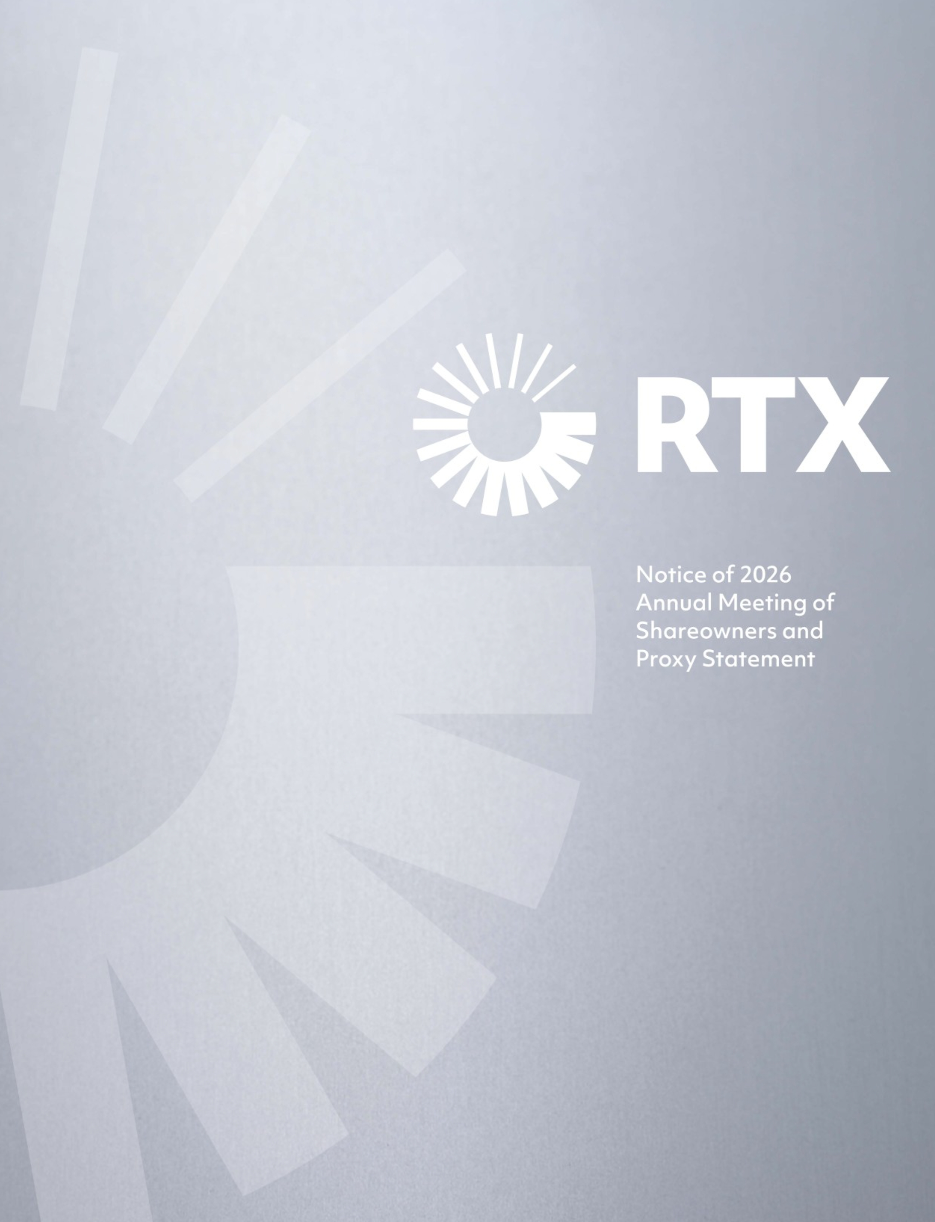

Table of Contents


Our Values

At RTX, we hold ourselves to the highest standard and live by our values:

 | Safety
 | We prioritize safety in every aspect of our work
 | Trust
 | We act with integrity and do the right thing
 | Respect
 | We embrace diverse perspectives and treat others the way they want to be treated
 | Accountability
 | We honor our commitments, expect excellence and take pride in our work
 | Collaboration
 | We share insights, learn together and perform as a team
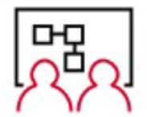 | Innovation
 | We experiment, design, build and transform with speed and agility

These values drive our actions, behaviors and performance with a vision for a safer, more connected world

Table of Contents

March 9, 2026

Notice of 2026 Annual
Meeting of Shareowners

RTX 2026 PROXY STATEMENT i
PLACE
Our 2026 Annual Meeting will be held in a virtual-only format at:
www.virtualshareholdermeeting.com/RTX2026
DATE AND TIME
April 30, 2026
8:00 a.m. Eastern time
Your vote is very important. Please submit your proxy card or voting instruction form as soon as possible.

Who may vote

If you owned shares of RTX Common Stock at the close of business on March 3, 2026, the record date for the 2026 Annual Meeting, you are entitled to receive this Notice of the 2026 Annual Meeting and to vote at the meeting, either during the virtual meeting or by proxy.

How to attend

To be admitted to the 2026 Annual Meeting via the website, enter the 16-digit voting control number found on your proxy card, voting instruction form, notice of internet availability of proxy materials or email notification. You can find detailed instructions on pages 90-92 of this Proxy Statement.

Please review this Proxy Statement and vote in one of the four ways shown to the right under “Voting Methods Available to You.”

By Order of the Board of Directors.

Edward G. Perrault
Senior Vice President & Secretary

AGENDA
1 | Election of the Ten Director Nominees Listed in this Proxy Statement
2 | Advisory Vote to Approve Executive Compensation
3 | Appointment of PricewaterhouseCoopers LLP to Serve as Independent Auditor for 2026
VOTING METHODS AVAILABLE TO YOU
 | Internet  Visit the website shown on your proxy card, voting instruction form or electronic communications.
 | Telephone  Call the number shown on your proxy card, voting instruction form or electronic communications.
 | Mail  Sign, date and return your proxy card or voting instruction form in the enclosed envelope.
 | During the Meeting  Attend the 2026 Annual Meeting online. See pages 90-92 for instructions.

Table of Contents

Table of Contents

Notice of 2026 Annual Meeting of Shareowners | i
Proxy Summary | 1
CORPORATE GOVERNANCE
Proposal 1  Election of Directors | 11
Nominees | 14
Corporate Governance | 20
Compensation of Directors | 33
Share Ownership | 35
EXECUTIVE COMPENSATION
Proposal 2  Advisory Vote to Approve Executive Compensation | 37
Compensation Discussion and Analysis | 39
Executive Summary | 40
How We Make Pay Decisions and Assess Our Programs | 44
2025 Principal Elements of Compensation | 47
2025 CEO Pay Decisions | 52
2025 Pay Decisions for Other NEOs | 54
Other Compensation Elements | 58
Other Executive Compensation Policies and Practices | 61

Report of the Human Capital & Compensation Committee | 63
Compensation Tables | 64
CEO Pay Ratio | 78
Pay versus Performance | 80
AUDIT
Audit Committee Report | 87
Proposal 3  Appointment of PricewaterhouseCoopers LLP to Serve as Independent Auditor for 2026 | 88
OTHER SHAREOWNER INFORMATION
Frequently Asked Questions About the Annual Meeting | 90
Other Important Information | 96
APPENDICES
Appendix A: Reconciliation of GAAP Measures to Corresponding Non-GAAP Measures | 99
Appendix B: Performance Metrics Used in Incentive Compensation Plans | 102

Important Notice Regarding the Availability of Proxy Materials for the Annual Meeting of Shareowners to be held on April 30, 2026. This Notice of the 2026 Annual Meeting of Shareowners and Proxy Statement, as well as RTX’s 2025 Annual Report, are available free of charge at www.proxyvote.com or at www.rtx.com/proxy. References in either document to our website are for the convenience of readers, and information available at or through our website is not a part of, nor is it incorporated by reference in, the Proxy Statement or Annual Report.

The Board of Directors of RTX Corporation (“RTX” or the “Company”) is soliciting proxies to be voted at our 2026 Annual Meeting of Shareowners to be held on April 30, 2026, and at any postponed or reconvened meeting. We expect that the proxy materials or a notice of internet availability will be mailed and made available to shareowners beginning on or about March 9, 2026. At the meeting, votes will be taken on the matters listed in the Notice of 2026 Annual Meeting of Shareowners.
ii RTX 2026 PROXY STATEMENT

Table of Contents
Proxy Summary
This section highlights selected information in this Proxy Statement. Please review the entire Proxy Statement and our 2025 Annual Report before voting your shares.

Annual Meeting Agenda

 |  |  | Board recommendation |  | Page numbers
Proposal 1: | Election of Directors |  | FOR each director nominee |  | 11-19
Proposal 2: | Advisory Vote to Approve Executive Compensation |  | FOR |  | 37-38
Proposal 3: | Appointment of PricewaterhouseCoopers LLP to Serve as Independent Auditor for 2026 |  | FOR |  | 88-89

2025 Performance Highlights

In 2025, we continued to build momentum across RTX, executing on our strategic priorities to support record demand in both the aerospace and defense markets, delivering on the needs of our customers and investing in manufacturing expansion and innovative technologies for the future.

Our operational excellence and disciplined execution drove strong financial results in 2025, with robust top- and bottom-line growth across all three of our industry-leading business units—Collins Aerospace, Pratt & Whitney and Raytheon. This performance was enabled through the continued maturity of our CORE operating system, which promotes consistent execution and operational productivity.

In 2025, we achieved more than $138 billion in new bookings, increasing our year-over-year backlog by 23% to $268 billion. We exceeded the adjusted net sales, free cash flow (“FCF”) and adjusted earnings per share (“EPS”) goals we communicated to investors for the year and saw adjusted segment margin expansion and organic sales growth from each of our business units. We achieved $10.6 billion in cash flow from operating activities and $7.9 billion in FCF during the year.(1)

2025 AT A GLANCE
1.56 |  | 7.9% increase |  | $161 billion |  | $107 billion
book-to-bill ratio |  | in dividend per share(2) |  | commercial aerospace  backlog at year-end |  | defense backlog  at year-end
61% |  | $3.6 billion |  | 89th consecutive year
total shareowner return |  | returned to investors |  | paying a dividend to our shareowners

(1) | Adjusted net sales, FCF, adjusted EPS, adjusted segment margin and organic sales are non-GAAP financial measures. See Appendix A on pages 99-101 for more information.
(2) | In the second quarter of 2025, we increased our quarterly dividend from $0.63 per share to $0.68 per share.
RTX 2026 PROXY STATEMENT 1

Table of Contents
PROXY SUMMARY
2025 PERFORMANCE HIGHLIGHTS

We faced ongoing supplier challenges and tariff-related pressures in 2025, but mitigated these headwinds through focused delivery on our customer commitments, cost discipline and increased enterprise-wide productivity. At the same time, we increased our dividend per share during the year by 7.9% and ended the year with a 61% total shareowner return (“TSR”), outpacing the S&P 500 Index’s 18% TSR.

2025 FINANCIAL PERFORMANCE

The strength of our people and the breadth of our business enabled us to deliver strong financial results in 2025.

DILUTED EARNINGS PER SHARE  ($ per share) |  | CASH FLOW  (in billions)
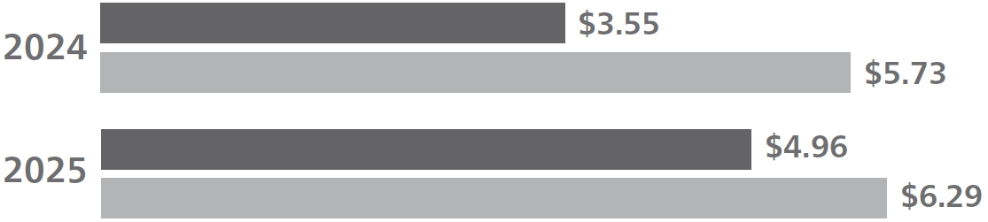 |  | 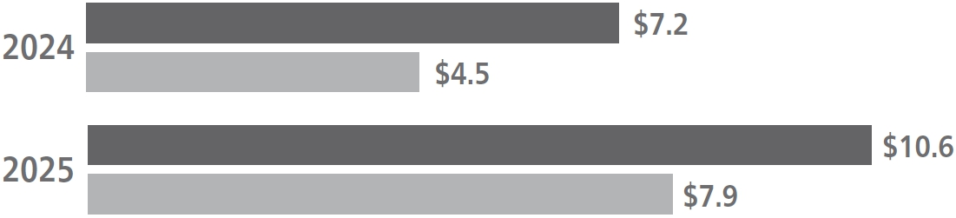
NET INCOME  (in billions) |  | NET SALES  (in billions)
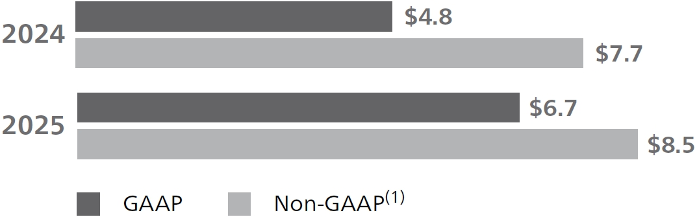 |  | 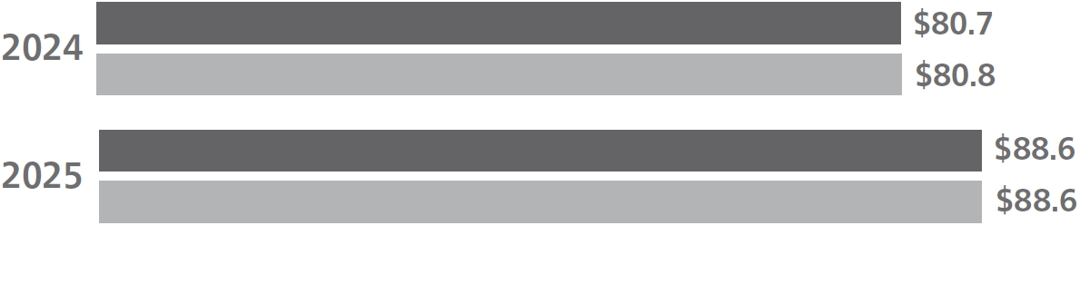

(1) | Adjusted EPS, FCF, adjusted net income and adjusted net sales are non-GAAP financial measures. See Appendix A on pages 99-101 for more information.

With record backlog, durable demand and momentum across all three of our businesses,
RTX remains well positioned to drive long-term growth in organic sales, earnings and free
cash flow—creating sustainable value for our shareowners
2 RTX 2026 PROXY STATEMENT

Table of Contents
PROXY SUMMARY
2025 PERFORMANCE HIGHLIGHTS

PROGRESS ON OUR KEY STRATEGIC PRIORITIES

2025 was defined by execution of our key strategic priorities, positioning RTX for sustained long-term value creation.

Executing on our customer commitments

With our record $268 billion backlog, demand for our products and services continued to shape our operating environment in 2025. To support this growth, we invested over $2.6 billion in capital expenditures, which included expanding our manufacturing capacity and delivering measurable efficiency gains across our portfolio. For example:

● | Site capacity at Raytheon’s Redstone Missile Integration Facility in Huntsville, Alabama, increased by 50%.
● | Raytheon designed, developed and tested a new ground-launched demonstrator StormBreaker variant in 50 days, delivering critical new technologies to our customers.
● | Collins Aerospace increased production rates across commercial platforms.
● | PW1100G-JM engine Maintenance, Repair & Overall (“MRO”) output saw 26% improvement year-over year.
● | Raytheon significantly increased output on Patriot GEM-T and Coyote effectors, and doubled year-over-year production of the Advanced Medium-Range Air-to-Air Missile (“AMRAAM”).

Innovating for future growth

We strive to shape the future of flight and to solve our customer’s toughest problems through continuous innovation and transformative technologies. To rise to this challenge in 2025, we deployed $7.7 billion in Company- and customer-funded research and development, and successfully achieved significant technical milestones and substantive advancements across our portfolio. Examples include:

● | Transitioning the Lower Tier Air and Missile Defense Sensor (“LTAMDS”) program from prototype to production within five years.
● | Increasing investment in Pratt & Whitney’s hybrid-electric propulsion technologies, which were selected by the European Union’s Clean Aviation program for the design and integration of a hybrid-electric propulsion demonstrator for regional aircraft. The system, which integrates a 250-kilowatt electric motor and advanced propeller technology from Collins Aerospace, is targeting 20% fuel efficiency gains.
● | Achieving Federal Aviation Administration (“FAA”) and European Aviation Safety Agency (“EASA”) engine certification for the Geared Turbofan (“GTF”) Advantage engine.
● | Partnering with non-traditional aerospace & defense (“A&D”) companies to integrate Artificial Intelligence “AI”-based capabilities into select products.

Leveraging our breadth and scale

We remain focused on strategically leveraging the breadth and scale of our business segments to drive superior performance. To this end, we continue to implement programs aimed at increasing enterprise-wide productivity, optimizing our cost structure and fostering deeper organizational collaboration to sustain long-term value creation. More specifically:

● | Through our investments in an integrated digital infrastructure, which includes connected systems, factories and products, we are converting asset data into actionable intelligence that enables more agile strategic decision-making and drives significant operational efficiencies and sustained innovation.
● | Through continued centralization of our supply chain sourcing practices, we contained net product inflation to outperform financial expectations and achieve net product savings.
● | We expanded both commercial and defense manufacturing capacity.
● | We continued to implement our proprietary data analytics and AI platform that connects our enterprise systems, manufacturing facilities and product data to enable more efficient operations and smarter decision-making.
RTX 2026 PROXY STATEMENT 3

Table of Contents
PROXY SUMMARY
EXECUTIVE COMPENSATION OVERVIEW

Executive Compensation Overview

HOW WE ALIGN PAY WITH PERFORMANCE

Our executive compensation program is structured to advance our fundamental objective: aligning our executives’ compensation with the long-term interests of our shareowners.

The primary goal of the Human Capital & Compensation Committee (the “HCC Committee”) is to design programs that reward financial and operating performance and motivate effective strategic leadership—key elements in building sustainable shareowner value. This pay-for-performance philosophy is embedded in our Guiding Principles (see page 42), which underpin the HCC Committee’s approach to program design.

How does our executive compensation program align pay with performance?

● | Performance Metrics. We use metrics that are designed to recognize and reward executive actions and decisions that drive long-term strategy, maximize performance and deliver results for our shareowners and customers.
● | “At-Risk” Compensation. The largest portion of compensation for our Named Executive Officers (“NEOs”) is “at-risk” compensation—annual and long-term incentive (“LTI”) awards that are contingent upon Company performance in our key metrics (see page 5) and our stock price performance.

2025 Pay Decisions
In making annual pay decisions, the HCC Committee focuses primarily on “total direct compensation,” which includes our three principal elements of executive compensation: base salary, annual incentives and LTI. Total direct compensation is set each year to reflect the HCC Committee’s assessment of Company, business unit and individual performance. 2025 total direct compensation for each NEO includes 2025 base salary, 2025 annual incentives paid in the first quarter of 2026 and the LTI grant values approved by the HCC Committee in February 2026, which were based on its assessment of 2025 performance and the competitive market pay for each NEO’s role. The February 2025 LTI award grant date fair values (accounting values at the time of grant) shown in the Summary Compensation Table on page 64 reflect the HCC Committee’s assessment of 2024 performance and the competitive market pay for each NEO’s role at the time of grant. 2025 LTI is, therefore, excluded from 2025 total direct compensation. Total direct compensation, as presented below, also uses year-end salary levels and does not reflect any salary changes that occurred during the year, as the Summary Compensation Table does. For more details on our principal elements of compensation, see pages 47-51, and on total direct compensation, see page 53.

The table below shows 2025 total direct compensation for our NEOs, as described above.

2025 PAY DECISIONS AND PAY MIX

 |  | Base Salary | Annual Incentive | LTI | Base Salary  ($K) |  | Annual Incentive  ($K) |  | LTI  ($K)(1) |  | Total  ($K)
Christopher T. Calio |  |  |  |  | $1,550 |  | $5,100 |  | $21,000 |  | $27,650
Neil G. Mitchill, Jr. |  |  |  |  | $1,100 |  | $2,525 |  | $7,500 |  | $11,125
Philip J. Jasper |  |  |  |  | $835 |  | $1,540 |  | $4,750 |  | $7,125
Shane G. Eddy |  |  |  |  | $840 |  | $1,425 |  | $4,500 |  | $6,765
Troy D. Brunk |  |  |  |  | $790 |  | $1,320 |  | $4,500 |  | $6,610
 |  | “At-Risk”

(1) | Reflects values approved by the HCC Committee for the LTI award granted on February 11, 2026. These values differ from those that will be reported in the Summary Compensation Table in 2027, which will be calculated in accordance with Financial Accounting Standards Board (FASB) Accounting Standards Codification (ASC) Topic 718, Compensation—Stock Compensation.
4 RTX 2026 PROXY STATEMENT

Table of Contents
PROXY SUMMARY
EXECUTIVE COMPENSATION OVERVIEW

2025 Performance Metrics

The HCC Committee believes that the metrics used for our annual and LTI plans are strong indicators of the long-term health of the Company and measure particularly important aspects of Company performance, therefore serving the fundamental objective of our executive compensation program.

Metrics for the Annual Incentive Plan (“AIP”)(1)

Earnings measure the immediate impact of operating decisions on the Company’s annual performance. For our Corporate executives, we use adjusted net income as our RTX-wide earnings metric. For our business units, we use adjusted segment operating income.

Free Cash Flow (“FCF”) measures our ability to generate cash to fund our operations and key business investments—such as funding critical research and development, strategic acquisitions, paying down debt or distributing earnings to our shareowners.

Metrics for Performance Share Units (“PSUs”)(1)

Adjusted Earnings Per Share (“EPS”) measures our ability to create long-term, sustainable earnings that will ultimately drive TSR.

Return on Invested Capital (“ROIC”) measures the efficiency with which we allocate capital resources, considering not just the quantity of earnings but also the quality of earnings and investments that drive sustainable growth.

Relative Total Shareowner Return (“TSR”) measures our ability to return value to our shareowners compared to competing investment opportunities like the S&P 500 Index and our Core A&D Peers(2) and reinforces our program’s pay-for-performance objectives.

(1) | See Appendix B on page 102 for definitions of financial metrics used for AIP and PSU purposes.
(2) | For the 2025 PSUs, Core A&D Peers consist of Airbus, Boeing, GE Aerospace, General Dynamics, Honeywell, L3Harris, Lockheed Martin, Northrop Grumman and Safran.

How 2025 Performance Affected Incentive Payouts

2025 Annual Incentives. The table below shows the RTX-wide goals established by the HCC Committee for AIP purposes, our 2025 performance relative to these goals, and how these results translated into the 2025 RTX performance factor.

Metric(1) |  | Weight |  | Threshold |  | Target |  | Maximum |  | Actual |  | Performance  Factor
RTX Earnings—Adjusted Net Income ($M) |  | 50% |  | $7,090 |  | $8,340 |  | $9,590 |  | $9,115 |  | 162%
RTX Free Cash Flow ($M) |  | 50% |  | $6,065 |  | $7,500 |  | $8,935 |  | $8,448 |  | 166%
2025 RTX Performance Factor |  |  |  |  |  |  |  |  |  |  |  | 164%

2023–2025 PSUs. The table below shows RTX’s performance for each of the four metrics used for the PSUs granted in 2023, which resulted in a PSU vesting factor of 146%.

Metric(2) |  | Weight |  | Threshold |  | Target |  | Maximum |  | Actual |  | Performance  Factor
Adjusted EPS |  | 35% |  | 5.7% |  | 11.6% |  | 15.1% |  | 12.9% |  | 137%
Return on Invested Capital |  | 35% |  | 6.5% |  | 7.5% |  | 8.3% |  | 7.6% |  | 109%
TSR vs. S&P 500 Index Companies |  | 15% |  | 25th percentile |  | 50th percentile |  | 75th percentile |  | 82.7th percentile |  | 200%
TSR vs. Core A&D Peers(3) |  | 15% |  | 25th percentile |  | 50th percentile |  | 75th percentile |  | 77.7th percentile |  | 200%
Final PSU Vesting Factor |  |  |  |  |  |  |  |  |  |  |  | 146%
(1) | AIP financial results for our business units differ from the above table (see page 49 for details). Adjusted net income and free cash flow are financial metrics used solely for AIP purposes and are defined in Appendix B on page 102. These metrics differ from other non-GAAP metrics used and described in Appendix A on pages 99-101.
(2) | See Appendix B on page 102 for a definition of PSU metrics. Adjusted EPS and ROIC metrics are used solely for PSU purposes and differ from other non-GAAP metrics used and described in Appendix A on pages 99-101.
(3) | For the 2023 PSUs, Core A&D Peers consist of Airbus, Boeing, GE Aerospace, General Dynamics, Honeywell, L3Harris, Lockheed Martin, Northrop Grumman and Safran.

RTX 2026 PROXY STATEMENT 5

Table of Contents
PROXY SUMMARY
EXECUTIVE COMPENSATION OVERVIEW

The HCC Committee believes that these final performance factors—164% for Corporate AIP and 146% for the 2023-2025 PSUs—demonstrate that our program is driving strong financial performance and achieving its fundamental objective of aligning executive pay with the interests of our shareowners.

CHANGES IN COMPENSATION DESIGN

The HCC Committee continuously evaluates RTX’s compensation programs and makes enhancements that align with our evolving business and strategic priorities. Based on its evaluation, the HCC Committee approved these changes:

What we changed |  | Why we changed it
COMPENSATION PEER GROUP
We modified our Compensation Peer Group (“CPG”). In 2025, we added Ford, Microsoft and Nvidia and removed 3M and L3Harris Technologies from the CPG. |  | As part of its ongoing process, the HCC Committee regularly reviews each company included in the CPG and the CPG’s overall composition. Since the previous CPG was established in 2020, RTX has grown, while several CPG companies have sold or spun-off portions of their businesses. These 2025 changes were made to ensure the CPG reflects an appropriate composite of companies comparable to RTX in size and complexity, while also keeping our pay programs competitive for the high-technology talent we need in the future.
ANNUAL INCENTIVES
We eliminated the non-financial component of our AIP design (the “Corporate Responsibility Scorecard”), instead allocating 100% of weighting to financial performance.  Beginning in 2025, performance for our Corporate executives is measured 50% on earnings and 50% on free cash flow. For our business unit executives, earnings and free cash flow are measured at both the RTX- and business unit-level—each weighted at 25%. |  | To better align with the Company’s focus on meeting our financial commitments to our investors, the HCC Committee determined that the funding formula for the AIP would be solely based on the financial performance of the Company and our business units.
LONG-TERM INCENTIVES
We increased the weighting of TSR in the 2026 PSUs.  Beginning with the February 2026 grant, PSUs will vest based on RTX’s performance relative to the following metrics and weightings: EPS (30%), ROIC (30%), TSR vs. Core A&D Peers (20%), and TSR vs. S&P 500 Index companies (20%). |  | The HCC Committee determined that increasing the weight of each TSR metric by 5% would more closely align PSU payouts with our shareowner experience.
We refined the composition of our Core A&D Peer group used to measure TSR for our PSUs.  For the 2026 PSU award, Textron replaced Safran in our Core A&D Peer group, while all other existing peers remained the same. |  | The HCC Committee concluded that replacing Safran with Textron improves peer group diversification and replaces a non-U.S.-based company with a U.S.-based company that is more likely to operate under similar macroeconomic conditions as RTX.

6 RTX 2026 PROXY STATEMENT

Table of Contents
PROXY SUMMARY
GOVERNANCE AND BOARD OVERVIEW

Governance and Board Overview

BOARD NOMINEES

 |  |  | Skills and Expertise
 |  |  |  |  |  |  |  |  |  |  | 
Tracy A. Atkinson  Retired Executive Vice President & Chief  Administrative Officer, State Street Corporation | 2020 | 1
Christopher T. Calio  Chairman, President & Chief Executive Officer,  RTX Corporation | 2023 | 0
Leanne G. Caret  Retired Executive Vice President, The Boeing Company  and Former CEO, Boeing Defense, Space & Security | 2023 | 1
Bernard A. Harris, Jr.  Chief Executive Officer and Managing Partner,  Vesalius Ventures, Inc. | 2021 | 2
George R. Oliver  Retired Chairman & Chief Executive Officer,  Johnson Controls International plc | 2020 | 1
Ellen M. Pawlikowski  General, U.S. Air Force (Retired) and  Former Commander, Air Force Materiel Command | 2020 | 1
Denise L. Ramos  Retired Chief Executive Officer & President,  ITT Inc. | 2018 | 1
Fredric G. Reynolds  Retired Executive Vice President &  Chief Financial Officer, CBS Corporation | 2016 | 1
Brian C. Rogers  Retired Chairman,  T. Rowe Price Group, Inc. | 2016 | 1
Robert O. Work  Retired Deputy Secretary of Defense,  U.S. Department of Defense | 2020 | 0

RTX 2026 PROXY STATEMENT 7

Table of Contents
PROXY SUMMARY
GOVERNANCE AND BOARD OVERVIEW

NOMINEE HIGHLIGHTS

The nominees for election at the Annual Meeting have a broad range of skills, expertise, attributes and experiences. This enables them to bring a diversity of perspectives to the boardroom, to make substantial contributions to Board deliberations and to provide effective oversight of the Company’s strategy and business plans.

Current or Former CEOs

STEM Degrees

Other Public Company Board Experience

Experience

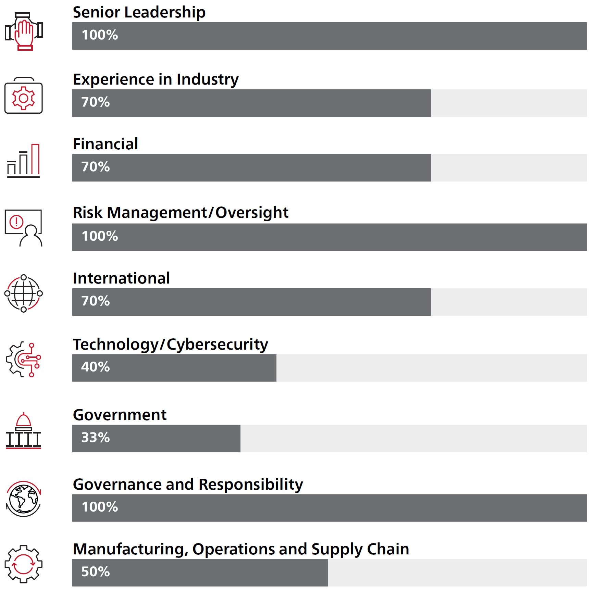

8 RTX 2026 PROXY STATEMENT

Table of Contents
PROXY SUMMARY
GOVERNANCE AND BOARD OVERVIEW

TENURE ON RTX BOARD  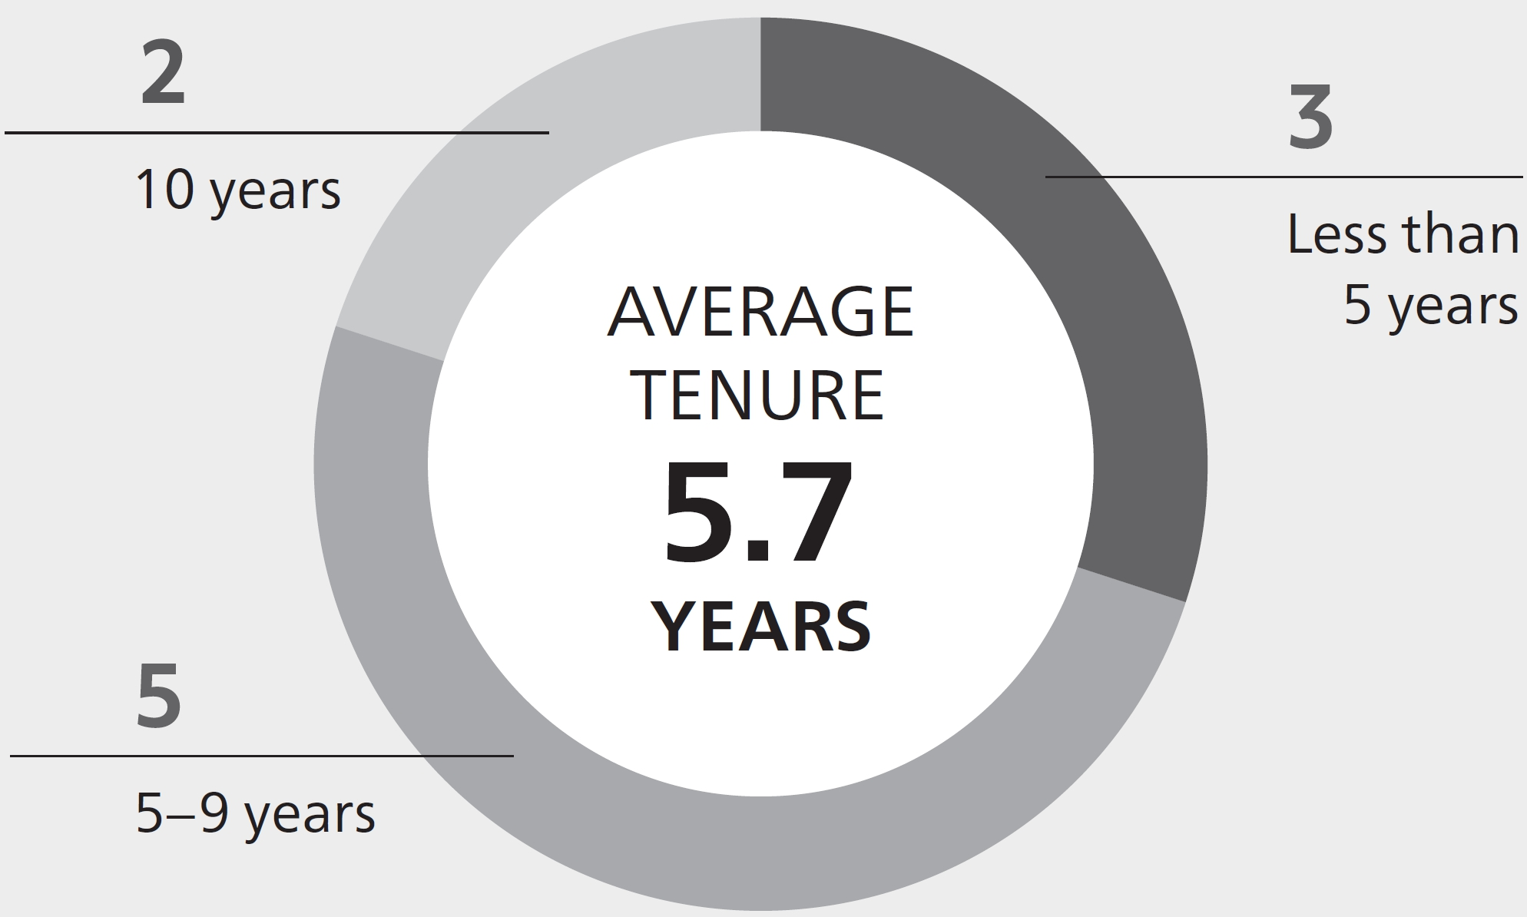 | AGE OF NOMINEES  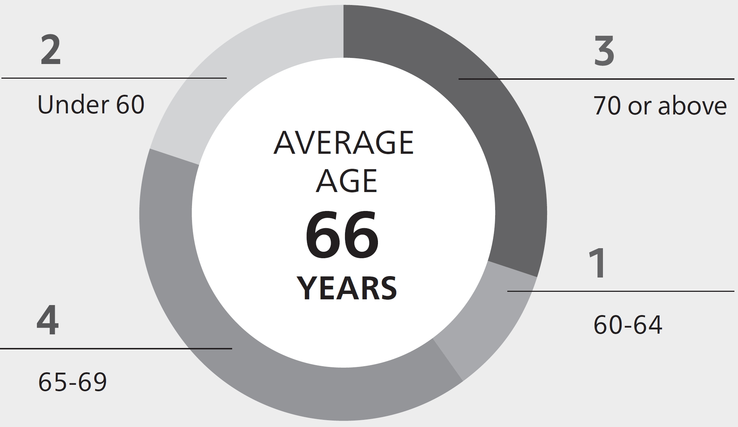

BOARD ENGAGEMENT IN 2025

Our Board worked closely with management in 2025 to provide robust oversight of RTX’s strategic priorities (such as our investments in technology and our initiatives to enhance our enterprise systems) and of the risks and opportunities associated with our efforts to increase production and manage our supply chain.

99% |  | 0
overall attendance by directors at the six Board meetings held during 2025 |  | number of special Board and Committee meetings during 2025
99% |  | 100%
overall attendance by directors at Board and Committee meetings in 2025 |  | overall attendance by directors at the 2025 Annual Meeting of Shareowners
Board oversight priorities and actions
• | Reviewing execution of our key business and financial priorities, including our initiatives to increase production and foster supply chain resiliency
• | Assessing our risk management approach, including the risks and opportunities associated with global defense spending, commercial aerospace demand and the cross-border regulatory environment
• | Strategic review of capital deployment, including technological investment, potential acquisitions and divestitures, and return of capital to shareowners
• | Enhancing our enterprise systems, including through reviews of our safety and quality programs, cybersecurity reviews and incident response briefings
• | Our response to evolving geopolitical and other external conditions, including tariffs and counter-tariffs and other governmental measures
• | Evaluating Board and Committee composition and leadership, as well as planning for anticipated Board refreshment and reviewing our senior management succession strategy

RTX 2026 PROXY STATEMENT 9

Table of Contents
PROXY SUMMARY
GOVERNANCE AND BOARD OVERVIEW

STRENGTHENING DIRECTOR OVERSIGHT

Essential to each director’s ability to provide robust and effective oversight is a deep understanding of our businesses, our strategic focus and the significant risks we may encounter, as well as an ongoing awareness of new developments and emerging risks that may arise during their Board service.

Below are some of the ways in which our directors are able to gain such understanding and awareness.

Independent Lead Director Role  Our Independent Lead Director plays a crucial role in facilitating the Board’s independent oversight. The Independent Lead Director regularly communicates with other directors, both in executive sessions and outside of Board meetings, to solicit feedback on Board matters, succession planning and management development, among other topics. The Independent Lead Director also collaborates with the Chairman & CEO on meeting agendas and communicates with the Chairman & CEO and other directors on developments in the Company’s business, emerging risks and issues, and Board operational and governance matters. |  | Employee Engagement and Site Visits  As part of their continuing education, our directors participate in employee engagement events and the Board visits at least one of our businesses each year. In 2025 the Board visited Raytheon’s facilities in Andover, Massachusetts, which include Raytheon’s Patriot Lower Tier Air and Missile Defense Sensor production, and Collins Aerospace’s facilities in Rockford, Illinois, home to the Collins Aerospace electrical systems business. Site visits and other employee engagement events give directors a firsthand understanding of the operations of the business and the opportunity to interact with employees and key executives.
Strategy and Business Plan Reviews  The Board regularly holds meetings with senior management to review the strategy and long-range plans for each of our businesses and to discuss other topics, such as key areas of focus and significant emerging risks. We also regularly engage in a rigorous portfolio review process to identify opportunities to optimize our portfolio, as reflected in 2025 by the divestiture of Collins Aerospace’s actuation and flight control business and the Simmonds Precision Products business. |  | Direct Interaction with Management  Our CEO and other members of senior management communicate with directors outside of regularly scheduled Board and Committee meetings. These communications occur on a regular basis, including through periodic written updates, special meetings and informal communications. These written communications and meetings occur more frequently in some circumstances.
Outside Perspectives  The Board is periodically briefed by outside advisors and counsel on strategic, financial, legal, compliance and other matters. This gives directors additional perspectives on the Company’s business environment, strategic focus areas, performance and significant emerging risks. The Independent Lead Director and other directors also directly engage with investors to address their feedback from time to time. |  | Continuing Education  Directors participate in individualized sessions to continue learning the roles and responsibilities of the Board and the Committees on which they serve. They also continue to learn about the Company’s strategy, businesses, technologies, compliance programs, corporate affairs and community relations, financial statements, and significant financial, accounting and risk management matters. Outside continuing education programs are made available to directors at the Company’s expense.

10 RTX 2026 PROXY STATEMENT

Table of Contents
Proposal 1:
Election of Directors

What  am I  voting on? | We are seeking your support for the election of the ten individuals nominated to serve on the Board of Directors until the 2027 Annual Meeting of Shareowners. We believe these nominees have the right experiences and perspectives to guide the Company and provide effective oversight of our strategy and our business plans. Each is well qualified to serve as a director of a large aerospace and defense company that competes in government and commercial markets worldwide.

Criteria for Board Membership

The Board and the Committee on Governance and Public Policy (the “Governance Committee”) believe that there are general attributes all directors must exhibit, in addition to key skills and expertise that should be represented on the Board as a whole, but not necessarily by each director.

THESE GENERAL ATTRIBUTES ARE ESSENTIAL FOR ALL DIRECTORS

● | Objectivity and independence in making informed business decisions
● | Extensive knowledge, experience and judgment
● | Highest integrity
● | Diversity of perspective
● | Willingness to devote the extensive time necessary to fulfill a director’s duties
● | Appreciation for the role of a corporation in society
● | Loyalty to the interests of RTX and its shareowners

The Governance Committee regularly considers whether the Board has all of the key skills and expertise needed for effective oversight of our businesses and strategy.

Further, the Governance Committee recognizes the value of selecting directors with diverse experiences to ensure that the Board as a whole has a wealth of perspectives to inform its decisions. We believe diversity in lived experiences, skills and capabilities makes our business stronger and more innovative and is critical to the Company’s long-term success.
RTX 2026 PROXY STATEMENT 11

Table of Contents
PROPOSAL 1: ELECTION OF DIRECTORS
CRITERIA FOR BOARD MEMBERSHIP

The charts below show the percentage of directors with skills and expertise in each key area. In the nominee biographies on pages 14-19, we highlight for each individual the three key skills and areas of expertise upon which the Board particularly relies.

KEY SKILLS AND EXPERTISE

 |  |  | 
 | Senior Leadership |  |  | Technology/Cybersecurity
 | Directors who have extensive leadership experience with a complex, large enterprise offer practical perspectives on and oversight of organizational and strategic planning, including in the areas of talent development, succession planning and driving change and long-term growth. |  |  | Directors with a background or experience in research and development, engineering, science, information technology, software, artificial intelligence, cybersecurity or other technology offer valuable perspectives on the development of advanced technologies and solutions, and serve a critical role in the Board’s oversight of cybersecurity risks.
 |  |  | 
 | Experience in Industry |  |  | Government
 | Directors with experience in the aerospace and defense markets, whether through leadership of a business engaged in those markets or as a government or military customer, provide valuable insights on industry developments and strong oversight of RTX’s strategic priorities and business performance. |  |  | Directors who have served in senior government or military roles provide constructive insights about significant government policies and regulations, as well as public policy issues, and their impact on the Company.
 |  |  | 
 | Financial |  |  | Governance and Responsibility
 | Directors with proficiency in complex financial management, financial reporting processes, capital allocation, capital markets and mergers and acquisitions provide strong oversight of the Company’s financial reporting, financial controls, capital deployment and strategic investments. |  |  | Directors with experience in product safety, ethics and compliance, sustainability, social responsibility and public company governance (including service on a public company board), strengthen the Board’s oversight of key governance initiatives, reporting and risks.
 |  |  | 
 | Risk Management/Oversight |  |  | Manufacturing, Operations and Supply Chain
 | Directors with knowledge and experience in managing major risk exposure for complex, large organizations—including significant financial, operational, compliance, reputational, strategic, international, political and cybersecurity risks—are critical to the Board’s important risk oversight role. |  |  | Directors who have led organizations with or otherwise managed manufacturing capabilities, operations and supply chains provide valuable insights on these aspects of our business, which are key to our focus on execution, operational efficiencies and cost reductions.

 | International
 | Directors who have conducted business or operations outside of the United States or worked on international policy and related issues provide perspectives and insights on international business, politics and culture that are invaluable to a global company with operations and sales around the world.
12 RTX 2026 PROXY STATEMENT

Table of Contents
PROPOSAL 1: ELECTION OF DIRECTORS
BOARD COMPOSITION AND REFRESHMENT

Board Composition and Refreshment

The Board strives to maintain an appropriate balance of tenure, viewpoints and experiences.

The Board’s composition has changed significantly in recent years. Eight directors have left the Board in the past six years. Three directors have joined in the past five years.

The Board will be undertaking a systematic refreshment of its composition during the coming years as directors retire. The Board believes that a balance of both new directors, who bring fresh perspectives, and longer-serving directors, who bring valuable experience and a deep understanding of the Company, helps the Board maintain continuity and stability in its oversight of the Company. The Board also believes that the current directors have the right attributes, experiences and perspectives to provide effective oversight of our strategy and business plans. For more information about the skills and experience of RTX’s directors, see “Nominee Highlights” on page 8.

TENURE OF RTX BOARD NOMINEES
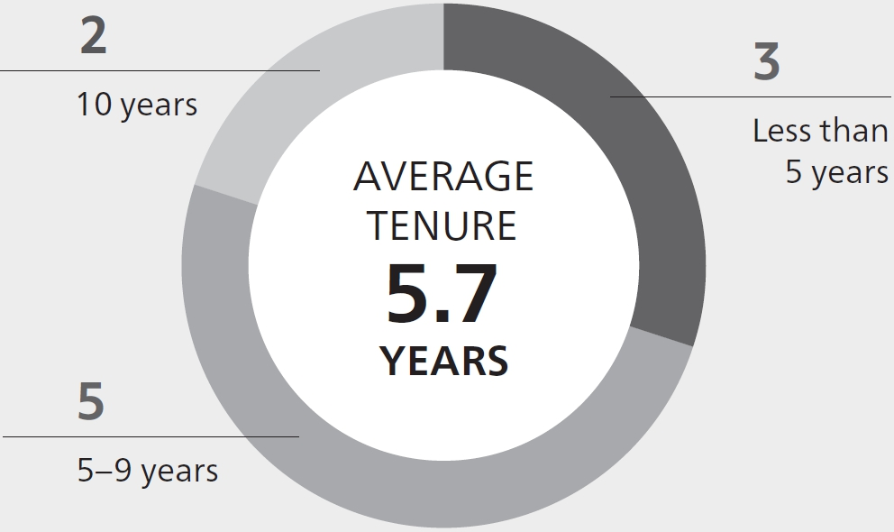

The Board recognizes that director refreshment is important to shareowners and critical for strong Board oversight. The Board will continue to promote refreshment by maintaining a succession strategy and planning for expected retirements, including by:

● | Regularly reviewing the attributes that are most important for directors to have as our business evolves, as well as the mix of capabilities and experience already represented on the Board.
● | Regularly considering individual director tenure and succession, as well as how current directors deploy their skills and expertise in service to the Company.
● | Using its self-evaluation process, including individual director evaluations, to inform its decisions about nominations and refreshment (see page 23 for more detail on the annual self-evaluation process).

Mr. Reynolds, our Independent Lead Director, celebrated his 75th birthday in 2025. Although Board policies normally bar the nomination of a director who has reached age 75, the Board has granted a waiver in this case because it strongly believes that RTX and its shareowners will be best served during the coming year by Mr. Reynolds’ re-election to the role of director and his continued service as Independent Lead Director. With Mr. Calio having assumed the role of Chairman on April 30, 2025, and Mr. Reynolds’ exemplary service and many contributions to Board deliberations, the Board believes that the extensive experience and proven leadership Mr. Reynolds brings to his roles will help the Board maintain continuity in its oversight of our strategy and our key priorities.

How Candidates Are Identified

In furtherance of its focus on director refreshment and Board composition, the Board strives to regularly identify potential director candidates who can bring unique perspectives, add new insights and expertise, and enhance the performance and effectiveness of the Board. The Governance Committee is responsible for identifying and evaluating director candidates to recommend to the Board. Potential directors can be brought to the Governance Committee’s attention in different ways, as shown below. The Governance Committee screens and evaluates all candidates (regardless of who recommends them) using the criteria described under “Criteria for Board Membership” on page 11, with the overall goal of ensuring a breadth and depth of experience on our Board.

The Governance Committee may engage search firms to assist it in finding qualified and interested candidates and verifying their credentials. |  | Any shareowner may recommend a director candidate by writing to the RTX Corporate Secretary (see page 95 for contact information). |  | Current Board members who become aware of suitable candidates may recommend them to the Governance Committee from time to time.
RTX 2026 PROXY STATEMENT 13

Table of Contents
PROPOSAL 1: ELECTION OF DIRECTORS
NOMINEES

Nominees

The Board, upon the recommendation of the Governance Committee, has nominated for election the ten individuals listed in this Proxy Statement. All are current directors of RTX.

 | The Board of Directors unanimously recommends a vote FOR each of the following nominees:

Tracy A. Atkinson

INDEPENDENT DIRECTOR  Retired Executive Vice President & Chief Administrative Officer, State Street Corporation |  | AGE 61  DIRECTOR SINCE 2020  BOARD COMMITTEES  Human Capital & Compensation (Chair), Finance
Key Skills and Expertise

 | FINANCIAL |  | SENIOR LEADERSHIP |  | RISK MANAGEMENT/OVERSIGHT



14 RTX 2026 PROXY STATEMENT
Qualifications

Ms. Atkinson provides the Board with significant experience in finance, risk management and compliance matters, as well as executive leadership experience developed through her senior finance and compliance leadership roles at State Street and MFS Investment Management. She also brings valuable accounting expertise derived from her experience as a Certified Public Accountant and a partner at PricewaterhouseCoopers LLP.

Experience

● | Chief Administrative Officer, State Street Corporation (financial services firm), 2019–2020
● | Executive Vice President & Chief Compliance Officer, State Street Corporation, 2017–2019
● | Executive Vice President, Finance, State Street Corporation, 2010–2017
● | Treasurer, State Street Corporation, 2016–2017

● | Executive Vice President, Chief Compliance Officer, State Street Corporation, 2009–2010
● | Executive Vice President, Chief Compliance Officer, State Street Global Advisors, 2008–2009
● | Senior positions with MFS Investment Management and PricewaterhouseCoopers LLP, 1999–2008

Other Current Directorships

● | Citizens Financial Group, Inc., since 2024

Former Public Company Directorships

● | United States Steel Corporation, 2020–2025
● | Affiliated Managers Group, 2020–2024
● | Raytheon Company, 2014–2020

Other Leadership Experience and Service

● | Director and Past President, The Arc of Massachusetts

Table of Contents
PROPOSAL 1: ELECTION OF DIRECTORS
NOMINEES

Christopher T. Calio

Chairman, President, Chief Executive Officer and Director, RTX Corporation |  | AGE 52  DIRECTOR SINCE 2023  BOARD COMMITTEES  Finance, Special Activities
Key Skills and Expertise

 | EXPERIENCE IN INDUSTRY |  | RISK MANAGEMENT/OVERSIGHT |  | SENIOR LEADERSHIP



Qualifications

Mr. Calio has substantial experience in the aerospace and defense industry and executive leadership experience gained through his Chairman, President, CEO and COO roles at RTX and other senior leadership roles at RTX and Pratt & Whitney. Through these roles and his legal roles at RTX-affiliated companies, he also brings risk management experience, as well as a significant background in manufacturing, operations and supply chain.

Experience

● | Chairman, President, Chief Executive Officer and Director, RTX Corporation, since April 2025
● | President, Chief Executive Officer and Director, RTX Corporation, May 2024–April 2025
● | President, Chief Operating Officer and Director, RTX Corporation, December 2023–May 2024
● | President & Chief Operating Officer, RTX Corporation, March 2023–December 2023

● | Chief Operating Officer, Raytheon Technologies Corporation, March 2022–February 2023
● | President, Pratt & Whitney, Raytheon Technologies Corporation (formerly United Technologies Corporation (“UTC”)), January 2020–February 2022
● | President, Commercial Engines, Pratt & Whitney, UTC, February 2017–December 2019
● | Chief of Staff to the Chairman and Chief Executive Officer, UTC, February 2015–January 2017
● | Various senior positions since joining UTC in 2005, including Vice President and General Counsel of UTC Aerospace Systems, and Vice President and Counsel, Commercial Engines, Pratt & Whitney

Other Leadership Experience and Service

● | Vice Chair, Aerospace Industries Association
● | Board of Directors, US-India Strategic Partnership Forum

Leanne G. Caret

INDEPENDENT DIRECTOR  Retired Executive Vice President, The Boeing Company and Former CEO, Boeing Defense, Space and Security |  | AGE 59  DIRECTOR SINCE 2023  BOARD COMMITTEES  Audit (Chair), Special Activities
Key Skills and Expertise

 | FINANCIAL |  | EXPERIENCE IN INDUSTRY |  | MANUFACTURING, OPERATIONS & SUPPLY CHAIN



RTX 2026 PROXY STATEMENT 15
Qualifications

Ms. Caret provides the Board with significant experience in the aerospace and defense industry and finance experience gained through her CEO and CFO roles with Boeing Defense, Space & Security and other senior leadership roles at The Boeing Company. Through these roles she also brings executive leadership experience, as well as a significant background in oversight of risk management and of manufacturing, operations and supply chain.

Experience

● | Executive Vice President and Senior Advisor, The Boeing Company (aerospace and defense systems & services), April 2022–December 2022
● | President & CEO, Defense, Space & Security, The Boeing Company, 2016–2022
● | President, Global Services & Support, The Boeing Company, 2015–2016

● | Chief Financial Officer, Defense, Space & Security, The Boeing Company, 2014–2015
● | Vice President & General Manager, Vertical Lift, The Boeing Company, 2013–2014
● | Vice President, H-47 Programs, The Boeing Company, 2009–2013
● | General Manager, Global Transport & Executive Systems, The Boeing Company, 1998–2009

Other Current Directorships

● | Deere & Company, since 2021

Other Leadership Experience and Service

● | Associate Fellow, American Institute of Aeronautics and Astronautics
● | Fellow, Royal Aeronautical Society

Table of Contents
PROPOSAL 1: ELECTION OF DIRECTORS
NOMINEES

Bernard A. Harris, Jr.

INDEPENDENT DIRECTOR  Chief Executive Officer and Managing Partner, Vesalius Ventures, Inc. |  | AGE 69  DIRECTOR SINCE 2021  BOARD COMMITTEES  Audit, Special Activities
Key Skills and Expertise

 | EXPERIENCE IN INDUSTRY |  | GOVERNANCE & RESPONSIBILITY |  | TECHNOLOGY/CYBERSECURITY

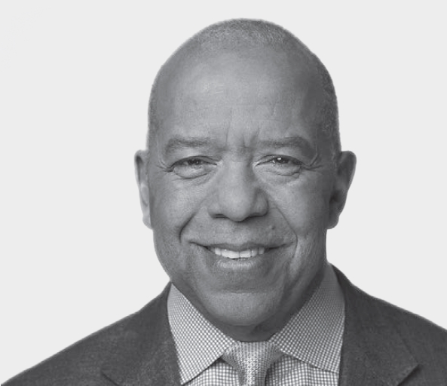

Qualifications

Dr. Harris has significant aerospace industry knowledge, a deep understanding of science and technology, and executive leadership experience gained through his CEO and other senior leadership roles at Vesalius Ventures and the National Math and Science Initiative, his service as Chief Medical Officer of SPACEHAB, and his years as an astronaut and flight surgeon at NASA. He has significant experience in technology innovation and strategic planning. He also brings valuable expertise in guiding organizations to leverage their resources in support of business operations, investment, community development and philanthropic endeavors.

Experience

● | Chief Executive Officer and Managing Partner, Vesalius Ventures (venture capital), since 1998
● | Executive Director, National Math and Science Initiative Inc. (education nonprofit), August 2022–March 2023
● | Chief Executive Officer, National Math and Science Initiative Inc., 2018–2022

● | Vice President, Business Development, Space Media Inc., 1999–2001
● | Vice President, Chief Medical Officer and Scientist, SPACEHAB Inc., 1996–2001
● | Astronaut, NASA, 1991–1996
● | Clinical Scientist & Flight Surgeon, Johnson Space Center, NASA, 1987–1990

Other Current Directorships

● | U.S. Physical Therapy, since 2005
● | Solventum Corporation, since 2024
● | MassMutual (non-public)

Former Public Company Directorships

● | Sterling Bancshares Inc., 2006–2011

Other Leadership Experience and Service

● | Board of Directors, Astronaut Scholarship Foundation
● | Board of Directors, Texas Medical Center
● | The Harris Foundation (founder)

George R. Oliver

INDEPENDENT DIRECTOR  Retired Chairman & Chief Executive Officer, Johnson Controls International plc |  | AGE 65  DIRECTOR SINCE 2020  BOARD COMMITTEES  Human Capital & Compensation, Finance
Key Skills and Expertise

 | INTERNATIONAL |  | SENIOR LEADERSHIP |  | MANUFACTURING, OPERATIONS & SUPPLY CHAIN



16 RTX 2026 PROXY STATEMENT
Qualifications

Mr. Oliver provides the Board with substantial executive leadership experience and global operational and management expertise, gained through his CEO and other leadership roles at the global industrial and technology companies Johnson Controls, Tyco International and General Electric. He also has significant experience in strategic planning, mergers and acquisitions, finance, risk management and technology.

Experience

● | Chairman of the Board & Chief Executive Officer, Johnson Controls International plc (diversified technology and multi-industrial company), 2017–2025
● | President & Chief Operating Officer, Johnson Controls International plc, 2016–2017
● | Chief Executive Officer, Tyco International Ltd., 2012–2016
● | President, Tyco International Ltd., 2011–2012
● | President, Tyco Electrical and Metal Products, 2007–2010

● | President, Tyco Safety Products, 2006–2010
● | Various leadership roles of increasing responsibility at several General Electric divisions, culminating as President of GE Water and Process Technologies, until 2006

Other Current Directorships

● | NVR, Inc., since 2025

Former Public Company Directorships

● | Johnson Controls International plc, 2016–2025
● | Raytheon Company, 2013–2020
● | Tyco International Ltd., 2012–2016

Other Leadership Experience and Service

● | Board of Trustees, Worcester Polytechnic Institute
● | Board of Directors, United Way of Greater Milwaukee & Waukesha Counties

Table of Contents
PROPOSAL 1: ELECTION OF DIRECTORS
NOMINEES

Ellen M. Pawlikowski

INDEPENDENT DIRECTOR  General, U.S. Air Force (Retired) and Former Commander, Air Force Materiel Command |  | AGE 69  DIRECTOR SINCE 2020  BOARD COMMITTEES  Human Capital & Compensation, Special Activities
Key Skills and Expertise

 | GOVERNMENT |  | SENIOR LEADERSHIP |  | EXPERIENCE IN INDUSTRY



Qualifications

General Pawlikowski delivers deep defense industry-specific expertise, senior leadership experience and understanding of leading-edge science and technology through her extensive military service, including as Commander, U.S. Air Force Materiel Command. She provides the Board with important insights regarding military critical mission needs, advanced weapons systems management, and acquisition and national security policy.

Experience

● | Commander, Air Force Materiel Command (military leadership), 2015–2018
● | Various positions of increasing responsibility during a 36-year career in the U.S. Air Force, including Military Deputy for the Assistant Secretary for Acquisition; Commander/Program Executive Officer, Space and Missile Systems Center; Commander, Air Force Research Laboratory; and Deputy Director and Chief Operating Officer, National Reconnaissance Office

Other Current Directorships

● | RPM International Inc., since 2022
● | Applied Research Associates (non-public)
● | SRI International (non-public)
● | CEM Defense Materials (non-public)

Former Public Company Directorships

● | Velo3D, Inc., March 2022–July 2023
● | Intelsat S.A., 2019–February 2022
● | Raytheon Company, 2018–2020

Other Leadership Experience and Service

● | Chair, Honorary Fellows Committee, American Institute of Aeronautics and Astronautics
● | Member, National Academy of Engineering
● | Member, Air Force Studies Board

Denise L. Ramos

INDEPENDENT DIRECTOR  Retired Chief Executive Officer & President, ITT Inc. |  | AGE 69  DIRECTOR SINCE 2018  BOARD COMMITTEES  Audit, Governance and Public Policy
Key Skills and Expertise

 | MANUFACTURING, OPERATIONS & SUPPLY CHAIN |  | SENIOR LEADERSHIP |  | FINANCIAL



RTX 2026 PROXY STATEMENT 17
Qualifications

Ms. Ramos provides the Board with executive leadership and substantial global operational and management experience gained through her CEO and other leadership roles at ITT Inc. She has extensive financial expertise and experience in strategic planning and mergers and acquisitions, having served as the Chief Financial Officer at ITT and other large global companies. She also brings experience and insights from her current and past service on boards of other public companies in a range of industries.

Experience

● | Chief Executive Officer & President, ITT Inc. (formerly ITT Corporation —diversified manufacturer), 2011–2019
● | Senior Vice President & Chief Financial Officer, ITT Corporation, 2007–2011

● | Chief Financial Officer, Furniture Brands International (home furnishings), 2005–2007
● | Senior Vice President & Corporate Treasurer, Yum! Brands, Inc., and Chief Financial Officer, KFC Corporation (U.S. Division), 2000–2005
● | Various finance positions of increasing responsibility during more than 20 years at Atlantic Richfield Company

Other Current Directorships

● | Bank of America Corp., since 2019

Former Public Company Directorships

● | Phillips 66 Company, 2016–2025
● | ITT Inc., 2011–2019
● | Praxair, Inc., 2014–2016

Table of Contents
PROPOSAL 1: ELECTION OF DIRECTORS
NOMINEES

Fredric G. Reynolds

INDEPENDENT LEAD DIRECTOR  Retired Executive Vice President & Chief Financial Officer, CBS Corporation |  | AGE 75  DIRECTOR SINCE 2016  BOARD COMMITTEES  Governance and Public Policy, Human Capital & Compensation
Key Skills and Expertise

 | FINANCIAL |  | RISK MANAGEMENT/OVERSIGHT |  | SENIOR LEADERSHIP



Qualifications

Mr. Reynolds brings to the Board substantial financial and risk management expertise, as well as executive leadership and strategic planning experience gained through his Chief Financial Officer and other leadership roles at large global companies CBS, Viacom and PepsiCo. He also brings his experience and insights from his current and past service on boards of other public companies in a range of industries.

Experience

● | Executive Vice President & Chief Financial Officer, CBS Corporation (media), 2005–2009
● | President & Chief Executive Officer, Viacom Television Stations Group (CBS predecessor), 2001–2005

● | Executive Vice President & Chief Financial Officer, Viacom, Inc., 2000–2001
● | Executive Vice President & Chief Financial Officer, Westinghouse Electric Corporation, 1994–2000
● | Various positions at PepsiCo, Inc., 1982–1994

Other Current Directorships

● | Pinterest, Inc., since 2017

Former Public Company Directorships

● | Mondelez International, Inc., 2007–May 2022
● | AOL, Inc., 2009–2015
● | Hess Corporation, 2013–2019

Brian C. Rogers

INDEPENDENT DIRECTOR  Retired Chairman,  T. Rowe Price Group, Inc. |  | AGE 70  DIRECTOR SINCE 2016  BOARD COMMITTEES  Finance (Chair), Human Capital & Compensation
Key Skills and Expertise

 | FINANCIAL |  | RISK MANAGEMENT/OVERSIGHT |  | SENIOR LEADERSHIP



18 RTX 2026 PROXY STATEMENT
Qualifications

Mr. Rogers provides the Board with extensive financial and investment expertise and risk management experience through his Chief Investment Officer and other investment management roles at T. Rowe Price, as well as significant executive leadership and governance experience gained through his service as the Chairman of the Board of T. Rowe Price. Mr. Rogers also provides the Board with important insights into the perspectives of institutional investors.

Experience

● | Chairman of the Board of Directors, T. Rowe Price Group, Inc. (investment management), 2007–2017
● | Chief Investment Officer, T. Rowe Price Group, Inc., 2004–2017
● | Various other senior leadership roles since joining T. Rowe Price Group, Inc., in 1982

Other Current Directorships

● | Lowe’s Companies, Inc., since 2018

Former Public Company Directorships

● | Chairman of the Board (non-executive), T. Rowe Price Group, Inc., 2017–2019

Other Leadership Experience and Service

● | Trustee, Brookings Institution
● | Trustee, Johns Hopkins Medicine

Table of Contents
PROPOSAL 1: ELECTION OF DIRECTORS
NOMINEES

Robert O. Work

INDEPENDENT DIRECTOR  Retired Deputy Secretary of Defense, U.S. Department of Defense |  | AGE 73  DIRECTOR SINCE 2020  BOARD COMMITTEES  Governance and Public Policy (Chair), Audit, Special Activities
Key Skills and Expertise

 | GOVERNMENT |  | EXPERIENCE IN INDUSTRY |  | GOVERNANCE & RESPONSIBILITY



RTX 2026 PROXY STATEMENT 19
Qualifications

Mr. Work provides the Board with significant insight into customer needs acquired through his command, leadership and management positions, including as a U.S. Marine Corps officer, Undersecretary of the Navy and Deputy Secretary of Defense. He has broad expertise in global security matters, including in the areas of defense strategy, advanced technologies, international studies and acquisition reform. He also brings experience with corporate governance and oversight of governance risks from current and past board service, including his leadership of the Governance Committee.

Experience

● | U.S. Deputy Secretary of Defense (executive department leadership), 2014–2017
● | Chief Executive Officer, Center for a New American Security, 2013–2014
● | Undersecretary of the Navy, U.S. Department of the Navy, 2009–2013
● | Positions with the Center for Strategic and Budgetary Assessments, serving in positions of increasing responsibility from 2002–2009, culminating in service as Vice President for Strategic Studies

● | Various positions of increasing responsibility during a 27-year career in the U.S. Marine Corps, including artillery battery commander; battalion commander; Base Commander, Camp Fuji, Japan; and Senior Aide to the Secretary of the Navy

Other Current Directorships

● | Govini, Chairman (non-public)
● | Black Sea (non-public)
● | Agile Defense (non-public)

Former Public Company Directorships

● | Raytheon Company, 2017–2020

Other Leadership Experience and Service

● | Senior Counselor for Defense, Distinguished Senior Fellow for Defense and National Security, Center for a New American Security
● | Senior Fellow, Johns Hopkins Applied Physics Laboratory
● | Member, International Institute for Strategic Studies

Table of Contents
Corporate Governance

Our Continuing Commitment to Sound Corporate Governance

RTX is committed to strong oversight and governance practices that are grounded in a culture of integrity, accountability, transparency and the highest ethical standards. The Board believes this commitment enhances shareowner value.

GOVERNANCE BEST PRACTICES

Our Board has adopted robust governance practices, set forth in our Corporate Governance Guidelines, our Committee charters and other RTX documents and policies. The Governance Committee regularly monitors and considers current developments in corporate governance, as well as the views of our shareowners, to determine when to recommend governance changes to the Board.

Effective Board oversight |  | Board independence
●  Highly qualified Board with diverse mix of perspectives, experience and tenures  ●  Regular Board review of strategic plans and priorities  ●  Regular Board and Committee review of significant risks, including product safety and cybersecurity risks  ●  Annual Board evaluation of CEO performance  ●  Regular CEO and senior management succession planning |  | ●  9 out of 10 director nominees are independent  ●  Robust Independent Lead Director role, a position of authority with clearly defined responsibilities  ●  Independent directors meet regularly without management  ●  Fully independent Audit, Human Capital & Compensation and Governance Committees  ●  All directors are empowered to suggest additional agenda topics for the Board to consider
Commitment to shareowner rights |  | Board accountability
●  Active and ongoing shareowner engagement  ●  Proxy access with customary terms  ●  Shareowners can act by written consent  ●  15% of voting stock can call special meetings  ●  No charter provisions requiring more than a simple majority vote of shares  ●  Robust clawback policies  ●  No hedging, short sales or pledging of RTX securities by officers or directors  ●  Rigorous share ownership requirements for directors and senior management |  | ●  Annual Board, Committee and individual director evaluations  ●  Annual election of all directors  ●  Majority voting for directors in uncontested elections  ●  Ongoing attention to Board composition and refreshment  ●  No re-nomination of a director who has served for 15 years or reached age 75, unless waived by the Board  ●  Regular review of Committee assignments and leadership; objective to rotate chairs, members at least every five years  ●  Limits on outside public company board service  ●  Process for considering and approving new outside directorships and paid consulting/advisory engagements

CODE OF CONDUCT

Our Code of Conduct reinforces our values and high governance standards by:

● | Explaining how our values of Safety, Trust, Respect, Accountability, Collaboration and Innovation must inform our actions
● | Guiding the conduct of our employees, officers and directors with each other, our business partners and our communities
● | Emphasizing the responsibility to conduct our business with integrity, to respect and protect human rights and to report violations of the Code without fear of retaliation

We encourage you to visit the Corporate Governance section of our website (www.rtx.com) for more information about corporate governance at RTX and our Code of Conduct.

20 RTX 2026 PROXY STATEMENT

Table of Contents
CORPORATE GOVERNANCE
BOARD LEADERSHIP STRUCTURE

Board Leadership Structure

The Board’s approach. Under our Corporate Governance Guidelines, the Board does not have a fixed policy on whether the roles of Chair of the Board and CEO should be separate or combined. Instead, the Governance Committee regularly reviews our Board leadership structure, and the Board selects the structure that it believes will provide the most effective leadership and oversight for RTX in light of the risks and opportunities then faced by the Company.

CHAIRMAN & CEO

In 2025, Mr. Gregory J. Hayes decided to step down as Executive Chairman of the Board. The Board reviewed its leadership structure at that time and elected Mr. Calio to succeed Mr. Hayes as Chairman. The Board also determined that Mr. Calio would continue to serve in his role as President & CEO and that Mr. Reynolds would continue to serve as Independent Lead Director. Informed by feedback from shareowners, Governance Committee members and other stakeholders, the Board continues to view a unified Chairman & CEO role—balanced by an otherwise fully independent Board that is led by an Independent Lead Director with robust responsibilities—as the appropriate leadership structure at this time to provide responsible governance for RTX and generate long-term returns for our shareowners.

Combining the roles of Chair and CEO continues to offer substantial advantages to RTX, including:

● | Decision-making agility, clarity, efficiency and speed.
● | Alignment between successful implementation of RTX’s strategy and thoughtful Board agendas and materials designed to facilitate strategic oversight.
● | Consistent messaging in leadership communication, both internally and with shareowners, customers and other key stakeholders.
● | Deeply informed Board leadership necessary to shape oversight of our business in the context of the technical, regulatory and competitive complexity of the aerospace and defense industries.

INDEPENDENT LEAD DIRECTOR

To ensure strong independent leadership of the Board, our Corporate Governance Guidelines provide that when the Chair of the Board is not independent, our independent directors must designate from among themselves an Independent Lead Director. This structure is supported by other key features of RTX’s governance that enable the Board to effectively oversee the Company, including:

● | All directors other than Mr. Calio are independent.
● | Our Audit, Governance and Human Capital & Compensation Committees are comprised entirely of independent directors.
● | The independent directors hold frequent private sessions under the guidance of Mr. Reynolds, at least once during each Board meeting and frequently more often, including private Committee sessions and cross-attendance of Committee meetings by directors.
● | All of our directors are empowered and encouraged to shape the agenda of the Board, including by suggesting items for meeting agendas, receiving meeting agendas and materials in advance and raising at any meeting topics not formally on the agenda.
● | The directors are supported by a fulsome and effective set of governance policies and practices, including our Corporate Governance Guidelines and our Code of Conduct.

Mr. Reynolds was unanimously designated as the Independent Lead Director by RTX’s independent directors because of his deep knowledge of the Company’s business and strategy, his experience with risk management, financial oversight and governance, and his proven leadership skills and judgment. In selecting Mr. Reynolds as Independent Lead Director, the independent directors considered the tenure, experience and capabilities of each independent director, as well as their willingness and capacity to satisfy the significant time commitment of the role. Further, in light of Mr. Reynolds’ exemplary service and Mr. Calio’s recent election to the role of Chairman effective April 30, 2025, the Board believes that RTX and its shareowners are best served by Mr. Reynolds’ re-election to the role of director and continuation in the role of Independent Lead Director.

RTX 2026 PROXY STATEMENT 21

Table of Contents
CORPORATE GOVERNANCE
BOARD LEADERSHIP STRUCTURE

ROLES, RESPONSIBILITIES AND AUTHORITY OF CHAIRMAN & CEO AND INDEPENDENT LEAD DIRECTOR

The Independent Lead Director and our Chairman & CEO meet with each other regularly about the Company’s strategy and operations and the functioning of the Board. The Board has vested significant authority in the Independent Lead Director under our Corporate Governance Guidelines, which are designed to promote strong, independent oversight of RTX’s management and affairs.

 | CHAIRMAN & CEO |  |  |  | INDEPENDENT LEAD DIRECTOR | 
 | Christopher T. Calio  Director since 2023 |  |  |  | Fredric G. Reynolds  Director since 2016
 | In his capacity as Chairman, Mr. Calio:  ●  Presides at all meetings of the full Board  ●  Presides at meetings of shareowners  ●  Calls special Board meetings  ●  Empowered to call special meetings of Board Committees  ●  In conjunction with the Independent Lead Director, plans and approves the schedule and agenda for Board meetings  ●  Ensures Board materials are appropriate, sufficient and of high quality  ●  Subject to input from the Independent Lead Director, approves information sent to the Board  ●  Engages with significant stakeholders, as appropriate |  |  |  | ●  Presides over all private sessions of the independent directors, whether regularly scheduled or called at the Independent Lead Director’s discretion  ●  Empowered to call special Board meetings  ●  Collaborates with the Chairman & CEO to approve the schedule and set the agenda for Board meetings  ●  Provides input to the Chairman & CEO on information sent to the Board  ●  Presides at Board meetings when the Chairman & CEO is not present  ●  Engages with significant stakeholders, as requested  ●  Oversees the Board’s evaluation of the performance of the Chairman & CEO  ●  Communicates regularly with the Chairman & CEO and other directors regarding risk management oversight  ●  Facilitates succession planning and management development  ●  Works with the Governance Committee Chair to lead the Board’s annual self-evaluation process and to review any director’s request to accept a new outside directorship or other paid engagement  ●  Authorizes retention of outside advisors and consultants who report to the Board

22 RTX 2026 PROXY STATEMENT

Table of Contents
CORPORATE GOVERNANCE
BOARD SELF-EVALUATION

Board Self-Evaluation

The Board believes that robust and constructive self-evaluation is an essential element of good corporate governance, Board effectiveness and continuous improvement. To this end, the Board annually evaluates its own performance and the performance of the Committees and of each individual director.

OVERVIEW OF THE SELF-EVALUATION PROCESS

Oversight and leadership

The Governance Committee designs and has oversight responsibility for the annual self-evaluation process.

The Independent Lead Director and the Governance Committee Chair jointly lead the process.

How it works
1 | Each director completes a survey regarding significant governance topics, such as the quality of information and briefings provided to the Board and the effectiveness of the Board’s relationship with, and oversight of, senior management.
2 | Each director also confers with the Independent Lead Director and the Governance Committee Chair to provide additional feedback, including a candid assessment of peer contributions and performance.
3 | The Independent Lead Director and the Governance Committee Chair communicate peer feedback to individual directors, making suggestions for improvement where appropriate, and provide feedback on Committee performance to each Committee chair for discussion with their Committee.
4 | The Independent Lead Director and the Governance Committee Chair provide the full Board with a summary of the self-evaluation results and facilitate a Board discussion regarding opportunities for improvement.

How it contributes to
Board performance

The self-evaluation process informs the Board’s consideration of:

● | Board and Committee structure
● | Board preparedness, effectiveness and oversight priorities
● | Committee assignments, leadership and performance
● | Refreshment objectives, including composition and key skills
● | Director and senior management succession planning
● | Individual director development

The self-evaluation process continues to generate improvements in our corporate governance and Board effectiveness, including:

● | Deepening our Board refreshment strategy
● | Sharpening the Board’s focus on key strategic oversight priorities and competitive challenges
● | Strengthening Board materials by identifying themes and issues that require enhanced Board oversight

During 2025, the Board updated its approach to self-evaluation by:

● | Re-instituting a survey process to elicit more detailed feedback from each director
● | Placing greater focus on Board and Committee refreshment planning
● | Creating more opportunities for Board feedback on long-term strategy and oversight considerations

RTX 2026 PROXY STATEMENT 23

Table of Contents
CORPORATE GOVERNANCE
BOARD COMMITTEES

Board Committees

Our Board currently has the following standing Committees: the Audit Committee, the Governance Committee, the Finance Committee, the Human Capital & Compensation Committee and the Special Activities Committee. Our Corporate Governance Guidelines require the Governance Committee to periodically review Committee structure and assignments. The Board gave consideration to individual director development, interests and the functioning of the Committees, and determined that Mr. George Oliver will be appointed Chair of the Governance Committee, with anticipated effect on April 30, 2026, immediately following the 2026 Annual Meeting. In addition, Mr. James Winnefeld, Jr. resigned from the Board effective March 5, 2026. The Board anticipates appointing a new Chair of the Special Activities Committee prior to or immediately following the 2026 Annual Meeting.

The Audit Committee, the Governance Committee and the Human Capital & Compensation Committee are composed exclusively of independent directors. Mr. Calio (who is an active employee) serves on the Finance Committee and the Special Activities Committee, because the Board believes he brings particular insights on topics within these Committees’ responsibilities.

Each Committee has the authority to retain independent advisors, to approve the fees paid to those advisors and to terminate their engagements.

Each Committee operates under a charter that it reviews annually. These charters are available in the Corporate Governance section of our website (www.rtx.com).

 |  | Audit  Leanne G. Caret  Chair | 
2025 MEETINGS: 8  COMMITTEE MEMBERS  Bernard A. Harris, Jr.  Denise L. Ramos  Robert O. Work |  | ● Assists the Board in overseeing: the integrity of RTX’s financial statements; the independence, qualifications and performance of RTX’s internal and external auditors; the Company’s compliance with its policies and procedures, internal controls, Code of Conduct and applicable laws and regulations; policies and procedures with respect to risk assessment and management; and other responsibilities as delegated by the Board from time to time  ● Recommends to the Board (for shareowner approval) a nominee accounting firm to serve as RTX’s independent auditor and maintains responsibility for compensation, retention and oversight of the auditor  ● Pre-approves all auditing services and permitted non-audit services to be performed for RTX by its independent auditor  ● Reviews and approves the appointment and replacement of the senior Internal Audit executive  The Board has determined that each of Ms. Caret and Ms. Ramos is an “audit committee financial expert,” as defined in the rules of the Securities and Exchange Commission (“SEC”).

24 RTX 2026 PROXY STATEMENT

Table of Contents
CORPORATE GOVERNANCE
BOARD COMMITTEES

 |  | Governance and Public Policy  Robert O. Work  Chair | 
2025 MEETINGS: 5  COMMITTEE MEMBERS  Denise L. Ramos  Fredric G. Reynolds  James A. Winnefeld, Jr.  Effective April 30, 2026, George R. Oliver will join the Governance Committee and serve as its Chair.  Effective March 5, 2026, Mr. James A. Winnefeld, Jr. resigned from the Board and is no longer a member of the Governance Committee. |  | ● Provides oversight of the safety of the Company’s products and services and its quality management system  ● Oversees RTX’s positions on significant public policy issues  ● Reviews and monitors the development of RTX’s AI strategy  ● Develops and recommends modifications to our Corporate Governance Guidelines  ● Identifies and recommends qualified candidates for election to the Board  ● Reviews periodically the Company’s policies on retirement age and term limits for non-employee directors  ● Makes recommendations to the Board for Committee assignments  ● Reviews and monitors the orientation of new Board members and the continuing education of all directors  ● Oversees the design and conduct of the annual self-evaluation of the Board, its Committees and individual directors  ● Reviews corporate governance developments and trends and, where appropriate, makes recommendations to the Board on the Company’s governance  ● Recommends to the Board appropriate compensation of non-employee directors

 |  | Finance  Brian C. Rogers  Chair | 
2025 MEETINGS: 4  COMMITTEE MEMBERS  Tracy A. Atkinson  Christopher T. Calio  George R. Oliver |  | ● Reviews and monitors the management of RTX’s financial resources and financial risks  ● Considers plans for significant acquisitions and divestitures  ● Monitors progress on pending and completed acquisitions and divestitures  ● Reviews significant financing programs in support of business objectives  ● Reviews significant capital appropriations  ● Reviews policies and programs related to: dividends and share repurchases; financing, working and long-term capital requirements; managing exposure with respect to foreign exchange, interest rates and raw material prices; investment of pension assets; and insurance and risk management

RTX 2026 PROXY STATEMENT 25

Table of Contents
CORPORATE GOVERNANCE
BOARD COMMITTEES

 |  | Human Capital & Compensation  Tracy A. Atkinson  Chair | 
2025 MEETINGS: 5  COMMITTEE MEMBERS  George R. Oliver  Ellen M. Pawlikowski  Fredric G. Reynolds  Brian C. Rogers |  | ● Reviews RTX’s executive compensation policies and practices to ensure that they adequately and appropriately align executive and shareowner interests  ● Reviews and approves the design of, and sets performance goals for, our executive annual and long-term incentive programs  ● Evaluates the performance of RTX, our business units and our NEOs relative to performance goals set by the HCC Committee for the annual and long-term incentive programs  ● Reviews and approves compensation for the CEO and other executive officers of the Company  ● Reviews a risk assessment of RTX’s compensation policies, plans and practices  ● Reviews the Company’s initiatives relating to human capital management

 |  | Special Activities  James A. Winnefeld, Jr.  Chair | 
2025 MEETINGS: 4  COMMITTEE MEMBERS  Christopher T. Calio  Leanne G. Caret  Bernard A. Harris, Jr.  Ellen M. Pawlikowski  Robert O. Work  Mr. James A. Winnefeld, Jr. served as the Chair of the Special Activities Committee throughout 2025. Effective March 5, 2026, Mr. Winnefeld resigned from the Board and is no longer a member of the Special Activities Committee. The Board anticipates appointing a new Chair of the Special Activities Committee prior to or immediately following the 2026 Annual Meeting. |  | ● Reviews and monitors activities involving classified business of RTX, including significant classified programs  ● Reviews policies, processes, risk management and internal controls applicable to classified business  ● Supports the Board as required in oversight of classified cybersecurity  ● Reviews RTX’s cybersecurity risk exposure with respect to the Company’s products and management’s efforts to manage that exposure  ● Assists other Committees with their activities and oversight related to product safety risk and development of technical talent  ● Monitors critical technology gaps and reviews investments, talent development and other efforts by management to address those gaps

26 RTX 2026 PROXY STATEMENT

Table of Contents
CORPORATE GOVERNANCE
DIRECTOR INDEPENDENCE

Director Independence

Under RTX’s Director Independence Policy and the New York Stock Exchange (“NYSE”) listing standards, a majority of our directors must be independent, meaning that they do not have a direct or indirect material relationship with RTX (other than as a director). The Board’s Director Independence Policy guides the independence determination and defines certain categories of relationships that will not be considered material relationships that would impair a director’s independence. This policy is available on the Corporate Governance section of our website (www.rtx.com).

Before joining the Board and annually thereafter, each director or nominee completes a questionnaire about relationships and transactions that may require disclosure, may affect independence or may affect our ability to meet the heightened independence standards for members of the Audit Committee and members of the Human Capital & Compensation Committee. The Governance Committee’s assessment of independence considers all known relevant facts and circumstances about the relationships bearing on the independence of a director or nominee. The Board considers potential materiality of a director’s relationship with RTX both from the director’s standpoint and from the standpoint of persons or organizations with which the director has an affiliation. The assessment also considers sales and purchases of products and services between RTX (including its subsidiaries) and other companies or charitable organizations where a director or a nominee (or an immediate family member of a director or nominee) may have relationships pertinent to the independence determination.

In accordance with the Director Independence Policy and NYSE listing standards, the Board has determined that, other than Mr. Calio (who is a current employee of RTX), none of the nominees for election at the 2026 Annual Meeting has, directly or indirectly, a material relationship with RTX (outside of serving as a director) or any direct or indirect material interest in any transaction involving RTX. Other than Mr. Calio, each nominee satisfies our independence criteria and the independence standards of the NYSE and the SEC.

The Board’s Role

Our Board provides active and independent oversight and guidance to management regarding the Company’s long-term strategy and priorities, risk management, and CEO and senior management succession planning, as well as other aspects of our business and affairs. In addition, the Board has adopted robust governance practices to enhance its effectiveness and is engaged on behalf of our shareowners.

As part of carrying out its oversight responsibilities, the Board:  ● Annually reviews the Company’s long-term plan and strategy and those of its business units  ● Engages in ongoing discussion of near-, medium- and long-term risks and strategic matters, including the geopolitical environment, economic conditions, industry trends and developments, and their impacts on our business, as well as strategic opportunities and challenges  ● Is regularly briefed on assessments of the Company’s business portfolio and is engaged in the Company’s mergers, acquisitions, divestitures and other corporate development activities  ● Reviews and approves the Company’s annual operating plan, and receives regular updates on management’s progress against its annual operating plan, including opportunities and challenges that arise  ● Periodically engages with shareowners on a variety of matters, including the financial performance, capital allocation and business strategy of the Company  ● Receives briefings from outside advisors and counsel on strategic, financial, legal and compliance, and other matters |  | In 2025, our Board worked closely with management to provide effective oversight of key priorities, including:  ● Our continued focus on our commitments to customers, returning value to shareowners and leveraging the breadth and scale of our business  ● Risk management efforts, including strengthening our supply chain, executing our production ramp and continuing the expansion of our GTF aftermarket operations, and expanding production capacity for critical munitions  ● Our strategic investments in technology and innovation to mature existing capabilities and introduce new capabilities for our customers, including the recent certification of our GTF Advantage engine  ● Ongoing attention to our CORE operating system, which drives continuous improvement in our operations  ● Enhancing our enterprise systems, including through the deployment of AI use cases to improve efficiency and productivity  ● Our response to evolving geopolitical issues and other external conditions, including tariffs and counter-tariffs and other governmental measures  ● Our talent development strategies, including senior management succession planning

RTX 2026 PROXY STATEMENT 27

Table of Contents
CORPORATE GOVERNANCE
THE BOARD’S ROLE

RISK MANAGEMENT OVERSIGHT

The chart below shows the current allocation of general risk oversight functions between management and the Board.

Management  Responsible for identifying, assessing, prioritizing and managing the various risks that the Company faces  ● Employs a comprehensive enterprise risk management (“ERM”) program  ● Maintains robust internal processes and an effective internal control environment |  | Board of Directors  Responsible for Board and Committee risk oversight governance, including allocation of risk oversight responsibilities  ● Audit Committee oversees management’s ERM program  ● Board has allocated specific responsibilities to itself and its Committees for overseeing particular risks, as shown below

 |  |  | Full Board
 | ●  Major strategic risks, such as geopolitical and other external conditions |  | ●  Enterprise cybersecurity (e.g., IT systems, factory, supply chain and hosted services) and compliance |  | ●  Succession planning  ●  Significant litigation  ●  Government relations
 |  |  |  |  |  |  |  | 
Audit Committee  ●  Financial reporting  ●  Internal controls  ●  Auditing matters  ●  Taxes  ●  Legal, ethical and regulatory compliance programs |  | Governance Committee  ●  Corporate governance  ●  Conflicts of interest  ●  Director independence  ●  Product quality  ●  Product safety  ●  Sustainability  ●  Workplace safety  ●  Human rights  ●  Public policy issues  ●  AI |  | Finance Committee  ●  Capital structure  ●  Financing  ●  Pensions  ●  Capital transactions  ●  Foreign exchange  ●  Interest rates  ●  Corporate transactions |  | Human Capital & Compensation Committee  ●  Executive compensation and benefits policies, practices and plans  ●  Incentive plan performance metrics and goals  ●  Compensation for senior leaders  ●  Compensation plan design  ●  Executive retention  ●  Human capital management initiatives |  | Special Activities Committee  ●  Classified business  ●  Technology and innovation  ●  Product cybersecurity

The Board’s risk oversight governance framework is designed to enable it to understand critical near-, medium- and long-term risks in the Company’s business and strategy, allocate responsibilities for risk oversight among the full Board and the Committees, evaluate the Company’s risk management processes and whether they are functioning adequately, and engage in regular communications with management regarding risk trends, developments, mitigation, major issues and responsive actions. For the sake of efficiency, the full Board retains primary oversight responsibility over certain risks that cut across the subject area expertise of multiple Committees, such as significant litigation and geopolitical conditions.

Although each Committee has primary responsibility for the particular risks assigned to it, the complexity of our business precludes a rigid approach to Board and Committee oversight. For example, a risk related to AI may have implications for legal, ethical and regulatory compliance, in which case risk management would be overseen by both the Audit Committee and the Governance Committee. Among the Board’s approaches to addressing this complexity is broadening attendance at Committee meetings. Directors are encouraged, and are regularly invited by the Committee Chairs, to attend meetings of Committees of which they are not members. This gives our directors a stronger and more nuanced understanding of the risks impacting the Company and how each Committee reviews those risks.

28 RTX 2026 PROXY STATEMENT

Table of Contents
CORPORATE GOVERNANCE
THE BOARD’S ROLE

The Company maintains robust internal processes and an effective internal control environment that facilitate the identification and management of risks and regular communication with the Board. A core element is the Company’s ERM program, which conforms to the Enterprise Risk Management—Integrated Framework established by the Committee of Sponsoring Organizations of the Treadway Commission and is designed to identify and evaluate the full range of significant risks to RTX, including legal, compliance, financial, operational, strategic and reputational risks. Our Finance function, in close collaboration with our Legal, Contracts & Compliance function, leads the ERM program, with an annual cycle for structured reviews, discussions and mitigation planning. Risks are identified and evaluated through both a “bottom-up” and a “top-down” process involving senior management and all of the functions and business units. Through this process, senior management considers trends and developments, as well as the effectiveness of the Company’s mitigation plans. Our risk management processes are informed by the results of our ERM program, including those relating to our Internal Audit plans, ethics and compliance programs, financial reporting and SEC disclosures.

The Chief Financial Officer and the General Counsel brief the Board at least biannually on the most significant risks under our ERM program and the associated mitigation plans. They also annually brief the Audit Committee on the ERM review process. In connection with these ERM reports and briefings, the Board reviews its allocation of risk oversight responsibilities among itself and the Committees.

In addition to these ERM briefings, management regularly reviews significant risks, including trends and developments, with the Board and its Committees, providing updates on long-term risks during annual long-range planning, strategic reviews and through regular reviews of annual operating plans, as well as providing a near- and medium-term focus on financial performance, market environment updates and presentations on specific associated risk areas. Between Board and Committee meetings, directors receive updates regarding developments in the Company’s business as well as emerging risks. In addition, the Independent Lead Director regularly communicates with the CEO and other directors about emerging risks and issues and the coverage of appropriate risk topics in Board meeting agendas.

Cybersecurity Risk Oversight

We have a robust program for identifying, assessing and managing cybersecurity risks. These risks include those relating to our internal systems, our products, services and programs for customers, and our supply chain. The full Board has primary oversight responsibility for “enterprise” cybersecurity risks, such as those relating to our information and operational technology systems and our suppliers and partners for those systems, and it receives regular briefings on these risks in addition to briefings on enterprise cybersecurity incidents and key Company defenses and mitigation strategies. Our Special Activities Committee has primary oversight responsibility for cybersecurity risks that relate to our products and services, is regularly briefed by management on such risks (including updates on product and service cybersecurity incidents, defenses and mitigation strategies), and supports the Board in oversight of classified business cybersecurity, such as with respect to Company internal information and operational technology systems. The Audit Committee also considers cybersecurity and data privacy risks in connection with its financial and compliance risk oversight role.

Product Safety Risk Oversight

Management fosters a strong safety culture and maintains robust safety programs across our businesses. Product safety is covered by our ERM program, and the Governance Committee has oversight responsibility for product safety risks (with the Special Activities Committee assisting on classified product safety). The Governance Committee annually reviews our corporate product safety program, receives an update at each meeting regarding product safety matters (including incident metrics and managed safety issues) and regularly receives a briefing from each business unit on its product safety management system, including how the system applies in practice, as well as the business unit’s product safety culture. Our product safety program also provides for immediate reporting to the Governance Committee in the event of certain significant product safety incidents.

Product Quality Risk Oversight

RTX is committed to providing our customers with products and services that meet or exceed our quality representations and requirements. The Governance Committee meets regularly to consider the operation of our quality management systems on both a Company-wide and business unit-level basis, to consider our product quality culture, and to review the role that our quality management systems play in our core functions, including supply chain and engineering. Our product quality program includes a Company-wide Quality Council and a layered quality management audit structure to reduce enterprise risk.

Artificial Intelligence Risk Oversight

The Governance Committee is responsible for overseeing the Company’s AI strategy. The Committee’s role includes review of RTX’s Responsible AI Corporate Policy, which articulates RTX’s AI ethical use principles, governance, training and incident response. Through this policy, RTX has established an AI risk management framework based on well-recognized AI governance processes to ensure our AI use complies with applicable law, our AI ethical principles and our Code of Conduct, and meets key stakeholder expectations. Our AI risk management framework identifies responsible leaders to implement its requirements for AI governance, establish incident response procedures, and deploy training, tools and communications to support RTX employees’ safe and ethical use of AI in our business and operations. The Board and the Committee are regularly briefed regarding the implementation of RTX’s AI strategy, approach to risk management and use of AI tools to accelerate our product development.

RTX 2026 PROXY STATEMENT 29

Table of Contents
CORPORATE GOVERNANCE
THE BOARD’S ROLE

Compensation Risk Oversight

The Human Capital & Compensation Committee (the “HCC Committee”) believes that executive compensation payouts must:

● | Align with the Company’s financial performance
● | Be earned in a manner consistent with RTX’s Code of Conduct and other compliance policies
● | Promote long-term, sustainable value for shareowners
● | Provide fair and equitable pay to employees of comparable experience and performance who perform similar work
● | Strike a balance between appropriate levels of financial opportunity and risk

The HCC Committee identifies, monitors and mitigates compensation risk in the following ways:

Sound Incentive Plan Design |  | Our annual and long-term incentive plans use complementary performance metrics that are essential indicators of RTX’s financial health. The HCC Committee establishes financial performance goals that are challenging, yet realistic, and maintains the ability to use its discretion to adjust payouts under our annual incentive plan (“AIP”) to the extent it believes the calculated results do not accurately reflect the overall quality of performance for the year. Discretionary adjustments can be made to address various circumstances, including our ability to meet customer commitments, such as those contemplated by the January 7, 2026, Executive Order (Prioritizing the Warfighter in Defense Contracting). Further, payouts for both AIP and PSUs are capped at 200% of target.
Emphasis on Long-term Performance |  | Long-term incentives (“LTI”) are the cornerstone of RTX’s executive compensation program. Our LTI program incorporates long-term financial performance metrics that are designed to align executive interests with shareowner interests.
Rigorous Share Ownership Requirements |  | RTX maintains significant share ownership requirements for our senior executives and directors, which are intended to reduce risk by aligning their economic interests with those of our shareowners. A significant stake in future performance discourages the pursuit of short-term opportunities that can create excessive risk. See pages 35-36 for more information.
Prohibition on Short Sales, Pledging and Hedging of RTX Securities |  | RTX prohibits directors, officers and employees from entering into transactions involving short sales of our securities. Directors and executive officers are also prohibited from pledging or assigning RTX stock, stock options or other equity interests as collateral for a loan. Transactions in put options, call options or other derivative securities that have the effect of hedging the value of RTX securities also are prohibited, whether or not those securities were granted to or held, directly or indirectly, by a director, officer or employee.
Clawback Policy |  | The RTX Corporation Clawback Policy is our comprehensive policy on recoupment of compensation that covers all RTX employees, including NEOs and executive officers. This policy allows RTX to recoup annual and LTI compensation in a number of circumstances, including financial restatements, compensation earned as a result of financial miscalculations, violations of RTX’s Code of Conduct and violations of post-employment restrictive covenants. Further, the RTX Corporation Executive Officer Clawback Policy, which complies with SEC regulations and NYSE listing standards, supplements, but does not replace, the RTX Corporation Clawback Policy. Under this policy, the Company can recoup covered incentive-based compensation from executive officers (as defined by the SEC) upon the occurrence of any restatement made to correct an error in previously issued financial statements due to material noncompliance with any financial reporting requirement under the securities laws. See page 61 for more information.
Restrictive Covenants |  | Members of the Company’s Executive Leadership Group (“ELG”), which includes each of our current NEOs, may not engage in post-employment activities detrimental to RTX, such as disclosing proprietary information, soliciting RTX employees or engaging in competitive activities. See page 60 for more details.

Compensation Risk Assessment. During 2025, the HCC Committee engaged FW Cook as its independent third-party consultant to perform a compensation risk assessment. As a result of this assessment, both FW Cook and the HCC Committee concluded that the Company’s incentive plans do not contain risky features that are likely to have a material and adverse impact on the Company. Further, FW Cook and the HCC Committee concluded that the Company’s compensation plans, programs and policies contain sufficient risk mitigation factors.

30 RTX 2026 PROXY STATEMENT

Table of Contents
CORPORATE GOVERNANCE
SHAREOWNER ENGAGEMENT

SUCCESSION PLANNING OVERSIGHT

The Board has primary responsibility for CEO and senior management succession planning. The Board considers effective continuity of leadership to be critical to the Company’s success and supports senior management in carefully considering and planning for successful leadership transitions. Our Chairman & CEO and the Executive Vice President & Chief Human Resources Officer regularly meet with the Board to discuss the development of potential candidates for succession to senior leadership roles, including the CEO role. The Board’s input and feedback are reflected in annual updates to succession plans. Succession plans include readiness assessments, biographical information and career development plans.

After several years of deliberate succession planning by the Board, Mr. Calio succeeded Mr. Hayes as CEO effective May 2, 2024, and as Chairman effective April 30, 2025. Mr. Reynolds continues to serve as the Board’s Independent Lead Director. The Board believes that this approach to leadership succession best serves the needs of the Company, as it emphasizes an orderly and stable transition supported by continuity in Board leadership. The Board plays an ongoing and continuous role in evaluating the Company’s leadership structure as part of its oversight of the succession planning process.

GOVERNANCE AND RESPONSIBILITY OVERSIGHT

Our commitment to innovation and collaboration drives our vision for a safer, more connected world, and underpins our approach to governance and responsibility, encompassing transformative technology, responsible business, and people and communities. RTX innovates new technologies to positively impact the world around us, including through the development of new products to advance global aviation and support armed forces operations. We operate our business with integrity and uphold the highest standards in ethical business practices, product safety and product quality. Through focused investments, volunteer commitments and strategic partnerships, we help meet the needs of our communities and build a better future together. And our high-performing teams prioritize safety to meet the needs of our customers and communities. As with risk management oversight, the Board has allocated responsibility for the various elements of our commitment to governance and responsibility to the Committees, while retaining full Board oversight of any matters that cut across the expertise of multiple Committees.

Shareowner Engagement

The Board and RTX management believe in transparent and open communication with shareowners. Over the years, these engagements have improved our corporate governance practices, led to expanded shareowner rights, enhanced the Board’s composition and improved the design and disclosure of our executive compensation program.

We regularly communicate with our shareowners throughout the year, including through calls, one-on-one and small group meetings, and conferences. We engage with our shareowners each Spring after our Proxy Statement is filed in anticipation of our Annual Meeting. We also engage with our investors each Fall to better understand their approach to the issues addressed during our Annual Meeting and other stewardship topics that arose during the proxy season among the broader investment community. In addition, management, at times joined by some of our independent directors, routinely meets with shareowners to discuss a range of matters, including financial performance, capital allocation, end markets, business strategy, executive compensation and corporate governance practices. In 2025, management participated in ten major investor conferences, visited shareowners, hosted investors and analysts at a technology showcase in Paris, France, and invited shareowners to visit key facilities across the Company.

In 2025, we engaged with shareowners holding RTX Common Stock
representing over 60% of our outstanding shares

RTX 2026 PROXY STATEMENT 31

Table of Contents
CORPORATE GOVERNANCE
POLITICAL ACTIVITIES AND PUBLIC POLICY ENGAGEMENT

Political Activities and Public Policy Engagement

RTX actively participates in the political and public policy process at the federal, state and local levels on matters that are core to our business interests. We operate in highly regulated industries, and our government relations initiatives are intended to educate and inform officials and the public on a broad range of public policy matters that impact our businesses. These initiatives are based on the Company’s interests and needs—not based on the personal agendas of individual directors, officers or employees—and are conducted in accordance with our Code of Conduct and applicable laws and regulations.

All political activities of RTX are managed at the highest levels of the Company. The Board of Directors, directly or through the Governance Committee, is responsible for overseeing the Company’s conduct of government relations activities, including its positions on significant public policy issues, advocacy efforts and political spending. The Governance Committee receives regular briefings from management on these matters to ensure that the Company’s political activities are well aligned with its strategy and values.

The Board also oversees the activities of the Employees of RTX Corporation Political Action Committee (“RTX PAC”). RTX PAC is voluntary, funded with employee contributions only, nonpartisan and supports candidates for federal and state office and the national political organizations of both major parties—giving employees, regardless of their political affiliations, a way to speak with a unified voice on issues important to RTX. RTX PAC is governed by a Steering Committee composed of members of RTX’s leadership team and considers several criteria before approving a contribution to a candidate, including a determination that the candidate demonstrates a commitment to RTX’s core values. RTX PAC does not give to candidates who are under Department of Justice investigation or who are under investigation for a significant violation of Congressional ethics rules. RTX PAC operates in accordance with all applicable laws and regulations, and its contributions are reflected in public filings with the Federal Election Commission.

The Executive Vice President for Global Government Relations leads RTX’s government relations and political activities initiatives, reports to the Governance Committee on the Company’s political and lobbying activities, including the activities of RTX PAC, and works closely with the Company’s Legal, Contracts & Compliance function to ensure the Company’s political activities comply with all legal requirements, established Company policies and the highest ethical standards.

RTX does not contribute Company funds to federal, state or local office candidates, Section 527 organizations, Super PACs, independent expenditures or other ‘grassroots’ communications to the general public related to the support or opposition of federal, state or local candidates, ballot measures or any other election-related matters.

In the ordinary course of business, RTX participates in and pays dues to nonprofit trade associations that help us stay abreast of technical issues and emerging trends relevant to our business, and provide educational and workforce development opportunities. Some trade associations use a portion of their membership dues for nondeductible purposes, such as lobbying. RTX does not make payments to trade associations or other tax-exempt organizations that are designated for election-related purposes.

We are transparent with respect to the Company’s political activities and the activities of RTX PAC, and we fully comply with all applicable public disclosure requirements. In particular:

● | We provide extensive information about our political activities on our website.
● | With respect to federal lobbying, we file quarterly lobbying activity reports and semi-annual lobbying contributions reports with the Clerk of the U.S. House of Representatives and the Secretary of the U.S. Senate. These reports contain details of our lobbying efforts, political activity and related expenditures in accordance with the Lobbying Disclosure Act, and are publicly accessible via the House and Senate websites and RTX’s website.
● | With respect to state and local lobbying, our activities at the state and local level are limited and generally involve issues related to economic development and business regulatory matters in states where we maintain a significant business presence. State and local lobbying activities are disclosed in compliance with applicable laws and regulations, and, for those jurisdictions that provide online availability, we disclose on our website where our filed reports can be obtained.
● | We disclose, through public filings with the Federal Election Commission, the full list of candidates and committees to which RTX PAC has contributed, and we provide a link to these filings on our website.
● | We disclose on our website a listing of the trade associations with disclosed lobbying expenses to which the Company paid $25,000 or more in membership dues or other contributions during the prior year, including the portion of such amounts, if any, that are nondeductible as a lobbying or political expenditure. In 2024, as shown in our current disclosure, no contributions to a single trade association with disclosed lobbying expenses exceeded $600,000.

Additional information regarding RTX’s public activities can be found on our website at www.rtx.com under the heading “Who We Are/Corporate Governance/Public Activities.”

32 RTX 2026 PROXY STATEMENT

Table of Contents
Compensation of Directors

Pay Structure

ANNUAL RETAINER

Under the terms of the RTX Corporation Board of Directors Deferred Stock Unit Plan (“RTX Director DSU Plan”), annual retainers for non-employee directors are payable 40% in cash and 60% in deferred stock units (“DSUs”). Directors, however, may elect to receive 100% of the annual retainer in DSUs. The annual retainer paid to non-employee directors for the May 2025 to May 2026 Board cycle is dependent upon the role each director holds, as follows:

Role |  | Cash ($) |  | Deferred  Stock Units ($) |  | Total Annual  Retainer ($)
All Directors (base retainer)  Additional Compensation for Services as: |  | $138,000 |  | $207,000 |  | $345,000
Independent Lead Director |  | $20,000 |  | $30,000 |  | $50,000
Audit Committee Chair |  | $16,000 |  | $24,000 |  | $40,000
Human Capital & Compensation Committee Chair |  | $14,000 |  | $21,000 |  | $35,000
Finance Committee Chair |  | $10,000 |  | $15,000 |  | $25,000
Governance and Public Policy Committee Chair |  | $10,000 |  | $15,000 |  | $25,000
Special Activities Committee Chair |  | $10,000 |  | $15,000 |  | $25,000

Annual retainers are paid each year following the Annual Meeting. Non-employee directors who join the Board or are appointed to a leadership role between the Annual Meeting and the end of September receive 100% of the annual retainer. Non-employee directors who join the Board or are appointed to a leadership role between October and the next Annual Meeting receive 50% of the annual retainer.

Non-employee directors do not receive additional compensation for attending regular Board or Committee meetings, although they do receive a $3,000 fee for special, in-person meetings. The special meeting fee applies only to formal Board or Committee meetings that are not on the Board’s annual calendar and do not take place during a regularly scheduled Board meeting. No special Board or Committee meetings took place in 2025.

DEFERRED RESTRICTED STOCK UNITS

Directors appointed to the Board before October 2019 received a one-time deferred restricted stock unit (“RSU”) award. This award vested in equal portions over five years, but distribution does not occur until a director retires from the Board. Non-employee directors appointed after October 2019 did not receive a deferred RSU award upon joining the Board. All deferred RSUs held by directors are fully vested.

DIVIDEND TREATMENT

When RTX pays a dividend on RTX Common Stock to shareowners, directors are credited with additional DSUs and deferred RSUs equal in value to the dividend paid on the corresponding number of shares of RTX Common Stock.

PLAN DISTRIBUTIONS

DSUs and deferred RSUs are not distributed to directors until they retire from the Board. Upon retirement, RTX DSUs and deferred RSUs are converted into shares of RTX Common Stock. For our legacy UTC directors, upon the 2020 spinoff by United Technologies Corporation (“UTC”) of Carrier and Otis, DSUs and deferred RSUs originally based in UTC stock were converted into DSUs and deferred RSUs in the stock of RTX, Carrier and Otis. When these directors retire from the RTX Board, the Carrier and Otis DSUs and deferred RSUs (if any) will be distributed in cash. Directors can elect to receive distributions in either a lump sum or in 10- or 15-year installments.

RTX 2026 PROXY STATEMENT 33

Table of Contents
COMPENSATION OF DIRECTORS
2025 DIRECTOR COMPENSATION

2025 Director Compensation

Name(1) |  | Fees Earned or  Paid in Cash ($)(2) |  | Stock  Award ($)(3) |  | All Other  Compensation ($)(4) |  | Total ($)
Tracy A. Atkinson |  | $152,000 |  | $228,000 |  | $26,850 |  |  | $406,850
Leanne G. Caret |  | $154,000 |  | $231,000 |  | $26,155 |  |  | $411,155
Bernard A. Harris, Jr. |  | $138,000 |  | $207,000 |  | $26,850 |  |  | $371,850
George R. Oliver |  | $0 |  | $345,000 |  | $25,695 |  |  | $370,695
Ellen M. Pawlikowski |  | $138,000 |  | $207,000 |  | $5,655 |  |  | $350,655
Denise L. Ramos |  | $0 |  | $345,000 |  | $1,850 |  |  | $346,850
Fredric G. Reynolds |  | $158,000 |  | $237,000 |  | $25,695 |  |  | $420,695
Brian C. Rogers |  | $0 |  | $370,000 |  | $26,850 |  |  | $396,850
James A. Winnefeld, Jr. |  | $0 |  | $370,000 |  | $31,951 |  |  | $401,951
Robert O. Work |  | $148,000 |  | $222,000 |  | $695 |  |  | $370,695
(1) | Mr. Hayes served as a director and an executive officer of the Company until April 30, 2025. For fiscal year 2025, he is not a Named Executive Officer because his compensation in 2025 was not higher than the three most highly compensated executive officers at year-end. Mr. Hayes did not receive any additional compensation during the year for his service as a director.
(2) | Reflects the portion of the directors’ annual retainer paid in cash. Messrs. Oliver, Rogers and Winnefeld, Jr. and Ms. Ramos elected to receive their annual cash retainer in DSUs, as detailed in footnote (3).
(3) | Reflects the grant date fair value of DSU awards credited to the director’s account, including any portion of the annual cash retainer that the director elected to receive as DSUs. The value of DSU awards is calculated in accordance with FASB ASC Topic 718 using assumptions described in Note 19: Stock Based Compensation, to the Consolidated Financial Statements in RTX’s 2025 Annual Report on Form 10-K. The number of units credited to each director in 2025 was calculated by dividing the value of the award by the NYSE closing price per share of RTX Common Stock on May 1, 2025, which was the date of the 2025 Annual Meeting of Shareowners, or for retainers paid to directors upon joining the Board or being appointed to a leadership role (if applicable), the RTX closing stock price on the grant date. DSU awards are credited with additional units each time the Company pays a dividend to shareowners and are restricted from distribution while a non-employee director serves on the Board.
(4) | Amounts in this column include incidental benefits and matching contributions to eligible nonprofit organizations under the Company’s matching charitable gift program that covers non-employee directors, as well as Company employees. The Company’s matching charitable gifts paid in 2025 were as follows: Ms. Atkinson, $25,000; Ms. Caret, $25,000; Mr. Harris, Jr., $25,000; Mr. Oliver, $25,000; Ms. Pawlikowski, $4,500; Mr. Reynolds, $25,000; Mr. Rogers, $25,000; and Mr. Winnefeld, Jr., $24,700.

CHANGES TO DIRECTOR COMPENSATION
For the May 2025 to May 2026 Board cycle, the Governance Committee increased the base retainer from $325,000 to $345,000 to better align with the competitive market. This change became effective on May 1, 2025, the date of the 2025 Annual Meeting of Shareowners. In 2025, the Governance Committee conducted a review of director compensation for the May 2026 to May 2027 Board cycle and determined that no changes were necessary at that time.

34 RTX 2026 PROXY STATEMENT

Table of Contents
Share Ownership

Share Ownership Requirements

Our rigorous share ownership requirements, shown below, promote and strengthen the alignment of our non-employee directors and senior management with the interests of our shareowners.

6x  base salary for our Chairman & CEO role |  | 5x  annual base cash retainer for non-employee directors |  | 4x  base salary for our CFO and business unit presidents |  | 3x  base salary for other ELG members |  | 2x  base salary for other officers(1)

For the purposes of determining compliance with the RTX Share Ownership Policy, shares are defined as RTX Common Stock held outright (by the executive/director or their spouse), RSUs, restricted stock awards and shares or share equivalents held in a Company savings plan or deferred compensation plan. Stock options, stock appreciation rights (“SARs”) and PSUs are excluded from the definition of shares under the RTX Share Ownership Policy.

Non-employee directors must achieve their required ownership level within five years of joining the Board, and ELG members (including the NEOs) must achieve their ownership levels within five years of appointment to the ELG or a role requiring a higher level of ownership. Other officers who are not ELG members must achieve their ownership levels within five years of appointment to an officer role. An individual who has not reached the applicable ownership level after this five-year period is not permitted to sell RTX shares until that ownership level is achieved. All directors, ELG members and other officers currently comply with their respective ownership requirements or are on track to meet them within the five-year period.

(1) | Other officers who are not ELG members.

Beneficial Share Ownership of Directors and Executive Officers

The following table shows the beneficial ownership of RTX Common Stock as of February 17, 2026, for: (i) each director and nominee; (ii) each NEO; and (iii) the directors and executive officers as a group. None of these individuals or the group as a whole beneficially owned more than 1% of RTX Common Stock as of that date. Unless otherwise noted, each person named in the table has sole voting power and sole investment power.

Name of Beneficial Owner |  | SARs Exercisable  within 60 days(1) |  | RSUs Convertible to  Shares within 60 days(2) |  | DSUs Convertible to  Shares within 60 days(3) |  | Total Shares  Beneficially Owned(4)
Each director as of February 17, 2026, including the Chairman, President & CEO
T. Atkinson |  | – |  | – |  | 15,322 |  | 19,402
C. Calio |  | 291,304 |  | – |  | – |  | 421,213
L. Caret |  | – |  | – |  | 7,400 |  | 7,400
B. Harris, Jr. |  | – |  | – |  | 10,754 |  | 10,754
G. Oliver |  | – |  | – |  | 15,815 |  | 32,081
E. Pawlikowski |  | – |  | – |  | 15,479 |  | 18,678
D. Ramos |  | – |  | 1,219 |  | 27,239 |  | 28,458
F. Reynolds |  | – |  | 1,244 |  | 23,374 |  | 46,843
B. Rogers |  | – |  | 1,244 |  | 36,198 |  | 42,442(5)
J. Winnefeld, Jr. |  | – |  | – |  | 22,558 |  | 30,558
R. Work |  | – |  | – |  | 17,155 |  | 22,356

RTX 2026 PROXY STATEMENT 35

Table of Contents
SHARE OWNERSHIP
CERTAIN BENEFICIAL OWNERS

Name of Beneficial Owner |  | SARs Exercisable  within 60 days(1) |  | RSUs Convertible to  Shares within 60 days(2) |  | DSUs Convertible to  Shares within 60 days(3) |  | Total Shares  Beneficially Owned(4)
CFO and other NEOs who are not also directors
N. Mitchill, Jr. |  | 175,149 |  | – |  | – |  | 259,711
P. Jasper |  | 72,085 |  | – |  | – |  | 99,097
S. Eddy |  | 118,431 |  | – |  | – |  | 118,630
T. Brunk |  | 6,554 |  | – |  | – |  | 10,959
All directors and executive officers as a group (19 in total)(6) |  |  |  |  |  |  |  | 1,406,743
(1) | Net number of shares of RTX Common Stock that would be issued to the current or former executive officers if their vested SARs were exercised within 60 days of February 17, 2026. Once vested, each SAR can be exercised for the number of shares of RTX Common Stock having a value equal to the difference between the market price on the exercise date and the exercise price of the SAR. The estimated net number of shares of RTX Common Stock was calculated using $203.50 per share, which was the NYSE closing price of RTX Common Stock on February 17, 2026.
(2) | Each non-employee director appointed to the Board prior to October 2019 received deferred RSUs that vest in equal portions over five years and are distributed in shares of RTX Common Stock when the director retires from the Board. The table reflects the vested deferred RSUs, which are the number of shares in which the director has the right to acquire beneficial ownership at any time within 60 days of February 17, 2026, following the director’s retirement from the Board.
(3) | Reflects the previously accrued portion of the non-employee director’s annual retainer earned in DSUs, which are restricted from distribution until retirement. The table reflects the number of shares in which the director or nominee has the right to acquire beneficial ownership at any time within 60 days of February 17, 2026, following the director’s retirement from the Board.
(4) | Reflects holdings by the director, nominee or officer of all shares beneficially owned and awards convertible to shares within 60 days of February 17, 2026.
(5) | Includes shares for which voting and investment power is jointly held by the director: B. Rogers (5,000 shares).
(6) | Holdings, as of February 17, 2026, of the directors and executive officers who are listed in the Company’s 2025 Annual Report on Form 10-K.

Certain Beneficial Owners

The following table shows all holders known to RTX to be beneficial owners of more than 5% of the outstanding shares of RTX Common Stock as of December 31, 2025.

Name and Address |  | Shares |  | Percent of Class
Vanguard Group, Inc.(1)  P.O. Box 2600  Valley Forge, PA 19482-2600 |  | 124,986,171 |  | 9.3%
BlackRock, Inc.(2)  50 Hudson Yards  New York, NY 10001 |  | 104,920,146 |  | 7.8%
State Street Corporation(3)  1 Congress Street, Suite 1  Boston, MA 02114-2016 |  | 91,884,588 |  | 6.8%
Capital Research Global Investors(4)  333 South Hope Street, 55th Floor  Los Angeles, CA 90071 |  | 76,140,352 |  | 5.7%
(1) | Based on a Form 13F filed with the SEC by Vanguard Group, Inc. (“Vanguard”) on January 29, 2026, as of December 31, 2025, Vanguard held sole voting power with respect to 19,434 shares of RTX Common Stock, shared voting power with respect to 8,166,292 shares of RTX Common Stock, sole investment discretion with respect to 111,788,856 shares of RTX Common Stock, and no voting or investment discretion with respect to any other shares of RTX Common Stock. Vanguard’s most recent Schedule 13G/A for RTX was filed with the SEC on February 13, 2024.
(2) | Based on a Form 13F filed with the SEC by BlackRock, Inc. (“BlackRock”) on February 12, 2026, as of December 31, 2025, BlackRock held sole voting power with respect to 97,984,630 shares of RTX Common Stock, sole investment discretion with respect to 104,920,146 shares of RTX Common Stock, and no voting or investment discretion with respect to any other shares of RTX Common Stock. BlackRock’s most recent Schedule 13G/A for RTX was filed on January 26, 2024.
(3) | Based on a Form 13F filed with the SEC by State Street Corporation (“State Street”) on February 13, 2026, as of December 31, 2025, State Street held sole voting power with respect to 6,581,924 shares of RTX Common Stock, shared voting power with respect to 37,202,192 shares of RTX Common Stock, shared investment discretion with respect to 91,884,588 shares of RTX Common Stock, and no voting or investment discretion with respect to any other shares of RTX Common Stock. State Street’s most recent Schedule 13G/A for RTX was filed with the SEC on January 30, 2024.
(4) | Based on a Form 13F filed with the SEC by Capital Research Global Investors (“Capital”) on February 11, 2026, as of December 31, 2025, Capital held sole voting power with respect to 76,118,391 shares of RTX Common Stock, shared investment discretion with respect to 76,140,352 shares of RTX Common Stock, and no voting or investment discretion with respect to any other shares of RTX Common Stock. Capital’s most recent Schedule 13G/A for RTX was filed with the SEC on February 9, 2024.

36 RTX 2026 PROXY STATEMENT

Table of Contents
Proposal 2:
Advisory Vote to Approve
Executive Compensation

What  am I  voting on? | Each year we ask shareowners to approve, on an advisory basis, the compensation of our Named Executive Officers (“NEOs”). Before voting, we encourage you to read and consider the Compensation Discussion and Analysis on pages 39-62, along with the compensation tables on pages 64-77.

How is shareowner feedback considered?

RTX values and considers shareowner views when making executive compensation decisions. Over the years, shareowner input has substantially contributed to the philosophy that underpins the design of our executive compensation program—our Guiding Principles—which are described on page 42 of this Proxy Statement. We continue to engage with investors each year to solicit their views on our executive compensation programs. The Human Capital & Compensation Committee (the “HCC Committee”) uses this feedback in its evaluation and oversight of our program. Shareowner feedback is also reflected in our ongoing effort to make the compensation information in our proxy statements clear and transparent.

Why should I vote for this proposal?

The HCC Committee is committed to designing an executive compensation program that is structured to advance our fundamental objective: aligning our executives’ compensation with the long-term interests of our shareowners. The HCC Committee’s primary goal is to ensure that our program rewards financial and operating performance and effective strategic leadership—key elements in building sustainable shareowner value.

In addition, compensation opportunities are structured to:

● | Facilitate the retention of highly talented executives who are critical to our long-term success
● | Deliver fair and equitable pay to executives of comparable experience and performance who perform similar work
● | Require ethical and responsible conduct in pursuit of our goals

Further, the performance metrics used in our incentive programs directly align with shareowner interests, with the timing and amount of actual payouts correlated to our short-, medium- and long-term performance.

Over the past several years, the HCC Committee has taken actions to reinforce these objectives, such as replacing RSUs with SARs and eliminating certain executive perquisites.

RTX 2026 PROXY STATEMENT 37

Table of Contents
PROPOSAL 2: ADVISORY VOTE TO APPROVE EXECUTIVE COMPENSATION

Accordingly, the Board recommends that shareowners vote FOR the following resolution:

“RESOLVED, that the compensation of RTX’s NEOs, as disclosed pursuant to the compensation disclosure rules of the Securities and Exchange Commission (the “SEC”), including the Compensation Discussion and Analysis, compensation tables and related information provided in this Proxy Statement, is hereby APPROVED on an advisory basis.”

As a matter of law, the approval or disapproval of this Proposal 2 may not be construed as overruling any decision by RTX or the Board, or as imposing any duty or obligation on RTX, the Board or any individual director.

 | The Board of Directors unanimously recommends a vote FOR this proposal.

38 RTX 2026 PROXY STATEMENT

Table of Contents
Compensation Discussion
and Analysis

What’s  in this  section? | In this section, we discuss our compensation philosophy and explain how our executive compensation program is structured to advance our fundamental objective of aligning our executives’ compensation with the long-term interests of RTX shareowners. We also explain how the Human Capital & Compensation Committee of the Board (the “HCC Committee”) determined compensation for our NEOs listed below, as well as its rationale for specific 2025 pay decisions.

2025 NAMED EXECUTIVE OFFICERS (“NEOs”)
 |  | Christopher T. Calio  Chairman, President & Chief Executive Officer(1)
 |  | Neil G. Mitchill, Jr.  Executive Vice President & Chief Financial Officer
 |  | Philip J. Jasper  President, Raytheon
 |  | Shane G. Eddy  President, Pratt & Whitney
 |  | Troy D. Brunk  President, Collins Aerospace
(1) | Mr. Calio served as President & Chief Executive Officer until April 30, 2025, at which point he assumed the role of Chairman of the Board, becoming Chairman, President & Chief Executive Officer.

Executive Summary | 40
Shareowner Engagement on Compensation | 40
2025 Performance Overview | 40
How We Align Pay and Performance | 42
How We Make Pay Decisions and Assess Our Programs | 44
Roles and Responsibilities | 44
2025 Independent Consultant Engagement | 45
Our Compensation Peer Group and Use of Market Data | 45
2025 Principal Elements of Compensation | 47
Base Salary | 47
Annual Incentive Awards | 47
LTI Awards | 50
2025 CEO Pay Decisions | 52
2025 Pay Decisions for Other NEOs | 54
Other Compensation Elements | 58
Retirement and Deferred Compensation Benefits | 58
Perquisites and Other Benefits | 59
Severance and Change-in-Control Arrangements | 59
Other Executive Compensation Policies and Practices | 61
Post-Employment Restrictive Covenants | 61
Clawback Policies | 61
Equity Award Granting Policy | 61
Prohibitions on Certain Transactions Involving RTX Stock | 62
Employment Agreements | 62
Tax Deductibility of Incentive Compensation | 62

RTX 2026 PROXY STATEMENT 39

Table of Contents
COMPENSATION DISCUSSION AND ANALYSIS
EXECUTIVE SUMMARY

Executive Summary

Shareowner Engagement on Compensation

We actively seek—and highly value—feedback from our shareowners and their advisors. The HCC Committee considers this feedback as part of its ongoing assessment of our program’s effectiveness.

Our 2025 Say-on-Pay Vote  Each year, we consider the results of our advisory vote on executive compensation (“Say-on-Pay”) from the prior year.  At our 2025 Annual Meeting of Shareowners, approximately 96% of the votes cast were in favor of the HCC Committee’s 2024 executive compensation decisions.  We interpreted this as an endorsement of our compensation program’s design and direction. |  | 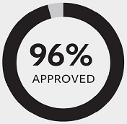

Investor Outreach

In 2025, our shareowner outreach efforts focused on the HCC Committee’s pay decisions for our NEOs and how we can continue to enhance our proxy disclosure to ensure it is clear and concise. Overall, investors were supportive of our current executive compensation program design. The feedback we received on our proxy disclosure in response to these outreach efforts has been incorporated into this year’s disclosure. For more information on our shareowner engagement, see page 31.

2025 Performance Overview

In 2025, we built upon our solid foundation by capitalizing on the robust demand across aerospace and defense markets to deliver strong operational and financial results.

Through continued operational discipline, each of our businesses—Collins Aerospace, Pratt & Whitney and Raytheon—achieved organic sales growth and improved adjusted segment margins. Despite significant headwinds from unplanned tariffs, we surpassed the adjusted net sales, adjusted EPS and free cash flow expectations we communicated to investors for the year. We also generated meaningful returns for our shareowners, closing the year with a total shareowner return (“TSR”) of 61%, outpacing the S&P 500 Index’s 18% TSR. Momentum for the future remains strong. With more than $138 billion in new bookings, our backlog reached a record $268 billion.

Looking ahead, we remain focused on our mission to connect and protect our world. By meeting sustained demand with disciplined execution and strategic investments, we are advancing the future of flight, delivering smarter defense systems and developing transformative technologies that shape global progress. At RTX, we are well positioned to drive long-term growth and create lasting value for our shareowners, while helping our customers achieve their most critical missions.

2025 HIGHLIGHTS
1.56  book-to-bill ratio | 7.9% increase  in dividend per share | $161 billion  commercial aerospace  backlog at year-end | $107 billion  defense backlog  at year-end

40 RTX 2026 PROXY STATEMENT

Table of Contents
COMPENSATION DISCUSSION AND ANALYSIS
EXECUTIVE SUMMARY

2025 FINANCIAL HIGHLIGHTS

DILUTED EARNINGS PER SHARE  ($ per share) |  | CASH FLOW  (in billions)
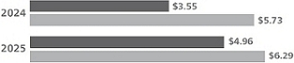 |  | 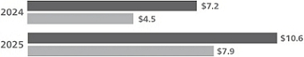
NET INCOME  (in billions) |  | NET SALES  (in billions)
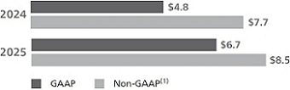 |  | 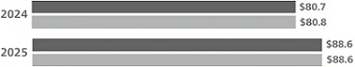

(1) | Adjusted EPS, FCF, adjusted net income and adjusted net sales are non-GAAP financial measures. See Appendix A on pages 99-101 for more information.

2025 STRATEGIC HIGHLIGHTS

In 2025, we advanced our key strategic priorities with a focus on the following:

Executing on our customer commitments |  | Innovating for future growth |  | Leveraging our breadth and scale
During the year, we capitalized on the powerful demand for our products and services, and strategically deployed over $2.6 billion in capital expenditures to expand our manufacturing capacity and to drive measurable efficiency gains across the enterprise. Examples include:  ●  Raytheon increased capacity at its Redstone Missile Integration Facility by 50% and designed, developed and tested a new StormBreaker variant in just 50 days.  ●  Pratt & Whitney doubled airfoil production at its Asheville, North Carolina, facility, and raised its prior year Isothermal Forging output by 13%.  ●  Collins Aerospace increased aircraft production rates across commercial platforms. |  | We remain focused on shaping the future of flight and defense through transformative technologies that deliver long-term shareowner value and meet the critical needs of our customers.  In 2025, we achieved key milestones and made several advancements in our innovation journey. Examples include:  ●  Raytheon transitioned its Lower Tier Air and Missile Defense Sensor program from prototype to production in five years.  ●  Pratt & Whitney continued to advance the development of hybrid-electric propulsion for regional aircraft by integrating a 250-kilowatt motor and advancing propeller technology from Collins Aerospace, targeting 20% fuel efficiency gains.  ●  We partnered with non-traditional A&D companies to integrate advanced artificial intelligence into select products. |  | Guided by CORE, our enterprise operating system, we implemented continuous improvement initiatives to optimize our cost structure, enhance productivity and strengthen collaboration across business segments.  Through centralization of our supply chain processes, we contained product inflation and achieved net-product savings.  We also continued to invest in digital infrastructure, AI-enabled analytics and connected systems to transform data into actionable insights—advancing operational efficiency and creating a foundation for sustained innovation.

RTX 2026 PROXY STATEMENT 41

Table of Contents
COMPENSATION DISCUSSION AND ANALYSIS
EXECUTIVE SUMMARY

How We Align Pay and Performance

Our executive compensation program is structured to advance our fundamental objective: aligning our executives’ compensation with the long-term interests of our shareowners.

The HCC Committee’s primary goal is to reward and recognize strong financial and operating performance and effective strategic leadership, which it believes drives long-term, sustainable shareowner value. This pay-for-performance philosophy is embedded in a set of Guiding Principles that underpin how the HCC Committee approaches the design of our executive compensation program.

OUR GUIDING PRINCIPLES

Competitive  Total compensation should be sufficiently competitive to attract, retain and motivate a leadership team capable of maximizing RTX’s performance. Each element should be benchmarked relative to peers.  Balance  Annual and long-term incentive opportunities should reward the appropriate balance of short-, medium- and long-term financial, strategic and operational business results.  Responsibility  A complete commitment to ethical and corporate responsibility is fundamental to our compensation program. Compensation should take into account each executive’s responsibility to act at all times in accordance with our Code of Conduct, our environmental, health, safety and other corporate responsibility objectives, and our compliance requirements. Financial, strategic and operational performance must not compromise these values. |  | Long-Term Focus  For our most senior executives, long-term, stock-based compensation opportunities should significantly outweigh short-term, cash-based opportunities. Annual objectives should complement sustainable, long-term performance.  Pay-for-Performance  A substantial portion of compensation should be variable, contingent and directly linked to Company, business unit and individual performance. The portion of total compensation contingent on performance should increase with an executive’s level of responsibility.  Shareowner Alignment  The financial interests of executives should be aligned with the long-term interests of our shareowners through stock-based compensation and performance metrics that correlate with long-term shareowner value.  Fair and Equitable  Compensation programs should be designed to deliver fair and equitable pay to executives of comparable experience and performance who perform similar work.

42 RTX 2026 PROXY STATEMENT

Table of Contents
COMPENSATION DISCUSSION AND ANALYSIS
EXECUTIVE SUMMARY

OVERVIEW OF 2025 PAY DECISIONS

2025 Pay Mix

Consistent with our Guiding Principles, the largest portion of compensation for our NEOs in 2025 was “at-risk” compensation—annual and LTI awards that are contingent on Company performance relative to our key metrics and stock price performance. See pages 5 and 48-50 for details on the metrics we use in our compensation program and why they were chosen.

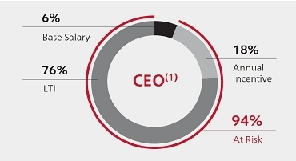 |  | 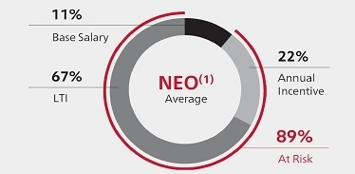

(1) | Percentages calculated based on 2025 total direct compensation, as shown in the table below. NEO average represents the average of all NEOs other than the CEO.

2025 Total Direct Compensation

In making annual pay decisions, the HCC Committee focuses primarily on “total direct compensation,” which includes our three principal elements of executive compensation: base salary, annual incentives and long-term incentives (“LTI”). These elements are discussed in detail on pages 47-51.

Total direct compensation is set each year to reflect the HCC Committee’s assessment of Company, business unit and individual performance for the year. 2025 total direct compensation includes 2025 base salary, 2025 annual incentives paid in the first quarter of 2026 and the February 2026 LTI grant values approved by the HCC Committee, which were based on its assessment of 2025 performance and the competitive market pay for each NEO’s role. These LTI grant values differ from the February 2025 LTI award grant date fair values (accounting values at the time of grant) shown in the Summary Compensation Table on page 64, which were based on the HCC Committee’s assessment of 2024 performance and the competitive market pay for each NEO’s role at that time. For more details on total direct compensation, see page 53.

The following chart shows the 2025 total direct compensation of our NEOs:

 |  | Base Salary ($K)(1) |  | Annual Incentive ($K) |  | LTI ($K)(2) |  | Total Direct  Compensation ($K)
Christopher T. Calio |  | $1,550 |  | $5,100 |  | $21,000 |  | $27,650
Neil G. Mitchill, Jr. |  | $1,100 |  | $2,525 |  | $7,500 |  | $11,125
Philip J. Jasper |  | $835 |  | $1,540 |  | $4,750 |  | $7,125
Shane G. Eddy |  | $840 |  | $1,425 |  | $4,500 |  | $6,765
Troy D. Brunk |  | $790 |  | $1,320 |  | $4,500 |  | $6,610
(1) | Reflects base salary in effect for each NEO as of December 31, 2025. These amounts differ from those in the Summary Compensation Table on page 64, which reflect salary adjustments (if any) made during the year.
(2) | Reflects values approved by the HCC Committee for the LTI award granted on February 11, 2026. These differ from the values that will be reported in the Summary Compensation Table in 2027, which will be calculated in accordance with FASB ASC Topic 718, Compensation—Stock Compensation.

RTX 2026 PROXY STATEMENT 43

Table of Contents
COMPENSATION DISCUSSION AND ANALYSIS
HOW WE MAKE PAY DECISIONS AND ASSESS OUR PROGRAMS

How We Make Pay Decisions and Assess Our Programs

Roles and Responsibilities

Human Capital & Compensation Committee

Oversees our programs

● | Sets the financial, strategic and operational goals and objectives for the Company, our business units, and the Chairman & CEO, as they relate to the Company’s annual and long-term incentive programs.
● | Assesses Company, business unit and NEO performance relative to the preestablished goals and objectives set for the year.
● | Evaluates the competitiveness of officers’ compensation and approves compensation adjustments, as appropriate.
● | Approves program design for executive severance, change-in-control, supplemental benefit arrangements and the Company’s Executive Leadership Group (“ELG”) program.
● | Appoints executives to the ELG.
● | Reviews risk assessments as they relate to RTX’s compensation plans, policies and practices.
● | Considers shareowner input regarding executive compensation decisions and policies.
● | Reviews the Company’s human capital management initiatives.
● | Engages an independent consultant, including approving the consultant’s compensation, determining the nature and scope of its services, evaluating its performance, terminating the engagement and replacing or adding consultants as needed.

Management

CEO provides input to the HCC Committee

● | Presents the HCC Committee with recommendations for each principal element of compensation for officers other than himself.
● | Considers the performance of each officer, their business unit and/or function, market benchmarks, internal equity and retention risk when making such recommendations.
● | Has no role in the performance evaluation or compensation decisions for himself.
Other executives provide insight and assistance

● | Our Executive Vice President & Chief Human Resources Officer, along with RTX’s Human Resources staff, provide insight on program design and gather compensation market data to assist the HCC Committee with its decision-making process.
● | Management also has the responsibility, delegated to it by the HCC Committee, for the administration of executive compensation plans for RTX employees who are not officers.

Independent Consultant

Provides an independent perspective and assessment

● | Advises the HCC Committee on a variety of subjects, including compensation plan design and trends, pay-for-performance analytics, benchmarking data, setting performance goals, governance and risk assessment.
● | Reports directly to the HCC Committee, participates in meetings as requested and communicates with the HCC Committee Chair between meetings as necessary.

Shareowners

Provide feedback on our programs

In assessing our programs each year, the HCC Committee considers feedback we receive from shareowners. Together with other factors, this helps the HCC Committee in its decision-making process and its ongoing assessment of program effectiveness.

44 RTX 2026 PROXY STATEMENT

Table of Contents
COMPENSATION DISCUSSION AND ANALYSIS
HOW WE MAKE PAY DECISIONS AND ASSESS OUR PROGRAMS

2025 Independent Consultant Engagement

In early 2025, the HCC Committee again engaged FW Cook as its independent consultant for the year. Prior to the engagement, it reviewed the firm’s qualifications, independence and any potential conflicts of interest. FW Cook did not perform other services for or receive other fees from the Company. As a result, the HCC Committee determined that FW Cook qualified as an independent consultant. During 2025, FW Cook representatives attended all HCC Committee meetings.

No other consulting firm made recommendations to the HCC Committee on RTX’s peer group composition or on the form, amount or design of executive compensation in 2025. However, the Company did obtain market data from other compensation consulting firms for various purposes, including benchmarking. Generally, such data is also available to other consulting clients of these firms.

Our Compensation Peer Group and Use of Market Data

How We Use Peer Group Data. The HCC Committee believes that to keep our executive compensation program sufficiently competitive, the target total direct compensation should approximate the market median of the companies RTX views as competitors for senior executive talent. For this reason, we compare our executive compensation program to the programs of companies within our Compensation Peer Group (“CPG”). In addition, we use market data from the aerospace and defense sector, the Fortune 100 and a broader group of companies to gain insight into general compensation trends and to supplement CPG market data for benchmarking when the HCC Committee finds it necessary or appropriate.

The HCC Committee annually evaluates each compensation element relative to the market for each officer’s role and makes adjustments as appropriate. Individual compensation may vary from market median benchmarks based on the Committee’s assessment of other factors that it considers relevant, including Company, business unit, function and/or individual performance, as well as job scope, retention risk, internal pay equity and sustained performance over time.

How Our Compensation Peer Group is Constructed. The CPG is composed of a mix of industry and non-industry peers. As part of its ongoing process, the HCC Committee regularly reviews each company included in the CPG and its overall composition. The previous CPG was established in 2020 following the merger of United Technologies Corporation and Raytheon Company. Since then, RTX has grown in size, while several CPG companies have sold or spun-off portions of their businesses. During its 2025 review, the HCC Committee made several changes to the CPG. These changes were made to ensure the CPG reflects an appropriate composite of companies comparable to RTX in size and complexity, while also keeping our pay programs competitive for the high-technology talent we need for future success.  The HCC Committee believes the 21 companies in our CPG (see page 46) provide a relevant comparison based on their similarity to RTX in size, geographic footprint and operational complexity, taking into account factors such as revenue, market capitalization, global scope of operations, manufacturing footprint, research and development activities, and technology and engineering focus. As competitors for executive talent, the CPG is used solely for the purpose of benchmarking executive compensation, and not as a part of the performance metrics in our incentive compensation programs. | Companies Added  + Ford Motor Company  + Microsoft Corporation  + Nvidia Corporation  Companies Removed  - 3M  - L3Harris Technologies

RTX 2026 PROXY STATEMENT 45

Table of Contents
COMPENSATION DISCUSSION AND ANALYSIS
HOW WE MAKE PAY DECISIONS AND ASSESS OUR PROGRAMS

OUR COMPENSATION PEER GROUP (CPG)

 |  |  |  | 
Aerospace & Defense | Equipment & Machinery | Technology/Communications |  | Oil & Gas
Boeing  GE Aerospace  General Dynamics  Lockheed Martin  Northrop Grumman | Caterpillar  Deere | AT&T  Cisco  HP Inc.  IBM | Intel  Microsoft  Nvidia  Verizon | Chevron
 |  |  |  | 
Chemicals  Dow | Diversified Industrials  Honeywell | Automotive  Ford  General Motors |  | Freight & Logistics  UPS

TIMELINE FOR COMPENSATION DECISIONS

The HCC Committee followed the process shown below in making pay decisions for each principal component of compensation included in 2025 total direct compensation, which includes the 2026 LTI awards, as explained on page 53.

January 2025  Approved 2025 base salary merit adjustments.  Approved 2025 annual incentive performance goals. | April 2025  2025 base salary merit adjustments took effect. | December 2025  Reviewed preliminary 2025 Company, business unit and individual NEO performance. | February 2026  Reviewed final 2025 Company, business unit and individual NEO performance.  Approved performance factors and individual 2025 annual incentive awards.  Approved 2026 LTI awards, reflective of 2025 performance. | 1st Quarter of 2026  2025 annual incentive awards paid.  2026 LTI awards granted.

46 RTX 2026 PROXY STATEMENT

Table of Contents
COMPENSATION DISCUSSION AND ANALYSIS
2025 PRINCIPAL ELEMENTS OF COMPENSATION

2025 Principal Elements of Compensation

Base Salary

To attract and retain talented and qualified executives, we provide competitive base salaries that generally target the market median, but may range above or below it based on tenure and experience, sustained performance over time, job scope and responsibilities, retention risk and internal pay equity. Each year, the HCC Committee reviews the CEO’s recommendations for base salary merit adjustments for our NEOs, relative to market ranges for each NEO’s role. The HCC Committee has complete discretion to modify or approve the CEO’s recommendations, and the CEO is not involved in its determination of his base salary.

Annual Incentive Awards

Annual incentive awards, which are granted under the RTX Corporation Executive Annual Incentive Plan (“AIP”), are an integral component of our executive compensation program. The AIP reinforces Company and business unit goals, promotes the achievement of these goals and enables us to attract, retain and motivate the highest caliber of executive talent.

HOW ANNUAL INCENTIVE AWARDS ARE DETERMINED

To align with the Company’s focus on achieving the financial commitments we make to our investors, the HCC Committee determined that, beginning in 2025, the funding formula for the AIP would be solely based on the financial performance of the Company and our business units, and would no longer consider non-financial performance measures (see page 6 for details on the HCC Committee’s decision).

The following formula is the basis for determining the 2025 annual incentive awards for our NEOs:

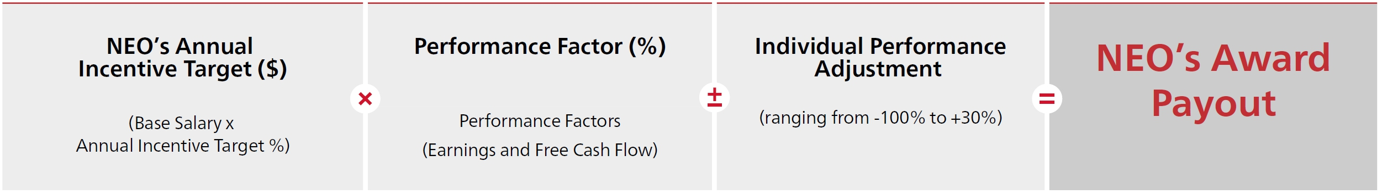

Though performance relative to preestablished financial goals is the primary basis for determining the performance factors under the AIP, the HCC Committee retains the right to make discretionary adjustments to how it measures annual incentive performance to maintain the integrity of the goals as originally established. In the past, it has made both positive and negative adjustments. Examples of situations that could result in discretionary adjustments include:

● | Significant, unforeseen circumstances beyond management’s control that affected performance relative to the established goals, including certain nonrecurring charges and credits unrelated to operating performance
● | Changes in tax laws and accounting rules that positively or negatively impact performance
● | Changes to the Company’s capital structure (restructuring, acquisitions and divestitures)

In addition, each NEO begins the year with individual financial, strategic and/or operational objectives. Based on the CEO’s performance assessment of the NEOs (other than himself), it may be recommended that the HCC Committee increase or decrease the award a NEO would otherwise receive based on the approved performance factor. The HCC Committee considers these recommendations and makes adjustments as it deems appropriate. The individual performance adjustments for our executive officers may range from a 100% decrease to the approved performance factor (e.g., a zero payout), up to a 30% increase to the approved performance factor. However, no payout under the AIP can be greater than 200% of target. When determining individual performance adjustments (if any), the HCC Committee also considers each executive’s responsibility to act at all times in accordance with our Code of Conduct, Company policies and compliance requirements.

RTX 2026 PROXY STATEMENT 47

Table of Contents
COMPENSATION DISCUSSION AND ANALYSIS
2025 PRINCIPAL ELEMENTS OF COMPENSATION

2025 ANNUAL INCENTIVE TARGETS

Each NEO has an annual incentive target that is expressed as a percentage of the NEO’s base salary as in effect on December 1, 2025. These targets are based on relevant market data for each NEO’s role. Changes in target percentages that occur mid-year (usually due to a change in role) are prorated. For the 2025 plan year, the HCC Committee increased annual incentive targets (effective on January 1, 2025) for our NEOs to maintain market competitiveness.

NEO |  | 2024 |  | 2025
Christopher T. Calio |  | 175% |  | 200%
Neil G. Mitchill, Jr. |  | 115% |  | 125%
Philip J. Jasper |  | 105% |  | 115%
Shane G. Eddy |  | 105% |  | 115%
Troy D. Brunk |  | 105% |  | 115%

2025 PERFORMANCE METRICS AND WEIGHTINGS

As shown in the charts below, performance for our Corporate executives (Messrs. Calio and Mitchill) is measured on a Company-wide basis, with equal weight given for earnings and free cash flow. For business unit executives (Messrs. Jasper, Eddy and Brunk), performance metrics are measured at both the business unit and Company-wide level, with earnings and free cash flow (“FCF”) weighted at 25% each. This program design is intended to motivate our business unit executives both to deliver on customer commitments and to leverage Company-wide resources to advance technology and innovation. Payout funding ranges from 0% to 200% of target for all metrics.

 |  | Performance Goals
 |  | Earnings |  | FCF
Corporate Executives  Funding based entirely on Company-wide performance |  | 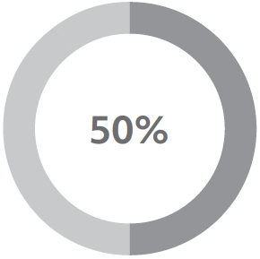 |  | 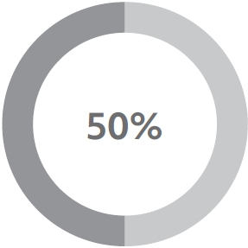
Business Unit Executives  Funding based equally on business unit performance and Company-wide performance   Company-Wide  Business Unit |  | 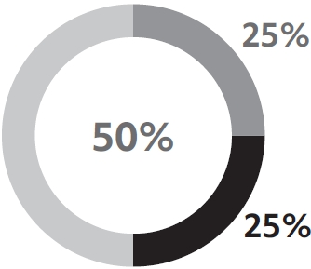 |  | 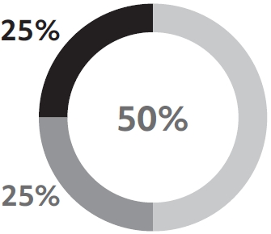

At its January 2025 meeting, the HCC Committee approved performance metric definitions for earnings and free cash flow for the 2025 AIP. Consistent with prior years, the HCC Committee included adjustments for changes in tax laws and accounting rules—factors outside of our employees’ control that can materially distort financial results. Applying the same principle, the HCC Committee concluded that changes in laws and regulations impacting tariffs should be neutralized for AIP performance purposes, because they are externally imposed, unpredictable and unrelated to operational execution. These adjustments are consistent with the HCC Committee’s belief that AIP outcomes should reflect business performance—not external policy shifts that employees cannot control.

PERFORMANCE METRICS DEFINITIONS

 |  | Company-Wide Metrics |  |  |  | Business Unit Metrics
 |  | RTX Earnings |  | RTX FCF |  | Business Unit Earnings |  | Business Unit FCF
How are AIP financial metrics defined? |  | We start with a GAAP measure: RTX’s net income attributable to common shareowners.(1) |  | We start by subtracting one GAAP measure from another: RTX’s consolidated net cash flow from operating activities, less RTX’s capital expenditures.(1) |  | We start with a GAAP measure: segment operating income.(1) |  | We start with an internal measure based on business unit net cash flow from operating activities, less business unit capital expenditures.
 |  | Then we adjust for the impact of certain items and external events unrelated to our operating performance. These may include, in any given year, changes in tax laws, tariffs and accounting rules, restructuring costs, the impact of acquisitions and divestitures (including acquisition accounting adjustments, if applicable), and significant and/or nonrecurring items. See Appendix B on page 102 for additional details.
Why did the HCC Committee choose these metrics? |  | The HCC Committee believes adjusted net income is relevant because it measures the immediate impact of operating decisions on RTX’s overall performance, and includes the impact of items such as tax, interest and foreign exchange fluctuations, which are managed at the Corporate level. |  | The HCC Committee believes that FCF performance is a relevant measure of our ability to generate cash to fund our operations and key business investments and to return capital to our shareowners. |  | The HCC Committee believes that operating income, exclusive of tax, interest and foreign exchange exposure, should be the focus of our business units. |  | The HCC Committee believes that FCF performance is a relevant measure of the business units’ ability to generate cash to fund their operations and key business investments.

(1) | As reported in our 2025 Annual Report on Form 10-K.

48 RTX 2026 PROXY STATEMENT

Table of Contents
COMPENSATION DISCUSSION AND ANALYSIS
2025 PRINCIPAL ELEMENTS OF COMPENSATION

Why we use non-GAAP financial metrics for our annual incentives

The HCC Committee believes that, to encourage decision-making aimed at long-term value creation, annual incentives should reflect the financial impact (positive or negative) of short-term decisions made in the best interest of RTX’s long-term business strategies. Through the adjustments noted on the prior page, our non-GAAP metrics allow for a clearer assessment of business performance and more closely align our AIP with the annual non-GAAP financial expectations we communicate to shareowners.

HOW WE PERFORMED ON OUR 2025 PERFORMANCE GOALS

The HCC Committee established goals for earnings and free cash flow at threshold, target and maximum performance levels, both for the Company overall and for each business unit. Performance relative to these goals determines the performance factors used to fund the annual incentive pool for Corporate executives and for executives in each business unit. For 2025, Company-wide AIP earnings and free cash flow goals were set to align with the expectations we communicated to investors for the year.

Performance below the threshold level will result in 0% funding for that metric, while performance above the maximum level cannot exceed the maximum funding level of 200%. Performance that falls between the threshold, target and maximum levels results in funding between the applicable levels.

2025 COMPANY-WIDE GOALS, RESULTS AND PERFORMANCE FACTORS

 |  |  |  | 2025 Goals
Financial Metric |  | Weight |  | Threshold  (50% funding) |  | Target  (100% funding) |  | Maximum  (200% funding) |  | 2025  Results(1) |  | Performance Factors
Earnings—adjusted net income ($M) |  | 50% |  | $7,090 |  | $8,340 |  | $9,590 |  | $9,115 |  | 162%
Free Cash Flow ($M) |  | 50% |  | $6,065 |  | $7,500 |  | $8,935 |  | $8,448 |  | 166%
RTX Performance Factor |  |  |  |  |  |  |  |  |  |  |  | 164%

RTX’s 2025 GAAP net income of $6,732 million was adjusted to $9,115 million for AIP purposes and RTX’s 2025 free cash flow of $7,940 million was adjusted to $8,448 million for AIP purposes.(1) These adjusted AIP metrics measure net income and free cash flow exclusive of the impacts of changes in tax laws, tariffs and/or accounting rules, restructuring costs, acquisitions and divestitures (including acquisition accounting adjustments), and significant and/or nonrecurring items. All adjustments made to earnings and free cash flow for AIP purposes aligned with the definitions approved by the HCC Committee at its January 2025 meeting.

2025 BUSINESS UNIT GOALS, RESULTS AND PERFORMANCE FACTORS

 |  | Business Unit Goals and Results(2)
 |  | Business Unit Earnings |  | Business Unit FCF
What 2025 financial goals were set for annual incentive purposes? |  | Adjusted operating income goals ranged from $2,830 million to $5,140 million for our business units. |  | FCF goals ranged from $2,085 million to $4,205 million for our business units.
What were the financial results used for annual incentive purposes? |  | Adjusted operating income results ranged from $2,858 million to $5,147 million for our business units. |  | FCF results ranged from $2,245 million to $4,471 million for our business units.
What were the resulting performance factors for each metric? |  | Ranged from 101% to 159% of target. |  | Ranged from 121% to 151% of target.
What were the performance factors for each metric after applying the 50% weighting of the Company-wide factor for each metric? |  | Ranged from 132% to 161% of target. |  | Ranged from 144% to 159% of target.

Combining the factors for each metric shown above, the performance factors for our business units ranged from 143% to 152% of target.

(1) | Adjusted net income and free cash flow are metrics used solely for AIP purposes and are defined in Appendix B on page 102. These metrics differ from other non-GAAP metrics used and described in Appendix A.
(2) | See the table on page 48 and Appendix B on page 102 for details on how we calculate earnings and FCF for the purposes of determining business unit financial performance factors.

RTX 2026 PROXY STATEMENT 49

Table of Contents
COMPENSATION DISCUSSION AND ANALYSIS
2025 PRINCIPAL ELEMENTS OF COMPENSATION

LTI Awards

LTI MIX

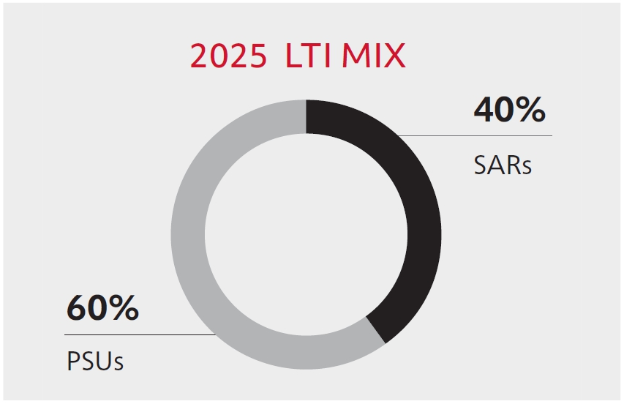
The HCC Committee annually reviews the design of our LTI awards to ensure consistency with our program’s fundamental objective of aligning the interests of executives and shareowners while attracting and retaining talented senior leaders.

In 2025, the LTI mix for our NEOs was 60% PSUs and 40% SARs. The HCC Committee believes each LTI vehicle serves a specific objective:

● | PSUs encourage the achievement of important financial goals and align payouts with the shareowner experience.
● | SARs motivate prudent long-term decision-making and have strong pay-for-performance alignment since they have no value unless the stock price increases from the price on the grant date.

PERFORMANCE SHARE UNITS

2025–2027 PSUs. 2025 PSUs will vest following the end of a three-year performance period, subject to Company performance relative to preestablished financial performance goals. Executives must also be employed by the Company on the vesting date, with exceptions for death, disability, qualifying separation within two years of a change-in-control, retirement and certain involuntary terminations.

If RTX achieves target-level performance for all four metrics, 100% of the PSUs granted would vest at the end of the performance period. Vesting factors can range from 0% if all metrics fall below threshold-level performance to 200% if all metrics meet or exceed maximum-level performance. Each PSU converts into one share of RTX Common Stock upon vesting. The goals established for our 2025–2027 PSUs are as follows:

PERFORMANCE GOALS AND WEIGHTINGS FOR 2025–2027 PSUs

Metric |  | Weighting |  | Threshold  (25% payout) |  | Target  (100% payout) |  | Maximum  (200% payout)
Adjusted Earnings Per Share(1)  ● Measured using a compound annual growth rate over the three-year performance period  ● Goals align with our mid-range strategic business plan |  | 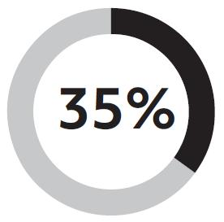 |  | 1.4% |  | 7.1% |  | 10.5%
Return on Invested Capital (“ROIC”)(1)  ● Calculated using a quarterly average over the three-year performance period |  | 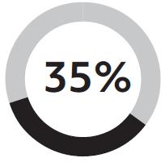 |  | 7.5% |  | 8.7% |  | 9.5%
TSR vs. Core A&D Peers(2)  ● Measures RTX’s cumulative three-year TSR(3) percentile rank relative to our nine Core A&D Peers  ● Payout for this portion of the award is capped at 100% of target if RTX’s TSR is negative |  | 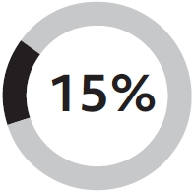 |  | 25th  percentile |  | 50th  percentile |  | 75th  percentile
TSR vs. S&P 500 Index Companies  ● Measures RTX’s cumulative three-year TSR(3) percentile rank relative to the companies within the S&P 500 Index at the beginning of the performance period  ● Payout for this portion of the award is capped at 100% of target if RTX’s TSR is negative |  | 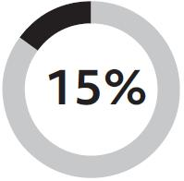 |  | 25th  percentile |  | 50th  percentile |  | 75th  percentile

(1) | Metrics used solely for PSU purposes and are defined in Appendix B on page 102. These metrics differ from other non-GAAP metrics used and described in Appendix A on pages 99-101.
(2) | For the 2025 PSUs, Core A&D Peers consist of Airbus, Boeing, GE Aerospace, General Dynamics, Honeywell, L3Harris, Lockheed Martin, Northrop Grumman and Safran.
(3) | See Appendix B on page 102 for details on how TSR is calculated.

50 RTX 2026 PROXY STATEMENT

Table of Contents
COMPENSATION DISCUSSION AND ANALYSIS
2025 PRINCIPAL ELEMENTS OF COMPENSATION

What the HCC Committee Considers when Setting Performance Goals and Measuring Performance. When setting adjusted EPS and ROIC goals for our PSU awards, the HCC Committee considers various long-term business factors, including planned share buybacks, macroeconomic market trends and cost-reduction plans. As defined in Appendix B, adjusted EPS and ROIC exclude the impact of changes in tax laws, tariffs and/or accounting rules, acquisitions and divestitures (including acquisition accounting adjustments), restructuring, nonrecurring and other significant, nonoperational items, nonoperating pension and postretirement income or expense, and changes in asset or liability valuations of deferred compensation plans recognized in interest income/ expense. Under the terms and conditions of the awards, when measuring performance, the HCC Committee may also make adjustments (positively or negatively) to exclude certain items unrelated to operational performance when necessary to maintain the validity of the original targets.

Limit on Maximum Vesting Value. If the value of PSUs at vesting (number of PSUs vesting multiplied by the closing price of RTX Common Stock on the vesting date) is greater than 400% of the value of the PSUs at grant (number of PSUs that would vest at target-level performance multiplied by the closing RTX stock price on the grant date), the vesting factor will be reduced so that the value delivered to executives will be no greater than 400% of the grant value.

2023–2025 PSU Vesting. PSU awards granted on February 8, 2023, were subject to vesting based on RTX’s three-year performance relative to preestablished goals for each of the four metrics shown below. Our performance over the three-year period resulted in the award vesting at 146% of target.

Metric(1) |  | Weight |  | Threshold |  | Target |  | Maximum |  | Actual |  | Performance Factor
Adjusted EPS(2) |  | 35% |  | 5.7% |  | 11.6% |  | 15.1% |  | 12.9% |  | 137%
ROIC |  | 35% |  | 6.5% |  | 7.5% |  | 8.3% |  | 7.6% |  | 109%
TSR vs. S&P 500 Index Companies |  | 15% |  | 25th percentile |  | 50th percentile |  | 75th percentile |  | 82.7th percentile |  | 200%
TSR vs. Core A&D Peers |  | 15% |  | 25th percentile |  | 50th percentile |  | 75th percentile |  | 77.7th percentile |  | 200%
Final PSU Vesting Factor |  |  |  |  |  |  |  |  |  |  |  | 146%

(1) | For a definition of performance metrics used for PSU purposes, see Appendix B on page 102.
(2) | 2025 EPS (GAAP) of $4.96 was adjusted to $6.88, in accordance with the definition we use for measuring PSU performance.

In evaluating performance for the 2023-2025 PSUs, the HCC Committee concluded that changes in laws and regulations impacting tariffs should be neutralized for PSU purposes, because they are externally imposed, unpredictable and unrelated to operational execution. This adjustment is consistent with the HCC Committee’s belief that PSU outcomes should reflect business performance—not external policy shifts that employees cannot control. Such adjustments to maintain the validity of the originally established goals are permitted under the terms and conditions of the 2023 PSU award.

CHANGES TO LONG-TERM INCENTIVES IN 2026

As described on page 6, PSUs granted in February 2026 will vest based on RTX’s performance relative to the following metrics and weightings: EPS (30%), ROIC (30%), TSR vs. Core A&D Peers (20%), and TSR vs. S&P 500 Index Companies (20%). In addition, beginning with the 2026 PSU award, Textron will replace Safran in our Core A&D Peer group.

STOCK APPRECIATION RIGHTS

Our current LTI award program also includes grants of SARs, which entitle the award recipient to receive, upon exercise, shares of RTX Common Stock with a market value equal to the difference between the market price of RTX Common Stock on the date the SARs are exercised and the exercise price that was set at the grant date (i.e., the closing price of RTX Common Stock on the date of grant). SARs vest and become exercisable three years from the grant date if the recipient is employed by the Company on the vesting date, with exceptions for death, disability, qualifying separation within two years of a change-in-control, retirement and certain involuntary terminations. SARs expire 10 years from the grant date.

RTX 2026 PROXY STATEMENT 51

Table of Contents
COMPENSATION DISCUSSION AND ANALYSIS
2025 CEO PAY DECISIONS

2025 CEO Pay Decisions

Christopher T. Calio  Chairman, President & Chief Executive Officer  AGE 52  RTX EXPERIENCE 20 YEARS |  | 

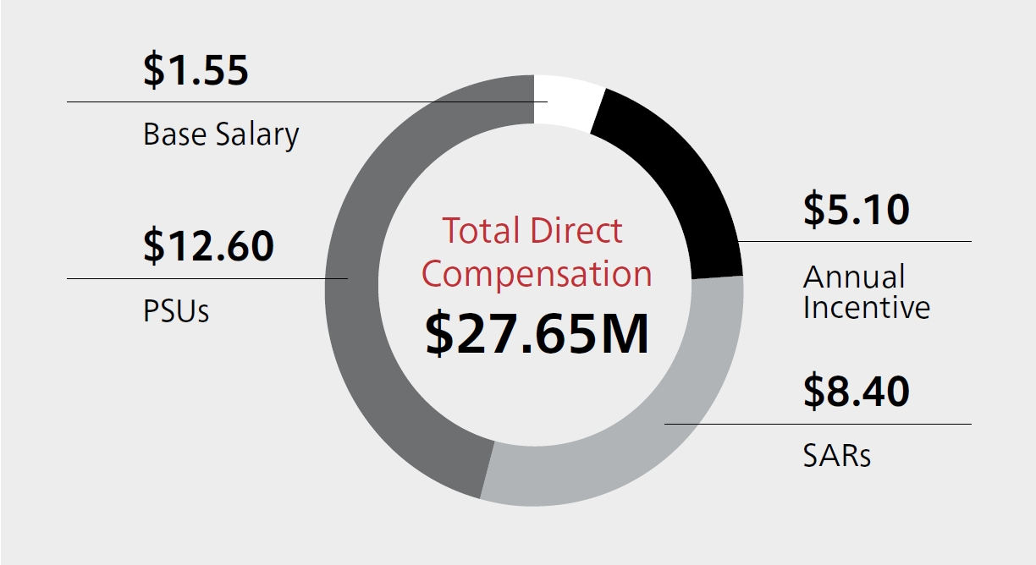
Mr. Calio served as President & CEO until April 30, 2025, at which point he assumed the role of Chairman of the Board, in addition to his role as President & CEO.

Compensation Overview

Base Salary. Mr. Calio received a base salary increase from $1,450,000 to $1,550,000 during 2025. Following this increase, Mr. Calio's base salary was below the market median for his role.

Annual Incentive Award. The HCC Committee approved a performance factor of 164% of target for Corporate. The HCC Committee considered this factor, Mr. Calio’s leadership during 2025 and the individual performance considerations noted here, and approved an annual incentive award of $5.1 million. This amount is aligned with the Corporate performance factor.
LTI. In consideration for Mr. Calio’s 2025 performance, the HCC Committee approved a 2026 LTI award of $21 million. This amount is an increase from his 2025 LTI award and is above the CPG median for his role.

Individual Performance Highlights

Mr. Calio exhibited strong leadership driving RTX results, including:
● | Exceeding the financial expectations we communicated to investors early in the year, despite tariff-related pressures and supplier challenges, which included:
 | – | Net sales growth of 9.7% (GAAP), 9.6% (adjusted) and organic sales growth of 11%, which includes organic sales growth at each business segment.(1)
 | – | Diluted EPS of $4.96 (GAAP) and $6.29 (adjusted).(1)
 | – | $10.6 billion in cash flow from operating activities and over $2.6 billion invested in capital expenditures, resulting in $7.9 billion in free cash flow.(1)
 | – | Adjusted operating profit increased by 12% year-over-year, with growth and margin expansion across all three segments.(1)

● | Achieving record backlog of $268 billion, a 23% increase since the end of 2024.
● | Driving greater technology collaboration across our business units in areas such as hybrid-electric propulsion, rotating detonation engines, attritable engines, microelectronics, high-temperature materials and autonomy—transformative capabilities for our customers that can enable expanded and new market opportunities.
● | Expanding manufacturing capacity for critical products, such as GTF engine MRO, munitions and Lower Tier Air and Missile Defense Sensors (LTAMDS).
● | Completing the divestiture of two non-core businesses during the year—Collins Aerospace’s actuation and flight control business and the Simmonds Precision Products business.

(1) | See Appendix A on pages 99-101 for details.

52 RTX 2026 PROXY STATEMENT

Table of Contents
COMPENSATION DISCUSSION AND ANALYSIS
2025 CEO PAY DECISIONS

What is total direct compensation?

In contrast to the Summary Compensation Table (on page 64), our discussion of CEO and NEO pay decisions in this Proxy Statement (pages 52-57) uses a measure called total direct compensation, which the HCC Committee believes provides a more accurate picture of its annual pay decisions and reflects its most recent assessment of Company, business unit and individual performance, and the competitive market for each NEO’s role. Total direct compensation includes 2025 base salary as of year-end, 2025 annual incentive for the completed performance year and LTI as described below.

How the HCC Committee Views LTI Award Values

Total Direct  Compensation |  | Includes the value of LTI awards approved by the HCC Committee and granted in February 2026. |  | Award values relate to the HCC Committee’s assessment of 2025 performance and the competitive market pay for each NEO’s role at the time of grant.
Summary  Compensation Table |  | Includes the grant date fair value of LTI awards granted in February 2025. |  | Award values relate back to the HCC Committee’s assessment of 2024 performance and the competitive market pay for each NEO’s role at the time of grant.

SEC rules require the LTI awards granted in February 2025 to be reported in the Summary Compensation Table of this Proxy Statement, with a different valuation methodology than we use for total direct compensation. In addition, the compensation values reported in the Summary Compensation Table include certain elements (e.g., changes in pension values, which are impacted by assumptions, such as interest rates and other formulaic compensation and benefit components) that we exclude from total direct compensation because they are not tied to performance and fall outside the scope of the HCC Committee’s annual pay decisions.

CEO TOTAL DIRECT COMPENSATION: THREE-YEAR COMPARISON(1)
As shown in the chart below, and as discussed in our Guiding Principles on page 42, the HCC Committee believes that a substantial portion of total direct compensation should be variable, contingent and directly linked to Company and individual performance. For 2025, 94% of Mr. Calio’s total direct compensation was “at-risk” variable compensation.

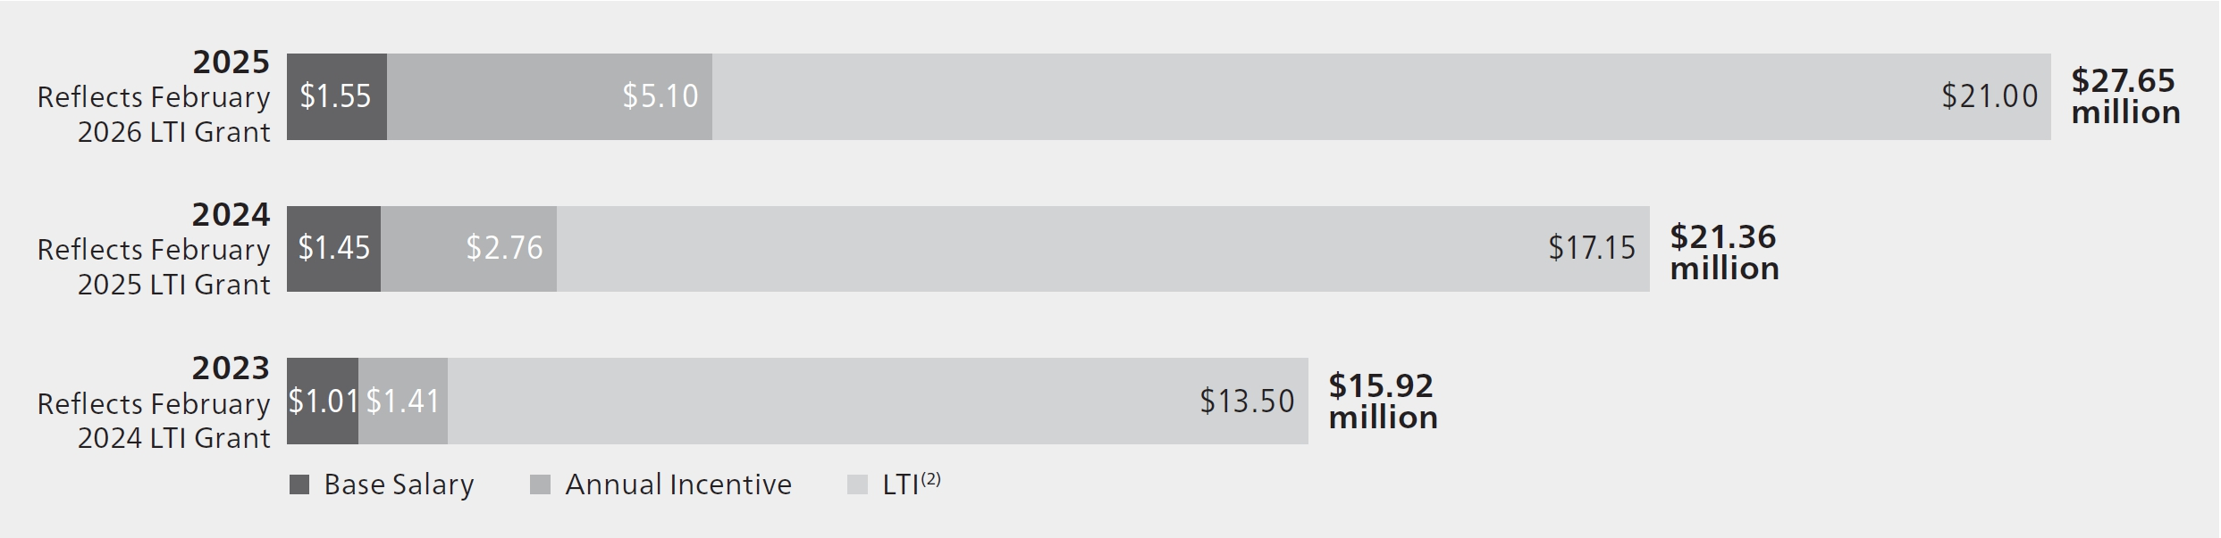

(1) | Mr. Calio was appointed President & Chief Executive Officer effective May 2, 2024, and elected Chairman effective April 30, 2025. Prior to his appointments to those roles, he served in the following roles: President & Chief Operating Officer (March 1, 2023, to May 1, 2024), and Chief Operating Officer (March 1, 2022, to February 28, 2023).
(2) | Reflects annual LTI award values approved by the HCC Committee. These values differ from those reported in the Summary Compensation Table on page 64, which are calculated in accordance with FASB ASC Topic 718.

RTX 2026 PROXY STATEMENT 53

Table of Contents
COMPENSATION DISCUSSION AND ANALYSIS
2025 PAY DECISIONS FOR OTHER NEOS

2025 Pay Decisions for Other NEOs

The HCC Committee makes annual compensation decisions for our NEOs based on their individual performance, the overall performance of the Company and, where applicable, the NEO’s business unit or function. In the following pages, we describe the components of total direct compensation for each NEO for 2025, noting aspects of their individual performance that contributed to the HCC Committee’s pay decisions (see page 53 for an explanation of total direct compensation).

Neil G. Mitchill, Jr.  Executive Vice President & Chief Financial Officer  AGE 50  RTX EXPERIENCE 11 YEARS |  | 

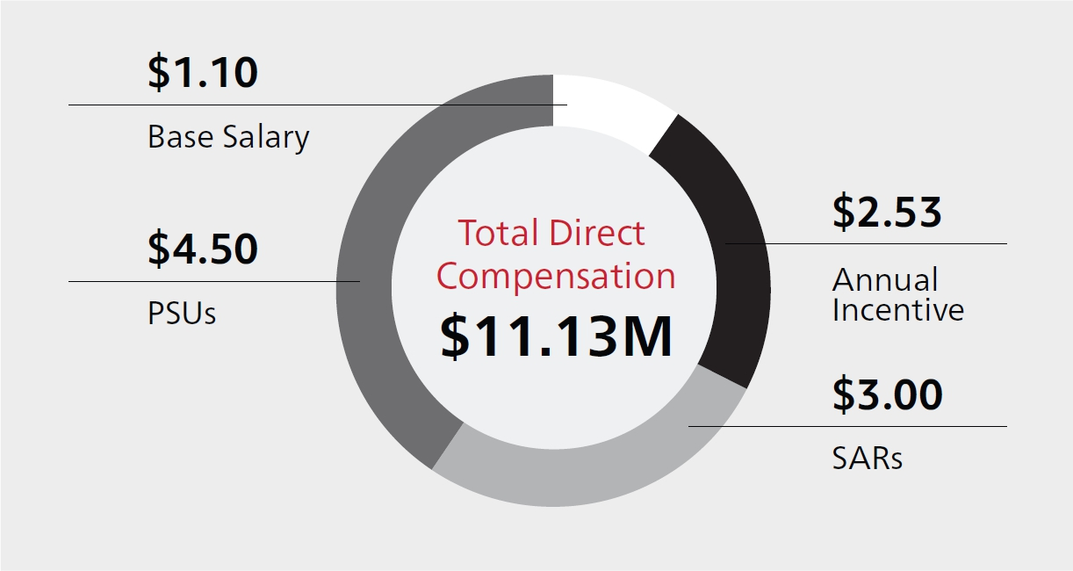
Compensation Overview

Base Salary. Mr. Mitchill received a base salary increase from $1,050,000 to $1,100,000 during 2025. Following this increase, Mr. Mitchill’s base salary was moderately above the market median for his role.

Annual Incentive Award. The HCC Committee approved a performance factor of 164% of target for Corporate. The HCC Committee considered this factor, Mr. Mitchill’s leadership of the RTX finance function and the individual performance considerations noted here, and approved a $2.525 million award for 2025. This amount is above the Corporate performance factor.
LTI. In consideration of Mr. Mitchill’s 2025 performance, the HCC Committee approved a $7.5 million 2026 LTI award, an amount that is above the market median for his role.

Individual Performance Highlights

Mr. Mitchill exhibited strong leadership in:
● | Overseeing the Company’s strong financial performance, which included exceeding the adjusted net sales, adjusted EPS and free cash flow expectations we communicated to investors for the year, despite headwinds from unplanned, incremental tariffs and supplier challenges.
● | Overseeing our robust investor outreach efforts, including participating in 8 investor conferences, and meeting individually with most of our top investors.

● | Leading RTX’s disciplined capital allocation strategy, including:
 | – | Investing $7.7 billion in Company- and customer- funded research and development spend and capital expenditures.
 | – | Increasing annual dividend rate by 7.9%(1), returning over $3.6 billion of capital to shareowners.
 | – | Paying down $3.4 billion of debt.
 | – | Deploying $85 million of capital investments in a combination of 11 new startup companies and 8 follow-on investments through RTX Ventures.

(1) | In the second quarter of 2025, we increased our quarterly dividend from $0.63 per share to $0.68 per share.

54 RTX 2026 PROXY STATEMENT

Table of Contents
COMPENSATION DISCUSSION AND ANALYSIS
2025 PAY DECISIONS FOR OTHER NEOS

Philip J. Jasper  President, Raytheon  AGE 57  RTX EXPERIENCE 34 YEARS |  | 

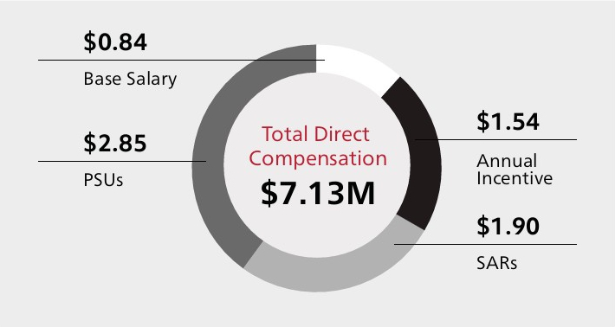
Compensation Overview

Base Salary. Mr. Jasper received a base salary increase from $790,000 to $835,000 in 2025. Following this increase, Mr. Jasper’s base salary is slightly below the market median for his role.

Annual Incentive Award. The HCC Committee approved a performance factor of 152% of target for Raytheon. The HCC Committee considered this factor, Mr. Jasper’s leadership of our Raytheon business unit and the individual performance considerations noted here, and approved a $1.54 million award, an amount that is above the Raytheon performance factor.

LTI. In consideration of Mr. Jasper’s 2025 performance, the HCC Committee approved a $4.75 million 2026 LTI award, an amount that is above the market median for his role.

Individual Performance Highlights

Mr. Jasper exhibited strong leadership driving Raytheon results, including:
● | Significant financial achievements:
 | – | Net sales growth of 5.0% (GAAP) and 4.7% (adjusted), which includes 6% organic sales growth.(1)
 | – | Backlog increase from $63 billion in 2024 to $75 billion in 2025 at accretive margins.
 | – | Return on sales of 11.5% (GAAP and adjusted).(1)
 | – | Operating profit up 24% (GAAP) and 18% (adjusted).(1)
● | Customer wins and operational accomplishments:
 | – | Doubled Advanced Medium-Range Air-to-Air Missile year-over-year production.

 | – | Proactively established munitions acceleration team to support customer priorities to notably increase production of key munitions.
 | – | Site capacity at Raytheon’s Redstone Missile Integration Facility in Huntsville, Alabama increased by 50%.
 | – | Transitioned Lower Tier Air and Missile Defense Sensor (LTAMDS) to production after achieving Milestone C.
 | – | Awarded $1.1 billion contract from the U.S. Navy to produce AIM-9X Block II missiles, which will increase production to 2,500 missiles per year.

(1) | See Appendix A on pages 99-101 for details.

RTX 2026 PROXY STATEMENT 55

Table of Contents
COMPENSATION DISCUSSION AND ANALYSIS
2025 PAY DECISIONS FOR OTHER NEOS

Shane G. Eddy  President, Pratt & Whitney  AGE 61  RTX EXPERIENCE 16 YEARS |  | 

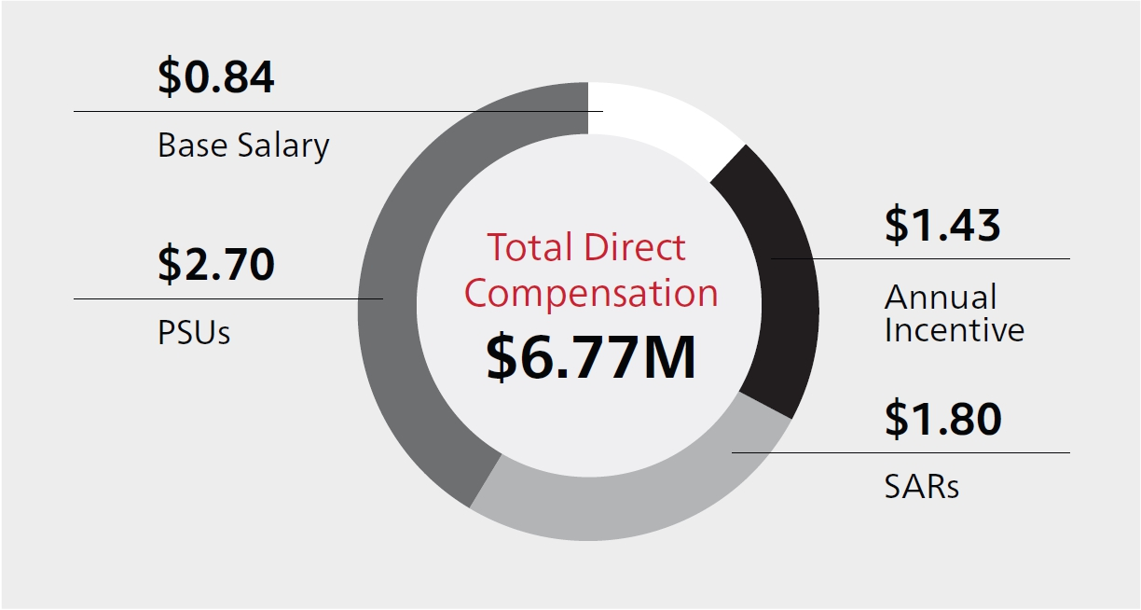
Compensation Overview

Base Salary. Mr. Eddy received a base salary increase from $810,000 to $840,000 during 2025. Following this increase, Mr. Eddy’s base salary is slightly below the market median for his role.

Annual Incentive Award. The HCC Committee approved a performance factor of 146% of target for Pratt & Whitney. The HCC Committee considered this factor, Mr. Eddy’s leadership of our Pratt & Whitney business unit and the individual performance considerations noted here, and approved a $1.425 million award, an amount that is aligned with the Pratt & Whitney performance factor.

LTI. In consideration of Mr. Eddy’s 2025 performance, the HCC Committee approved a $4.50 million 2026 LTI award, an amount that is slightly above the market median for his role.

Individual Performance Highlights

Mr. Eddy exhibited strong leadership driving Pratt & Whitney results, including:
● | Significant financial achievements:
 | – | Net sales growth of 17.3% (GAAP and adjusted), which includes 17% organic sales growth.(1)
 | – | Return on sales of 7.9% (GAAP) and 8.3% (adjusted).(1)
 | – | Operating profit up 29% (GAAP) and 19% (adjusted).(1)
● | Customer wins and operational accomplishments:
 | – | Improved RPW1100G-JM engine Maintenance, Repair & Overall (“MRO”) output by 26% year-over year.
 | – | Increased output of critical parts, including doubling airfoil production at our Asheville, North Carolina, facility,

 |  | and increasing Isothermal Forging output by 13% from 2024 to 2025.
 | – | Achieved Federal Aviation Administration (“FAA”) and European Aviation Safety Agency (“EASA”) engine certification for the GTF Advantage engine.
 | – | Received EASA certification for the first GTF-powered A321XLR to enter into service.
 | – | Achieved $5.3 billion in F135 engine orders, including $2.9 billion for F135 production contracts and $2.4 billion for F135 sustainment contracts.

(1) | See Appendix A on pages 99-101 for details.

56 RTX 2026 PROXY STATEMENT

Table of Contents
COMPENSATION DISCUSSION AND ANALYSIS
2025 PAY DECISIONS FOR OTHER NEOS

Troy D. Brunk  President, Collins Aerospace  AGE 56  RTX EXPERIENCE 34 YEARS |  | 

LTI. In February 2026, Mr. Brunk was awarded a $4.50 million 2026 LTI award, an amount that is slightly above the market median for his role.
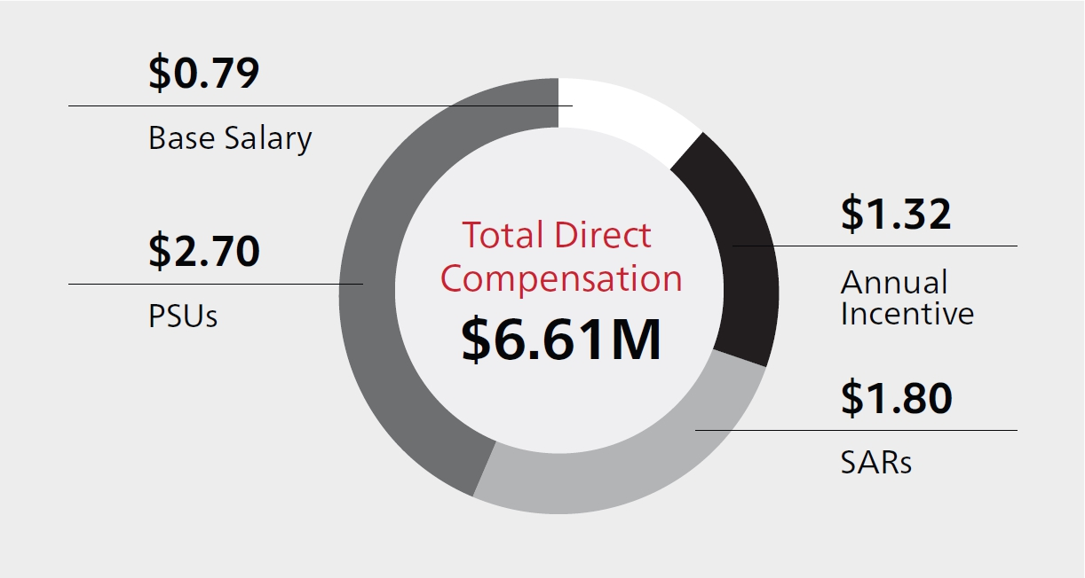
Compensation Overview

Base Salary. Mr. Brunk received a base salary increase from $750,000 to $790,000 in 2025. Following the adjustment, Mr. Brunk’s base salary is below the market median for his role.

Annual Incentive Award. The HCC Committee approved a performance factor of 143% of target for Collins Aerospace. The HCC Committee considered this factor, Mr. Brunk’s leadership of Collins Aerospace and the individual performance considerations noted here, and approved a $1.32 million award. This amount aligns with the Collins Aerospace performance factor.

Individual Performance Highlights

Mr. Brunk exhibited strong leadership driving Collins Aerospace results, including:
● | Significant financial achievements:
 | – | Net sales growth of 6.8% (GAAP and adjusted), which includes 9% organic sales growth.(1)
 | – | Return on sales of 16.3% (GAAP) and 16.2% (adjusted).(1)
 | – | Operating profit up 19% (GAAP) and 9% (adjusted).(1)
● | Customer wins and operational accomplishments:
 | – | Secured a $438 million Federal Aviation Administration contract to deploy next-generation surveillance radars that will modernize the National Airspace System.

 | – | Improved operational performance, achieving a 5% increase in on-time delivery.
 | – | Increased production volume to support an increase in aircraft production rates across our commercial platforms.
 | – | Demonstrated unprecedented speed and agility to support a critical next-generation encryption contract by achieving all major development milestones.
 | – | Advanced predictive health monitoring solutions for airlines as part of the Digital Alliance for Aviation.

(1) | See Appendix A on pages 99-101 for details.

RTX 2026 PROXY STATEMENT 57

Table of Contents
COMPENSATION DISCUSSION AND ANALYSIS
OTHER COMPENSATION ELEMENTS

Other Compensation Elements

Retirement and Deferred Compensation Benefits

Our retirement and deferred compensation plans play an important role in our executive compensation program by providing an element of financial security that helps us attract and retain talented executives. Over the years, we have modified these programs to maintain a competitive position within an evolving market. Many of our NEOs were previously employed by companies that RTX acquired over the years, and therefore retain balances and/or receive pension accruals under various formulas of these acquired companies’ plans that have since been closed.

DEFINED BENEFIT PLANS

The Company maintains the following qualified and nonqualified defined benefit plans that apply to our current NEOs:

Qualified Plans

● | The RTX Consolidated Pension Plan is an accumulation of all qualified pension plans of our legacy companies and companies acquired by our legacy companies.
 | – | For legacy UTC employees, the relevant plan was closed to new hires on December 31, 2009, and pre-2010 hires stopped accruing benefits on December 31, 2019, when the plan was frozen, except with respect to interest credits on the Cash Balance formula.
 | – | For legacy Rockwell Collins employees, the relevant plan was closed to new hires and employees stopped accruing benefits on September 30, 2006, when the plan was frozen. The plan was merged into the RTX Consolidated Pension Plan on December 31, 2018.

Nonqualified Plans

● | The nonqualified UTC Pension Preservation Plan (“UTC PPP”) was closed to new hires on December 31, 2009. Legacy UTC employees hired prior to 2010 stopped accruing benefits on December 31, 2019, when the plan was frozen, except with respect to interest credits on the Cash Balance formula under the plan.
● | The nonqualified Rockwell Collins Pension Plan was closed to new hires and employees stopped accruing benefits on September 30, 2006, when the plan was frozen. The plan was merged into the UTC PPP on December 31, 2018. The majority of the assets under this plan were distributed to participants upon UTC’s acquisition of Rockwell Collins in 2018, in accordance with the change-in-control provisions of this plan.

For additional details, refer to the Pension Benefits section on pages 69-70.

DEFINED CONTRIBUTION AND DEFERRED COMPENSATION PLANS

The Company maintains the following active and closed qualified and nonqualified defined contribution and deferred compensation plans that apply to our current NEOs:

Qualified Plans

● | Under the RTX Corporation Savings Plan (“RTX Savings Plan”), all plan participants are eligible to receive Company matching contributions, and for employees (like each of our NEOs) who do not accrue pension benefits under the RTX Consolidated Pension Plan, an additional age-based Company retirement contribution.

Nonqualified Plans

● | The RTX Corporation Compensation Deferral Plan (“RTX CDP”) provides eligible employees (including each of our NEOs) an opportunity to defer up to 50% of base salary and/or 80% of their annual incentive award. This plan also provides Company matching contributions, and, for employees not accruing pension benefits (like each of our NEOs), Company retirement contributions on eligible earnings above the Internal Revenue Code (“IRC”) limit applicable to the qualified RTX Savings Plan.
● | RTX executives are eligible to participate in the RTX Corporation Performance Share Unit Deferral Plan (“RTX PSU Deferral Plan”), which allows deferrals between 10%-100% of vested PSUs.
● | The UTC Savings Restoration Plan, the UTC Company Automatic Contribution Excess Plan and the UTC Deferred Compensation Plan (applicable to legacy UTC employees) were closed to new contributions on December 31, 2022. The Rockwell Collins Non-Qualified Savings Plan is also maintained by the Company but closed to new contributions. Account balances for these closed plans remain subject to each participant’s distribution elections.

For additional details, see the Nonqualified Deferred Compensation section on pages 71-72.

58 RTX 2026 PROXY STATEMENT

Table of Contents
COMPENSATION DISCUSSION AND ANALYSIS
OTHER COMPENSATION ELEMENTS

Perquisites and Other Benefits

Our approach to executive perquisites is based on the HCC Committee’s belief that the continued health and financial well-being of our senior leaders is of vital interest to the Company and our shareowners. The HCC Committee further believes that these benefits contribute to recruitment and retention of top talent and are consistent with market practice.

As one of the leading defense contractors to the U.S. government, we provide certain security benefits for our CEO (and Executive Chairman, if applicable), including personal use of the corporate aircraft, Company-provided cars and drivers (who are trained security personnel), and a home security benefit.

PERQUISITES AND BENEFITS(1)

Financial Planning |  | All NEOs are eligible to receive a financial planning allowance, which is capped at $13,500 annually.
Enhanced Basic Life Insurance |  | All NEOs are covered by an enhanced basic life insurance benefit while employed, equal to three times base salary.
Executive Physical |  | All NEOs are eligible to participate in the same healthcare benefits offered to other employees of the Company. They are also eligible for a comprehensive annual executive physical, a benefit that is capped at $5,000 annually.
ELG Long-Term Disability Insurance |  | The ELG long-term disability program supplements the Company’s standard disability benefit and is paid only upon an ELG member’s disability. This annual benefit is equal to 80% of the sum of the executive’s base salary and target annual incentive award at the time of disability.
Personal Aircraft Usage |  | RTX’s policy generally allows only our CEO to use the corporate aircraft for personal use, though special approval may be given to other executives in extraordinary circumstances. The HCC Committee believes this is essential for security and personal safety, in addition to allowing for more efficient use of time.
Company-Provided Car and Driver |  | For security and business efficiency reasons, our CEO has access to Company-provided cars and drivers (who are trained security personnel) when needed. They are primarily used for business purposes, but are also used in limited circumstances that have a personal element.
Security Benefit |  | The Company covers the cost of the installation, maintenance and monitoring of a security system at the personal residence of our CEO.
Entertainment and Sporting Events |  | RTX’s senior executives participate in community and philanthropic activities for the benefit of the Company. This may include attending various cultural, charitable, civic, entertainment and sporting events for business development and relationship-building purposes and/or community involvement, and may require the purchase of tickets, catering and parking. Tickets may also be used for team-building events and sometimes are provided to employees, including our senior executives, for personal use.
(1) | See footnote (6) of the Summary Compensation Table on page 65 for more details on these perquisites/benefits.

Severance and Change-in-Control Arrangements

EXECUTIVE LEADERSHIP GROUP PROGRAM

The ELG program covers the Company’s most senior leaders and key executives who are potential successors to senior leadership roles. The program has been in place since 1989, but has been modified over the years to align with best practices and to serve the evolving needs of the Company.

Program. The ELG program, which covers all of our NEOs, provides an RSU award with a grant value depending on role (currently no less than $1.5 million) upon an executive’s appointment to the ELG. The ELG RSU award acts as both a retention vehicle and cash severance replacement tool. The HCC Committee believes ELG RSUs more closely align our executives with the interest of our shareowners than a cash severance payment would.

ELG RSU awards vest only if there is a qualifying separation (defined on page 60) and the executive enters into an agreement containing certain restrictive covenants (explained on page 60). ELG RSUs earn dividend equivalents during the vesting period that are reinvested as additional RSUs each time the Company pays a dividend to shareowners. These RSUs are subject to the same vesting conditions as the underlying award.

RTX 2026 PROXY STATEMENT 59

Table of Contents
COMPENSATION DISCUSSION AND ANALYSIS
OTHER COMPENSATION ELEMENTS

From time to time, the HCC Committee has granted ELG RSU awards to supplement the original ELG RSU award granted upon ELG appointment. These supplemental awards are generally intended to reinforce the long-term retention needs of the Company for certain critical ELG talent, or in conjunction with a role expansion. Supplemental ELG RSUs carry the same terms and conditions as the ELG RSU grant made upon ELG appointment.

Qualifying Separation. Under the ELG program, a “qualifying separation” is defined as:

● | A mutually agreeable separation from the Company, including an ELG member’s position being eliminated or diminished by a divestiture, restructuring, shift in priorities or similar event following three years of ELG membership;
● | Retirement on or after age 62 following three years of ELG membership; or
● | Involuntary (not for cause) or voluntary (for good reason) terminations within two years after a change-in-control event.

Restrictive Covenants. Regardless of whether ELG separation benefits are provided, all ELG members are subject to the following restrictive covenants under the ELG program and/or the terms of the RTX LTIP (as defined below): (i) a duty to protect confidential, sensitive and proprietary information; (ii) a two-year, post-employment employee non-solicitation agreement; (iii) a one-year, post-employment noncompetition agreement; (iv) a two-year, post-employment non-disparagement agreement; and (v) an intellectual property agreement. Where ELG separation benefits are provided, ELG members are subject to: (a) an additional one-year, post-employment noncompetition agreement; (b) a release of claims against the Company; and (c) a post-employment cooperation agreement.

RTX CORPORATION LONG-TERM INCENTIVE PLAN

Under the RTX Corporation Long-Term Incentive Plan, as amended and restated (“RTX LTIP”), if a change-in-control event occurs and a plan participant has a qualifying termination within two years of that event, the vesting of outstanding LTI awards granted to such participant under the RTX LTIP would accelerate. For performance-based awards, performance goals would be deemed achieved at the greater of actual or target performance levels.

A change-in-control is defined in the RTX LTIP to generally mean:

● | The acquisition by a person or a group of 20% or more of RTX’s outstanding shares or the combined voting power of RTX’s outstanding voting securities entitled to vote generally in the election of directors;
● | Incumbent directors no longer constituting a majority of the Board;
● | A merger or similar event where RTX shareowners own less than 50% of the voting shares of the new organization; or
● | A complete liquidation or dissolution is approved by RTX’s shareowners.

A qualifying termination is defined in the RTX LTIP to mean:

● | An involuntary (not for cause) termination; or
● | A voluntary termination for “good reason” (as defined in the plan).

60 RTX 2026 PROXY STATEMENT

Table of Contents
COMPENSATION DISCUSSION AND ANALYSIS
OTHER EXECUTIVE COMPENSATION POLICIES AND PRACTICES

Other Executive Compensation Policies and Practices

We have adopted a number of practices and policies to help ensure that our executive compensation program operates as intended and aligns with our Guiding Principles (see page 42). In addition, the HCC Committee identifies, monitors and mitigates compensation risk in a number of important ways, as summarized on page 30.

Post-Employment Restrictive Covenants

ELG members may not engage in activities after termination or retirement that are detrimental to RTX, such as disclosing proprietary information, soliciting RTX employees or engaging in competitive activities. Violations can result in a clawback of annual and LTI awards.

Clawback Policies

RTX CORPORATION CLAWBACK POLICY

The RTX Corporation Clawback Policy—our comprehensive policy on recoupment of compensation—covers all RTX employees. We have enhanced this policy several times over the years in response to shareowner feedback and to ensure that it continues to meet the evolving needs of the Company.

Under this policy, in the event of a financial restatement (whether or not this involves misconduct on the part of the employee) or a recalculation of a financial metric affecting an award, the Company has the right to recover from any employee (including our NEOs and officers) annual incentive payments and gains realized from vested LTI awards (including both time-based and performance-based awards).

Clawbacks of annual incentive awards and time-based and performance-based LTI awards, as well as of compensation realized from prior awards, also may be triggered by violations of our Code of Conduct, failure to adhere to employee health and safety standards, violations of post-employment restrictive covenants or the exposure of RTX to excessive risk, as determined under our Enterprise Risk Management program. In addition, we have the right to recover compensation when an employee’s negligence (including negligent supervision of a subordinate) causes significant harm to RTX. If required or otherwise appropriate, the Company may publicly disclose the circumstances surrounding the HCC Committee’s decision to seek recoupment. The Policy can be found on the Corporate Governance page of our website at https://www.rtx.com/who-we-are/corporate-governance#documents.

RTX CORPORATION EXECUTIVE OFFICER CLAWBACK POLICY

The RTX Corporation Executive Officer Clawback Policy is intended to comply with Section 10D of the Exchange Act and Section 303A of the NYSE Listed Company Manual. This policy requires the Company to recoup erroneously awarded, covered incentive-based compensation from executive officers (as defined by the SEC) if any restatement is made to correct an error in previously issued financial statements due to material noncompliance with any financial reporting requirement under the securities laws. This policy supplements, but does not replace, the RTX Corporation Clawback Policy and can be found at https://www.rtx.com/who-we-are/corporate-governance#documents.

Equity Award Granting Policy

In December 2024, the Company adopted the RTX Corporation Equity Award Granting Policy. The policy provides that, in order to minimize the risk of award decisions being made while the Company is in possession of material non-public information, it is the Company’s intent to grant equity-based awards on regularly scheduled predetermined dates that fall outside of the period beginning four trading days before, and ending one trading day after, the filing or furnishing of any periodic report on Form 10-Q or Form 10-K, or any current report on Form 8-K that discloses material non-public information (“Grant Restriction Period”).

As outlined in the policy, annual equity-based awards to Company executives are to be granted within the two-week period following the first regularly scheduled Board or HCC Committee meeting for the year. From time to time, the Company may also grant equity-based awards in connection with a new hire, promotion, retention or for various other reasons. Such grants are to be made on the first trading day of each month, unless the HCC Committee approves an exception. If such planned date falls within a Grant Restriction Period, the grant date shall be postponed, to the extent practicable, to the first trading day following the Grant Restriction Period.

RTX 2026 PROXY STATEMENT 61

Table of Contents
COMPENSATION DISCUSSION AND ANALYSIS
OTHER EXECUTIVE COMPENSATION POLICIES AND PRACTICES

The RTX Corporation Board of Directors Deferred Stock Unit Plan outlines the grant timing for non-employee directors. Under the Plan, non-employee directors are granted annual Deferred Stock Unit awards on the date of our Annual Meeting of Shareowners. New directors joining the Board may be granted a whole or partial annual DSU award on the date they join the Board. For Board members appointed to a leadership role outside of the standard Board cycle, the grant date is the date of appointment.

Prohibitions on Certain Transactions Involving RTX Stock

RTX does not allow its directors, officers or executives to enter into short sales of RTX Common Stock. Similarly, directors and executive officers may not pledge or assign an interest in RTX Common Stock or other equity interests as collateral for a loan. Transactions in put options, call options or other derivative securities that have the effect of hedging the value of RTX securities are also prohibited, whether or not those securities were granted to or held, directly or indirectly, by the director, officer or employee. In addition, RTX’s LTIP generally prohibits buyouts/repricing of underwater stock options and SARs without shareowner approval.

Employment Agreements

As a general matter, the HCC Committee does not believe that fixed-term executive employment contracts guaranteeing minimum levels of compensation over multiple years enhance shareowner value. Accordingly, our U.S.-based executives do not have such contracts. However, in rare cases involving mergers and acquisitions, the HCC Committee has found such contracts to be in the Company’s best interests. In addition, over the years, the Company has acquired companies whose employees have existing contractual agreements. We also enter into employment agreements with executives based outside the U.S. when local regulations and practices require such agreements.

Tax Deductibility of Incentive Compensation

While the HCC Committee considers corporate tax deductibility as one of several relevant factors in determining compensation, it retains the flexibility to design and maintain executive compensation arrangements that it believes will attract and retain executive talent, even if such compensation is not deductible by the Company for federal income tax purposes. For 2025, RTX’s deduction is limited to $1 million for annual compensation paid to each of our NEOs, as defined in IRC Section 162(m).

62 RTX 2026 PROXY STATEMENT

Table of Contents
Report of the Human Capital &
Compensation Committee

The Human Capital & Compensation Committee establishes and oversees the design and function of RTX’s executive compensation program. We have reviewed and discussed the foregoing Compensation Discussion and Analysis with the management of the Company and have recommended to the Board of Directors that the Compensation Discussion and Analysis be included in RTX’s Proxy Statement for the 2026 Annual Meeting of Shareowners.

Human Capital & Compensation Committee
 | Tracy A. Atkinson, Chair |  | Fredric G. Reynolds
 | George R. Oliver |  | Brian C. Rogers
 | Ellen M. Pawlikowski

RTX 2026 PROXY STATEMENT 63

Table of Contents
Compensation Tables

Summary Compensation Table

Year |  | Salary  ($)(1) |  | Bonus  ($)(2) |  | Stock Awards  ($)(3) |  | Option Awards  ($)(4) |  | Change in Pension  Value and  Nonqualified  Deferred  Compensation  Earnings ($)(5) |  | All Other  Compensation  ($)(6) |  | Total  ($)
Christopher T. Calio Chairman, President & Chief Executive Officer(7)
2025 |  | $1,525,000 |  | $5,100,000 |  | $10,875,391 |  | $6,753,909 |  | $48,257 |  | $544,269 |  | $24,846,826
2024 |  | $1,182,500 |  | $2,760,000 |  | $8,315,559 |  | $5,379,072 |  | $0 |  | $367,700 |  | $18,004,831
2023 |  | $986,667 |  | $1,410,000 |  | $5,922,384 |  | $3,992,454 |  | $77,771 |  | $354,156 |  | $12,743,432
Neil G. Mitchill, Jr. Executive Vice President & Chief Financial Officer
2025 |  | $1,087,500 |  | $2,525,000 |  | $4,121,652 |  | $2,560,448 |  | $0 |  | $312,802 |  | $10,607,402
2024 |  | $1,031,250 |  | $1,500,000 |  | $3,387,907 |  | $2,191,232 |  | $0 |  | $235,983 |  | $8,346,372
2023 |  | $956,250 |  | $1,100,000 |  | $2,813,482 |  | $1,896,354 |  | $0 |  | $235,785 |  | $7,001,871
Philip J. Jasper President, Raytheon
2025 |  | $824,615 |  | $1,540,000 |  | $2,536,820 |  | $1,574,821 |  | $36,897 |  | $232,678 |  | $6,745,831
2024 |  | $724,167 |  | $950,000 |  | $2,001,902 |  | $1,294,720 |  | $0 |  | $175,444 |  | $5,146,233
Shane G. Eddy President, Pratt & Whitney
2025 |  | $832,500 |  | $1,425,000 |  | $2,536,820 |  | $1,574,821 |  | $10,707 |  | $231,545 |  | $6,611,393
2024 |  | $803,750 |  | $900,000 |  | $2,156,111 |  | $1,394,816 |  | $4,248 |  | $207,534 |  | $5,466,459
Troy D. Brunk President, Collins Aerospace
2025 |  | $781,111 |  | $1,320,000 |  | $2,219,718 |  | $1,378,423 |  | $20,906 |  | $171,660 |  | $5,891,818
2024 |  | $568,462 |  | $565,000 |  | $3,633,256 |  | $400,384 |  | $0 |  | $139,140 |  | $5,306,242
(1) | Salary. Base salary shown includes any midyear adjustments.
(2) | Bonus. Annual incentive awards provided under the RTX Corporation Executive Annual Incentive Plan are primarily based on measured performance against preestablished goals (as detailed on pages 48-49). However, the Human Capital & Compensation Committee (the “HCC Committee”) retains discretion to adjust annual incentive award amounts based on its assessment of overall performance. Consequently, we report annual incentive awards in the Bonus column rather than in a Non-Equity Incentive Plan Compensation column.
(3) | Stock Awards. Amounts shown include the grant date fair value of PSUs (with vesting assumed at 100% of target) granted in 2025 under the RTX Corporation Long-Term Incentive Plan, as amended and restated (“RTX LTIP”). The assumptions made in calculating the fair value of these awards are set forth in Note 19: Stock Based Compensation, to the Consolidated Financial Statements in RTX’s 2025 Annual Report on Form 10-K (“2025 Form 10-K”). For the 2025 PSUs, if the highest level of performance is achieved for all performance metrics, the grant date fair values would be: Mr. Calio, $17,679,568; Mr. Mitchill, $6,700,359; Mr. Jasper, $4,123,979; Mr. Eddy, $4,123,979; and Mr. Brunk, $3,608,481.
(4) | Option Awards. Amounts shown include the grant date fair value of SARs granted under the RTX LTIP during 2025. The assumptions made in the valuation of these awards are set forth in Note 19: Stock Based Compensation, to the Consolidated Financial Statements in RTX’s 2025 Form 10-K.
(5) | Change in Pension Value and Nonqualified Deferred Compensation Earnings. The amounts in this column reflect the change (if any) in the year-over-year actuarial present value of each NEO’s accrued benefit under the Company’s defined benefit plans. The legacy UTC pension plans were closed effective December 31, 2019, and the legacy Rockwell Collins pension plans were closed on September 30, 2006. As a result, for our NEOs, the change in pension value is entirely attributable to year-over-year changes in pension plan actuarial assumptions. Mr. Mitchill was hired after the legacy UTC pension plans were closed to new participants. Actuarial value computations are based on the assumptions established in accordance with FASB ASC Topic 715 and are discussed in Note 10: Employee Benefit Plans, to the Consolidated Financial Statements in RTX’s 2025 Form 10-K.

64 RTX 2026 PROXY STATEMENT

Table of Contents
COMPENSATION TABLES
SUMMARY COMPENSATION TABLE

(6) | All Other Compensation. The 2025 amounts in this column consist of the following items shown in the table below. See page 59 for details on executive perquisites and other benefits.

 | Name |  | Personal Use of  Corporate Aircraft(a) |  | Executive Life Insurance  Premiums(b) |  | Company Contributions to  Defined Contribution  Plans(c) |  | Health & Welfare  Benefits(d) |  | Misc.(e) |  | Total
 | C. Calio |  | $13,634 |  | $7,036 |  | $468,517 |  | $24,416 |  | $30,665 |  | $544,269
 | N. Mitchill, Jr. |  | $0 |  | $5,018 |  | $258,750 |  | $24,331 |  | $24,703 |  | $312,802
 | P. Jasper |  | $0 |  | $3,801 |  | $195,017 |  | $23,488 |  | $10,372 |  | $232,678
 | S. Eddy |  | $0 |  | $3,841 |  | $190,575 |  | $21,199 |  | $15,930 |  | $231,545
 | T. Brunk |  | $0 |  | $3,599 |  | $148,034 |  | $15,978 |  | $4,049 |  | $171,660
 | (a) | Incremental variable operating costs incurred for personal air travel, which includes fuel (calculated on the basis of aircraft-specific average consumption rates and fleet average fuel costs), fleet average landing and handling fees, crew lodging and meal allowances, and catering and hourly maintenance contract charges, when applicable. Because fleet-wide aircraft utilization is primarily for business purposes, capital and other fixed expenditures are not treated as an incremental cost.
 | (b) | Reflects premiums paid on an enhanced basic life insurance benefit equal to three times base salary.
 | (c) | Amounts represent total Company contributions into the Company’s defined contribution plans—the qualified RTX Corporation Savings Plan and the nonqualified RTX Corporation Compensation Deferral Plan. Under these plans, participants are eligible to receive Company matching contributions and age-based Company retirement contributions. However, Company retirement contributions are only provided to employees who are not accruing benefits under a Company pension plan. For further details on RTX’s qualified and nonqualified defined contribution plans, refer to pages 58 and 71-72 of this Proxy Statement.
 | (d) | Costs associated with annual executive physicals and Company-covered health and welfare benefits. The annual executive physical benefit is capped at $5,000.
 | (e) | Amounts include costs associated with membership and meeting attendance fees for an aerospace and defense industry club, a financial planning benefit, and personal use of a Company-provided car and driver used for security purposes for Mr. Calio, as well as costs associated with a spouse joining an executive at business events, employee gifts, medical transportation services, and other incidental items. Further, RTX’s senior executives participate in community and philanthropic activities for the benefit of the Company. This may include attending various cultural, charitable, civic, entertainment and sporting events for business development and relationship-building purposes and/or community involvement, and may require the purchase of tickets, catering and parking. Tickets may also be used for team-building events and sometimes are provided to employees, including our senior executives, for personal use; the incremental cost of such use is included in this column.
(7) | Mr. Calio served as President & Chief Executive Officer until April 30, 2025, when he assumed the role of Chairman of the Board, becoming Chairman, President & Chief Executive Officer.

RTX 2026 PROXY STATEMENT 65

Table of Contents
COMPENSATION TABLES
GRANTS OF PLAN-BASED AWARDS

Grants of Plan-Based Awards

 |  |  |  | Estimated Future Payouts under Equity  Incentive Plan Awards(1) |  |  |  |  |  | All Other Option  Awards: Number  of Securities  Underlying  Options (#)(2) |  | Exercise or Base  Price of Option  Awards ($/Sh)(3) |  | Grant Date Fair  Value of Stock  and Option  Awards ($)(4)
Grant Date |  | Approval  Date |  | Threshold (#) |  | Target (#) |  | Maximum (#) |  |  |  | Exercise or Base  Price of Option  Awards ($/Sh)(3) |  | Grant Date Fair  Value of Stock  and Option  Awards ($)(4)
C. Calio
2/6/2025 |  | 1/31/2025 |  | 2,997 |  | 79,910 |  | 159,820 |  | – |  | – |  | $10,875,391
2/6/2025 |  | 1/31/2025 |  | – |  | – |  | – |  | 185,700 |  | $128.78 |  | $6,753,909
N. Mitchill, Jr.
2/6/2025 |  | 1/31/2025 |  | 1,136 |  | 30,285 |  | 60,570 |  | – |  | – |  | $4,121,652
2/6/2025 |  | 1/31/2025 |  | – |  | – |  | – |  | 70,400 |  | $128.78 |  | $2,560,448
P. Jasper
2/6/2025 |  | 1/31/2025 |  | 699 |  | 18,640 |  | 37,280 |  | – |  | – |  | $2,536,820
2/6/2025 |  | 1/31/2025 |  | – |  | – |  | – |  | 43,300 |  | $128.78 |  | $1,574,821
S. Eddy
2/6/2025 |  | 1/31/2025 |  | 699 |  | 18,640 |  | 37,280 |  | – |  | – |  | $2,536,820
2/6/2025 |  | 1/31/2025 |  | – |  | – |  | – |  | 43,300 |  | $128.78 |  | $1,574,821
T. Brunk
2/6/2025 |  | 1/31/2025 |  | 612 |  | 16,310 |  | 32,620 |  | – |  | – |  | $2,219,718
2/6/2025 |  | 1/31/2025 |  | – |  | – |  | – |  | 37,900 |  | $128.78 |  | $1,378,423
(1) | Reflects the number of PSUs granted under the RTX LTIP during 2025, which vest based on Company performance relative to four performance metrics and the executive’s continued employment, except in the case of death, disability, qualifying separation within two years of a change-in-control, retirement or certain involuntary terminations. Vesting occurs following the three-year performance period with payouts ranging from 3.75%, if threshold performance is achieved for one of the TSR metrics that are weighted at 15%, to a maximum payout of 200%, if maximum performance is achieved for all four metrics. If RTX’s three-year TSR is negative, the payout for each TSR portion of the award is capped at 100%, regardless of RTX’s performance relative to the companies within the S&P 500 Index and our Core A&D Peers. Unvested PSUs do not earn dividend equivalents. Vested PSUs are settled in unrestricted shares of RTX Common Stock at the end of the performance period following the HCC Committee’s review and approval of performance achievement levels.
(2) | Reflects the number of SARs granted under the RTX LTIP during 2025, which vest and become exercisable three years from the grant date. Vesting is subject to the executive’s continued employment, except in the case of death, disability, qualifying separation within two years of a change-in-control, retirement and certain involuntary terminations. Exercised SARs are settled in unrestricted shares of RTX Common Stock.
(3) | The SAR exercise price equals the NYSE closing price of RTX Common Stock on the grant date.
(4) | Reflects the grant date fair value of awards granted in 2025, with vesting assumed at 100% of target for PSUs. Values are calculated in accordance with FASB ASC Topic 718 but exclude the effect of estimated forfeitures.

66 RTX 2026 PROXY STATEMENT

Table of Contents
COMPENSATION TABLES
OUTSTANDING EQUITY AWARDS AT FISCAL YEAR-END

Outstanding Equity Awards at Fiscal Year-End

 |  | Option Awards |  |  |  |  |  |  |  | Stock Awards
Grant Date |  | Number of  Securities  Underlying  Unexercised  Options (#)  (Exercisable) |  | Number of  Securities  Underlying  Unexercised  Options (#)  (Unexercisable)(1) |  | Option  Exercise  Price ($)(2) |  | Option  Expiration  Date |  | Number of  Shares or  Units of Stock  That Have Not  Vested (#) |  | Market Value of  Shares or Units  of Stock That  Have Not  Vested ($)(3) |  | Equity Incentive  Plan Awards:  Number of  Unearned  Shares, Units or  Other Rights  That Have Not  Vested (#)(4) |  | Equity Incentive  Plan Awards:  Market or  Payout Value of  Unearned  Shares, Units or  Other Rights  That Have Not  Vested ($)(5)
C. Calio
2/6/2025 |  | – |  | 185,700 |  | $128.78 |  | 2/5/2035 |  | – |  | – |  | 159,820 |  | $29,310,988
2/8/2024 |  | – |  | 247,200 |  | $91.04 |  | 2/7/2034 |  | – |  | – |  | 177,950 |  | $32,636,030
2/8/2023 |  | – |  | 161,900 |  | $97.65 |  | 2/7/2033 |  | – |  | – |  | 89,710 |  | $16,452,759
2/15/2022 |  | 135,400 |  | – |  | $94.04 |  | 2/14/2032 |  | – |  | – |  | – |  | –
2/8/2021 |  | 43,900 |  | – |  | $72.49 |  | 2/7/2031 |  | – |  | – |  | – |  | –
2/4/2020 |  | 91,912 |  | – |  | $90.73 |  | 2/3/2030 |  | – |  | – |  | – |  | –
2/5/2019 |  | 54,810 |  | – |  | $71.62 |  | 2/4/2029 |  | – |  | – |  | – |  | –
1/2/2018 |  | 31,199 |  | – |  | $76.00 |  | 1/1/2028 |  | – |  | – |  | – |  | –
1/18/2017 |  | – |  | – |  | – |  | – |  | 18,765(6) |  | $3,441,501 |  | – |  | –
N. Mitchill, Jr.
2/6/2025 |  | – |  | 70,400 |  | $128.78 |  | 2/5/2035 |  | – |  | – |  | 60,570 |  | $11,108,538
2/8/2024 |  | – |  | 100,700 |  | $91.04 |  | 2/7/2034 |  | – |  | – |  | 72,500 |  | $13,296,500
2/8/2023 |  | – |  | 76,900 |  | $97.65 |  | 2/7/2033 |  | – |  | – |  | 42,617 |  | $7,816,031
2/15/2022 |  | 77,400 |  | – |  | $94.04 |  | 2/14/2032 |  | – |  | – |  | – |  | –
4/26/2021 |  | 16,900 |  | – |  | $81.00 |  | 4/25/2031 |  | – |  | – |  | – |  | –
2/8/2021 |  | 18,900 |  | – |  | $72.49 |  | 2/7/2031 |  | – |  | – |  | – |  | –
2/4/2020 |  | 52,280 |  | – |  | $90.73 |  | 2/3/2030 |  | – |  | – |  | – |  | –
2/5/2019 |  | 46,377 |  | – |  | $71.62 |  | 2/4/2029 |  | – |  | – |  | – |  | –
1/2/2018 |  | 19,394 |  | – |  | $76.00 |  | 1/1/2028 |  | – |  | – |  | – |  | –
1/18/2017 |  | – |  | – |  | – |  | – |  | 18,765(6) |  | $3,441,501 |  | – |  | –
P. Jasper
2/6/2025 |  | – |  | 43,300 |  | $128.78 |  | 2/5/2035 |  | – |  | – |  | 37,280 |  | $6,837,152
2/8/2024 |  | – |  | 59,500 |  | $91.04 |  | 2/7/2034 |  | – |  | – |  | 42,840 |  | $7,856,856
2/8/2023 |  | – |  | 21,900 |  | $97.65 |  | 2/7/2033 |  | 2,832(7) |  | $519,389 |  | 8,074 |  | $1,480,735
2/15/2022 |  | 26,100 |  | – |  | $94.04 |  | 2/14/2032 |  | – |  | – |  | – |  | –
2/8/2021 |  | 16,100 |  | – |  | $72.49 |  | 2/7/2031 |  | – |  | – |  | – |  | –
2/4/2020 |  | 37,945 |  | – |  | $90.73 |  | 2/3/2030 |  | – |  | – |  | – |  | –
1/28/2020 |  | – |  | – |  | – |  | – |  | 12,684(6) |  | $2,326,246 |  | – |  | –
2/5/2019 |  | 23,552 |  | – |  | $71.62 |  | 2/4/2029 |  | – |  | – |  | – |  | –

RTX 2026 PROXY STATEMENT 67

Table of Contents
COMPENSATION TABLES
OUTSTANDING EQUITY AWARDS AT FISCAL YEAR-END

 |  | Option Awards |  |  |  |  |  |  |  | Stock Awards
Grant Date |  | Number of  Securities  Underlying  Unexercised  Options (#)  (Exercisable) |  | Number of  Securities  Underlying  Unexercised  Options (#)  (Unexercisable)(1) |  | Option  Exercise  Price ($)(2) |  | Option  Expiration  Date |  | Number of  Shares or  Units of Stock  That Have Not  Vested (#) |  | Market Value of  Shares or Units  of Stock That  Have Not  Vested ($)(3) |  | Equity Incentive  Plan Awards:  Number of  Unearned  Shares, Units or  Other Rights  That Have Not  Vested (#)(4) |  | Equity Incentive  Plan Awards:  Market or  Payout Value of  Unearned  Shares, Units or  Other Rights  That Have Not  Vested ($)(5)
S. Eddy
2/6/2025 |  | – |  | 43,300 |  | $128.78 |  | 2/5/2035 |  | – |  | – |  | 37,280 |  | $6,837,152
2/8/2024 |  | – |  | 64,100 |  | $91.04 |  | 2/7/2034 |  | – |  | – |  | 46,140 |  | $8,462,076
2/8/2023 |  | – |  | 56,700 |  | $97.65 |  | 2/7/2033 |  | – |  | – |  | 31,405 |  | $5,759,604
2/15/2022 |  | 58,000 |  | – |  | $94.04 |  | 2/14/2032 |  | – |  | – |  | – |  | –
2/8/2021 |  | 16,600 |  | – |  | $72.49 |  | 2/7/2031 |  | – |  | – |  | – |  | –
2/4/2020 |  | 40,475 |  | – |  | $90.73 |  | 2/3/2030 |  | – |  | – |  | – |  | –
2/5/2019 |  | 38,000 |  | – |  | $71.62 |  | 2/4/2029 |  | – |  | – |  | – |  | –
11/1/2016 |  | – |  | – |  | – |  | – |  | 30,753(6) |  | $5,640,100 |  | – |  | –
T. Brunk
2/6/2025 |  | – |  | 37,900 |  | $128.78 |  | 2/5/2035 |  | – |  | – |  | 32,620 |  | $5,982,508
12/18/2024 |  | – |  | – |  | – |  | – |  | 17,790(6) |  | $3,262,686 |  | – |  | –
3/1/2024 |  | – |  | – |  | – |  | – |  | 11,527(6) |  | $2,114,052 |  | – |  | –
2/8/2024 |  | – |  | 18,400 |  | $91.04 |  | 2/7/2034 |  | 2,199(7) |  | $403,297 |  | 8,790 |  | $1,612,086
2/8/2023 |  | – |  | 12,600 |  | $97.65 |  | 2/7/2033 |  | 2,442(7) |  | $447,863 |  | 3,482 |  | $638,617
(1) | SARs scheduled to vest on the third anniversary of the grant date, subject to the executive’s continued employment with the Company, except in the case of death, disability, qualifying separation within two years of a change-in-control, retirement and certain involuntary terminations. SARs granted on February 8, 2023, vested on February 8, 2026.
(2) | The exercise price of each SAR is equal to the NYSE closing price of RTX Common Stock on the grant date. However, for SARs granted prior to April 3, 2020, exercise prices shown were adjusted upon the spinoffs of Carrier and Otis, in accordance with plan rules and the Employee Matters Agreement, as amended.
(3) | Calculated by multiplying the number of unvested RSUs by the NYSE closing price of RTX Common Stock on the last trading day of 2025.
(4) | PSUs scheduled to vest following the three-year performance/time-based vesting period. Vesting is subject to Company performance relative to preestablished performance goals and the executive’s continued employment with the Company, except in the case of death, disability, qualifying separation within two years of a change-in-control, retirement and certain involuntary terminations. PSUs are settled following the HCC Committee’s certification of performance achievement levels. Pursuant to SEC rules, the number of shares shown with respect to PSU awards granted in 2024 and 2025 assumes maximum-level performance, based on vesting estimates as of December 31, 2025. For PSUs granted on February 8, 2023, a performance factor of 146% is shown, reflecting the number of shares that vested on February 8, 2026.
(5) | Calculated by multiplying the number of unvested PSUs by the NYSE closing price of RTX Common Stock on the last trading day of 2025.
(6) | ELG RSUs vest in the event of a qualifying separation (as defined under the ELG program and detailed on pages 59-60), death or disability. Each time the Company pays a dividend to shareowners, dividend equivalents are reinvested as additional RSUs. The reinvested RSUs vest on the same date as the underlying RSUs.
(7) | RSUs scheduled to vest on the third anniversary of the grant date, subject to the executive’s continued employment with the Company, except in the case of death, disability, qualifying separation within two years of a change-in-control, retirement and certain involuntary terminations. Each time the Company pays a dividend to shareowners, dividend equivalents are reinvested as additional RSUs. The reinvested RSUs vest on the same date as the underlying RSUs. RSUs granted on February 8, 2023, vested on February 8, 2026.

68 RTX 2026 PROXY STATEMENT

Table of Contents
COMPENSATION TABLES
OPTIONS EXERCISED AND STOCK VESTED

Options Exercised and Stock Vested

 |  | Option Awards |  |  |  | Stock Awards
Name |  | Number of Shares  Acquired on Exercise (#)(1) |  | Value Realized  on Exercise ($)(2) |  | Number of Shares  Acquired on Vesting (#)(3) |  | Value Realized  on Vesting ($)(4)
C. Calio |  | 8,938 |  | $858,639 |  | 49,132 |  | $6,014,248
N. Mitchill, Jr. |  | 8,938 |  | $872,723 |  | 28,078 |  | $3,437,028
P. Jasper |  | 23,500 |  | $2,029,569 |  | 9,281 |  | $1,136,087
S. Eddy |  | 58,235 |  | $4,559,226 |  | 21,060 |  | $2,577,955
T. Brunk |  | 18,773 |  | $1,187,901 |  | 3,962 |  | $489,064
(1) | RTX SARs exercised during 2025.
(2) | Calculated by multiplying the number of RTX SARs exercised by the difference between the market price of RTX Common Stock on the exercise date and the exercise price of the award.
(3) | PSUs and RSUs that vested in 2025, including shares withheld to cover U.S. Social Security and Medicare taxes due during the year as a result of the executive attaining retirement-eligible status under the terms of RTX RSU awards.
(4) | Calculated by multiplying the number of vested PSUs and RSUs by the market price of RTX Common Stock on the vest date. Mr. Brunk deferred $301,006 of his 2022 PSUs into the RTX PSU Deferral Plan (see pages 71-72).

Pension Benefits

Overview of Plans. Like many other RTX employees, some of our NEOs were previously employed by companies that we acquired over the years. Benefit accruals earned under the Company’s pension plans depend upon the employee’s legacy company, the date the employee was hired and the pension formula in use at the time of the accrual.

For our current NEOs, the following Company pension plans apply:

RTX Consolidated Pension Plan: A tax-qualified, defined benefit plan that is an accumulation of all qualified pension plans of our legacy companies.

● | For legacy UTC participants, such as Messrs. Calio and Eddy, annual compensation and annual retirement benefits up to IRC limits are recognized through December 31, 2019, the date the relevant plan was frozen.
● | For legacy Rockwell Collins participants, such as Messrs. Jasper and Brunk, annual compensation and annual retirement benefits up to IRC limits are recognized through September 30, 2006, the date the relevant plan was frozen.

UTC Pension Preservation Plan (“UTC PPP”): An unfunded, nonqualified defined benefit plan that mirrors the benefit formulas, retirement eligibility provisions and vesting requirements that applied to legacy UTC and Rockwell Collins participants, respectively, under the RTX Consolidated Pension Plan, but provides benefits that could not be accrued under the qualified plan due to IRC limits. The Rockwell Collins Non-Qualified Pension Plan was merged into the UTC PPP in 2018. Benefit formulas under the UTC PPP were frozen at the same time as their equivalent qualified pension plans.

Pension Formula

Legacy UTC: Legacy UTC employees hired prior to July 1, 2002, were eligible for a final average earnings (“FAE”) formula through December 31, 2014. After that, they transitioned to a Cash Balance formula (which was already in use for those hired on or after July 1, 2002, and before January 1, 2010). The legacy UTC pension plans were frozen on December 31, 2019. There was no pension benefit for those hired in 2010 or later.

Messrs. Calio and Eddy accrued benefits under the Cash Balance formula only. Mr. Mitchill was hired after January 1, 2010, and was never eligible to participate in the legacy UTC pension plans. The legacy UTC FAE formula and Cash Balance formula are described in detail in our prior proxy statements.

Legacy Rockwell Collins: For legacy Rockwell Collins employees, including Messrs. Jasper and Brunk, benefits were accrued under an FAE formula under the frozen Rockwell Collins qualified and nonqualified pension plans.

RTX 2026 PROXY STATEMENT 69

Table of Contents
COMPENSATION TABLES
PENSION BENEFITS

Distribution Options. Under the RTX Consolidated Pension Plan, legacy UTC participants can take distributions as either a lump sum or as annuity payments, while annuity payments are the only option for legacy Rockwell Collins participants. Under the UTC PPP, in addition to lump-sum and annuity payments, legacy UTC participants may elect annual installments over periods between two and ten years. For legacy Rockwell Collins participants of the UTC PPP, a lump-sum option is available on the post-2004 portion of the benefit, in addition to monthly annuity options. The form of payment for nonqualified plans was generally required to be elected in advance of earning benefits under the plans.

Retirement. For both legacy UTC and Rockwell Collins participants, the normal retirement age is 65, with early retirement benefits available under the FAE formula beginning at age 55. FAE benefits are reduced for early retirement prior to age 62. The value of the legacy UTC Cash Balance account is not impacted by an employee’s age at retirement. As of December 31, 2025, Messrs. Jasper and Brunk were eligible for early retirement under the FAE formula of their respective plans.

Name |  | Plan Name |  | Number of Years  of Credited Service (#) |  | Present Value of  Accumulated  Benefit ($)(1) |  | Payments During  Last Fiscal Year ($)
C. Calio(2) |  | RTX Consolidated Pension Plan |  | 15 |  | $296,948 |  | –
C. Calio(2) |  | UTC Pension Preservation Plan |  | 15 |  | $253,104 |  | –
C. Calio(2) |  | Total |  | – |  | $550,052 |  | –
N. Mitchill, Jr.(3) |  | RTX Consolidated Pension Plan |  | – |  | – |  | –
N. Mitchill, Jr.(3) |  | UTC Pension Preservation Plan |  | – |  | – |  | –
N. Mitchill, Jr.(3) |  | Total |  | – |  | – |  | –
P. Jasper(4) |  | RTX Consolidated Pension Plan |  | 15 |  | $358,293 |  | –
P. Jasper(4) |  | UTC Pension Preservation Plan |  | 15 |  | $11,641 |  | –
P. Jasper(4) |  | Total |  | – |  | $369,934 |  | –
S. Eddy(2) |  | RTX Consolidated Pension Plan |  | 6 |  | $181,674 |  | –
S. Eddy(2) |  | UTC Pension Preservation Plan |  | – |  | – |  | –
S. Eddy(2) |  | Total |  | – |  | $181,674 |  | –
T. Brunk(4) |  | RTX Consolidated Pension Plan |  | 15 |  | $204,074 |  | –
T. Brunk(4) |  | UTC Pension Preservation Plan |  | – |  | – |  | –
T. Brunk(4) |  | Total |  | – |  | $204,074 |  | –
(1) | The assumptions used to determine the present value of the accumulated pension benefit under the Company’s pension plans are generally consistent with those described in Note 10: Employee Benefit Plans, to the Consolidated Financial Statements in RTX’s 2025 Form 10-K. More specifically, discount rates ranging from 5.08% to 5.25% for the various pension plans, Pri-2012 mortality table with a plan-specific adjustment and MP-2021 to project future improvements are used.
(2) | The following additional assumptions are used to determine the present value of the accumulated pension benefit under the legacy UTC pension plans: (i) retirement at age 65 for Cash Balance benefits, because benefits are actuarially reduced for commencements prior to normal retirement age (age 65); and (ii) a lump-sum payment for benefits accrued under the Cash Balance formula of the RTX Consolidated Pension Plan and the UTC Pension Preservation Plan.
(3) | Mr. Mitchill was hired after January 1, 2010, and therefore does not participate in the legacy UTC pension plans.
(4) | The present value of the accumulated benefits shown for Messrs. Jasper and Brunk are based on benefits earned under the legacy Rockwell Collins qualified and nonqualified defined benefit pension plans, which were frozen on September 30, 2006, and have since merged into the RTX Consolidated Pension Plan and the UTC Pension Preservation Plan, respectively. The number of years of credited service reflects the years of service they had when the plans were frozen. Benefit calculations are based on age, years of service and average annual base salary and annual incentives. All of Mr. Brunk’s nonqualified pension benefits, and a portion of Mr. Jasper’s nonqualified pension benefit, were previously distributed upon UTC’s acquisition of Rockwell Collins in a lump-sum payment in accordance with the change-in-control provisions in that plan. The following assumptions are also used: (i) retirement at age 62, the earliest date a participant can retire without a reduction of benefits due to age; and (ii) 100% life annuity for benefits under the plan.

70 RTX 2026 PROXY STATEMENT

Table of Contents
COMPENSATION TABLES
NONQUALIFIED DEFERRED COMPENSATION

Nonqualified Deferred Compensation

Active Plans. RTX maintains the following nonqualified deferred compensation plans that remain open to new contributions.

Plan Name |  | Description
RTX Corporation Compensation Deferral Plan (“RTX CDP”) |  | The RTX CDP is an unfunded, nonqualified defined contribution plan that opened on January 1, 2023, and provides eligible employees an opportunity to defer up to 50% of base salary and/or 80% of annual incentive awards. Participants receive Company matching and Company retirement contributions (if eligible) once they can no longer receive these contributions into the qualified RTX Corporation Savings Plan due to IRC limits. Participants who accrue benefits under a Company-sponsored pension plan are not eligible for Company retirement contributions into this plan.  The RTX CDP also provides missed Company matching and Company retirement contributions (if applicable) for employees who have not reached the annual IRC compensation limit, but whose contributions to the qualified RTX Corporation Savings Plan exceed the IRC annual contributions limit for the year. Participants are immediately vested in their own deferrals and vest in Company contributions upon the earlier of: (i) two years of service with the Company; (ii) reaching age 65 ; or (iii) reaching age 55 and terminating employment with the Company. Distributions of Company contributions begin upon a separation of service. Participants may elect to begin distributions of employee deferrals either upon separation of service from the Company or upon a future date selected by the participant (which may be no earlier than three years from the date the election was made). RTX CDP balances are distributed in cash, in a lump-sum payment or in annual installments over periods ranging from two to 15 years per the participant’s election.
RTX Corporation Performance Share Unit Deferral Plan (“RTX PSU Deferral Plan”) |  | The RTX PSU Deferral Plan is an unfunded, nonqualified deferred compensation arrangement that enables executives to defer between 10% and 100% of their vested PSU awards that would otherwise be settled in unrestricted shares of RTX Common Stock. The deferred portion of the PSU award is converted into deferred stock units that accrue dividend equivalents. Participants may elect to receive distributions from the plan in a lump sum or in two to 15 annual installments, either upon separation of service from the Company or at a future date selected by the participant (which may be no earlier than three years from the year the PSUs are deferred). Distributions are made in whole shares of RTX Common Stock with any fractional units paid in cash.

Closed Plans. Some of our NEOs were previously employed by companies that we acquired over the years, and thus retain balances in nonqualified deferred compensation plans of these acquired companies that have since been closed to new contributions. In addition, we have closed some of our legacy plans to allow for consistent benefits regardless of an employee’s legacy employer.

Our NEOs hold balances in the following closed nonqualified deferred compensation plans: (i) UTC Company Automatic Contribution Excess Plan, which closed on December 31, 2022; (ii) UTC Deferred Compensation Plan, which closed on December 31, 2022; (iii) UTC Savings Restoration Plan, which closed on December 31, 2022; (iv) Rockwell Collins Non-Qualified Savings Plan, which closed on December 31, 2019; and (v) Rockwell Collins Deferred Compensation Plan, which closed on December 31, 2019. Details on these plans can be found in our previous proxy statements.

Name |  | Plan |  | Executive  Contributions  in Last FY ($)(1) |  | Registrant  Contributions  in Last FY ($)(2) |  | Aggregate  Earnings in  Last FY ($)(3) |  | Aggregate  Withdrawals/  Distributions ($) |  | Aggregate  Balance at  Last FYE ($)(4)
C. Calio |  | RTX Compensation Deferral Plan |  | $238,975 |  | $434,767 |  | $177,195 |  | $0 |  | $1,735,536
C. Calio |  | UTC Company Automatic Contribution Excess Plan |  | $0 |  | $0 |  | $15,064 |  | $0 |  | $339,883
C. Calio |  | UTC Savings Restoration Plan |  | $0 |  | $0 |  | $256,478 |  | $0 |  | $962,445
N. Mitchill, Jr. |  | RTX Compensation Deferral Plan |  | $142,125 |  | $223,750 |  | $175,397 |  | $0 |  | $1,207,736
N. Mitchill, Jr. |  | UTC Company Automatic Contribution Excess Plan |  | $0 |  | $0 |  | $56,147 |  | $0 |  | $434,972
N. Mitchill, Jr. |  | UTC Savings Restoration Plan |  | $0 |  | $0 |  | $342,932 |  | $0 |  | $1,309,530
P. Jasper |  | RTX Compensation Deferral Plan |  | $99,081 |  | $156,517 |  | $114,850 |  | $0 |  | $370,703
P. Jasper |  | UTC Company Automatic Contribution Excess Plan |  | $0 |  | $0 |  | $38,816 |  | $0 |  | $191,994
P. Jasper |  | UTC Savings Restoration Plan |  | $0 |  | $0 |  | $139,981 |  | $0 |  | $342,152
P. Jasper |  | Rockwell Collins Deferred Compensation Plan |  | $0 |  | $0 |  | $37,232 |  | $0 |  | $200,966
P. Jasper |  | Rockwell Collins Non-Qualified Savings Plan |  | $0 |  | $0 |  | $442,774 |  | $0 |  | $1,146,311

RTX 2026 PROXY STATEMENT 71

Table of Contents
COMPENSATION TABLES
NONQUALIFIED DEFERRED COMPENSATION

Name |  | Plan |  | Executive  Contributions  in Last FY ($)(1) |  | Registrant  Contributions  in Last FY ($)(2) |  | Aggregate  Earnings in  Last FY ($)(3) |  | Aggregate  Withdrawals/  Distributions ($) |  | Aggregate  Balance at  Last FYE ($)(4)
S. Eddy |  | RTX Compensation Deferral Plan |  | $93,825 |  | $155,433 |  | $153,643 |  | $0 |  | $1,062,489
S. Eddy |  | UTC Company Automatic Contribution Excess Plan |  | $0 |  | $0 |  | $55,079 |  | $0 |  | $419,245
S. Eddy |  | UTC Savings Restoration Plan |  | $0 |  | $0 |  | $311,770 |  | $0 |  | $1,216,388
T. Brunk |  | RTX Compensation Deferral Plan |  | $220,510 |  | $109,534 |  | $117,722 |  | $0 |  | $756,540
T. Brunk |  | UTC Company Automatic Contribution Excess Plan |  | $0 |  | $0 |  | $24,489 |  | $0 |  | $139,994
T. Brunk |  | UTC Savings Restoration Plan |  | $0 |  | $0 |  | $50,929 |  | $0 |  | $150,081
T. Brunk |  | UTC Deferred Compensation Plan |  | $0 |  | $0 |  | $128,748 |  | $0 |  | $721,033
T. Brunk |  | RTX PSU Deferral Plan |  | $289,745 |  | $0 |  | $328,159 |  | $0 |  | $336,215
T. Brunk |  | Rockwell Collins Non-Qualified Savings Plan |  | $0 |  | $0 |  | $14,422 |  | $0 |  | $38,526
(1) | Amounts shown are included in the Salary and Bonus columns of the Summary Compensation Table on page 64, except for contributions into the RTX PSU Deferral Plan, which are included in the Options Exercised and Stock Vested table on page 69.
(2) | Amounts shown are included in the All Other Compensation column of the Summary Compensation Table on page 64.
(3) | Amounts shown reflect hypothetical investment returns (less fees, if applicable) based on fixed income, bond and equity indices selected by the participant. Participants also may elect RTX stock units with dividend reinvestments (except under the UTC Company Automatic Contribution Excess Plan). These returns do not constitute above-market earnings.
(4) | The sum of contributions (by both the executive and RTX) and credited earnings on those prior deferrals, less withdrawals. Of these totals, the following amounts have been included in the Summary Compensation Table in prior years: Mr. Calio, $1,245,996; Mr. Mitchill, $1,210,024; Mr. Jasper, $139,695; Mr. Eddy, $274,999; and Mr. Brunk, $216,434.

72 RTX 2026 PROXY STATEMENT

Table of Contents
COMPENSATION TABLES
POTENTIAL PAYMENTS UPON TERMINATION OR CHANGE-IN-CONTROL

Potential Payments upon Termination or Change-in-Control

For descriptions of our Executive Leadership Group (“ELG”) program and the RTX Corporation Long-Term Incentive Plan (“RTX LTIP”), see pages 59-60.

CHRISTOPHER T. CALIO

The table below shows the estimated value of payments and benefits that Mr. Calio would have been entitled to receive had his employment terminated on December 31, 2025, under various hypothetical circumstances.

 |  | Involuntary Separation  (for Cause)(1) |  | Involuntary Separation  (without Cause)(2) |  | Voluntary  Separation(3) |  | Separation following a  Change-in-Control(4)
Annual Incentive Award(5) |  | $0 |  | $3,100,000 |  | $0 |  | $3,100,000
Pension(6) |  | $0 |  | $0 |  | $0 |  | $0
Health & Welfare Continuation(7) |  | $0 |  | $39,566 |  | $0 |  | $39,566
Accrued Paid Time Off |  | $0 |  | $0 |  | $0 |  | $0
Option Awards(8) |  | $0 |  | $36,714,317 |  | $36,714,317 |  | $46,857,251
Stock Awards(8) |  | $0 |  | $52,530,290 |  | $49,088,789 |  | $81,841,278
Total |  | $0 |  | $92,384,173 |  | $85,803,106 |  | $131,838,095
(1) | Outstanding LTI awards would be forfeited upon an involuntary separation for cause.
(2) | As of December 31, 2025, Mr. Calio had attained retirement eligibility status under the terms of the RTX LTIP. As a result, in the event of an involuntary separation (without cause), his annual LTI awards would receive the beneficial treatment reserved for retirement-eligible employees. These awards, if outstanding for more than one year, would be treated as follows: (i) SARs would vest; and (ii) PSUs would remain eligible to vest on the original vesting date, subject to the achievement of Company performance goals. An involuntary (without cause) separation would constitute a qualifying separation under the terms of the ELG RSU awards and as a result, those RSUs would vest. Annual LTI awards outstanding for less than one year would be forfeited.
(3) | As of December 31, 2025, Mr. Calio had attained retirement eligibility status under the terms of the RTX LTIP. As a result, in the event of a voluntary separation, his annual LTI awards would receive the beneficial treatment reserved for retirement-eligible employees. These awards, if outstanding for more than one year, would be treated as follows: (i) SARs would vest; and (ii) PSUs would remain eligible to vest on the original vesting date, subject to the achievement of Company performance goals. Annual LTI awards outstanding for less than one year and his ELG RSU award, which does not carry beneficial retirement treatment, would be forfeited in the case of a voluntary separation from the Company, unless the terms of Mr. Calio’s separation were determined to be “mutually agreeable” following three years of service within the ELG. In this case, the Company may elect to vest his ELG RSU award.
(4) | In the event of a qualifying termination within two years of an RTX change-in-control, all outstanding awards would vest in accordance with the RTX LTIP, including PSUs, which would vest at the greater of actual or target performance.
(5) | Upon an involuntary separation (without cause) or a qualifying separation following a change-in-control, the Company provides a pro-rata portion of target annual incentive awards for the period of time employed during the plan year. Since this table assumes a December 31, 2025, separation, a full-year 2025 target annual incentive award is shown.
(6) | An estimated lump-sum present value of the qualified and nonqualified pension benefits payable to Mr. Calio upon a separation from the Company can be found in the Pension Benefits table on page 70.
(7) | Upon an involuntary separation (without cause) or a qualifying separation following a change-in-control, the Company provides one year of continuation of health and welfare benefits. Amounts shown reflect the estimated cost of one year of health and welfare benefit continuation based on elections as of December 31, 2025.
(8) | Reflects the value of unvested LTI awards that would vest (or remain eligible to vest) following a separation from the Company, calculated using the closing stock price of RTX on the last trading day of 2025 ($183.40). Where included, the 2025 and 2024 PSUs assume maximum-level performance based on estimated performance as of December 31, 2025, and actual performance is used for the 2023 PSUs.

RTX 2026 PROXY STATEMENT 73

Table of Contents
COMPENSATION TABLES
POTENTIAL PAYMENTS UPON TERMINATION OR CHANGE-IN-CONTROL

NEIL G. MITCHILL, JR.

The table below shows the estimated value of payments and benefits that Mr. Mitchill would have been entitled to receive had his employment terminated on December 31, 2025, under various hypothetical circumstances.

 |  | Involuntary Separation  (for Cause)(1) |  | Involuntary Separation  (without Cause)(2) |  | Voluntary  Separation(3) |  | Separation following a  Change-in-Control(4)
Annual Incentive Award(5) |  | $0 |  | $1,375,000 |  | $0 |  | $1,375,000
Pension(6) |  | $0 |  | $0 |  | $0 |  | $0
Health & Welfare Continuation(7) |  | $0 |  | $37,490 |  | $0 |  | $37,490
Accrued Paid Time Off |  | $0 |  | $0 |  | $0 |  | $0
Option Awards(8) |  | $0 |  | $12,353,178 |  | $0 |  | $19,740,075
Stock Awards(8) |  | $0 |  | $19,535,731 |  | $0 |  | $35,662,570
Total |  | $0 |  | $33,301,399 |  | $0 |  | $56,815,135
(1) | Outstanding LTI awards would be forfeited upon an involuntary separation for cause.
(2) | As of December 31, 2025, Mr. Mitchill had not attained retirement eligibility status under the terms of the RTX LTIP. As a result, in the event of an involuntary separation (without cause), his annual LTI awards, if outstanding for more than one year, would be treated as follows: (i) SARs would vest on a pro-rata basis; and (ii) a pro-rata portion of PSUs would remain eligible to vest on the original vesting date, subject to the achievement of Company performance goals and his execution of a release of claims in favor of the Company. An involuntary (without cause) separation would constitute a qualifying separation under the terms of the ELG RSU awards and as a result, those RSUs would vest. Annual LTI awards outstanding for less than one year, and the pro-rata portion of annual LTI awards (held for more than one year) that do not vest or remain eligible to vest, would be forfeited.
(3) | As of December 31, 2025, Mr. Mitchill had not attained retirement eligibility status under the terms of the RTX LTIP. As a result, in the event of a voluntary separation from the Company, all unvested awards would be forfeited, unless the terms of Mr. Mitchill’s separation were determined to be “mutually agreeable” following three years of service within the ELG. In this case, the Company may elect to vest his ELG RSU award.
(4) | In the event of a qualifying termination within two years of an RTX change-in-control, all outstanding awards would vest in accordance with the RTX LTIP, including PSUs, which would vest at the greater of actual or target performance.
(5) | Upon an involuntary separation (without cause) or a qualifying separation following a change-in-control, the Company provides a pro-rata portion of target annual incentive awards for the period of time employed during the plan year. Since this table assumes a December 31, 2025, separation, a full-year 2025 target annual incentive award is shown.
(6) | Mr. Mitchill does not participate in the Company’s pension plans.
(7) | Upon an involuntary separation (without cause), or a qualifying separation following a change-in-control, the Company provides one year of continuation of health and welfare benefits. Amounts shown reflect the estimated cost of one year of health and welfare benefit continuation based on elections as of December 31, 2025.
(8) | Reflects the value of unvested LTI awards that would vest (or remain eligible to vest) following a separation from the Company, calculated using the closing stock price of RTX on the last trading day of 2025 ($183.40). Where included, the 2025 and 2024 PSUs assume maximum-level performance based on estimated performance as of December 31, 2025, and actual performance is used for the 2023 PSUs.

74 RTX 2026 PROXY STATEMENT

Table of Contents
COMPENSATION TABLES
POTENTIAL PAYMENTS UPON TERMINATION OR CHANGE-IN-CONTROL

PHILIP J. JASPER

The table below shows the estimated value of payments and benefits that Mr. Jasper would have been entitled to receive had his employment terminated on December 31, 2025, under various hypothetical circumstances.

 |  | Involuntary Separation  (for Cause)(1) |  | Involuntary Separation  (without Cause)(2) |  | Voluntary  Separation(3) |  | Separation following a  Change-in-Control(4)
Annual Incentive Award(5) |  | $0 |  | $960,250 |  | $0 |  | $960,250
Pension(6) |  | $0 |  | $0 |  | $0 |  | $0
Health & Welfare Continuation(7) |  | $0 |  | $34,279 |  | $0 |  | $34,279
Accrued Paid Time Off(8) |  | $17,663 |  | $17,663 |  | $17,663 |  | $17,663
Option Awards(9) |  | $0 |  | $7,373,345 |  | $7,373,345 |  | $9,738,391
Stock Awards(9) |  | $0 |  | $12,183,225 |  | $9,856,980 |  | $19,020,377
Total |  | $17,663 |  | $20,568,762 |  | $17,247,988 |  | $29,770,960
(1) | Outstanding LTI awards would be forfeited upon an involuntary separation for cause.
(2) | As of December 31, 2025, Mr. Jasper had attained retirement eligibility status under the terms of the RTX LTIP. As a result, in the event of an involuntary separation (without cause), his annual LTI awards would receive the beneficial treatment reserved for retirement-eligible employees. These awards, if outstanding for more than one year, would be treated as follows: (i) SARs and RSUs would vest; and (ii) PSUs would remain eligible to vest on the original vesting date, subject to the achievement of Company performance goals. An involuntary (without cause) separation would constitute a qualifying separation under the terms of the ELG RSU awards and as a result, those RSUs would vest. Annual LTI awards outstanding for less than one year would be forfeited.
(3) | As of December 31, 2025, Mr. Jasper had attained retirement eligibility status under the terms of the RTX LTIP. As a result, in the event of a voluntary separation, his annual LTI awards would have received the beneficial treatment reserved for retirement-eligible employees. These awards, if outstanding for more than one year, would be treated as follows: (i) SARs and RSUs would vest; and (ii) PSUs would remain eligible to vest on the original vesting date, subject to the achievement of Company performance goals. Annual LTI awards outstanding for less than one year and his ELG RSU award, which does not carry beneficial retirement treatment, would be forfeited in the case of a voluntary separation from the Company, unless the terms of Mr. Jasper’s separation were determined to be “mutually agreeable” following three years of service within the ELG. In this case, the Company may elect to vest his ELG RSU award.
(4) | In the event of a qualifying termination within two years of an RTX change-in-control, all outstanding awards would vest in accordance with the RTX LTIP, including PSUs, which would vest at the greater of actual or target performance.
(5) | Upon an involuntary separation (without cause) or a qualifying separation following a change-in-control, the Company provides a pro-rata portion of target annual incentive awards for the period of time employed during the plan year. Since this table assumes a December 31, 2025, separation, a full-year 2025 target annual incentive award is shown.
(6) | An estimated lump-sum present value of the qualified and nonqualified pension benefits payable to Mr. Jasper upon separation from the Company can be found in the Pension Benefits table on page 70.
(7) | Upon an involuntary separation (without cause), or a qualifying separation following a change-in-control, the Company provides one year of continuation of health and welfare benefits. Amounts shown reflect the estimated cost of one year of health and welfare benefit continuation based on elections as of December 31, 2025.
(8) | Reflects the value of accrued (and unused) paid time off that would be paid to Mr. Jasper upon his separation from the Company.
(9) | Reflects the value of unvested LTI awards that would vest (or remain eligible to vest) following a separation from the Company, calculated using the closing stock price of RTX on the last trading day of 2025 ($183.40). Where included, the 2025 and 2024 PSUs assume maximum-level performance based on estimated performance as of December 31, 2025, and actual performance is used for the 2023 PSUs.

RTX 2026 PROXY STATEMENT 75

Table of Contents
COMPENSATION TABLES
POTENTIAL PAYMENTS UPON TERMINATION OR CHANGE-IN-CONTROL

SHANE G. EDDY

The table below shows the estimated value of payments and benefits that Mr. Eddy would have been entitled to receive had his employment terminated on December 31, 2025, under various hypothetical circumstances.

 |  | Involuntary Separation  (for Cause)(1) |  | Involuntary Separation  (without Cause)(2) |  | Voluntary  Separation(3) |  | Separation following a  Change-in-Control(4)
Annual Incentive Award(5) |  | $0 |  | $966,000 |  | $0 |  | $966,000
Pension(6) |  | $0 |  | $0 |  | $0 |  | $0
Health & Welfare Continuation(7) |  | $0 |  | $27,904 |  | $0 |  | $27,904
Accrued Paid Time Off |  | $0 |  | $0 |  | $0 |  | $0
Option Awards(8) |  | $0 |  | $10,782,301 |  | $10,782,301 |  | $13,147,347
Stock Awards(8) |  | $0 |  | $19,861,780 |  | $14,221,680 |  | $26,698,932
Total |  | $0 |  | $31,637,985 |  | $25,003,981 |  | $40,840,183
(1) | Outstanding LTI awards would be forfeited upon an involuntary separation for cause.
(2) | As of December 31, 2025, Mr. Eddy had attained retirement eligibility status under the terms of the RTX LTIP. As a result, in the event of an involuntary separation (without cause), his annual LTI awards would receive the beneficial treatment reserved for retirement-eligible employees. These awards, if outstanding for more than one year, would be treated as follows: (i) SARs would vest; and (ii) PSUs would remain eligible to vest on the original vesting date, subject to the achievement of Company performance goals. An involuntary (without cause) separation would constitute a qualifying separation under the terms of the ELG RSU awards and as a result, those RSUs would vest. Annual LTI awards outstanding for less than one year would be forfeited.
(3) | As of December 31, 2025, Mr. Eddy had attained retirement eligibility status under the terms of the RTX LTIP. As a result, in the event of a voluntary separation, his annual LTI awards would have received the beneficial treatment reserved for retirement-eligible employees. These awards, if outstanding for more than one year, would be treated as follows: (i) SARs would vest; and (ii) PSUs would remain eligible to vest on the original vesting date, subject to the achievement of Company performance goals. Annual LTI awards outstanding for less than one year and his ELG RSU award, which does not carry beneficial retirement treatment, would be forfeited in the case of a voluntary separation from the Company, unless the terms of Mr. Eddy’s separation were determined to be “mutually agreeable” following three years of service within the ELG. In this case, the Company may elect to vest his ELG RSU award.
(4) | In the event of a qualifying termination within two years of an RTX change-in-control, all outstanding awards would vest in accordance with the RTX LTIP, including PSUs, which would vest at the greater of actual or target performance.
(5) | Upon an involuntary separation (without cause) or a qualifying separation following a change-in-control, the Company provides a pro-rata portion of target annual incentive awards for the period of time employed during the plan year. Since this table assumes a December 31, 2025, separation, a full-year 2025 target annual incentive award is shown.
(6) | An estimated lump-sum present value of the qualified pension benefits payable to Mr. Eddy upon separation from the Company can be found in the Pension Benefits table on page 70.
(7) | Upon an involuntary separation (without cause), or a qualifying separation following a change-in-control, the Company provides one year of continuation of health and welfare benefits. Amounts shown reflect the estimated cost of one year of health and welfare benefit continuation based on elections as of December 31, 2025.
(8) | Reflects the value of unvested LTI awards that would vest (or remain eligible to vest) following a separation from the Company, calculated using the closing stock price of RTX on the last trading day of 2025 ($183.40). Where included, the 2025 and 2024 PSUs assume maximum-level performance based on estimated performance as of December 31, 2025, and actual performance is used for the 2023 PSUs.

76 RTX 2026 PROXY STATEMENT

Table of Contents
COMPENSATION TABLES
POTENTIAL PAYMENTS UPON TERMINATION OR CHANGE-IN-CONTROL

TROY D. BRUNK

The table below shows the estimated value of payments and benefits that Mr. Brunk would have been entitled to receive had his employment terminated on December 31, 2025, under various hypothetical circumstances.

 |  | Involuntary Separation  (for Cause)(1) |  | Involuntary Separation  (without Cause)(2) |  | Voluntary  Separation(3) |  | Separation following a  Change-in-Control(4)
Annual Incentive Award(5) |  | $0 |  | $908,500 |  | $0 |  | $908,500
Pension(6) |  | $0 |  | $0 |  | $0 |  | $0
Health & Welfare Continuation(7) |  | $0 |  | $26,283 |  | $0 |  | $26,283
Accrued Paid Time Off |  | $0 |  | $0 |  | $0 |  | $0
Option Awards(8) |  | $0 |  | $2,779,874 |  | $2,779,874 |  | $4,849,972
Stock Awards(8) |  | $0 |  | $3,101,863 |  | $3,101,863 |  | $14,461,108
Total |  | $0 |  | $6,816,520 |  | $5,881,737 |  | $20,245,863
(1) | Outstanding LTI awards would be forfeited upon an involuntary separation for cause.
(2) | As of December 31, 2025, Mr. Brunk had attained retirement eligibility status under the terms of the RTX LTIP. As a result, in the event of an involuntary separation (without cause), his annual LTI awards would receive the beneficial treatment reserved for retirement-eligible employees. These awards, if outstanding for more than one year, would be treated as follows: (i) SARs and RSUs would vest; and (ii) PSUs would remain eligible to vest on the original vesting date, subject to the achievement of Company performance goals. An involuntary (without cause) separation would constitute a qualifying separation under the terms of the ELG RSU awards. However, as of December 31, 2025, Mr. Brunk had not been a member of the ELG for three or more years and as a result, his ELG RSU awards would be forfeited upon an involuntary (not for cause) separation. Annual LTI awards outstanding for less than one year would also be forfeited.
(3) | As of December 31, 2025, Mr. Brunk had attained retirement eligibility status under the terms of the RTX LTIP. As a result, in the event of a voluntary separation, his annual LTI awards would have received the beneficial treatment reserved for retirement-eligible employees. These awards, if outstanding for more than one year, would be treated as follows: (i) SARs and RSUs would vest; and (ii) PSUs would remain eligible to vest on the original vesting date, subject to the achievement of Company performance goals. Annual LTI awards outstanding for less than one year and his ELG RSU award, which does not carry beneficial retirement treatment, would be forfeited in the case of a voluntary separation from the Company, unless the terms of Mr. Brunk’s separation were determined to be “mutually agreeable” following three years of service within the ELG. However, as of December 31, 2025, Mr. Brunk had not been in the ELG for three or more years, and therefore would not have been eligible to vest in his ELG award upon a mutually agreeable separation from the Company.
(4) | In the event of a qualifying termination within two years of an RTX change-in-control, all outstanding awards would vest in accordance with the RTX LTIP, including PSUs, which would vest at the greater of actual or target performance.
(5) | Upon an involuntary separation (without cause) or a qualifying separation following a change-in-control, the Company provides a pro-rata portion of target annual incentive awards for the period of time employed during the plan year. Since this table assumes a December 31, 2025, separation, a full-year 2025 target annual incentive award is shown.
(6) | An estimated lump-sum present value of the qualified pension benefits payable to Mr. Brunk upon separation from the Company can be found in the Pension Benefits table on page 70.
(7) | Upon an involuntary separation (without cause), or a qualifying separation following a change-in-control, the Company provides one year of continuation of health and welfare benefits. Amounts shown reflect the estimated cost of one year of health and welfare benefit continuation based on elections as of December 31, 2025.
(8) | Reflects the value of unvested LTI awards that would vest (or remain eligible to vest) following a separation from the Company, calculated using the closing stock price of RTX on the last trading day of 2025 ($183.40). Where included, the 2025 and 2024 PSUs assume maximum-level performance based on estimated performance as of December 31, 2025, and actual performance is used for the 2023 PSUs.

RTX 2026 PROXY STATEMENT 77

Table of Contents
CEO Pay Ratio

Background

The following section discloses the ratio of our median employee’s total annual compensation to the total annual compensation of the CEO. Below we explain the methodology that we used, in accordance with SEC rules, to identify the median employee and to calculate the 2025 ratio.

Identifying the Median Employee

The Company used the following parameters to identify the employee whose pay was at the median of all RTX employees globally.

COMPENSATION MEASURE

We identified the median employee on October 1, 2025, by assessing gross cash compensation paid to employees from October 1, 2024, to September 30, 2025. Gross cash compensation varies by country and is based on local pay practices, but generally includes:

● | Base salary (including any local allowances)
● | Incentive pay (including cash bonuses, sales incentives and other variable pay programs)
● | Any other cash awards or payments(1)

Annualized pay. Pay was annualized for employees who worked a partial year between October 1, 2024, and September 30, 2025. Partial-year employees may include midyear hires, employees on paid or unpaid leave, and employees on active military duty.

Foreign exchange rates. Foreign currencies were converted into U.S. dollars as of October 1, 2025, based on the average daily spot rates during September 2025.

EMPLOYEES INCLUDED AND EXCLUDED

For the purposes of identifying the median employee, we included all active RTX employees (excluding the Chairman & CEO) on October 1, 2025, located in 10 countries in which RTX has operations. RTX’s employee population in these 10 countries represents approximately 95% (or 171,485) of our 179,282 active employees on that date. As of October 1, 2025, our global population consisted of 124,562 U.S. employees and 54,720 non-U.S. employees.

We excluded 7,797 employees from 42 countries under the SEC’s de minimis exemption.(2) No employees of recently acquired entities were excluded from the calculation in 2025.

(1) | In some countries, due to differences in payroll systems and local laws and regulations, gains realized on the vesting and/or exercise of LTI awards, as well as Company contributions to government-sponsored benefit plans, may be included.
(2) | The countries and approximate number of RTX employees excluded from the calculation are as follows: Algeria (1), Australia (1,421), Belgium (14), Brazil (107), Cayman Islands (1), Chile (20), China (including Hong Kong) (2,155), Colombia (23), Costa Rica (2), Denmark (1), Dominican Republic (2), Egypt (8), El Salvador (1), Greece (5), Hungary (2), Indonesia (7), Ireland (237), Israel (997), Italy (63), Japan (137), Kenya (11), Korea (33), Latvia (1), Luxembourg (1), Malaysia (147), Morocco (257), Netherlands (311), New Zealand (479), Norway (3), Oman (5), Qatar (37), Saudi Arabia (198), South Africa (4), Spain (31), Sweden (3), Switzerland (33), Taiwan (81), Tanzania (14), Thailand (4), Turkey (642), United Arab Emirates (284) and Vietnam (14).

78 RTX 2026 PROXY STATEMENT

Table of Contents
CEO PAY RATIO
CALCULATING THE RATIO

Calculating the Ratio

METHODOLOGY

Once we identified the median employee using gross cash compensation as our compensation measure, we then calculated 2025 total compensation for our CEO and for the median employee for the full calendar year, using the same methodology outlined by the SEC for reporting in the Summary Compensation Table (see page 64). Under this methodology, compensation includes employee fringe benefits, such as Company contributions to healthcare and retirement plans.

RESULTS

The 2025 total annual compensation value for Mr. Calio was $24,846,826 and for RTX’s global median employee (as of October 1, 2025), it was $120,092, resulting in a ratio of 207:1.

With approximately 31% of our employees located outside the U.S., RTX has operations around the world. We believe paying competitive wages applicable for the local labor markets within our industry is essential to ensuring a productive, engaged workforce and a sustainable business. Consequently, a global ratio may not be particularly informative without any context for foreign labor markets and the diverse roles of RTX’s employees around the world.

Comparing RTX’s Ratio to Other Companies

A number of factors unrelated to compensation significantly impact this calculation and are particularly important when comparing RTX’s ratio to ratios at other companies. These factors include industry-specific pay differentials, company and organizational structure (e.g., outsourcing versus insourcing), and the geographic location of employee populations.

RTX 2026 PROXY STATEMENT 79

Table of Contents
Pay versus Performance

Background

The following section provides information regarding executive pay and performance in accordance with the SEC’s pay versus performance (“PvP”) disclosure rules. These rules require disclosure of compensation paid to our NEOs using a measure called Compensation Actually Paid (“CAP”), as well as disclosure of certain aspects of Company performance.

This section does not reflect how the Human Capital & Compensation Committee (the “HCC Committee”) makes executive compensation decisions. In addition, this section generally uses different metrics from those used in our compensation plans, as discussed below. Refer to page 4 for additional details on how we align pay with performance, and page 42 for the Guiding Principles that underpin how the HCC Committee approaches executive compensation program design.

Our Most Important Metrics Used for Linking Pay and Performance

The most important metrics the HCC Committee used to link pay to performance for 2025 are listed below. Performance relative to these metrics determines our annual incentive pool funding and PSU vesting payouts.

Annual Incentive Plan |  | ●  Earnings measure the immediate impact of operating decisions on the Company’s annual performance. For our Corporate executives, we use adjusted net income as our RTX-wide earnings metric, and for our business units, we use adjusted segment operating income.  ●  Free Cash Flow measures our ability to generate cash to fund our operations and key business investments—whether that means funding critical research and development, strategic acquisitions, paying down debt or distributing earnings to our shareowners.
Performance Share Units |  | ●  Adjusted Earnings Per Share measures the Company’s ability to create long-term, sustainable earnings that will ultimately drive total shareowner return.  ●  Return on Invested Capital measures the efficiency with which we allocate capital resources, considering not just the quantity of earnings but also the quality of earnings and investments that drive sustainable growth.  ●  Total Shareowner Return vs. our Core A&D Peers and the companies in the S&P 500 Index measures our ability to return value to our shareowners compared to our Core A&D Peers and a broad index investment opportunity.

INDIVIDUAL PERFORMANCE CONSIDERATIONS

Each NEO’s total direct compensation (as defined on page 53) is also based on rigorous individual performance assessments by the HCC Committee, and on individual and job-specific factors, typically including job scope and responsibilities, tenure, experience, external market positioning, sustained performance and retention risk. See pages 52-57 for additional details on the individual performance considerations used to determine 2025 total direct compensation.

80 RTX 2026 PROXY STATEMENT

Table of Contents
PAY VERSUS PERFORMANCE
PAY VERSUS PERFORMANCE TABLE—COMPENSATION DEFINITIONS

Pay versus Performance Table—Compensation Definitions

The table below outlines the differences between the values reported in the Summary Compensation Table on page 64 and the SEC-mandated CAP calculation:

Summary Compensation Table (“SCT”) |  | Basic concept |  | ●  Includes a mix of compensation earned during the year (e.g., base salary and annual incentives) and estimated future pay opportunities (e.g., LTI and pension benefits).  ●  Uses accounting conventions to estimate the fair value of LTI awards on the grant date, which can significantly differ from the value ultimately realized by the NEO.  ●  Includes aggregate change in the actuarial present value of pension benefits, which is impacted by various economic actuarial assumptions that do not necessarily represent the additional benefit earned by the NEO during the year.
 |  | How it is calculated |  | ●  Base salary paid during the year  ●  Annual incentives earned for the applicable year’s performance  ●  Grant date accounting fair value of LTI awards granted during the year, which reflects the HCC Committee’s evaluation of the prior year’s performance  ●  Change in the actuarial present value of pension benefits, plus above-market earnings on nonqualified deferred compensation  ●  All other compensation
Compensation Actually Paid |  | Basic concept |  | ●  Like the SCT, includes a mix of compensation earned during the year (e.g., base salary and annual incentives) and estimated future pay opportunities (e.g., LTI and pension benefits).  ●  Uses the same accounting conventions as the SCT to estimate the value of LTI. However, the CAP LTI values represent a year-over-year change in the accounting values of unvested LTI awards and LTI awards that vested or forfeited during the year, as well as the year-end valuation for LTI awards granted during the year. For SARs, this accounting value at vesting does not represent the actual value realized by the NEO, which will ultimately be determined when the NEO exercises vested SARs.  ●  Includes the pension benefit service cost for the year, which seeks to neutralize the effect of certain economic actuarial assumptions and more closely estimates the amount actually earned by the NEO during the relevant year.
 |  | How it is calculated |  | ●  Base salary paid during the year  ●  Annual incentives earned for the applicable year’s performance  ●  Change in accounting fair value of LTI awards that are unvested as of year-end and that vested or forfeited during the year (vs. prior year-end values), fair value at year-end of awards granted during the year, plus any cash dividends paid on these awards during the year  ●  Current year service cost of pension benefits and any prior year service cost of pension benefits (if a plan amendment occurred during the year), plus above-market earnings on nonqualified deferred compensation  ●  All other compensation

RTX 2026 PROXY STATEMENT 81

Table of Contents
PAY VERSUS PERFORMANCE
PAY VERSUS PERFORMANCE TABLE

Pay versus Performance Table

The required SEC tabular disclosure for the Company’s Principal Executive Officers (“PEOs”) and average NEOs (excluding the PEOs) is set forth below:

Value of Initial Fixed $100
Investment Based on:
Year(1)  (a) |  | Summary  Compensation  Table Total for  PEO (Calio)  (b) |  | Compensation  Actually  Paid to PEO  (Calio)(2)(4)(5)  (c) |  | Summary  Compensation  Table Total  for PEO (Hayes)  (d) |  | Compensation  Actually  Paid to PEO  (Hayes)(2)(4)(5)  (e) |  | Average  Summary  Compensation  Table Total for  Non-PEO NEOs  (f) |  | Average  Compensation  Actually Paid to  Non-PEO  NEOs(3)(4)(5)  (g) |  | Total  Shareowner  Return(6)  (h) |  | Peer Group  Total  Shareowner  Return(6)  (i) |  | Net Income  (GAAP)(7)  (j) |  | Adjusted  Earnings  Per Share(8)  (k)
2025 |  | $24,846,826 |  | $88,622,978 |  | – |  | – |  | $7,464,111 |  | $24,903,063 |  | $287.64 |  | $230.45 |  | $6,732 |  | $6.88
2024 |  | $18,004,831 |  | $43,160,374 |  | $14,598,458 |  | $48,639,528 |  | $6,119,056 |  | $14,115,544 |  | $178.17 |  | $162.31 |  | $4,774 |  | $6.26
2023 |  | – |  | – |  | $21,929,459 |  | -$3,811,432 |  | $8,225,337 |  | $267,298 |  | $126.58 |  | $141.88 |  | $3,195 |  | $5.06
2022 |  | – |  | – |  | $22,609,036 |  | $45,201,677 |  | $7,597,628 |  | $12,510,354 |  | $147.94 |  | $132.89 |  | $5,216 |  | $4.78
2021 |  | – |  | – |  | $23,316,063 |  | $39,680,968 |  | $9,666,013 |  | $11,257,846 |  | $123.27 |  | $113.22 |  | $3,897 |  | $4.27

(1) | The PEO in the 2025 reporting year was Christopher T. Calio. The PEOs in the 2024 reporting year were Christopher T. Calio and Gregory J. Hayes. The PEO for the 2023-2021 reporting years was Gregory J. Hayes. The NEOs in the 2025 reporting year were Neil G. Mitchill, Jr., Philip J. Jasper, Shane G. Eddy and Troy D. Brunk. The NEOs in the 2024 reporting year were: Neil G. Mitchill, Jr., Philip J. Jasper, Shane G. Eddy, Troy D. Brunk and Stephen J. Timm. The NEOs in the 2023 and 2022 reporting years were: Neil G. Mitchill, Jr., Christopher T. Calio, Stephen J. Timm and Wesley D. Kremer. The NEOs in the 2021 reporting year were Neil G. Mitchill, Jr., Christopher T. Calio, Stephen J. Timm, Michael R. Dumais, Anthony F. O’Brien III and Thomas A. Kennedy.

(2) | The following amounts were deducted from and added to the SCT to arrive at the CAP for each of the applicable years for the PEO, as shown in columns (c) and (e):

 |  |  | 2025  (Calio) |  | 2024  (Hayes) |  | 2024  (Calio) |  | 2023 |  | 2022 |  | 2021
 | Summary Compensation Table |  | $24,846,826 |  | $14,598,458 |  | $18,004,831 |  | $21,929,459 |  | $22,609,036 |  | $23,316,063
 | Stock Awards |  | $10,875,391 |  | $6,159,916 |  | $8,315,559 |  | $9,772,488 |  | $9,352,104 |  | $11,740,098
 | Option Awards |  | $6,753,909 |  | $3,984,256 |  | $5,379,072 |  | $6,586,686 |  | $6,425,871 |  | $2,815,812
 | Change in Present Value of Pension Benefits |  | $48,257 |  | $0 |  | $0 |  | $0 |  | $0 |  | $1,513,140
 | Total Deductions from SCT |  | $17,677,557 |  | $10,144,172 |  | $13,694,631 |  | $16,359,174 |  | $15,777,975 |  | $16,069,050
 | Fair Value of Awards Granted During Year and Unvested as of Year-End |  | $36,841,486 |  | $18,658,660 |  | $25,189,252 |  | $9,249,682 |  | $18,142,022 |  | $23,685,247
 | Fair Value of Awards Granted and Vested During the Year |  | $0 |  | $0 |  | $0 |  | $0 |  | $0 |  | $0
 | Change in Fair Value of Prior Year Awards Unvested as of Year-End |  | $43,618,294 |  | $23,409,788 |  | $13,150,013 |  | -$17,590,182 |  | $15,968,806 |  | $8,869,318
 | Change in Fair Value of Prior Year Awards that Vested During Year |  | $993,929 |  | $2,116,794 |  | $510,909 |  | -$1,041,217 |  | $4,259,788 |  | -$120,609
 | Change in Fair Value of Prior Year Awards that Forfeited During Year |  | $0 |  | $0 |  | $0 |  | $0 |  | $0 |  | $0
 | Dividends/Other Earnings Paid on Unvested Awards During Year |  | $0 |  | $0 |  | $0 |  | $0 |  | $0 |  | $0
 | Service Cost of Pension Benefits |  | $0 |  | $0 |  | $0 |  | $0 |  | $0 |  | $0
 | Prior Service Cost of Pension Benefits |  | $0 |  | $0 |  | $0 |  | $0 |  | $0 |  | $0
 | Total Additions to CAP |  | $81,453,709 |  | $44,185,242 |  | $38,850,174 |  | -$9,381,717 |  | $38,370,616 |  | $32,433,955
 | Compensation Actually Paid |  | $88,622,978 |  | $48,639,528 |  | $43,160,374 |  | -$3,811,432 |  | $45,201,677 |  | $39,680,968

82 RTX 2026 PROXY STATEMENT

Table of Contents
PAY VERSUS PERFORMANCE
PAY VERSUS PERFORMANCE TABLE

(3) | The following amounts were deducted from and added to the SCT to arrive at the CAP for each of the applicable years for the average non-PEO NEOs, as shown in column (g):

 |  |  | 2025 |  | 2024 |  | 2023 |  | 2022 |  | 2021
 | Summary Compensation Table |  | $7,464,111 |  | $6,119,056 |  | $8,225,337 |  | $7,597,628 |  | $9,666,013
 | Stock Awards |  | $2,853,753 |  | $2,790,237 |  | $3,294,564 |  | $3,219,892 |  | $4,389,543
 | Option Awards |  | $1,772,128 |  | $1,414,835 |  | $2,221,250 |  | $2,212,775 |  | $1,093,639
 | Change in Present Value of Pension Benefits |  | $17,128 |  | $850 |  | $462,721 |  | $0 |  | $1,461,448
 | Total Deductions from SCT |  | $4,643,008 |  | $4,205,922 |  | $5,978,534 |  | $5,432,667 |  | $6,944,629
 | Fair Value of Awards Granted During Year and Unvested as of Year-End |  | $9,667,096 |  | $7,271,020 |  | $3,118,865 |  | $6,246,737 |  | $6,453,006
 | Fair Value of Awards Granted and Vested During the Year |  | $0 |  | $0 |  | $0 |  | $0 |  | $0
 | Change in Fair Value of Prior Year Awards Unvested as of Year-End |  | $12,096,356 |  | $4,596,314 |  | -$5,105,124 |  | $3,459,419 |  | $1,880,243
 | Change in Fair Value of Prior Year Awards that Vested During Year |  | $318,509 |  | $335,076 |  | -$150,609 |  | $440,110 |  | $104,110
 | Change in Fair Value of Prior Year Awards that Forfeited During Year |  | $0 |  | $0 |  | $0 |  | $0 |  | -$326,443
 | Dividends/Other Earnings Paid on Unvested Awards During Year |  | $0 |  | $0 |  | $26,113 |  | $30,377 |  | $99,047
 | Service Cost of Pension Benefits |  | $0 |  | $0 |  | $131,250 |  | $168,750 |  | $326,500
 | Prior Service Cost of Pension Benefits |  | $0 |  | $0 |  | $0 |  | $0 |  | $0
 | Total Additions to CAP |  | $22,081,961 |  | $12,202,410 |  | -$1,979,504 |  | $10,345,393 |  | $8,536,463
 | Compensation Actually Paid |  | $24,903,063 |  | $14,115,544 |  | $267,298 |  | $12,510,354 |  | $11,257,846

(4) | The fair value of SARs reported for CAP purposes in columns (c), (e) and (g) is estimated using a binomial lattice model for the purposes of disclosure in accordance with the SEC’s PvP rules. The following table shows the assumptions used to determine the fair value for SARs granted between 2018 and 2025 at various dates, as required to calculate CAP. Lattice-based option models incorporate ranges of assumptions for inputs; those ranges are as follows:

 | Grant Year |  | 2025 |  | 2024 |  | 2023 |  | 2022 |  | 2021 |  | 2020 |  | 2019 |  | 2018
 | Volatility |  | 28.74% |  | 24.84%–27.90% |  | 25.01%–31.39% |  | 22.65%–32.00% |  | 24.68%–35.00% |  | 27.99%–33.92% |  | 19.76%–31.85% |  | 20.14%–33.33%
 | Expected life (in years) |  | 6.11 |  | 5.11–5.97 |  | 4.12–6.31 |  | 4.00–5.64 |  | 3.81–5.79 |  | 3.60–6.47 |  | 3.51–6.15 |  | 3.75–4.65
 | Expected dividend yield |  | 1.48% |  | 1.48%–2.18% |  | 1.48%–2.80% |  | 2.06%–2.80% |  | 2.18%–2.80% |  | 2.17%–2.66% |  | 1.91%–2.83% |  | 1.99%–2.83%
 | Risk-free rate |  | 3.81% |  | 3.71%–4.38% |  | 3.62%–4.33% |  | 3.81%–4.28% |  | 0.76%–4.71% |  | 0.57%–4.16% |  | 0.32%–2.84% |  | 0.24%–1.67%

(5) | The fair value of PSUs reported for CAP purposes in columns (c), (e) and (g) assumes actual performance results (if known) or estimated performance results as of the end of each reporting year for internal metrics (i.e., EPS and ROIC), and the Monte Carlo value of target-level performance for the market metrics (i.e., TSR vs. companies in the S&P 500 Index and TSR vs. Core A&D Peers), in accordance with FASB ACS 718. PSUs will ultimately vest based on measured performance through the end of the three-year performance period for all metrics.

(6) | Reflects TSR indexed to $100 per share for RTX and the S&P 500 Aerospace & Defense Industry Index, which is the industry line peer group reported in our 2025 Form 10-K. See page 84 for the TSR measurement periods used for each reporting year.

(7) | Values shown are in millions.

(8) | The value shown for 2025 reflects the 2025 Adjusted EPS used to calculate performance for the 2023-2025 PSUs, as defined in Appendix B on page 102. The value shown for 2024 reflects the 2024 Adjusted EPS used to calculate performance for the 2022-2024 PSUs, as defined in Appendix B of our Proxy Statement filed on March 10, 2025. Adjusted EPS for 2023, 2022 and 2021 are detailed in Appendix A of our Proxy Statements filed on March 11, 2024, March 13, 2023, and March 14, 2022, respectively.

RTX 2026 PROXY STATEMENT 83

Table of Contents
PAY VERSUS PERFORMANCE
RELATIONSHIP BETWEEN CAP AND TSR

Relationship between CAP and TSR

The charts below reflect the relationship between the CEO and Average NEO CAP (per the SEC’s definition), RTX’s TSR and the SEC-mandated TSR Peer Group—the S&P 500 Aerospace & Defense Industry Index.

CEO CAP vs. TSR

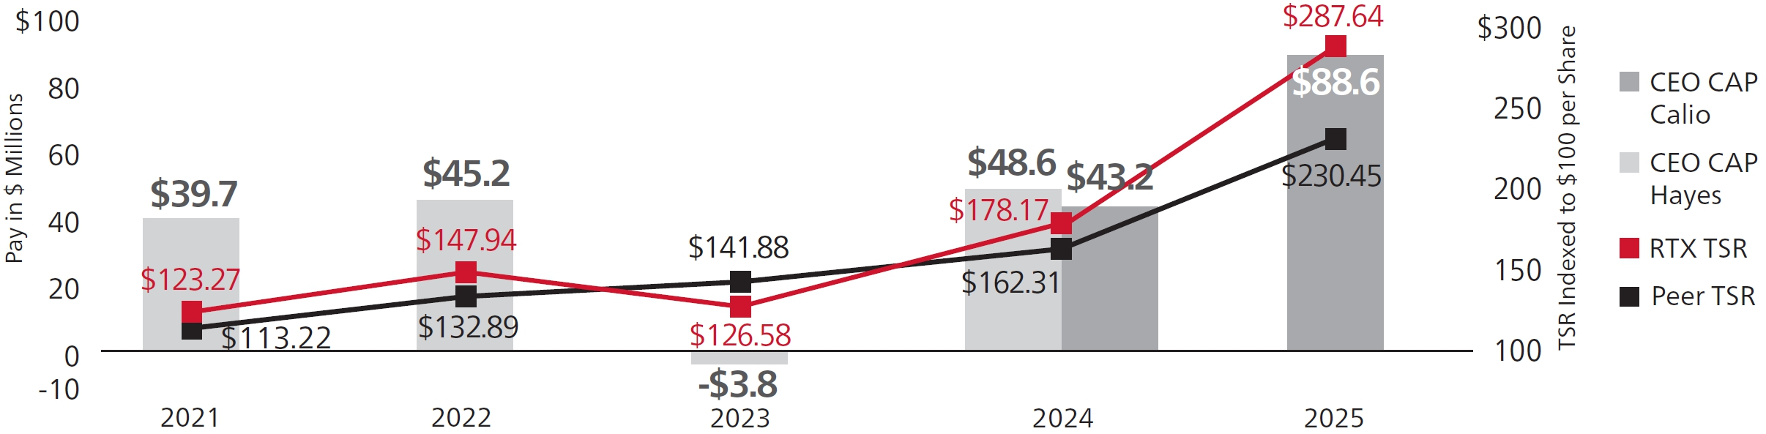

AVERAGE NEO CAP vs. TSR

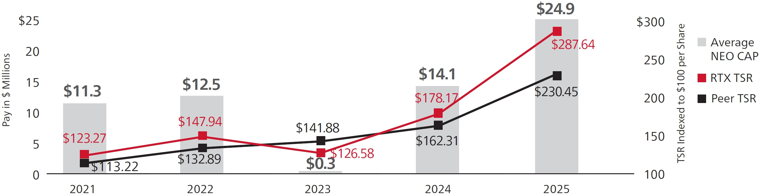

HOW TSR USED FOR THE PVP TABLE DIFFERS FROM HOW WE USE TSR IN OUR PSUS

The SEC’s PvP disclosure rules require a comparison of CAP to RTX’s TSR and Peer Group TSR over differing time periods. This mandated comparison, and the performance measurement periods used, differ in the following ways from how our incentive plans are designed:

● | For our PSUs, we compare our TSR to both the companies within the S&P 500 Index and our Core A&D Peers (together “PSU Peer Groups”). For the SEC’s PvP disclosure, we compare our TSR only to the S&P 500 Aerospace & Defense Industry Index.
● | For our PSUs, we calculate TSR for both RTX and the companies within our PSU Peer Groups using a November/ December trailing average adjusted closing stock price for both the beginning and ending of the performance period. However, the PvP disclosures require the use of a point-to-point calculation.
● | For our PSUs, we measure performance using a three-year performance period, while the SEC rules require TSR to be calculated based on the following performance periods:

Reporting Year |  | Beginning |  | End |  | Number of Years
2025 |  | 1/2/2021 |  | 12/31/2025 |  | 5 years
2024 |  | 1/2/2021 |  | 12/31/2024 |  | 4 years
2023 |  | 1/2/2021 |  | 12/31/2023 |  | 3 years
2022 |  | 1/2/2021 |  | 12/31/2022 |  | 2 years
2021 |  | 1/2/2021 |  | 12/31/2021 |  | 1 year

84 RTX 2026 PROXY STATEMENT

Table of Contents
PAY VERSUS PERFORMANCE
RELATIONSHIP BETWEEN CAP AND NET INCOME (GAAP)

Relationship between CAP and Net Income (GAAP)

The charts below reflect the relationship between the CEO and Average NEO CAP, RTX’s GAAP net income (as required by the SEC), and a supplemental net income metric (adjusted net income) that we use for our annual incentive plan. Both GAAP and adjusted net income reflect a one-year performance measurement period.

We do not use net income as a metric in our long-term incentive plan. Since long-term incentives comprise the largest portion of our NEOs’ pay, and CAP values include four years of LTI awards and only one year of annual incentives in each reporting year, the relationship between CAP and net income is less evident.

CEO CAP vs. NET INCOME

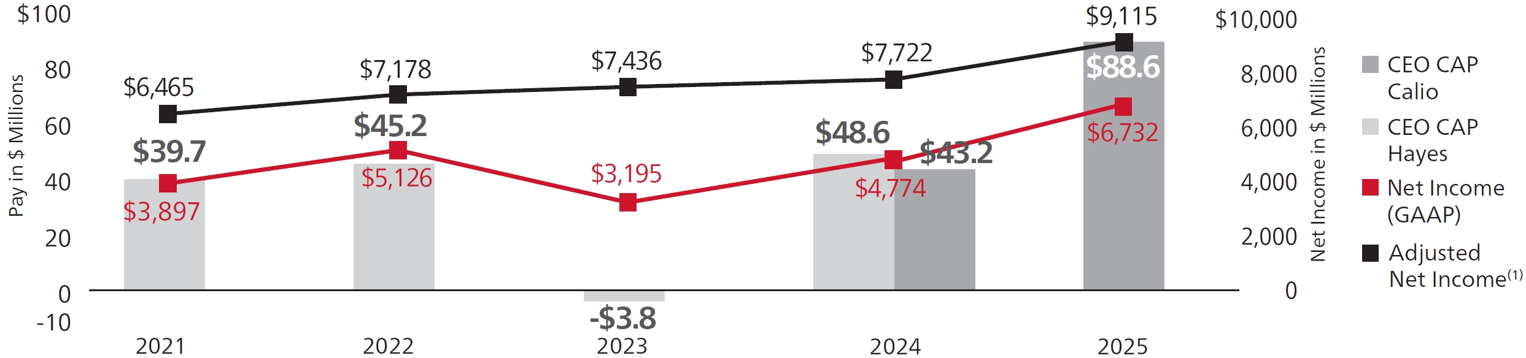

AVERAGE NEO CAP vs. NET INCOME

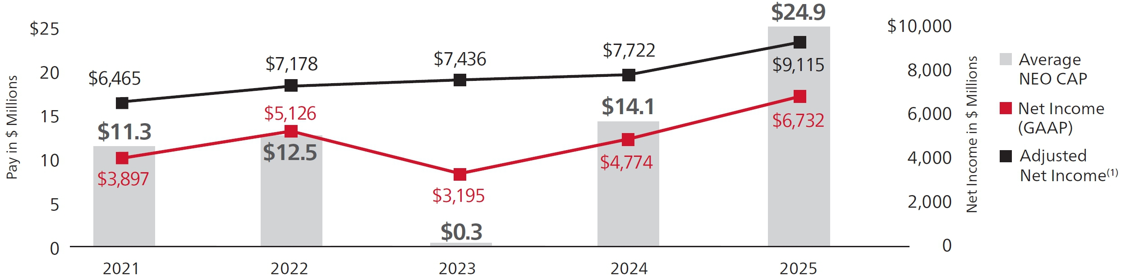

(1) | Adjusted net income is a financial metric used solely for AIP purposes and is defined in Appendix B on page 102. This metric may differ from other non-GAAP metrics used and described in Appendix A.

HOW NET INCOME USED FOR THE PVP TABLE DIFFERS FROM HOW WE USE NET INCOME IN OUR ANNUAL INCENTIVE PLAN

The SEC’s PvP disclosure rules require disclosure of the relationship between CAP and RTX’s net income (GAAP) for each reporting year. This use of GAAP net income differs from the adjusted net income measure we use for annual incentive purposes, which more closely aligns with the non-GAAP financial expectations and results we communicate to shareowners.

For our annual incentive plan, GAAP net income is adjusted for changes in tax laws, tariffs and accounting rules, restructuring, the impact of acquisitions and divestitures (including acquisition accounting adjustments), and significant and/or nonrecurring items, as shown in Appendix B on page 102. Our use of this adjusted net income definition aligns with the HCC Committee’s belief that annual incentives should not be positively or negatively impacted by short-term decisions made in the best interests of RTX’s long-term business strategies. Adjusted net income encourages decision-making that considers long-term value creation but does not conflict with our short-term incentive metrics.

RTX 2026 PROXY STATEMENT 85

Table of Contents
PAY VERSUS PERFORMANCE
RELATIONSHIP BETWEEN CAP AND THE COMPANY-SELECTED MEASURE (ADJUSTED EPS)

Relationship between CAP and the Company-Selected Measure (Adjusted EPS)

The charts below reflect the relationship between the CEO CAP and Average NEO CAP and RTX’s adjusted EPS for the applicable reporting year. This metric is used to determine vesting of our PSUs. We consider adjusted EPS to be the most important financial measure used to link pay to performance in 2024 because LTI is the largest component of NEO compensation, PSUs make up 60% of LTI and adjusted EPS performance determines 35% of total PSU vesting. Further, because we use adjusted EPS when we communicate our earnings expectations to our investors, we believe it is substantially correlated with our stock price performance, and thus to CAP.

CEO CAP vs. ADJUSTED EPS

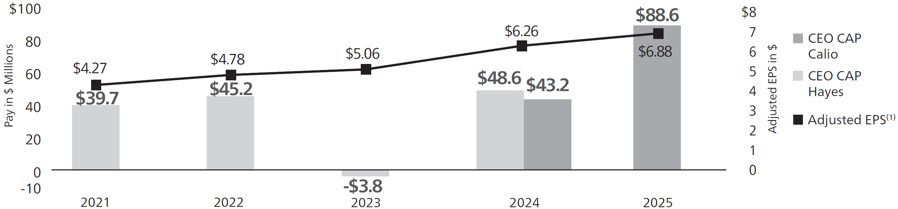

AVERAGE NEO CAP vs. ADJUSTED EPS

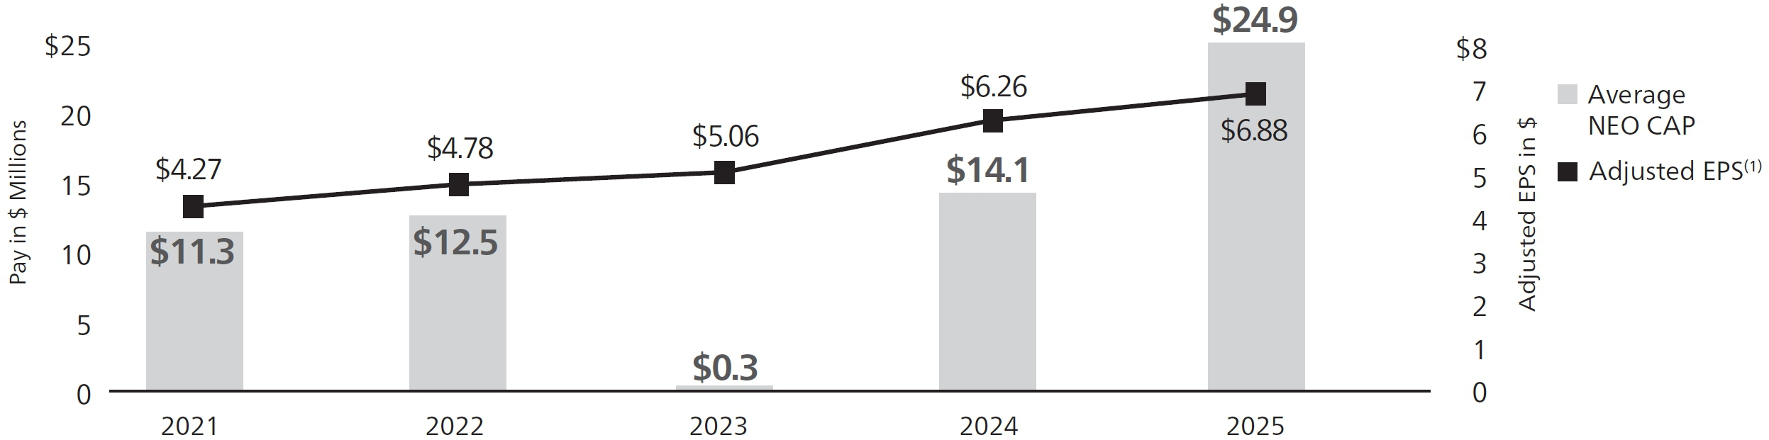

(1) | The value shown for 2025 reflects the 2025 Adjusted EPS used to calculate performance for the 2023-2025 PSUs, as defined in Appendix B on page 102. The value shown for 2024 reflects the 2024 Adjusted EPS used to calculate performance for the 2022-2024 PSUs, as defined in Appendix B of our Proxy Statement filed on March 10, 2025. Adjusted EPS for 2023, 2022 and 2021 are detailed in Appendix A of our Proxy Statements filed on March 11, 2024, March 13, 2023, and March 14, 2022, respectively.

86 RTX 2026 PROXY STATEMENT

Table of Contents
Audit Committee Report

The Audit Committee assists the Board of Directors in its oversight responsibilities relating to: the integrity of RTX’s financial statements; the independence, qualifications and performance of RTX’s internal and external auditors; the Company’s compliance with its policies and procedures, internal controls, Code of Conduct and applicable laws and regulations; policies and procedures with respect to risk assessment and management; and such other responsibilities as delegated by the Board from time to time. The Committee’s specific responsibilities and duties are set forth in the Audit Committee Charter adopted by the Board, which is available on the Company’s website. The Committee is composed entirely of independent directors who meet the independence and financial literacy requirements of the NYSE and the SEC.

Management has the primary responsibility for the financial statements and the financial reporting processes, including the system of internal control over financial reporting. PricewaterhouseCoopers LLP (“PwC”), the Company’s independent auditor, is responsible for auditing the financial statements prepared by management and expressing an opinion on both the conformity of the Company’s audited financial statements with U.S. generally accepted accounting principles and the effectiveness of our internal control over financial reporting. PwC is also responsible for discussing any issues they believe should be raised to the Committee.

In performing its oversight responsibilities, the Committee reviewed and discussed, with management and PwC, RTX’s consolidated financial statements as of and for the year ended December 31, 2025, and RTX’s internal control over financial reporting as of December 31, 2025. The Committee also discussed with RTX’s internal auditors and PwC the overall scope and plans for their respective audits. The Committee also met with the internal auditors and PwC, with and without management present, to discuss the results of their examinations, the evaluation of RTX’s internal control over financial reporting, management’s representations regarding internal control over financial reporting and the overall quality of RTX’s financial reporting.

The Committee has discussed with PwC the matters required by the applicable requirements of the SEC and the Public Company Accounting and Oversight Board’s (“PCAOB”) Auditing Standard No. 1301 Communications with Audit Committees. It has also discussed with PwC its independence from RTX and its management, including communications from PwC required by the PCAOB’s Rule 3526, Communication with Audit Committees Concerning Independence, Rule 3524, Audit Committee Pre-Approval of Certain Tax Services, and Rule 3525, Audit Committee Pre-approval of Non-audit Services Related to Internal Control Over Financial Reporting.

The Committee pre-approves all audit and non-audit services to be provided by PwC and the related fees for those services. The Committee has concluded that PwC’s provision of non-audit services, as described on pages 88-89, does not impair PwC’s independence as the external auditor.

PwC has reported to the Committee that RTX’s audited financial statements are fairly presented in accordance with U.S. generally accepted accounting principles. The Committee reviewed management’s assessment and report on the effectiveness of RTX’s internal control over financial reporting, as well as PwC’s audit report on the effectiveness of RTX’s internal control over financial reporting, which are both included in RTX’s Annual Report on Form 10-K for the fiscal year ending on December 31, 2025. Based on the reviews and discussions referred to above, the Committee has recommended to the Board of Directors that the audited financial statements be included in RTX’s Annual Report on Form 10-K for the year ending on December 31, 2025, for filing with the SEC.

The Committee has nominated PwC for appointment by the shareowners at the 2026 Annual Meeting to serve as RTX’s independent auditor for 2026.

Audit Committee
 | Leanne G. Caret, Chair  Bernard A. Harris, Jr. | Denise L. Ramos  Robert O. Work

RTX 2026 PROXY STATEMENT 87

Table of Contents
Proposal 3:
Appointment of
PricewaterhouseCoopers LLP to
Serve as Independent Auditor for 2026

What  am I  voting on? |  | As required by our Bylaws, we are asking shareowners to vote on a proposal to appoint a firm of independent registered public accountants to serve as the Company’s independent auditor until the next Annual Meeting. PricewaterhouseCoopers LLP (“PwC”), an independent registered public accounting firm, served as RTX’s independent auditor in 2025. For 2026, the Audit Committee has again nominated PwC to be our independent auditor, and the Board of Directors has approved the firm for appointment by the shareowners to serve until the next Annual Meeting in 2027.

Frequently Asked Questions About the Auditor

HOW IS THE AUDITOR RETAINED AND REVIEWED BY THE COMPANY?

The Audit Committee is directly responsible for the nomination, compensation, retention and oversight of the Company’s independent auditor. To fulfill this responsibility, the Committee engages in an annual evaluation of the independent auditor’s qualifications, performance and independence, and periodically considers the advisability of selecting a different independent registered public accounting firm to serve in that capacity. PwC, or one of its predecessor firms, has been retained as RTX’s independent audit firm continuously since 1947.

HOW LONG MAY AN AUDIT PARTNER PROVIDE SERVICES TO RTX?

In accordance with SEC rules and PwC policies, audit partners are subject to rotation requirements that limit the number of consecutive years an individual partner may provide service to RTX. For lead and concurring audit partners, the limit is five years. The selection process for the lead audit partner includes a meeting between the Chair of the Audit Committee and the candidate, as well as consideration of the candidate by the full Committee with input from management.

WILL THE AUDITOR ATTEND THE ANNUAL MEETING?

Representatives of PwC will attend the 2026 Annual Meeting. The representatives may make a statement and will be available to respond to appropriate questions from shareowners.

WHAT WERE THE AUDITOR’S FEES IN 2025 AND 2024?

(in thousands) |  | Audit |  | Audit-Related |  | Tax |  | All Other Fees |  | Total
2025 |  | $35,195 |  | $4,368 |  | $8,054 |  | $22 |  | $47,639
2024 |  | $34,840 |  | $6,445 |  | $5,850 |  | $36 |  | $47,171

88 RTX 2026 PROXY STATEMENT

Table of Contents
PROPOSAL 3: APPOINTMENT OF PRICEWATERHOUSECOOPERS LLP TO SERVE AS INDEPENDENT AUDITOR FOR 2026

Audit Fees. Audit fees in both years consisted of fees for the audit of RTX’s consolidated annual financial statements and the effectiveness of its internal control over financial reporting, the review of interim financial statements in RTX’s quarterly reports on Form 10-Q and the performance of audits in accordance with statutory requirements. Audit fees for statutory audits were approximately $12,700,000 in 2025 and $11,700,000 in 2024. In both years, audit fees also included fees associated with various SEC filings.

Audit-Related Fees. Audit-related fees in both years included fees for employee benefit plan audits, special reports pursuant to contractually required attestations and compliance assessments. Audit-related fees also included approximately $2,640,000 in 2024 for fees associated with carve-out audits.

Tax Fees. Tax fees in 2025 and 2024 consisted of approximately $4,761,000 and $3,225,000, respectively, for U.S. and non-U.S. tax compliance, related planning and assistance with tax refund claims and expatriate tax services, and approximately $3,293,000 and $2,625,000, respectively, for tax advisory services.

All Other Fees. All other fees in 2025 and 2024 consisted of fees for subscriptions to a benchmarking tool and licenses to technical accounting research software.

HOW DOES THE COMMITTEE MONITOR AND CONTROL NON-AUDIT SERVICES?

The Audit Committee has established procedures requiring its review and advance approval of all engagements for non-audit services provided by PwC. The Committee Chair has the delegated authority to pre-approve non-audit services with certain limitations and must notify the Committee at its next meeting of each service so approved. The Committee approved all of PwC’s engagements and fees for 2025 and 2024.

The Committee reviews with PwC whether non-audit services to be provided are compatible with maintaining the firm’s independence. In addition, the Committee monitors the fees paid to PwC to ensure that fees paid in any year to PwC for non-audit services do not exceed the fees paid for audit and audit-related services. Non-audit services consist of those described above, as included in the tax fees and all other fees categories.

WHY SHOULD I VOTE FOR THIS PROPOSAL?

Through its review process, the Audit Committee determined that PwC has acquired extensive knowledge of the Company’s operations, performance and development through its previous service as the independent auditor for RTX. The Audit Committee and the Board of Directors believe that the continued retention of PwC as our independent auditor is in the best interest of the Company and our shareowners.

 |  | The Board of Directors unanimously recommends a vote FOR the appointment of PwC to serve as the Company’s Independent Auditor for 2026.

RTX 2026 PROXY STATEMENT 89

Table of Contents
Frequently Asked Questions
About the Annual Meeting

Your vote  is very  important! |  | WHY AM I BEING PROVIDED WITH THESE PROXY MATERIALS?  We are providing these proxy materials to you in connection with the solicitation by the Board of Directors of RTX Corporation of proxies to be voted at our 2026 Annual Meeting of Shareowners and at any postponed or reconvened meeting.  WILL THE ANNUAL MEETING ALSO BE HELD IN PERSON OR ONLY VIRTUALLY?  As noted in the Notice at the beginning of this Proxy Statement, the 2026 Annual Meeting will be in a virtual format only.

WHO CAN ATTEND THE ANNUAL MEETING?

Shareowners holding RTX stock as of the close of business on the record date, March 3, 2026, are entitled to attend the Annual Meeting to be held virtually via www.virtualshareholdermeeting.com/RTX2026. To be admitted to the Annual Meeting via the website, shareowners must enter the 16-digit voting control number found on their proxy card, voting instruction form, notice of internet availability of proxy materials or email notification.

WHO CAN VOTE AT THE MEETING?

Shareowners of record as of March 3, 2026, and shareowners holding a proxy for the 2026 Annual Meeting provided by their bank, broker or nominee may vote during the Annual Meeting to be held virtually by following the instructions available on the meeting website. If you vote prior to the meeting by using the internet, toll-free telephone number, proxy card or voting instruction form, you do not need to take any action during the meeting unless you wish to change your vote. A list of shareowners of record will be available at www.virtualshareholdermeeting.com/RTX2026 during the Annual Meeting for inspection by shareowners for any legally valid purpose related to the Annual Meeting.

WHEN IS THE ANNUAL MEETING?

We will hold our Annual Meeting on April 30, 2026, at 8:00 a.m. Eastern time. If you plan to attend the Annual Meeting, you should log into the website at www.virtualshareholdermeeting.com/RTX2026 approximately fifteen minutes before the meeting is scheduled to begin.

WILL THERE BE AN OPPORTUNITY TO ASK QUESTIONS BEFORE OR DURING THE MEETING?

Time will be allotted after the adjournment of the formal meeting for a Question and Answer period. Shareowners will be able to submit questions relevant to the business of the meeting either in advance of the Annual Meeting via www.proxyvote.com or during the meeting via www.virtualshareholdermeeting.com/RTX2026 by typing the question into the indicated question box and clicking “Submit.” Time may not permit the answering of every question submitted. Questions relevant to the business of the meeting to which a response is not provided during the Question and Answer period will be addressed on www.rtx.com/Investors following the meeting. To ask questions, you will need to have your voting control number found on your proxy card, voting instruction form, notice of internet availability of proxy materials or email notification.

90 RTX 2026 PROXY STATEMENT

Table of Contents
FREQUENTLY ASKED QUESTIONS ABOUT THE ANNUAL MEETING

WHAT IF I HAVE TROUBLE LOGGING INTO THE ANNUAL MEETING?

If you encounter any difficulties accessing the virtual meeting during the check-in or meeting time, please call the technical support number that will be posted on the Annual Meeting login page.

DOES THE COMPANY HAVE A POLICY ABOUT DIRECTORS’ ATTENDANCE AT THE ANNUAL MEETING?

The Company does not have a formal policy requiring that directors attend the Annual Meeting, but directors are encouraged to do so unless there is an unavoidable scheduling conflict. All directors at the time attended the 2025 Annual Meeting.

WHAT IS THE QUORUM REQUIREMENT FOR THE ANNUAL MEETING?

Under the Company’s Bylaws, a quorum is required to transact business at the Annual Meeting. The holders of a majority of the outstanding shares of RTX Common Stock as of the record date, present either virtually in person or by proxy and entitled to vote, will constitute a quorum. As of the record date, March 3, 2026, 1,345,974,220 shares of Common Stock were issued and outstanding. Abstentions and “broker non-votes” are counted as present and entitled to vote for purposes of determining a quorum.

HOW DO I VOTE?

Registered Shareowners:

 | Internet  You can vote online at: www.proxyvote.com. | Internet and telephone voting facilities will be available 24 hours a day until 11:59 p.m. Eastern time on April 29, 2026 (except for participants in a company savings plan as described on page 92 and beneficial holders who must vote by the time specified in their voting instruction form).  To authenticate your internet or telephone vote, you will need to enter your confidential voter control number as shown on the voting materials you received. If you vote online or by telephone, you do not need to return a proxy card or voting instruction form.
Telephone
In the United States or Canada, you can vote by telephone. Easy-to-follow voice prompts allow you to vote your shares and confirm that your instructions have been properly recorded.

You can find the telephone number on your proxy card, voting instruction form or other communications.

Mail
You can mail the proxy card or voting instruction form enclosed with your printed proxy materials. Mark, sign and date your proxy card or voting instruction form, and return it in the prepaid envelope we have provided, or in an envelope addressed to:

Vote Processing, c/o Broadridge, 51 Mercedes Way, Edgewood, NY 11717

Please allow sufficient time for delivery of your proxy card or voting instruction form if you decide to vote by mail.
During the Meeting
Shareowners as of the close of business on the record date, March 3, 2026, are entitled to virtually attend and vote during the Annual Meeting online via www.virtualshareholdermeeting.com/RTX2026.

If you have already voted online, by telephone or by mail, your vote during the Annual Meeting will supersede your earlier vote.

RTX 2026 PROXY STATEMENT 91

Table of Contents
FREQUENTLY ASKED QUESTIONS ABOUT THE ANNUAL MEETING

Beneficial Shareowners. If you own shares in street name through an account with a bank, brokerage firm or other intermediary, then your intermediary will send you printed copies of the proxy materials or provide instructions on how to access proxy materials electronically. You are entitled to direct the intermediary how to vote your shares by following the voting instructions that the intermediary provides to you.

Shares Held in a Savings Plan Sponsored by RTX. You can direct the voting of your proportionate interest in shares of RTX Common Stock held by the ESOP Fund and the Company Stock Fund under an RTX savings plan by returning a voting instruction card or providing voting instructions by the internet or by telephone. If you do not provide voting instructions (or if your instructions are incomplete or unclear) as to one or more of the matters to be voted on, the plan trustees will vote your proportionate interest in shares held by the ESOP Fund for the voting choice with respect to each applicable proposal that receives the greatest number of votes based on voting instructions received from ESOP Fund participants. Similarly, the plan trustees will vote your uninstructed proportionate interest in shares held by the Company Stock Fund for the voting choice with respect to each applicable proposal that receives the greatest number of votes based on voting instructions received from the Company Stock Fund participants. For shares of RTX Common Stock held in the ESOP Fund that are not allocated to participant accounts, the plan trustees will vote the unallocated shares for the voting choice with respect to each applicable proposal that receives the greatest number of votes from those ESOP Fund participants who have submitted voting instructions.

Earlier Voting Deadline for Participants in a Savings Plan Sponsored by RTX. Broadridge Financial Solutions must receive your voting instructions by 11:59 p.m. Eastern time on Monday, April 27, 2026, so that it will have time to tabulate all voting instructions of participants and communicate those instructions to the trustees, who will vote the shares held by the savings plans. Because the plan trustees are designated to vote on your behalf, you will not be able to vote your shares held in a savings plan virtually at the Annual Meeting.

HOW CAN I CHANGE MY VOTE?

Registered shareowners. If you voted by telephone or online, you may change your vote by accessing the same method you used and following the instructions for revoking a proxy. If you mailed a signed proxy card, you may override your vote by mailing a new proxy card with a later date. And no matter what voting method you originally used, you can change your vote by voting virtually during the Annual Meeting.

Beneficial shareowners. Ask your bank, brokerage firm or other intermediary how to revoke or change your previous voting instructions.

HOW WILL MY SHARES BE VOTED?

Each share of RTX Common Stock is entitled to one vote. Your shares will be voted in accordance with your instructions. In addition, if you have returned a signed proxy card or submitted voting instructions by telephone or the internet, the proxy holders will have, and intend to exercise, discretion to vote your shares (other than shares held in an RTX employee savings plan) in accordance with their best judgment on any matters not identified in this Proxy Statement that are brought to a vote at the Annual Meeting. We do not know of any such additional matters at this time.

If your shares are registered in your name and you sign and return a proxy card or vote by telephone or the internet but do not give voting instructions on a particular matter, the proxy holders will be authorized to vote your shares on that matter in accordance with the Board’s recommendation. If you hold your shares through an account with a broker and do not give voting instructions on a matter, your broker is entitled under New York Stock Exchange rules to vote your shares in its discretion only on Proposal 3 (appointment of the Independent Auditor) and is required to withhold a vote on each of the other Proposals, resulting in a so-called “broker non-vote.”

92 RTX 2026 PROXY STATEMENT

Table of Contents
FREQUENTLY ASKED QUESTIONS ABOUT THE ANNUAL MEETING

HOW DO ABSTENTIONS AND BROKER NON-VOTES AFFECT THE VOTING RESULTS?

Matter |  | Vote Required for Approval |  | Impact of Abstentions |  | Impact of Broker Non-Votes
Election of Directors |  | Votes for a nominee must exceed 50% of the votes cast with respect to that nominee. |  | Not counted as votes cast; no impact on outcome. |  | Not counted as votes cast; no impact on outcome.
Advisory Vote to Approve Executive Compensation |  | The affirmative vote of the holders of a majority of shares of our common stock, present at the Annual Meeting or represented by proxy and entitled to vote, is required for approval. |  | An abstention is treated as present and entitled to vote and therefore has the effect of a vote against approval. |  | Not counted as shares entitled to vote; no impact on outcome.
Appointment of PricewaterhouseCoopers LLP to Serve as Independent Auditor for 2026 |  | The affirmative vote of the holders of a majority of shares of our common stock, present at the Annual Meeting or represented by proxy and entitled to vote, is required for approval. |  | An abstention is treated as present and entitled to vote and therefore has the effect of a vote against approval. |  | Discretionary voting permitted.

WHAT HAPPENS IF A DIRECTOR IN AN UNCONTESTED ELECTION RECEIVES MORE VOTES “AGAINST” THAN “FOR” THEIR ELECTION?

In an uncontested election of directors, any nominee who is an incumbent director and who receives a greater number of votes cast “against” than votes cast “for” their election must, under RTX’s Corporate Governance Guidelines, promptly tender their resignation to the Chair of the Governance Committee following certification of the shareowner vote. The Governance Committee must promptly make a recommendation to the Board about whether to accept or reject the tendered resignation. The director who tendered a resignation may not participate in the Governance Committee’s recommendation or the Board’s consideration.

Under our Corporate Governance Guidelines, the Board must act on the Governance Committee’s recommendation no later than 90 days after the date of the shareowners’ meeting. Regardless of whether the Board accepts or rejects the resignation, RTX must promptly file a Report on Form 8-K with the SEC that explains the process by which the decision was reached and, if applicable, the reasons for rejecting the tendered resignation.

If a director’s resignation is accepted, the Governance Committee also will recommend to the Board whether to fill the vacancy or to reduce the size of the Board. Under the RTX Bylaws, a vacancy arising in these circumstances may be filled, at the discretion of the Board, by a majority vote of the directors or at a special meeting of shareowners called by the Board in accordance with the Bylaws.

WHO COUNTS THE VOTES?

Broadridge Financial Solutions (“Broadridge”), an independent entity, will tabulate the votes. At the Annual Meeting, a representative of Broadridge will act as the independent Inspector of Election and in this capacity will supervise the voting, decide the validity of proxies and certify the results.

Broadridge has been instructed to keep the vote of each shareowner confidential and the vote may not be disclosed, except in legal proceedings or for the purpose of soliciting shareowner votes in a contested proxy solicitation.

RTX 2026 PROXY STATEMENT 93

Table of Contents
FREQUENTLY ASKED QUESTIONS ABOUT THE ANNUAL MEETING

HOW MAY THE COMPANY SOLICIT MY PROXY?

We will pay the cost of soliciting proxies. Proxies may be solicited on behalf of RTX by directors, officers or employees of RTX in person or by telephone, facsimile or other electronic means. We have retained D.F. King & Co., Inc. (“D.F. King”) to assist in the distribution and solicitation of proxies. Based on our agreement with D.F. King, we anticipate paying fees ranging from approximately $35,000 up to approximately $100,000, plus out-of-pocket expenses, for these services, depending upon the extent of proxy solicitation efforts undertaken.

As required by the SEC and the NYSE, we also will reimburse brokerage firms and other custodians, nominees and fiduciaries for their expenses incurred in sending proxies and proxy materials to beneficial owners of our Common Stock.

WHY DID I RECEIVE A NOTICE OF INTERNET AVAILABILITY?

To conserve natural resources and reduce costs, we are sending most shareowners a notice of internet availability of proxy materials, as permitted by SEC rules. The notice of internet availability of proxy materials explains how you can access RTX’s proxy materials on the internet and how to obtain printed copies if you prefer. It also explains how you can choose either electronic or print delivery of proxy materials for future annual meetings.

HOW CAN I RECEIVE MY PROXY MATERIALS ELECTRONICALLY?

To conserve resources and reduce costs, we encourage shareowners to access their proxy materials electronically.

If you are a registered shareowner, you can sign up at https://landing.computershare.com/green to get electronic access to proxy materials for future meetings, rather than receiving them in the mail. Once you sign up, you will receive an email each year explaining how to access RTX’s Annual Report and Proxy Statement, and how to vote online. Your enrollment for electronic access will remain in effect unless you cancel it, which you can do up to two weeks before the record date for any future annual meeting.

If you are a beneficial shareowner, you may obtain electronic access to proxy materials by contacting your bank, brokerage firm or other intermediary, or by contacting Broadridge at https://enroll.icsdelivery.com/rtx.

WHAT IF I SHARE THE SAME ADDRESS AS ANOTHER RTX SHAREOWNER?

If you share an address with one or more other RTX shareowners, you may have received only a single copy of the Annual Report, Proxy Statement or notice of internet availability of proxy materials for your entire household. This practice, known as “householding,” is intended to conserve resources and reduce printing and mailing costs.

If you are a registered shareowner and you prefer to receive a separate Annual Report, Proxy Statement or notice of internet availability of proxy materials this year or in the future, or if you are receiving multiple copies at your address and would like to enroll in “householding” and receive a single copy, please contact Computershare at 1-800-488-9281. If you are a beneficial shareowner, please contact your bank, brokerage firm or other intermediary to make your request. There is no charge for separate copies.

HOW CAN I RECEIVE A COPY OF THE COMPANY’S 2025 ANNUAL REPORT ON FORM 10-K?

RTX will provide, without charge, a copy of the Annual Report on Form 10-K to any shareowner upon a request directed to the RTX Corporate Secretary (see page 95 for contact information).

HOW DO I SUBMIT PROPOSALS AND NOMINATIONS FOR THE 2027 ANNUAL MEETING?

Shareowner Proposals. To submit a shareowner proposal to be considered for inclusion in RTX’s Proxy Statement for the 2027 Annual Meeting under SEC Rule 14a-8, you must send the proposal to our Corporate Secretary. The Corporate Secretary must receive the proposal in writing by close of the Company’s regular business hours at 5:00 p.m. Eastern time on November 9, 2026.

94 RTX 2026 PROXY STATEMENT

Table of Contents
FREQUENTLY ASKED QUESTIONS ABOUT THE ANNUAL MEETING

To introduce a proposal for vote at the 2027 Annual Meeting (other than a shareowner proposal included in the Proxy Statement in accordance with SEC Rule 14a-8), RTX’s Bylaws require that the shareowner send advance written notice to the RTX Corporate Secretary for receipt no earlier than close of the Company’s regular business hours at 5:00 p.m. Eastern time on December 31, 2026, and no later than close of the Company’s regular business hours at 5:00 p.m. Eastern time on February 1, 2027. This notice must include the information specified by Section 1.10 of the Bylaws, a copy of which is available on our website at www.rtx.com.

Director Nominations at the 2027 Annual Meeting. RTX’s Bylaws require that a shareowner who wishes to nominate a candidate for election as a director at the 2027 Annual Meeting (other than pursuant to the “proxy access” provisions of Section 1.12 of the Bylaws) must send advance written notice to the RTX Corporate Secretary for receipt no earlier than close of the Company’s regular business hours at 5:00 p.m. Eastern time on December 31, 2026, and no later than close of the Company’s regular business hours at 5:00 p.m. Eastern time on February 1, 2027. This notice must include the information, documents and agreements specified by Section 1.12 of the Bylaws, a copy of which is available on our website at www.rtx.com.

Director Nominations by Proxy Access. RTX’s Bylaws require that an eligible shareowner who wishes to have a nominee of that shareowner included in RTX’s proxy materials for the 2027 Annual Meeting pursuant to the “proxy access” provisions of Section 1.12 of our Bylaws send advance written notice to the RTX Corporate Secretary for receipt no earlier than close of the Company’s regular business hours at 5:00 p.m. Eastern time on October 9, 2026, and no later than close of the Company’s regular business hours at 5:00 p.m. Eastern time on November 9, 2026. This notice must include the information, documents and agreements specified by Section 1.12 of the Bylaws, a copy of which is available on our website at www.rtx.com.

HOW DO I CONTACT THE CORPORATE SECRETARY’S OFFICE?

Shareowners may contact RTX’s Corporate Secretary’s Office by one of the two methods shown below:

Communication Method | Contact Information
Write a letter | RTX Corporate Secretary  RTX Corporation  1000 Wilson Blvd.  Arlington, VA 22209
Send an email | corpsec@rtx.com

Our Bylaws and other governance documents are available under the Corporate Governance section of the Company website at www.rtx.com.

RTX 2026 PROXY STATEMENT 95

Table of Contents
Other Important Information

Cautionary Note Concerning Factors That May Affect Future Results. This Proxy Statement contains statements which, to the extent they are not statements of historical or present fact, constitute “forward-looking statements” under the securities laws. These forward-looking statements are intended to provide management’s current expectations or plans for our future operating and financial performance, based on assumptions currently believed to be valid, and are not statements of historical fact. Forward-looking statements can be identified by the use of words such as “believe,” “expect,” “expectations,” “plans,” “strategy,” “prospects,” “estimate,” “project,” “target,” “commit,” “commitment,” “anticipate,” “will,” “should,” “see,” “guidance,” “outlook,” “goals,” “objectives,” “confident,” “on track,” “designed to,” and other words of similar meaning. Forward-looking statements may include, among other things, statements relating to future sales, earnings, cash flow, results of operations, uses of cash, share repurchases, tax payments and rates, research and development spending, cost savings, other measures of financial performance, potential future plans, strategies or transactions, credit ratings and net indebtedness, a rare condition in powder metal used to manufacture certain engine parts requiring accelerated inspection of the PW1100G-JM Geared Turbofan fleet, which powers the A320neo family of aircraft (the “Powder Metal Matter”), and related matters and activities, including without limitation other engine models that may be impacted, targets and commitments (including for share repurchases or otherwise), and other statements which are not solely historical facts. All forward-looking statements involve risks, uncertainties, changes in circumstances, and other factors that are hard to predict, and each of which may cause actual results to differ materially from those expressed or implied in the forward-looking statements. For those statements, we claim the protection of the safe harbor for forward-looking statements contained in the U.S. Private Securities Litigation Reform Act of 1995, as amended. Such risks, uncertainties, and other factors include, without limitation:

● | changes in economic, capital market, and political conditions in the U.S. and globally;
● | changes in U.S. government defense spending, national priorities, and policy positions;
● | our performance on our contracts and programs, including our ability to control costs, and our dependence on U.S. government approvals for certain international contracts;
● | challenges in the development, certification, production, delivery, support, and performance of RTX’s advanced technologies and new products and services and the realization of anticipated benefits;
● | the challenges of operating in RTX’s highly competitive industries both domestically and abroad;
● | our reliance on U.S. and non-U.S. suppliers and commodity markets, including cost increases and disruptions in the delivery of materials and services to RTX or our suppliers;
● | changes in trade policies, implementation of sanctions, imposition of tariffs (and counter-tariffs), and other trade measures and restrictions, foreign currency fluctuations, and sales methods;
● | the economic condition of the aerospace industry;
● | the ability of RTX to attract, train, qualify, and retain qualified personnel and maintain its culture and high ethical standards, and the ability of our personnel to continue to operate our facilities and businesses around the world;
● | the scope, nature, timing, and challenges of managing and completing acquisitions, investments, divestitures, and other transactions;
● | compliance with legal, environmental, regulatory, and other requirements in the U.S. and other countries in which RTX and its businesses operate;
● | pending, threatened, and future legal proceedings, investigations, audits, and other contingencies;
● | the previously disclosed deferred prosecution agreements entered into between the Company and the Department of Justice (“DOJ”), the Securities and Exchange Commission (“SEC”) administrative order imposed on the Company, and the related investigations by the SEC and DOJ, and the consent agreement between the Company and the Department of State;
● | RTX’s ability to engage in desirable capital-raising or strategic transactions;
● | repurchases by RTX of its common stock, or declarations of cash dividends, which may be discontinued, accelerated, suspended, or delayed at any time due to various factors;
● | realizing expected benefits from, incurring costs for, and successfully managing strategic initiatives such as cost reduction, restructuring, digital transformation, and other operational initiatives;
● | additional tax exposures due to new tax legislation or other developments in the U.S. and other countries in which RTX and its businesses operate;
● | the Powder Metal Matter;
● | changes in production volumes of one or more of our significant customers as a result of business, labor, or other challenges, and the resulting effect on its or their demand for our products and services;

96 RTX 2026 PROXY STATEMENT

Table of Contents
OTHER IMPORTANT INFORMATION

● | an RTX product safety failure, quality issue, or other failure affecting RTX’s or its customers’ or suppliers’ products or systems;
● | cybersecurity, including cyber-attacks on RTX’s information technology (IT) infrastructure, products, suppliers, customers and partners, and cybersecurity-related regulations;
● | insufficient indemnity or insurance coverage;
● | our intellectual property and certain third-party intellectual property;
● | threats to RTX facilities and personnel, or those of its suppliers or customers, as well as public health crises, damaging weather, acts of nature, or other similar events outside of RTX’s control that may affect RTX or its suppliers or customers;
● | changes in accounting estimates for our programs on our financial results;
● | changes in pension and other postretirement plan estimates and assumptions and contributions;
● | an impairment of goodwill and other intangible assets; and
● | climate change and climate-related regulations, and any related customer and market demands, products, and technologies.

In addition, our 2025 Annual Report on Form 10-K includes important information as to risks, uncertainties, and other factors that may cause actual results to differ materially from those expressed or implied in the forward-looking statements. The forward-looking statements speak only as of the date of this Proxy Statement or, in the case of any document incorporated by reference, the date of that document. We undertake no obligation to publicly update or revise any forward-looking statements, whether as a result of new information, future events or otherwise, except as required by applicable law. Additional information as to factors that may cause actual results to differ materially from those expressed or implied in the forward-looking statements is disclosed from time to time in our other filings with the SEC.

Corporate Governance Information, our Code of Conduct and How to Contact the Board. RTX’s Corporate Governance Guidelines (and related documents), the charters for each Board Committee and RTX’s Code of Conduct are available on RTX’s website (www.rtx.com). Printed copies will be provided, without charge, to any shareowner upon a request addressed to the RTX Corporate Secretary through the contact information provided on page 95. The Code of Conduct applies to all directors and employees, including the principal executive, financial and accounting officers. Shareowners and other interested persons may send communications to the Board, the Independent Lead Director or one or more independent directors by: (i) using the contact information provided on the Corporate Governance section of RTX’s website (www.rtx.com); or (ii) letters addressed to the RTX Corporate Secretary (see page 95 for contact information). Communications relating to RTX’s accounting, internal controls, auditing matters or business practices will be reviewed by the Senior Vice President & Chief Compliance Officer, and reported to the Audit Committee pursuant to the RTX Corporate Governance Guidelines. All other communications will be reviewed by the RTX Corporate Secretary and reported to the Board, as appropriate, pursuant to the Corporate Governance Guidelines.

Transactions with Related Persons. RTX has a written policy that requires the Governance Committee to review and determine whether to approve or ratify transactions exceeding $120,000 in which RTX or a subsidiary is a participant and in which a related person has a direct or indirect material interest. A related person is defined as an RTX director or executive officer, a beneficial owner of more than 5% of RTX’s outstanding shares, or an immediate family member of any of the foregoing persons. Under the policy, any potential related person transaction must be reported for review by the RTX Corporate Secretary who will, in consultation with the Senior Vice President & Chief Compliance Officer, assess whether the transaction may require review, approval or ratification by the Governance Committee. The Governance Committee determines whether each transaction presented to it should be approved (or, where applicable, ratified) or disapproved based on whether the transaction is determined to be in, or not inconsistent with, the best interests of RTX and its shareowners. In making this determination, the Governance Committee must take into consideration whether the transaction is on terms no less favorable to RTX than those available under similar circumstances with unaffiliated third parties and the extent of the related person’s interest in the transaction. The policy generally permits employment of relatives of related persons possessing qualifications consistent with RTX’s requirements for non-related persons in similar circumstances, provided the employment is approved by the Executive Vice President & Chief Human Resources Officer and the Senior Vice President & Chief Compliance Officer.

State Street Corporation (“State Street”), acting in various fiduciary capacities, filed a Schedule 13F with the SEC reporting that as of December 31, 2025, State Street and certain of its subsidiaries collectively were the beneficial owners of more than 5% of RTX’s outstanding shares of Common Stock. A subsidiary of State Street is the trustee for the RTX Savings Plan Master Trust. Other State Street subsidiaries provide investment management services. During 2025, RTX paid State Street and its subsidiaries approximately $7.4 million for services as trustee, as investment managers and for administrative and other services.

RTX 2026 PROXY STATEMENT 97

Table of Contents
OTHER IMPORTANT INFORMATION

BlackRock, Inc. (“BlackRock”) filed a Schedule 13F with the SEC reporting that as of December 31, 2025, BlackRock and certain of its subsidiaries collectively were the beneficial owners of more than 5% of RTX’s outstanding shares of Common Stock. During 2025, BlackRock acted as an investment manager for certain assets within RTX’s global pension plans and employee savings plans. BlackRock received approximately $1.8 million for such services.

Zachary Hayes, an employee of Collins Aerospace, is the son of RTX’s former Executive Chairman, Gregory Hayes. In 2025, Zachary Hayes received approximately $152,936 in total compensation, consisting of his salary and participation in employee benefit plans and programs generally made available to employees of similar responsibility levels.

Uri Shafir, an employee of RTX’s Corporate Office, is the brother-in-law of RTX’s former Executive Chairman, Gregory Hayes. In 2025, Mr. Shafir received approximately $362,513 in total compensation, consisting of his salary and participation in employee benefit plans and programs generally made available to employees of similar responsibility levels.

Emiliya S. West, an employee of RTX’s Corporate Office, is the sister-in-law of RTX’s former Executive Chairman, Gregory Hayes. In 2025, Ms. West received approximately $253,177 in total compensation, consisting of her salary and participation in employee benefit plans and programs generally made available to employees of similar responsibility levels.

Roderick Williams, an employee of Pratt & Whitney, is the spouse of Dantaya Williams, RTX’s Executive Vice President & Chief Human Resources Officer. In 2025, Mr. Williams received approximately $301,993 in total compensation, consisting of his salary and participation in employee benefit plans and programs generally made available to employees of similar responsibility levels.

Hunter Brunk, an employee of Collins Aerospace, is the son of Troy Brunk, the President of Collins Aerospace. In 2025, Mr. Hunter Brunk received approximately $161,260 in total compensation, consisting of his salary and participation in employee benefit plans and programs generally made available to employees of similar responsibility levels.

Trevor Brunk, an employee of Collins Aerospace, is the son of Troy Brunk, the President of Collins Aerospace. In 2025, Mr. Trevor Brunk received approximately $148,032 in total compensation, consisting of his salary and participation in employee benefit plans and programs generally made available to employees of similar responsibility levels.

Each of the relationships described above was reviewed and approved in accordance with RTX’s Related Person Transactions Policy, which is available on our website (www.rtx.com).

Delinquent Section 16(a) Reports. Section 16(a) of the Securities Exchange Act of 1934 requires our directors, executive officers and persons who beneficially own more than 10% of a registered class of our equity securities to file reports of holdings and transactions in our Common Stock with the SEC and the NYSE. Based on our records and other information, we believe that, in 2025, none of our directors, executive officers or 10% shareowners failed to file a required report on time.

Incorporation by Reference. In connection with our discussion of director and executive compensation, we have incorporated by reference in this Proxy Statement certain information from Note 10: Employee Benefit Plans and Note 19: Stock-Based Compensation, to the Consolidated Financial Statements in RTX’s 2025 Annual Report on Form 10-K filed on February 6, 2026. These are the only portions of such filings that are incorporated by reference in this Proxy Statement.

Company Names, Trademarks and Trade Names. RTX Corporation and its subsidiaries’ names, abbreviations thereof, logos and product and service designators are either the registered or unregistered trademarks or trade names of RTX Corporation and its subsidiaries. Names of other companies and organizations, abbreviations thereof, logos of other companies and organizations, and product and service designators of other companies are either the registered or unregistered trademarks or trade names of their respective owners.

Websites. The links to our website or any third-party website provided in these proxy materials have been provided for convenience purposes only, and the content contained therein is not incorporated by reference into these proxy materials unless otherwise specified.

98 RTX 2026 PROXY STATEMENT

Table of Contents
Appendix A: Reconciliation of
GAAP Measures to Corresponding
Non-GAAP Measures

RECONCILIATION OF NET SALES (GAAP) TO ADJUSTED NET SALES (NON-GAAP) AND SEGMENT OPERATING PROFIT MARGIN (GAAP) TO ADJUSTED SEGMENT OPERATING PROFIT MARGIN (NON-GAAP)
(dollars in millions) |  | 2023 |  | 2024 |  | 2025
Net sales |  | $68,920 |  | $80,738 |  | $86,603
Reconciliation to segment net sales:
Eliminations and other |  | $1,979 |  | $2,325 |  | $2,552
Segment net sales |  | $70,899 |  | $83,063 |  | $91,155
Reconciliation to adjusted segment net sales:
Net significant and/or non-recurring items |  | $5,346 |  | $70 |  | –
Adjusted segment net sales |  | $76,245 |  | $83,133 |  | $91,155
Reconciliation to adjusted net sales:
Eliminations and other |  | ($1,940) |  | ($2,325) |  | ($2,552)
Adjusted net sales |  | $74,305 |  | $80,808 |  | $88,603
Operating profit |  | $3,561 |  | $6,538 |  | $9,300
Operating profit margin |  | 5.2% |  | 8.1% |  | 10.5%
Reconciliation to segment operating profit:
Eliminations and other |  | $42 |  | $48 |  | ($54)
Corporate expenses and other unallocated items |  | $275 |  | $933 |  | $248
FAS/CAS operating adjustment |  | ($1,127) |  | ($833) |  | ($753)
Acquisition accounting adjustments |  | $1,998 |  | $2,058 |  | $2,005
Segment operating profit |  | $4,749 |  | $8,744 |  | $10,746
Segment operating profit margin |  | 6.7% |  | 10.5% |  | 11.8%
Reconciliation to adjusted segment operating profit:
Restructuring |  | $187 |  | $185 |  | $229
Net significant and/or non-recurring items |  | $3,082 |  | $576 |  | ($126)
Adjusted segment operating profit |  | $8,018 |  | $9,505 |  | $10,849
Adjusted segment operating profit margin |  | 10.5% |  | 11.4% |  | 11.9%

RTX 2026 PROXY STATEMENT 99

Table of Contents
APPENDIX A: RECONCILIATION OF GAAP MEASURES TO CORRESPONDING NON-GAAP MEASURES

RECONCILIATION OF NET INCOME AND DILUTED EARNINGS PER SHARE (GAAP) TO ADJUSTED NET INCOME AND ADJUSTED DILUTED EARNINGS PER SHARE (NON-GAAP)
(dollars in millions, except per share amounts) |  | 2023 |  | 2024 |  | 2025
Net income attributable to common shareowners |  | $3,195 |  | $4,774 |  | $6,732
Adjustments to net income attributable to common shareowners:
Restructuring costs |  | $246 |  | $194 |  | $246
Acquisition accounting adjustments |  | $1,998 |  | $2,058 |  | $2,005
Significant and/or nonrecurring items included in operating profit |  | $3,090 |  | $1,393 |  | ($162)
Significant and/or nonrecurring items included in non-service pension income |  | $4 |  | – |  | $261
Significant and/or nonrecurring items included in interest expense, net |  | ($11) |  | ($67) |  | ($54)
Tax effect of restructuring and significant and/or nonrecurring items above |  | ($1,191) |  | ($516) |  | ($438)
Significant and/or nonrecurring items included in income tax expense (benefit) |  | ($48) |  | ($140) |  | ($59)
Significant and/or nonrecurring items included in noncontrolling Interest |  | ($20) |  | $9 |  | –
Total adjustments to net income attributable to common shareowners |  | $4,068 |  | $2,931 |  | $1,799
Adjusted net income attributable to common shareowners |  | $7,263 |  | $7,705 |  | $8,531
Weighted average diluted shares outstanding |  | 1,435.4 |  | 1,343.6 |  | 1,356.4
Diluted earnings per share |  | $2.23 |  | $3.55 |  | $4.96
Impact of significant and/or nonrecurring items on diluted earnings per share |  | $2.83 |  | $2.18 |  | $1.33
Adjusted diluted earnings per share |  | $5.06 |  | $5.73 |  | $6.29

RECONCILIATION OF CASH FLOW FROM OPERATING ACTIVITIES (GAAP) TO FREE CASH FLOW (NON-GAAP)
(dollars in millions) |  | 2023 |  | 2024 |  | 2025
Net cash flows provided by operating activities |  | $7,883 |  | $7,159 |  | $10,567
Less: Capital expenditures |  | $2,415 |  | $2,625 |  | $2,627
Free cash flow |  | $5,468 |  | $4,534 |  | $7,940

RECONCILIATION OF ORGANIC SALES
(dollars in millions) |  | Twelve Months Ended December 31, 2025 compared to the Twelve Months Ended December 31, 2024
 |  | Total  Reported  Change |  | Acquisitions &  Divestitures  Change |  | FX/Other  Change(1) |  | Organic  Change |  | Prior Year Adjusted  Sales(2) |  | Organic Change as a %  of Adjusted Sales
Collins Aerospace |  | $1,912 |  | ($754) |  | $60 |  | $2,606 |  | $28,284 |  | 9%
Pratt & Whitney |  | $4,850 |  | – |  | $40 |  | $4,810 |  | $28,066 |  | 17%
Raytheon |  | $1,330 |  | ($460) |  | $75 |  | $1,715 |  | $26,783 |  | 6%
Eliminations and other(3) |  | ($227) |  | $35 |  | ($25) |  | ($237) |  | ($2,325) |  | 10%
Consolidated |  | $7,865 |  | $1,179 |  | $150 |  | $8,894 |  | $80,808 |  | 11%
(1) | FX/Other Change includes the transactional impact of foreign exchange hedging at Pratt & Whitney Canada, which is included in Pratt & Whitney’s FX/Other Change, but excluded for Consolidated RTX.
(2) | For the full Non-GAAP reconciliation of adjusted sales, refer to “Reconciliation of Adjusted (Non-GAAP) Results - Net Sales and Adjusted Net Sales and Segment Operating Profit Margin and Adjusted Segment Operating Profit Margin.”
(3) | Includes other significant nonoperational items and/or significant operational items that may occur at irregular intervals.

100 RTX 2026 PROXY STATEMENT

Table of Contents
APPENDIX A: RECONCILIATION OF GAAP MEASURES TO CORRESPONDING NON-GAAP MEASURES

USE AND DEFINITIONS OF NON-GAAP FINANCIAL MEASURES
The Company reports its financial results in accordance with accounting principles generally accepted in the United States (“GAAP”). We supplement the reporting of our financial information determined under GAAP with certain non-GAAP financial information. The non-GAAP information presented provides investors with additional useful information but should not be considered in isolation or as substitutes for the related GAAP measures. We believe that these non-GAAP measures provide investors with additional insight into the Company’s ongoing business performance. Other companies may define non-GAAP measures differently, which limits the usefulness of these measures for comparisons with such other companies. We encourage investors to review our financial statements and publicly-filed reports in their entirety and not to rely on any single financial measure. A reconciliation of the non-GAAP measures to the corresponding amounts prepared in accordance with GAAP appears in the tables in this Appendix. Certain non-GAAP financial adjustments are also described in this Appendix. Below are our non-GAAP financial measures:

Non-GAAP measure |  | Definition
Adjusted net sales / Adjusted sales |  | Represents consolidated net sales (a GAAP measure), excluding net significant and/or nonrecurring items(1) (hereinafter referred to as “net significant and/or nonrecurring items”).
Organic sales |  | Organic sales represents the change in consolidated net sales (a GAAP measure), excluding the impact of foreign currency translation, acquisitions and divestitures completed in the preceding twelve months and net significant and/or nonrecurring items.
Adjusted operating profit (loss) and margin percentage (ROS) |  | Adjusted operating profit (loss) represents operating profit (loss) (a GAAP measure), excluding restructuring costs, acquisition accounting adjustments(2) and net significant and/or nonrecurring items. Adjusted operating profit margin percentage represents adjusted operating profit (loss) as a percentage of adjusted net sales.
Segment operating profit (loss) and margin percentage (ROS) |  | Segment operating profit (loss) represents operating profit (loss) (a GAAP measure) excluding acquisition accounting adjustments, the FAS/CAS operating adjustment(3) , Corporate expenses and other unallocated items, and Eliminations and other. Segment operating profit margin percentage represents segment operating profit (loss) as a percentage of segment sales (net sales, excluding Eliminations and other).
Adjusted segment sales |  | Represents consolidated net sales (a GAAP measure) excluding eliminations and other and net significant and/or nonrecurring items.
Adjusted segment operating profit (loss) and margin percentage (ROS) |  | Adjusted segment operating profit (loss) represents segment operating profit (loss) excluding restructuring costs, and net significant and/or nonrecurring items. Adjusted segment operating profit margin percentage represents adjusted segment operating profit (loss) as a percentage of adjusted segment sales (adjusted net sales excluding Eliminations and other).
Adjusted net income |  | Adjusted net income represents net income (a GAAP measure), excluding restructuring costs, acquisition accounting adjustments and net significant and/or nonrecurring items.
Adjusted earnings per share (EPS) |  | Adjusted EPS represents diluted earnings per share (a GAAP measure), excluding restructuring costs, acquisition accounting adjustments and net significant and/or nonrecurring items.
Free cash flow |  | Free cash flow represents cash flow provided by operating activities (a GAAP measure) less capital expenditures. Management believes free cash flow is a useful measure of liquidity and an additional basis for assessing RTX’s ability to fund its activities, including the financing of acquisitions, debt service, repurchases of RTX’s common stock and distribution of earnings to shareowners.
(1) | Net significant and/or nonrecurring items represent significant nonoperational items and/or significant operational items that may occur at irregular intervals.
(2) | Acquisition Accounting Adjustments include the amortization of acquired intangible assets related to acquisitions, the amortization of the property, plant and equipment fair value adjustment acquired through acquisitions, the amortization of customer contractual obligations related to loss making or below market contracts acquired, and goodwill impairment, if applicable.
(3) | The FAS/CAS operating adjustment represents the difference between the service cost component of our pension and postretirement benefit (PRB) expense under the Financial Accounting Standards (FAS) requirements of GAAP and our pension and PRB expense under U.S. government Cost Accounting Standards (CAS) primarily related to our Raytheon segment.

When we provide our expectation for adjusted net sales (also referred to as adjusted sales), organic sales, adjusted operating profit (loss) and margin percentage (ROS), adjusted segment operating profit (loss) and margin percentage (ROS), adjusted EPS and free cash flow on a forward-looking basis, a reconciliation of the differences between the non-GAAP expectations and the corresponding GAAP measures, as described above, generally are not available without unreasonable effort due to potentially high variability, complexity, and low visibility as to the items that would be excluded from the GAAP measure in the relevant future period, such as unusual gains and losses, the ultimate outcome of pending litigation, fluctuations in foreign currency exchange rates, the impact and timing of potential acquisitions and divestitures, and other structural changes or their probable significance. The variability of the excluded items may have a significant, and potentially unpredictable, impact on our future GAAP results.

RTX 2026 PROXY STATEMENT 101

Table of Contents
Appendix B: Performance Metrics
Used in Incentive
Compensation Plans

Performance metrics defined below are used solely for 2025 incentive plan purposes. All performance measures are based on results from continuing operations, unless otherwise noted.

Plan |  | Metric |  | RTX |  | Business Units
Annual incentives |  | Earnings |  | RTX’s net income attributable to common shareowners (as reported in the 2025 Annual Report on Form 10-K), adjusted for changes in tax laws, tariffs and accounting rules, restructuring, the impact of acquisitions and divestitures (including acquisition accounting adjustments), and significant and/or nonrecurring items. |  | Segment operating income (as reported in the 2025 Annual Report on Form 10-K), adjusted for changes in tax laws, tariffs and accounting rules, restructuring costs, the impact of acquisitions and divestitures, and significant and/or nonrecurring items.
 |  | Free Cash Flow |  | Consolidated net cash flow provided by operating activities, less capital expenditures (both as reported in the 2025 Annual Report on Form 10-K), adjusted for changes in tax laws, tariffs and accounting rules, restructuring, the impact of acquisitions and divestitures, and significant and/or nonrecurring items. |  | Internal measure based on business unit net cash flow provided by operating activities, less capital expenditures, adjusted for changes in tax laws, tariffs and accounting rules, restructuring, the impact of acquisitions and divestitures, and significant and/or nonrecurring items.
Long-term incentives |  | Adjusted Earnings Per Share |  | Net income attributable to common shareowners divided by weighted average diluted shares outstanding, subject to adjustments for changes in tax laws, tariffs and/or accounting rules, the impact of acquisitions and divestitures (including acquisition accounting adjustments), restructuring, nonrecurring and other significant, nonoperational items, nonoperating pension and postretirement income or expense, and changes in asset or liability valuations of deferred compensation plans recognized in interest income/expense.
 |  | Return on Invested Capital |  | Quarterly average of the ratio of net operating profit after tax (“NOPAT”) to Invested Capital (total debt less cash plus equity), subject to certain adjustments as detailed below. NOPAT excludes non-controlling interest, non-service pension income/expense, the impact of acquisitions and divestitures (including acquisition accounting adjustments), the impact of foreign exchange fluctuations, material one-time tax charges, restructuring, non-recurring and other significant, non-operational items and changes in tax laws, tariffs and/or accounting rules. Invested Capital excludes accumulated other comprehensive income, cash and equivalents, acquisition and divestiture borrowings, short-term borrowings, the impact of acquisitions and divestitures and changes in tax laws, tariffs and/or accounting rules.
 |  | Relative Total Shareowner Return |  | The percentage change in stock price over the cumulative three-year performance period (plus reinvested dividends) divided by the stock price at the beginning of the performance period, calculated using the trailing November/December average adjusted closing stock price prior to and at the end of the three-year period for RTX and each of the companies within the S&P 500 Index and our Core A&D Peers.

102 RTX 2026 PROXY STATEMENT

Table of Contents
RTX’s business operating system, CORE, fuels a culture of continuous improvement across our company. This enables us to drive operational excellence, deliver groundbreaking solutions, and help our customers meet their most critical needs.

CORE Foundation

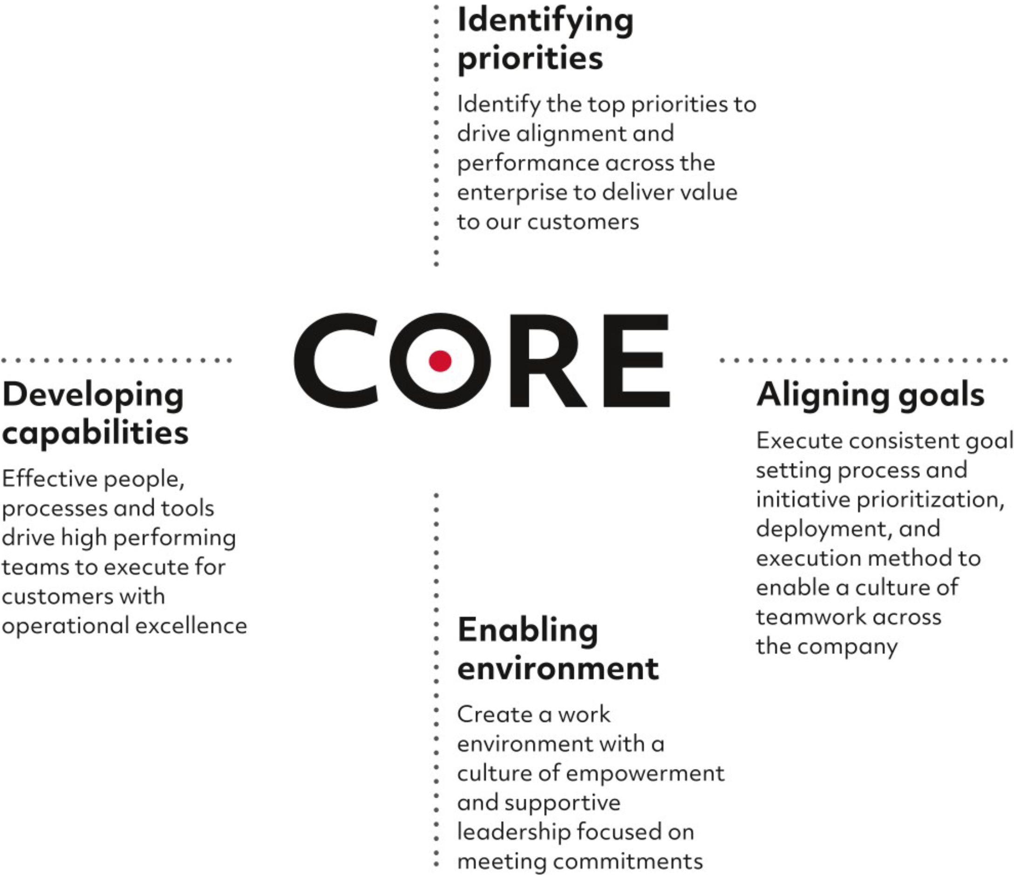

Customer Oriented Results and Excellence™
© 2026 RTX Corporation. All rights reserved. |  | CORE and Customer Oriented Results & Excellence  are trademarks of RTX Corporation.

Table of Contents


Table of Contents

RTX CORPORATION
1000 WILSON BOULEVARD
ARLINGTON, VIRGINIA 22209

 |  | SCAN TO  VIEW MATERIALS & VOTE |  | 
VOTE BY INTERNET
Before The Meeting - Go to www.proxyvote.com or scan the QR Barcode above
Use the Internet to transmit your voting instructions up until 11:59 P.M. Eastern Time on April 29, 2026 for shares held directly and up until 11:59 P.M. Eastern Time on April 27, 2026 for shares held in a company savings plan. Have your proxy card in hand when you access the website listed above and follow the instructions to complete an electronic voting instruction form.
During The Meeting - Go to www.virtualshareholdermeeting.com/RTX2026
You may attend the meeting via the Internet and vote during the meeting if you are a direct shareowner. Have the information that is printed in the box marked by the arrow available and follow the instructions.
For shares held through a company savings plan, you must vote prior to the meeting, but may still attend the meeting.
VOTE BY PHONE - 1-800-690-6903
Use any touch-tone telephone to transmit your voting instructions up until 11:59 P.M. Eastern Time on April 29, 2026 for shares held directly and up until 11:59 P.M. Eastern Time on April 27, 2026 for shares held in a company savings plan. Have your proxy card in hand when you call and then follow the instructions.
VOTE BY MAIL
Mark, sign and date your proxy card and return it in the postage-paid envelope we have provided or return it to Vote Processing, c/o Broadridge, 51 Mercedes Way, Edgewood, NY 11717.
TO VOTE, MARK BLOCKS BELOW IN BLUE OR BLACK INK AS FOLLOWS:
V88187-P42225-Z91759 | KEEP THIS PORTION FOR YOUR RECORDS
 | DETACH AND RETURN THIS PORTION ONLY
THIS PROXY CARD IS VALID ONLY WHEN SIGNED AND DATED.
RTX CORPORATION
The Board of Directors recommends a vote FOR the listed nominees under Item 1.
Item 1 - | Election of Directors
 |  |  | For | Against | Abstain
 | Nominees:
 | 1a. | Tracy A. Atkinson | ☐ | ☐ | ☐
 | 1b. | Christopher T. Calio | ☐ | ☐ | ☐
 | 1c. | Leanne G. Caret | ☐ | ☐ | ☐
 | 1d. | Bernard A. Harris, Jr. | ☐ | ☐ | ☐
 | 1e. | George R. Oliver | ☐ | ☐ | ☐
 | 1f. | Ellen M. Pawlikowski | ☐ | ☐ | ☐
 | 1g. | Denise L. Ramos | ☐ | ☐ | ☐
 | 1h. | Fredric G. Reynolds | ☐ | ☐ | ☐
 | 1i. | Brian C. Rogers | ☐ | ☐ | ☐
 | 1j. | Robert O. Work | ☐ | ☐ | ☐

COMPANY PROPOSALS: The Board of Directors recommends a vote FOR Items 2 and 3. |  |  | For | Against | Abstain
Item 2 - | Advisory Vote to Approve Executive Compensation |  | ☐ | ☐ | ☐
Item 3 - | Appointment of PricewaterhouseCoopers LLP to Serve as Independent Auditor for 2026 |  | ☐ | ☐ | ☐

Please date and sign name exactly as it appears hereon. Executors, administrators, trustees, etc. should so indicate when signing. If the shareowner is a corporation, the full corporate name should be inserted and the proxy signed by an officer of the corporation indicating his/her title.
Signature [PLEASE SIGN WITHIN BOX] | Date |  | Signature (Joint Owners) | Date

Table of Contents



Thursday, April 30, 2026, 8:00 a.m. Eastern Time
www.virtualshareholdermeeting.com/RTX2026

Important Notice Regarding the Availability of Proxy Materials for the Annual Meeting:
The Notice and Proxy Statement and Annual Report are available at www.proxyvote.com.

V88188-P42225-Z91759

THIS PROXY IS SOLICITED ON BEHALF OF THE BOARD OF DIRECTORS
ANNUAL MEETING OF SHAREOWNERS
THURSDAY, APRIL 30, 2026

The undersigned hereby appoints Christopher T. Calio, Neil G. Mitchill, Jr. and Ramsaran Maharajh, or any of them, as proxies, each with full power of substitution, and hereby authorizes them to represent and to vote, as designated on the reverse side of this ballot (with discretionary authority as to any and all other business that may properly come before the meeting), all of the shares of Common Stock of RTX Corporation that the Shareowner(s) is/are entitled to vote at the Annual Meeting of Shareowners to be held at 8:00 a.m. Eastern Time on Thursday, April 30, 2026 virtually at www.virtualshareholdermeeting.com/RTX2026, and at any adjournment, continuation or postponement thereof.

THIS PROXY, WHEN PROPERLY EXECUTED, WILL BE VOTED AS DIRECTED BY THE SHAREOWNER(S). IF NO SUCH DIRECTIONS ARE MADE, THIS PROXY WILL BE VOTED IN ACCORDANCE WITH THE RECOMMENDATION OF THE BOARD OF DIRECTORS.

If the undersigned is a participant in a company savings plan and has shares of Common Stock of RTX Corporation allocated to their plan account, the undersigned hereby instructs the plan trustee to vote all such shares of stock in accordance with the instructions on the reverse side of this ballot at the Annual Meeting and at any adjournment, continuation or postponement thereof. IF NO VOTING INSTRUCTION IS PROVIDED, THE PLAN TRUSTEE WILL VOTE THE SHARES ALLOCATED TO THE PARTICIPANT’S PLAN ACCOUNT IN ACCORDANCE WITH THE PROPER VOTING INSTRUCTIONS THE TRUSTEE RECEIVES WITH RESPECT TO A PLURALITY OF PLAN SHARES FOR WHICH THE TRUSTEE RECEIVES PROPER VOTING INSTRUCTIONS.

IF YOU ARE NOT VOTING ON THE INTERNET OR BY TELEPHONE, PLEASE MARK, SIGN, DATE
AND RETURN THIS PROXY CARD PROMPTLY USING THE ENCLOSED REPLY ENVELOPE.

